Domesday 1986 – Concise user guide

|  |
| --- |
|  |

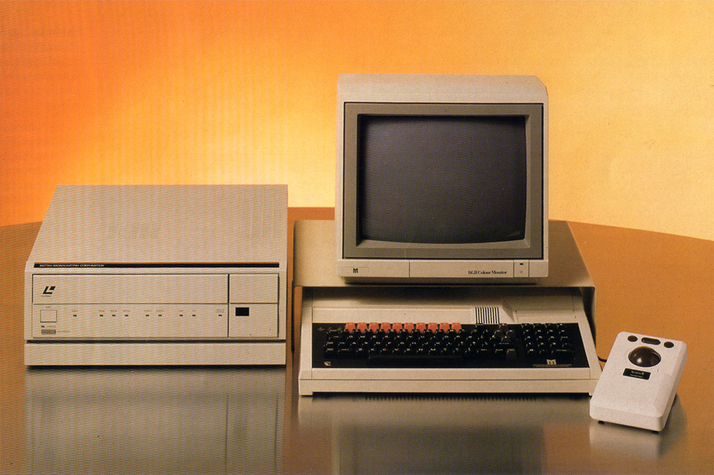

*Version*: 1.0



Visit <http://www.domesday86.com> for more information and resources.

Document information

This document is based on the original Domesday video disc user guide by Peter Armstrong and Mike Tibbets published by BBC Publications and © BBC Enterprises Ltd 1986. The document has been typeset and re-organised for use as a PDF document. In addition, the original text has been updated and corrected where required. All the original (black and white) photographs have been replaced with colour photographs and all diagrams have been redrawn in high-resolution colour.

This document also contains additional information about areal descriptions, a detailed list of the video content of side B of the National Disc, a (non-exhaustive) list of the picture-sets found on the National disc and a summary of the VFS commands for laser disc control. Some of the examples have been rewritten (as the originals did not work with the release version of the Domesday system). All chapter references have been replaced with hyperlinked section titles and all chapters have been arranged hierarchically to allow simple navigation of the many sections contained within.

All additional content and typesetting is © Simon Inns 2017 and is released under a Creative Commons Attribution-ShareAlike 4.0 International (CC BY-SA 4.0) licence. For details please see:

<https://creativecommons.org/licenses/by-sa/4.0/>

Thanks to **Ian Smallshire** for additional proof-reading and suggestions and to **Alex Wilson** for supplying the Domesday disc set used to create the many screenshots. The list of picture-sets from the National disc was taken from the “Domesday Display” manual and was kindly prepared by **Phil Mainwaring**.

If you have any comments on this document, or would like to suggest updates and/or corrections, please use the contact form available on: <http://www.domesday86.com>

Version guide:

1.0 – 20170903 - First release version of the document.

Contents

1 Quick start 7

1.1 All you need to know to get under way 7

1.2 A quick guide to Domesday grammar 8

2 The Domesday system 9

2.1 Introduction to the Domesday discs 9

2.2 Controlling the system 11

2.2.1 Switching on and starting up 11

2.2.2 Aligning graphic and video output 12

2.2.3 System structure 13

2.2.4 Common screen features 14

2.2.5 The mouse or trackerball 16

2.2.6 Basics of system control: the screen pointer 17

2.2.7 Basics of system control: the menu bars 18

2.2.8 Basics of system control: function keys, [ESCAPE] and [BREAK] 18

2.2.9 Printing, downloading and copyright 20

2.3 The help sequences 22

2.3.1 Selecting help and receiving the status report 22

2.3.2 Moving on to the pages of help text 23

2.3.3 Viewing the video demonstration 24

2.3.4 Special help with areal units 25

2.3.5 Access to the operating system 25

2.3.6 The bookmark function 25

2.3.7 Returning from the help sequence 26

3 The Community Disc 27

3.1 Introduction to the people's database 27

3.1.1 The 4 top-level functions 28

3.1.2 Options and help 29

3.1.3 Booting up 29

3.1.4 Finding your way with maps 30

3.1.5 Map walking 34

3.1.6 Map options 38

3.2 The local photographs 52

3.2.1 Viewing the photographs 52

3.2.2 Picture options 53

3.2.3 Specialised photographs 54

3.2.4 Leaving photographs 55

3.2.5 For example – To find the false colour Landsat image of the Portsmouth area and read the descriptive caption 55

3.3 Five levels of text 60

3.3.1 Reading the text 61

3.3.2 Cross references to regional articles 62

3.3.3 Text options 63

3.4 Using the main index with find 71

3.4.1 Finding maps 72

3.4.2 Finding text and photographs 74

3.4.3 Synonyms and word stems 77

3.4.4 The specific keywords 77

3.4.5 Scope of search 77

3.4.6 The art of retrieval 78

3.4.7 Leaving find and returning later 79

3.4.8 For example – To find pictures and text on Steam Trains in Northern Britain 80

4 The National Disc 89

4.1 Introduction to the National Disc 89

4.1.1 The two sides of the National Disc 89

4.1.2 The organisation of material 89

4.1.3 Retrieving data from the disc 89

4.1.4 The four top-level states of the National Disc 90

4.2 Using the National index 91

4.2.1 What do you want to know about? 91

4.2.2 Synonyms and word stems 94

4.2.3 Entering item names directly 95

4.2.4 The art of retrieval 95

4.2.5 Leaving find and returning later 95

4.2.6 For example – Finding pictures about Flowers with special reference to Liverpool 96

4.3 Contents - The hierarchical approach 100

4.3.1 The branching hierarchy 100

4.3.2 Retreating up the hierarchy 103

4.3.3 Reviewing cross-references 103

4.3.4 The special case of overview essays 104

4.3.5 Exiting from contents 104

4.4 Looking at picture sets 104

4.4.1 Viewing the pictures 105

4.4.2 The other functions on the menu bar 107

4.4.3 Leaving photographs 108

4.4.4 For example – Finding a photograph of the Clouded Yellow butterfly and displaying it without the caption or menu bar 109

4.5 Reading text 115

4.5.1 Reading the text 116

4.5.2 The local paper front pages 117

4.5.3 Text options 117

4.5.4 For example – Finding the overview essay on housing and read details about the author 118

4.6 Taking surrogate walks 121

4.6.1 Finding the walks 122

4.6.2 Beginning the walk 122

4.6.3 Plan and help 124

4.6.4 The full move options 124

4.6.5 Close-up details 125

4.6.6 Ending your walk 125

4.6.7 For example – To explore the stone cottage and examine the ornaments on display in the living room 126

4.7 Viewing the film and video clips 135

4.7.1 Viewing the video clips 136

4.7.2 For example – To watch the first London Marathon 138

4.8 An introduction to numerical data on the National Disc 143

4.8.1 Sources 143

4.8.2 Different types of data 144

4.8.3 Organisation of data in data sets 146

4.8.4 Meaningful displays of raw data 146

4.8.5 Reprocessing to enable comparison: your chance to be a pioneer 148

4.8.6 Rasterization of irregular areas 149

4.9 Displaying and manipulating data maps 151

4.9.1 Three main elements of a data map 151

4.9.2 Entering the data-mapping procedure 152

4.9.3 Area 153

4.9.4 Plotting the initial data map 165

4.9.5 The key option 167

4.9.6 Where did the initial class intervals come from? 167

4.9.7 The special case of incidence data maps 167

4.9.8 District 170

4.10 Displaying and manipulating statistical chart displays 179

4.10.1 Definitions and terminology 180

4.10.2 The chart screen 182

4.10.3 Further options available from the menu-bar 188

4.11 The Domesday gallery 191

4.11.1 Arriving at the gallery 191

4.11.2 Moving around the gallery 191

4.11.3 Examining items in the gallery 192

4.11.4 Ending your walk around the gallery 194

4.11.5 For example – Exploring pictures about sport in the Gallery and viewing the 1500-metre final from the 1984 Olympics 194

5 Postscript on future uses of the system 202

5.1 Advanced applications of the Domesday discs 202

6 Appendices 204

6.1 Appendix I - Disc maps 204

6.1.1 Community disc maps 204

6.1.2 National disc maps 204

6.1.3 Detailed list of National disc picture-sets and frame numbers 209

6.2 Appendix II - Technical description of software 220

6.3 Appendix III - Formats of downloaded files 221

6.3.1 Photo and text 221

6.3.2 Tabular data 222

6.3.3 Mappable data 222

6.4 Appendix IV – Acorn VFS laser disc command summary 223

# Quick start

## All you need to know to get under way

If you are one of those people who likes to try out new programs before settling down to read the manual, this section should give you all the information you need to get under way. You can then rely on the comprehensive **Help** option to guide you further as you explore the discs. We do, however, suggest you read the rest of this manual later - there are some features which need more explanation.

We assume that you have set up the hardware correctly (this is described in the relevant hardware manuals and briefly here in the “Controlling the system” section). Make sure that the key-strip is inserted above the function keys, particularly if you are not using a mouse or trackerball. Line it up so that Help is above function key [f1]. The blue and yellow boxes will correspond to boxes of the same colour on the screen menu bar. The changing function of these keys will be indicated at different points on the discs.

You are now ready to try out the Community Disc. This is the simpler of the two discs to start with. Here are ten crucial points to follow to get under way:

1. Put the disc into the video disc player with either side up. Close the drawer or lid. Press [Q] with [CTRL] and [BREAK] to initialise the micro. Wait for the prompt symbol (>) to appear. Now hold down [SHIFT] and press [BREAK] once. The start-up sequence takes about 40 seconds, after which you will see the opening film which lasts for one minute.
2. After the film ends on a map of the UK, a menu bar appears showing your options and you are in control. Use the pointer to direct the action. Move it with your mouse or trackerball, or with the cursor keys on the keyboard.
3. To zoom in on a map, move the pointer to the right spot and press [ACTION]. This is button 1 on the mouse or the [RETURN] key on the keyboard. This is also how you **select** items from the menu bar at the bottom of the screen. To zoom out select **Out** on the menu bar.
4. To move to an adjacent map, position the pointer towards the appropriate edge of the screen and press [CHANGE]. This is button 2 on the mouse or [TAB] on the keyboard.
5. To select the pictures or text that belong to any map, just select **Photo** or **Text** from the menu bar.
6. To move to the next picture or page of text, move the pointer to the right of the screen (like turning a page) and press [CHANGE]. Use the left of the screen to page backwards. Keys [f7] and [f8] are the alternative method from the keyboard.
7. To choose an item from any list you are offered, point at the item you want and press [ACTION].
8. If you get stuck, select **Help** and then **Help Text**, and page through the guidance text you find there. It will always relate directly to where you are in the system. Leave the pages of **Help** to return to where you were by selecting **Exit**.
9. If you have no idea about how one of the major functions is supposed to work, select **Help** and then select **Demo**. This will give you a short video sequence with commentary, so that you can see that part of the system working in practice.
10. If you want to start again with the UK map just press [ESCAPE] and respond to the message 'Do you want to restart (y/n)?' by entering [y] from the keyboard.

Enjoy your exploration of the Domesday Discs. Because they are interactive they should be easier to understand than most software systems. On the other hand, there is a mass of material on the discs, so don't be surprised if you get lost at times. Nothing you do from the keyboard or with the mouse can damage the system or erase any material on the video discs.

## A quick guide to Domesday grammar

The following common commands within the Domesday discs are accessible using either the mouse/trackerball or the keyboard:

|  |  |  |
| --- | --- | --- |
| **Mouse** | **Command** | **Keyboard** |
| Move mouse | *Move pointer* | Cursor keys |
| Button 1 | *Action* | [RETURN] |
| Button 2 | *Change* | [TAB] |
| Point and [ACTION] | *Select* | Function keys |
| Point right and [CHANGE] | *Page forward* | [f8] |
| Point left and [CHANGE] | *Page back* | [f7] |

# The Domesday system

## Introduction to the Domesday discs

The idea for a 20th Century Domesday Book - produced in a comprehensive form that could be widely available - was only possible because of new developments in optical storage (in the early 1980s). The interactive video disc offers to anyone interested in exploration through words, data and pictures a medium that is close to ideal. It can store film, still photographs, text, data and computer software on the same surface. And, despite its huge volume of 108,000 still images and 648 megabytes of data per disc, it can be accessed quickly, so that as a user you can move straight to the section you want without being burdened by the sheer mass of material at your disposal. This is made possible by the combination of replay hardware, indexes and retrieval software that the new generation of interactive video discs brings together.

How should one think of this new medium? In some ways, it is like an electronic book, with screen pages that can be arranged into chapters, an index and a table of contents. But most books have a beginning, a middle and an end, whereas the disc offers random access: it is not designed to be read in any order. Does this make it an encyclopaedia? In a way - though this suggests fixed sections related to topics, while the video disc can put the same material into an almost infinite series of patterns in response to different enquiries. Seen in this way, therefore, it is closer to a database with pictures, or a set of television programme elements, put together by the disc user, who takes the place of the television producer. Then again interactive video can be seen as operating in the same way as a teacher or expert, offering information and insight to the person using the disc.

Our own preference is to see the Domesday Discs as a kind of exhibition - an electronic exhibition of British Life in the 1980s. This exhibition tries to reflect many aspects of life today in just the same way that, for example, the Great Exhibition of 1851 or the 1951 Festival of Britain did for their times with traditional means. Like them it is highly selective: it does not aim at the comprehensiveness of an encyclopaedia. It offers not general truths but insights and images that we hope are characteristic of our times. And the visitor to this electronic exhibition can wander around freely, focusing on those elements that catch the eye.

Who is the exhibition for? The advantage of an electronic exhibition is that it can claim to be for everyone. We hope the Domesday Discs will be of real value today as a way of taking stock of the state of the country and as a practical resource particularly in education. But if the exhibition stands the test of time, it can equally be visited in the coming centuries by those who want to look back at what we thought, how we looked, what we did in the 1980s, and from what we decided to include in the exhibition - what we thought important. It was this idea of the creation of a multi-media record of our times for use in the future that was the primary motivation in the creation of the Domesday Discs for the 900th anniversary of William the Conqueror's Domesday Book. For a fuller account of how the Domesday Project arose and the final form it took, we would refer you to the article "The Domesday Project" on the National Disc. A second article, called "Credits and Acknowledgements", lists the many hundred people whose collaborative work these discs represent.

Contributions from members of local communities are usually acknowledged in the items they have provided.

This document cannot be a user guide of the usual kind, since it must cover not only the working of a large suite of computer programs, but also give some introduction to the contents of the Domesday Discs as well. These must be understood together. A data map showing, for example, the distribution of red deer in Scotland derives from both. The database provides the statistics, the map library provides the background map and the computer program produces the resulting composite image. The system must be understood as a whole.

Nor is it always possible to use a reassuringly step-by-step approach. What you should do depends on where you want to go. At any point on the discs you have a huge choice of options open to you. Here the analogy is more like driving a car across unknown country. This guide can show you the techniques you will need at different points on the journey, but it must also indicate how to use the maps of the terrain provided on the discs - the indexes in all their different forms.

The final consideration is the sheer size of the Domesday database. We estimate that it would take you about seven years to call up and examine all the material on the two discs. So, this manual can only sketch in the broadest terms some of the possibilities for using the system.

The good news is that using the discs in a straightforward way is in practice very easy. As the last section made clear, they are designed so that you can dive in at any point and explore from there. If you understand the basic Domesday grammar (which comes down for the most part to 'point and click') you can pick up any extra information you need from the help text that is available wherever you go. We have arranged this book in the same way. The basic grammar is printed on the summary card. We have also built in a certain amount of repetition of key points. So, although it is most logical to read the manual through from beginning to end, you can in fact turn to a topic that interests you and pick it up without reference to earlier sections. The only exceptions are the sections “Displaying and manipulating data maps” and “Displaying and manipulating statistical chart displays” sections on data handling. These are more complex and you should read the section “An introduction to numerical data on the National Disc” first.

Technical terms have been kept to a minimum - the Domesday Discs are for everyone, not for computer specialists. The convention we have followed in this manual is to refer to keys on the micro computer keyboard in this form - [BREAK], and to use bold type for menu bar names, e.g. **Help**.

This manual applies to the LV-ROM version of the Domesday system: that is the system where an advanced Laservision player reads both the pictures and the digital data from the video discs. If you are using the system with simpler hardware, for example with compact discs or magnetic discs for the digital content, then you should refer to the relevant manuals, although the general principles are very much the same. The microcomputer primarily referred to is the BBC Master Series AIV, though other micros that can drive the video discs do so in very similar ways.

The Domesday Discs comprise two double-sided discs. The first is the Community Disc. This looks at the United Kingdom from a geographical point of view. It is based on a linked set of thousands of maps, with pictures and text about areas and communities. At a regional level, the material has been prepared by professionals, while at the local level the pictures and text have been provided by local people, usually in schools. This gives the disc a unique flavour – a self-portrait of the United Kingdom in the 1980s painted by her (mostly young) citizens. One side of the disc covers Southern Britain and the Channel Islands, the other side covers Northern Britain and Northern Ireland.

The second disc is the National Disc. This is a view of life in the United Kingdom as a whole, drawn (for the most part) from official sources. It is arranged by topic and offers statistics as well as text, pictures and maps. On its second side are video sequences which cover the images and events of the individual years from 1980 to August 1986.

As we say several times in this book, much the best way to learn your way around the Domesday Discs and their computer programs is to use them. Although this book can be read on its own, it is best used alongside the system, so that you can try each function as we describe it.

## Controlling the system

The Domesday System includes a suite of programs to retrieve and manipulate data from the Domesday Discs. Audio-visual material plus numbers and text are presented in a wide range of screen displays which you can change and modify with great flexibility. Though powerful, the system is comparatively simple to use.

We compare it with driving a car. There are a few straightforward controls but learning them simply enables you to get the car on the road. Practice and experience will get the best out of the system and its ultimate potential is limited only by your needs and imagination.

This section outlines some fundamentals, including the start-up sequences on each disc; system structure; common screen features; the screen pointer and its operation by mouse, tracker-ball or keyboard; basics of system control, the use of the menu bar and function keys plus [ESCAPE] and [BREAK] and the means of printing output or downloading to a floppy disc, together with an important note on the implications of copyright.

### Switching on and starting up

To start using the system you will obviously need to ensure that everything is connected, has power and is switched on. You should connect the system as shown in the manual supplied with your equipment. If you do not feel confident enough to set up the system yourself, you should consult your dealer or technical support centre.

You insert the appropriate Domesday Disc (either the National or Community Disc) in the player with the label of the required side facing upwards.

Hint: Disc labels

Nothing is ever quite as straightforward as it seems. The side of the video disc in use is the **downward**-facing side. However, it is a convention of video disc manufacture that the label on one side refers to the content of the **other** side. Thus, you load a disc with the required label facing **upwards**.

On the National Disc, you will always start with Side A, since you will usually only turn to Side B when requested by the system. When using the Community Disc, you may consider whether you will initially be taking more interest in Northern Britain (including Scotland, Northern Ireland, the Isle of Man and the North of England), or Southern Britain (including Wales and the Channel Islands). You can start equally well on either side of the Community Disc, but a little forethought could save you an early change-over of disc sides.

In handling the discs, you will notice that, unlike floppy or magnetic discs, they are not encased in any protective cover. They are indeed very robust, which is one of the reasons why the Domesday Project chose optical discs as a vehicle. However, you should note that the discs are read by a sensitive light beam and any serious blemish of the surface could introduce errors. As far as possible, therefore, look after your discs. Protect the surface from grease, dust, finger-marks and scratches. A good rule of thumb (literally!) would be to give them the same care as you would your most prized gramophone records.

Having inserted a disc, there are two stages in getting the controlling software started (known as "booting up"). Firstly, you need to initialise the VFS (Video disc Filing System) by holding down both [CONTROL] and [Q] whilst you press and release [BREAK]. This initiates some processing and you must wait until it is complete, indicated by the return of the ">" character to the screen. Next you boot up the Domesday System itself by holding down [SHIFT] whilst you press and release [BREAK]. This initiates a start-up sequence which takes about 40 seconds. You will then see a video sequence lasting a further minute. After you have seen this a few times you can cut it short by pressing the [ESCAPE] key after it starts.

Hint: Resetting the 'CMOS'

There can be a problem with the CMOS (the permanent settings controlling the default state of the micro on power-up: see the microcomputer manual for details) if you are booting up the Domesday system after the microcomputer has been used for other purposes in which the CMOS parameters were changed. In these circumstances, you will need to re-set the CMOS prior to booting up Domesday by means of a *CONFIGURE command. Please refer to the Acorn manual. The required settings are:

*CONFIGURE TUBE  
*CONFIGURE INTUBE  
*CONFIGURE VFSDIR  
*CONFIGURE TV 255,0

To configure the system to auto-boot, the following commands are also required:

*CONFIGURE BOOT  
*CONFIGURE FILE 8

Librarians and others who must manage a Domesday System which is open to public or general access may like to know of a further CMOS setting which will disable the user's ability to eject the video disc from the player.

This is useful if you want to be sure that you are the only person who handles the discs and the player. The setting is:

*NOEJECT

Remember to perform a [CTRL]+[BREAK] after performing configuration to ensure the new settings are correctly loaded.

After the opening film, or in response to [ESCAPE], the system will come to rest in an initial state, ready to accept your instructions. The Community Disc (either side) will start with a map of the whole UK. The National Disc will transport you into the video "gallery" where you can browse what is on the disc, or call other procedures to search the index.

### Aligning graphic and video output

The first thing is to check that the graphic output from the microcomputer is· correctly aligned with the video output from the videodisc player. The best way to do this is on the Community Disc, by calling up a level 2 or level 3 map (see section “Finding your way with maps”) and checking the thin dark grid lines on the video map against the yellow rectangle which borders the area of the screen used by the micro. This rectangle should align with the grid lines on the map. If not, you should adjust the slotted "horizontal shift" control on the back of the video disc player. (Check the player manual for exact location and marking). A thin screwdriver will adjust the lateral position of the rectangle to align with the background video map.

### System structure

The two Domesday Discs are quite different in the information they contain and how it is accessed.

The Community Disc portrays geographical areas of the UK in the form of maps, photographs and text. Primary access to this material is via the maps, of which the disc has over 24,000. You locate the map showing the area about which you want to know, then call up any associated pictures or text·. One way to find the map you need is to start with a map of the whole UK and then select maps of increasingly detailed scale until you have "zoomed in" on your area of interest.

Another way is to ask the system to locate the right map for you by specifying a place-name or its grid reference. A further means of accessing Community Disc information without using maps at all is by specifying a subject in which you are interested. The Community Disc system will automatically show you pages of text and photographs which deal with your topic, wherever they occur.

Hint: Grid References

The system often uses grid references and a review of the National Grid concept and the representation of grid references at various levels of precision might be useful.

The National Grid locates any point in Great Britain by reference to its distances East and North of a fixed point or “origin” near the Scilly Isles. Grid-references, therefore, consist of two numbers: an “Easting” followed by a “Northing”. The precision of a reference depends upon the precision of the Easting and Northing distances. These can be specified to any degree of accuracy but there are conventions. Four-figure numbers are taken to be whole kilometres: 0395 0407 indicating a point 395km East of the origin and 407km North.

Theoretically this is an exact spot, but is usually taken to mean a whole kilometre square by pointing to its South-West corner. Extending the reference to five-figure numbers, e.g. 03958 04073, increases accuracy and refers to a 100m square beginning 395.8km East and 407.3km North of the origin. Restricting a reference to three-figure numbers reduces accuracy, with 039 040 referring to a 10km square beginning 390km East of the origin and 400km North.

An alternative system of grid-references codes the 100km squares of the National Grid as a pair of letters. In our example, 03 04 is coded as SD. Figures are added to increase precision, e.g. SD 3 6 (10km square); SD 27 58 (1km square) or SD 268 583 (100m square).

Both these methods are recognised by the Domesday System.

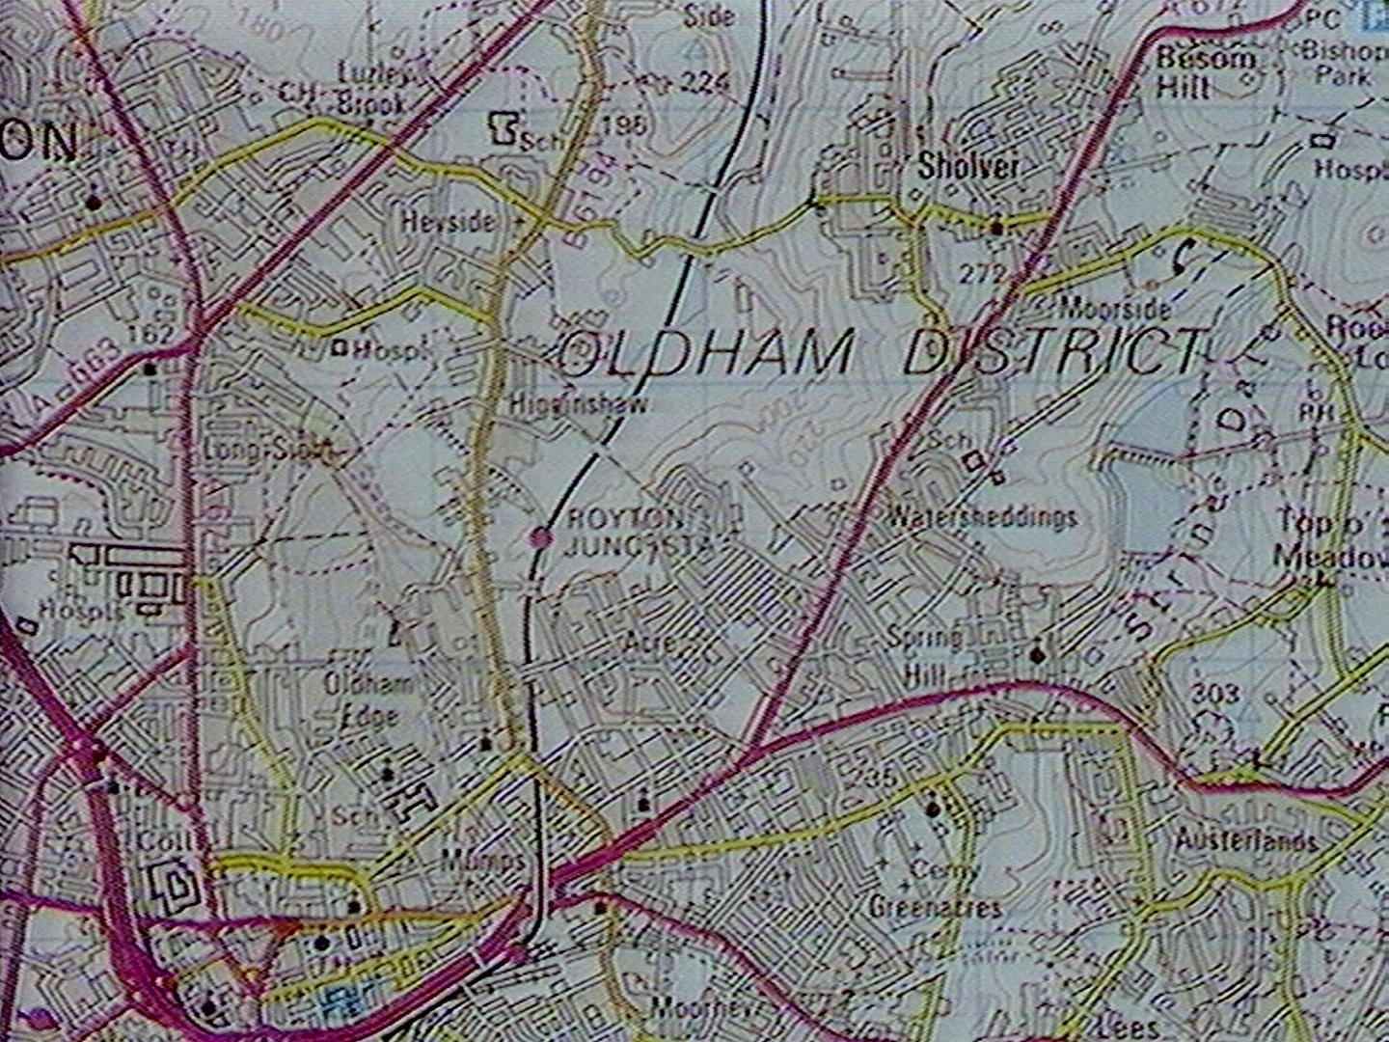

Figure 1 - Square referenced by 0395 0407

The **National Disc** differs from the Community Disc in focusing on topics and subjects rather than places. Use of this disc starts with processes to identify items of interest via powerful indexes. Then, specialised sub­systems display and manipulate different kinds of material: text, sets of still pictures, moving film clips, mappable data, tabular data, etc., invoked automatically when you choose to see an item.

On either disc, you will find yourself moving around hierarchical structure. On the Community Disc you will be moving around maps, stepping up and down to different scales as well as across maps. On the National Disc you will be moving around index searching and data-handling processes, delving down to detailed levels for specialised operations and moving back up the levels for more general operations and index-searches. The key to effective use of the system is awareness of the current level at which you are working and the nature of the function currently in operation. Harking back to our car-driving analogy, this is akin to knowing what gear you are in and watching your road-position.

### Common screen features

Domesday screen displays are a combination of the microcomputer's graphic output and video images from the disc. The form of display is particular to each function, but some standard features appear on most screens.

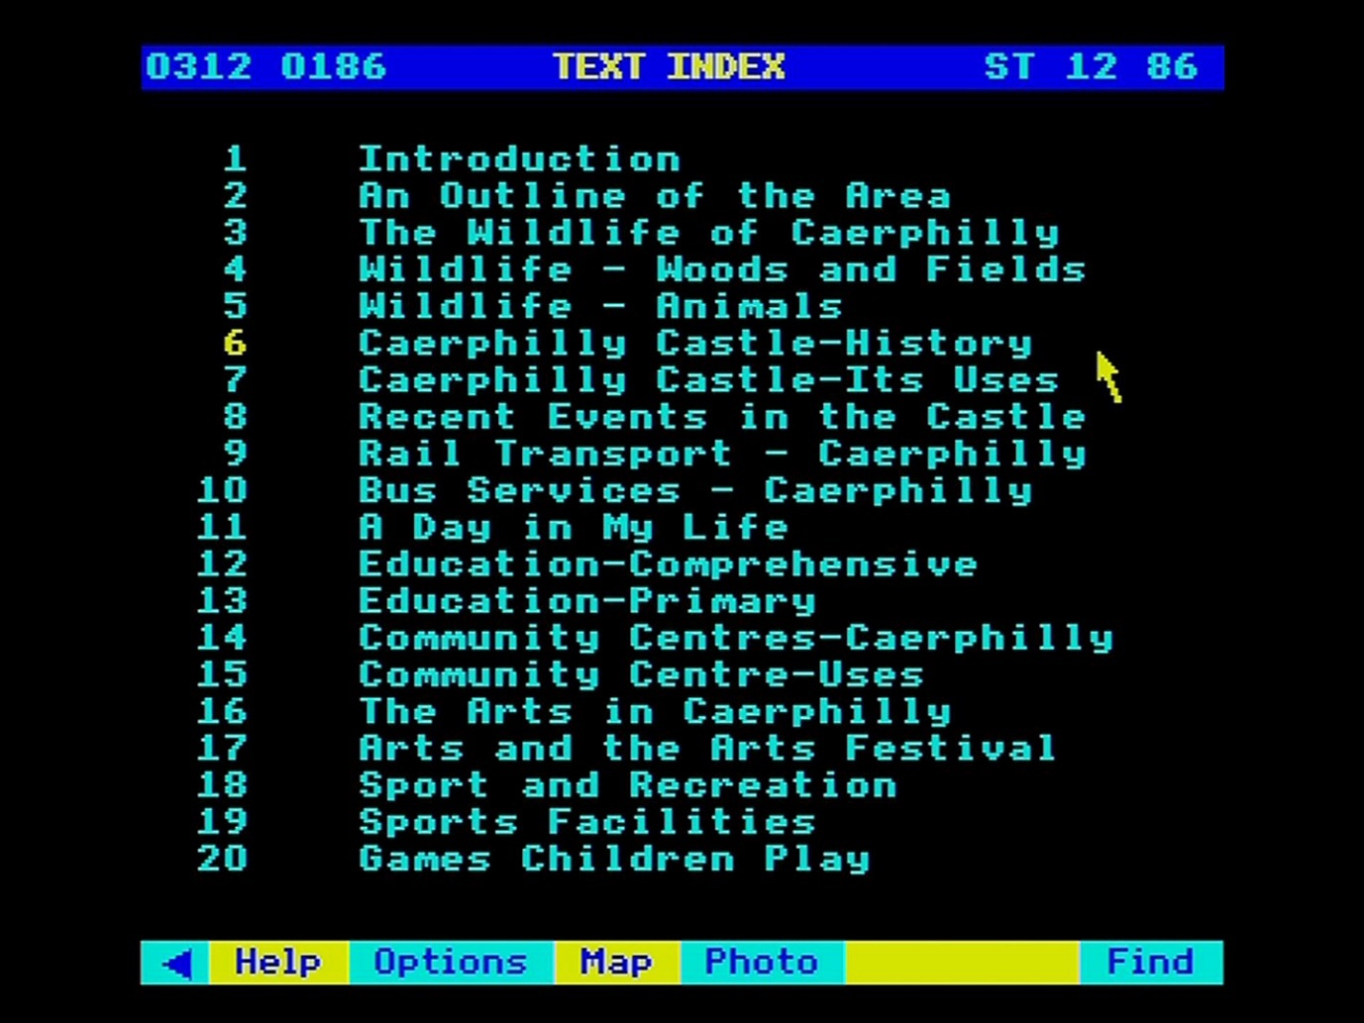

Figure 2 - Common screen features

Along the bottom of the screen is the all-important *menu bar*. This lists the system options currently available and it is the main indication of where you are in the system, as well as your principal means of moving from one stage to the next. As described in more detail below, you use the menu bar to select the next option you need and this may bring with it a whole new set of sub-options which become available as further steps. Thus, as you work with the disc, the contents of the menu bar will change repeatedly. You do not need to work out what you can do at any point, the system will keep the menu bar updated for you. If an option is shown, then you can do it; if you can't do it, then it simply won't be offered.

Hint: Check other menu bars

If a function you need is not shown on the menu bar, it might be worth checking that it is not available further down the hierarchy. For example, on a Community Disc map, you might want to see a key to the map-symbols, but be confused because no such facility is mentioned on the menu bar. Selecting Options from the menu bar, however, will reveal a new menu including the Key option.

Along the top of the screen is a one-line *message area* used to display prompts and error messages, and sometimes for keyed input.

Between message area and menu bar is the main *display area* of the screen where the bulk of each screen display will appear. The only feature of this area which needs to be noted at this point is the *screen pointer* which appears as an arrow pointing towards the top-left or, near the menu bar, as a cross. The exact spot indicated by the screen pointer is the tip of the arrow or the centre of the cross. This pointer is an important means of system control, as outlined below.

### The mouse or trackerball

The position of the screen pointer is controlled by either a *mouse* or a *trackerball* or by the cursor-control keys of the computer’s keyboard.

The mouse and the trackerball are effectively the same device, designed specifically to manage the screen pointer and to initiate action when it has reached a certain point. The mouse is a hand-held unit with a rolling ball mounted underneath. You track it across a flat surface and the micro senses the movements of the ball, moving the screen pointer accordingly. The trackerball is the same mechanism on its back, so that the device itself stays still whilst the rolling ball is manipulated directly. This is particularly suitable for use in a fixed workstation which must withstand handling by many users, as in a library. Both mouse and trackerball have buttons with which to signal to the computer. The Domesday system uses two of them: [ACTION] and [CHANGE] and on three-button units they will usually be the left-hand and central buttons. With your Domesday system, you may find supplied a pair of sticky labels with which you can mark the buttons of your mouse or trackerball. In this guide, we will refer only to the "mouse" but imply either mouse or trackerball.

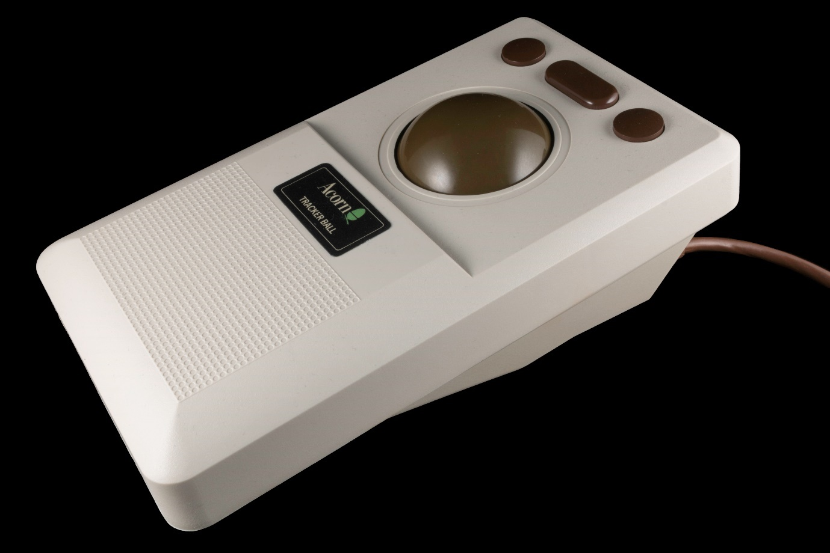

Figure 3 - The Marconi RB2 trackerball

The Domesday System has been designed to take advantage of the mouse. However, if you are not using this device, the keyboard's cursor-control keys will move the screen pointer. To optimise their performance, we have installed accelerators so that holding down a cursor-control key for more than half a second will speed up the movement.

Hint: Cursor key use

If you use the cursor-keys to move the screen painter over a large distance and need high accuracy at the end-point move the pointer quickly into the general target area by holding down the key and then make fine adjustments with a series of rapid presses.

Also, if you are interested in using a touch-screen for interactive video control, the Domesday System has been designed for extension to touch-screen. However, since this device is not ideal for all Domesday applications, it is not implemented in the present software.

The mouse buttons, [ACTION] and [CHANGE], are permanently equivalent to [RETURN] and [TAB] on the keyboard. Throughout this guide, references to [ACTION] or [CHANGE] are equally valid for [RETURN] or [TAB]. Indeed, it is a useful discipline to forget [RETURN] and [TAB] and think of these keys as [ACTION] and [CHANGE] for the purposes of the Domesday System.

### Basics of system control: the screen pointer

Much control is by "point and click" using the screen pointer and [ACTION) or [CHANGE). In general, the effect of the two buttons is as follows:

* Point and [ACTION]: move in / activate this option / give me more of
* Point and [CHANGE]: alter this feature/ change to next (previous) item

As far as possible the system sticks to these principles but it is important to be aware of the precise needs of each function. For guidance, however, the following situations are likely to recur:

Many screen displays include explicit option boxes which can be activated by moving the pointer into the box and pressing [ACTION]. This is most important on the menu bar, as described below. In general, we will use the term "selecting" to imply moving the screen pointer to the required item and pressing [ACTION] to make the selection.

On screens where lists of items or menu lists are displayed, moving the screen pointer up and down the list, irrespective of the horizontal position along any line, will generally cause the item currently pointed to, or at least some part of it, to change colour to yellow.

Pressing [ACTION] will then select the highlighted item.

The screen pointer sometimes comes into play when the system needs you to key in one or more alphabetic or numeric parameters. Often several input boxes will be displayed on one screen and you use the screen pointer to indicate which box you currently want to use. Usually you don't need to press any button here: the system will constantly monitor the position of the pointer, activating and de-activating boxes and indicating this by changing and restoring their colour as you move over them.

Occasionally the screen pointer may be used right up in the message area when the system uses this part of the screen to display a set of options and you use the mouse pointer to [ACTION] a selection or make a [CHANGE].

A major use of the screen pointer is to indicate directions of movement through a sequence of items. On the Community disc this is the key to "map walking". You place the pointer on the edge of the map-screen in the direction you want to step onto an adjacent map and press [CHANGE] to make the move. A similar function on the National Disc is in a "surrogate walk" where moving the pointer to either side of the screen and pressing [CHANGE] rotates your viewpoint in that direction.

Finally, the screen pointer is used on both discs to step backwards and forwards through a sequence of items such as the individual photographs making up a picture set or the pages of a text sequence. Moving the pointer to the right-hand edge of the screen and pressing [CHANGE] requests "next", whilst a similar move to the left indicates "previous".

For convenience, this basic "grammar" of communicating with the Domesday System is summarised on a reference card supplied with the system.

### Basics of system control: the menu bars

Using the menu bar is a special case of the "point and click" procedure outlined above but merits extra attention as a fundamental system control. The menu bar is your "compass" through the system. It tells you where you are, where you can go next, and enables you to get back to where you came from. It also offers you more detailed guidance at every stage.

Each menu bar carries up to seven options in boxes across the bar, alternately coloured light-blue and yellow. The two leftmost of these will be the same on every menu bar: the other five will vary according to where you are in the system. You select options from the menu bar by moving the screen pointer into the box on the menu which contains the required option and pressing [ACTION]. The system emphasises to you that selections from the menu bar imply a fundamental system move by changing the screen pointer icon from its usual oblique arrow to a cross.

Hint:

When you are using the screen pointer in the main display area of the screen, for example in stepping out distances on a map, watch out when you are near the menu bar that the pointer icon does not change from arrow to cross. If it does so, and you inadvertently press [ACTION] then you will make an unwanted menu bar selection which may have undesired results.

The two permanent menu bar features are a left pointing triangle and **Help**. Selecting the former removes the menu bar temporarily from the screen, useful if you wish to view a video frame unencumbered for a moment. When removed, the menu bar will be replaced by an unobtrusive right­ pointing yellow triangle which can be actioned with the screen pointer to reinstate the menu bar. Selecting **Help** takes you into the comprehensive guidance system constantly available while you use the disc, ready to give you more detailed instructions about your current operation, including video and **Bookmark** but you should refer to the section on Help for more details.

The five-variable menu-bar elements show the options available to you at this point. You will need to refer to the section dealing with each operation to find out how they work. **Main**, however, appears on many menu bars and is the means of stepping back to the preceding operation.

### Basics of system control: function keys, [ESCAPE] and [BREAK]

The function keys on the micro keyboard have permanently defined roles. Some of these duplicate the action of the screen pointer, for convenience and for keyboard-only users, while others have extra functions.

The first seven function keys ([f0] through [f6]) mirror the options currently displayed on the menu bar:

* [f0] Turns the menu-bar on and off (the same as actioning the menu-bar triangle)
* [f1] Invokes the "Help" system for guidance on using the disc (equivalent to selecting option 2 from the menu bar)
* [f2] Selects the second blue box on the menu bar (whatever it is)
* [f3] Selects the second yellow box on the menu bar (whatever it is)
* [f4] Selects the third blue box on the menu bar (whatever it is)
* [f5] Selects the third yellow box on the menu bar (whatever it is)
* [f6] Selects the fourth blue box on the menu bar (whatever it is)

Here we should introduce the key-strip supplied with the system to be inserted under the clear plastic strip above the function keys, aligned so that "Help" is above [f1]. The colours against each function key will always correspond with the colours along the menu bar and the key-strip enables you to see at a glance which function key actions which option:

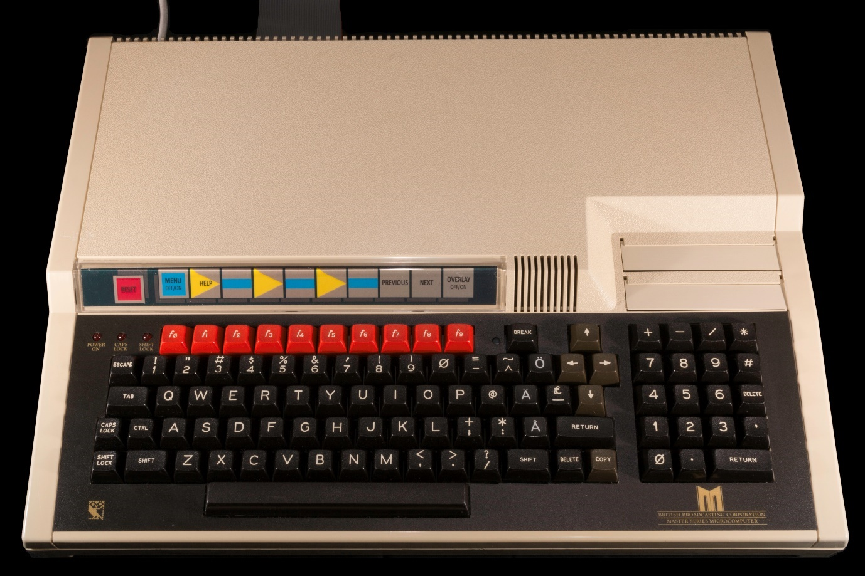

Figure 4 - Acorn Master AIV computer with Domesday key-strip

Hint: Function keys or mouse

While the function keys are vital for users without mouse or trackerball, all users may find them more convenient at times than moving the screen pointer. We will try to point out occasions when use of the function keys is likely to be particularly advantageous.

Function keys 7 and 8 duplicate the screen-pointer action described earlier to call up the "previous" or "next" item in a sequence:

* [f7] Requests the "PREVIOUS" page or picture in a sequence
* [f8] Requests the "NEXT" page or picture in a sequence

Function key 9, [ESCAPE] and [BREAK] each have unique functions which cannot be duplicated using the screen pointer:

* [f9] Clears the whole of the micro output from the screen, leaving just the video, if any. You cannot similarly switch off the video picture, which is under system control (except in data-mapping: see the section “Adding the background (maybe)”). Pressing [f9] again, or any key except [BREAK], will bring the micro output back on again.

Hint: Blank screen

If you come to a system which has been left running by the previous user, but the screen is blank, it is a good idea to start by pressing any key but [BREAK] - say the space-bar - to see if you can discover what state the system is in.

[ESCAPE] takes you back to the start-up state, as if you had just switched this disc on and viewed the opening film sequence. On pressing [ESCAPE] you will be asked in the message area to confirm that you want to abandon your work. Pressing [Y] will abort everything and reset the system; keying anything else except [BREAK] will restore your status quo.

[BREAK] switches off the system abruptly and catastrophically. You cannot recover from this. We recommend that after using [BREAK] to boot up the system you lock it in the manner described in the microcomputer manual to avoid accidentally pressing this key.

Hint: Remote control unit

One further control device, though not strictly part of the Domesday System, can be a useful adjunct: the remote-control unit supplied with the player. This might be an asset when using the system as a presentational visual aid. You use normal system options to display the first frame of a picture set You can then walk away from the keyboard and use the remote control to step through the frames of the set. Of course, you must return to the keyboard to call up captions. Similarly, if you want to review the contents of a picture set then you can use the remote control to set the sequence stepping slowly forward. Finally, in the Help sequences you may wish to stop and repeat sections of the filmed demonstrations. The best way to do this is by the remote control. The remote-control unit is usually disabled while the Domesday system is in progress but you can re-enable it by issuing a command to the operating system. For details on how to do this, please refer to the section on the System option in the Help sequence described in “The help sequences” section. The command to re-enable the remote-control unit is:

*FCODE J1

and to disable the remote control:

*FCODE J0

You should be aware that at times the system may not detect your remote moves and could lose track. However, experimentation will establish the system's tolerance.

### Printing, downloading and copyright

Users are free to access all the material on the two Domesday Discs via the monitor screen. However, occasions may arise when a printed copy or a subset of material downloaded to a floppy disc may be required for private research purposes. The system includes **Print** and **Write** facilities for this.

We must stress however, that provision of these functions does not imply any right for users to reproduce or re-use the disc contents in ways that would infringe copyright. While a single hard copy reproduction of text for purposes of research or private study would be permissible under the 'fair dealing' provision of the Copyright Act 1956 and would not infringe copyright, multiple copying for classroom purposes, for example, would require prior clearance with the copyright owner, as would other non-private or commercial uses. Anyone wishing to seek such permission should be able to establish who the copyright owner is from the information on the disc. If the information cannot readily be found or the copyright owner's address is difficult to track down then the Education and Training Sales Department at BBC Enterprises should be contacted. As when using all published works, it is up to the user to make sure that the necessary licences and permissions have been obtained to allow the copying of copyright material.

Having clarified the legal situation, we can outline the use of the print-out and downloading functions.

The system provides no means of printing hard copy versions of any video material, nor can it dump the micro's graphical displays. The only material which can be passed directly to a printer is a screen full of text. This facility is available when the **Print** option appears on the menu bar. When selected, the text on the screen is printed out with whatever printer is currently available to the system. A general-purpose printer driver is included in the Domesday System, but you may need to issue system commands to set up the printer to work as you require. You can issue those commands from within the Domesday System by selecting **Help** and then selecting the **System** sub-option. This will put you in direct contact with the operating system, displaying your commands and its responses in the message area. When you have finished the system commands, select **Main** from the menu bar, which takes you back into **Help**, or **Exit** which will take you straight back into the main system.

Hint: System

We should emphasise that when you access System you are on your own. Many commands will disrupt the running of the Domesday System, necessitating a re-boot and you must be very aware of all the effects of what you ask the operating system to do.

Downloading to a floppy disc is more flexible than printing and, for anything other than a screen of text, you should plan to produce hard copy from downloaded discs using your own software. Downloading is available whenever **Write** appears on the menu bar and the result of selecting this option will depend on the Domesday function in operation at the time. For example, selecting **Write** from a statistical data-chart will download a file containing the parts of the tabular data set currently being displayed. By contrast, selecting **Write** during a data-mapping operation will download selected values from the current mappable data set, covering the area of interest shown on the screen at the time. Finally, selecting **Write** with a page of text on the screen will set up a text-file containing the characters from the screen. All material downloaded to a floppy disc is recorded as ASCII text characters and is stored under a file name with the form **DOMxxxx** where xxxx is a sequence number initialised as 0001 when you start each session and incremented by 1 each time a **Write** operation is executed.

Hint: Renaming files

If a previous file on your floppy disc has the same name as the system is about to write, it will be overwritten and lost. However, as noted above, you can issue system commands from within the Domesday software by selecting System within Help. If you do a lot of downloading it might be a good idea to use this option after downloading a file to issue a *RENAME command to give the new file a more meaningful name which won't be inadvertently overwritten by any future downloading operations.

Also, downloaded files will be written under the ADFS filing system. Files written in this way will not be readable by other BBC micros running under DFS. One way to take care of this problem is to enter System and use a *MOVE command to copy a file from ADFS to DFS format Consult the Master-Series manual for more detail on this.

## The help sequences

Software packages often claim to be self-documenting but few can match the Domesday System's HELP sequences for user-support at every stage. The **Help** option appears on every menu bar and can be called up at any time without jeopardising the work in progress. It offers guidance on the part of the system currently in operation, in pages of written instructions and in most cases a filmed demonstration, if required.

A secondary function of the **Help** option is to provide access to some of the more sophisticated facilities of the Domesday System, including **System** and **Bookmark** which are described in more detail below.

### Selecting help and receiving the status report

On selecting **Help** from the menu bar, the first screen displayed will be a report of the current system status, which will be slightly different in format, depending on which disc is in use.

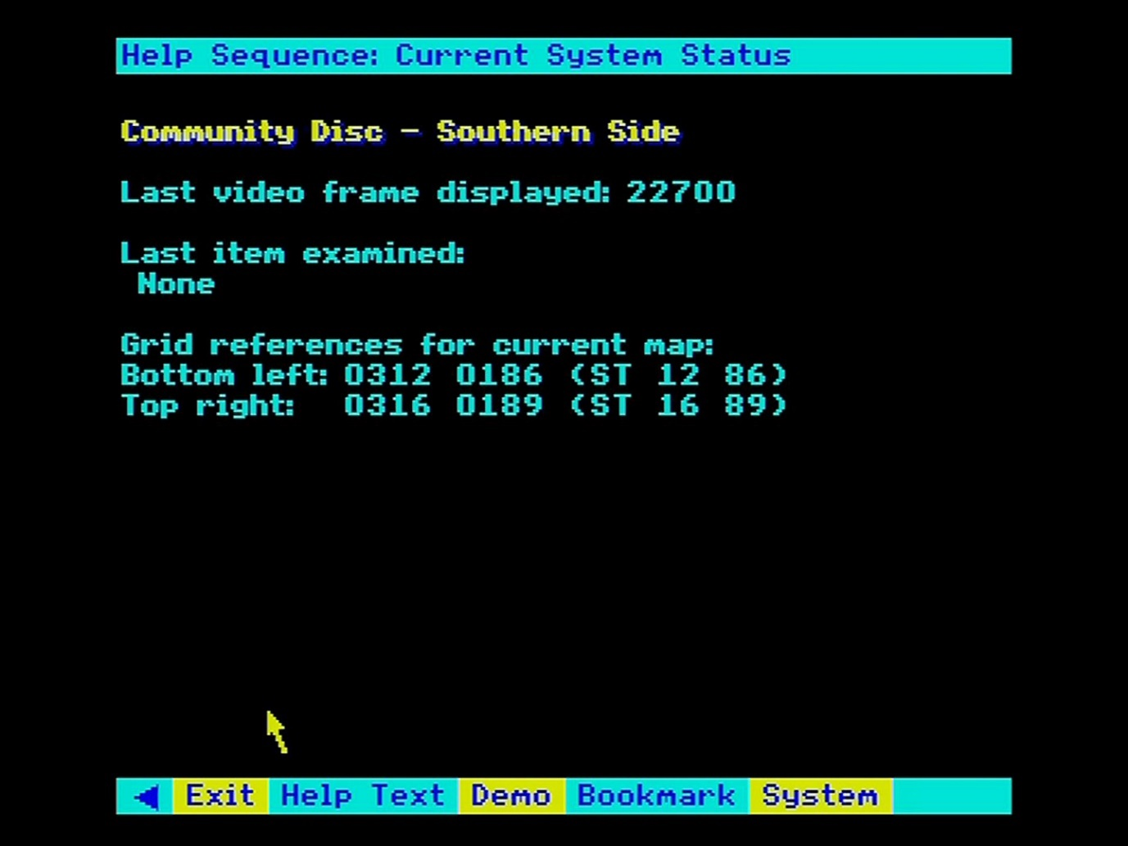

Figure 5 - Community disc help

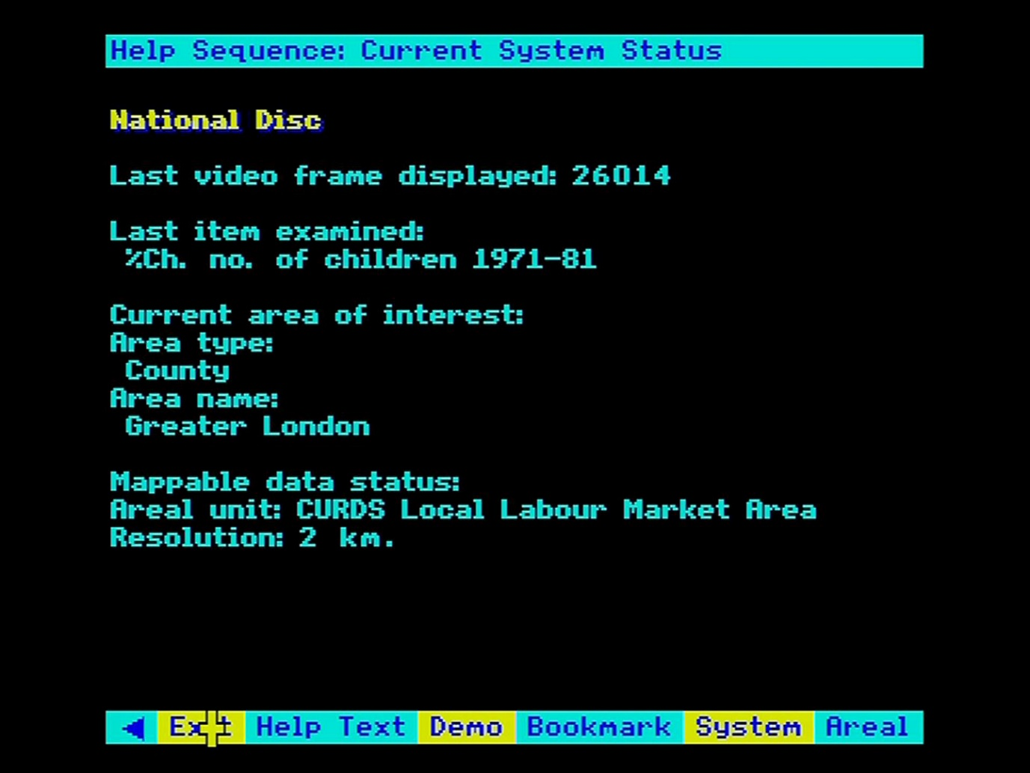

Figure 6 - National disc help

If you have sought **Help** in confusion about some aspect of the system, it is worthwhile reviewing this report to ensure that there is nothing which takes you by surprise: are you on the disc side you expected, is the current function the one you wanted to be in, etc. Not everything on the report may be directly meaningful but it is a useful first step.

Hint:

You don’t have to be confused to make use of Help! The status report often contains handy information which is easier to access by calling up Help than by any other method. For example, on the Community Disc the grid references of the South-West and North-East corners of the current map are included in the status report. It is easier to get them this way than to interrogate the map with the grid reference system supplied.

### Moving on to the pages of help text

While the status report is displayed, the menu bar is as follows:

|  |  |  |  |  |  |  |
| --- | --- | --- | --- | --- | --- | --- |
| < | Exit | Help text | Demo | Bookmark | System | Areal |

(Note: Areal will only appear if you have selected **Help** from the **Area** function or from data mapping.)

The pages of written instructions are accessed by selecting **Help text** from this menu bar. The first page displayed may be a contents page showing the sections of this help sequence. You can access individual sections directly or you can page through the whole sequence in the same way as a text-essay is used on the National Disc. The section “Reading text” will give you more details of how to control the display of a text-essay, but, briefly, you select a section by moving the screen pointer to the appropriate line on the contents page so that the section number changes colour and then press [ACTION]. You move backwards or forwards between pages by moving the pointer respectively to the left or right of the screen and pressing [CHANGE], or you press [f7] for "previous" and [f8] for "next".

Paging forward repeatedly through the Help text will eventually bring you to the end of this sequence but if you continue to page forward then you will be shown further help-text for the more general part of the system within which you are working. For example, if you have asked for help during the **Compare** sub-option of data-mapping then passing through the help-text on this function will take you on to more help-text on the general subject of data maps. Passing through this in turn will take you to the most general help-text available, dealing with the nature of the National Disc as a whole. The principle of starting with specifics and moving on to the more general is fundamental to the Domesday Help system.

During the display of pages of help-text, the menu-bar will become:

|  |  |  |  |  |  |  |
| --- | --- | --- | --- | --- | --- | --- |
| < | Exit | Help text | Demo | Bookmark | System | Areal |

Selecting **Main** from this menu will return you to the main status-report. Selecting **Exit** will take you out of **Help** altogether.

### Viewing the video demonstration

You view a demonstration by selecting **Demo** from the menu bar. You will then see a sequence lasting about 60 seconds with sound commentary demonstrating the general part of the system in which you are working. Moving video is hugely expensive in disc space so you should be aware that each demonstration sequence will present a brief introduction to how each function works in practice and may not deal in depth with the aspect of interest to you.

During the video sequence the menu bar will change to:

|  |  |  |  |  |  |  |
| --- | --- | --- | --- | --- | --- | --- |
| < | Exit | Main | Pause |  |  |  |

Selecting **Pause** will halt the video temporarily, perhaps to enable you to take a note, and the menu bar will become:

|  |  |  |  |  |  |  |
| --- | --- | --- | --- | --- | --- | --- |
| < | Exit | Main | Continue |  |  |  |

Selecting Continue will resume the video and the menu bar will go back as above.

Hint:

The videodisc player's remote control can also be useful when viewing filmed demonstrations. You can use this device to stop, start, review and slow-motion the demonstration until you have seen exactly the sequence you need.

Selecting **Main** while the video is showing will stop it and return you to the main Help sequence exactly where you left it.

### Special help with areal units

When you select **Help** from a data-mapping procedure or from the **Area** function itself, the extra option of **Areal** will appear on the menu bar. Selecting this option will display the list of standard areal units recognised by the Domesday System. This begins with a display of the standard types of areal unit. These are shown in a list and you select the one you would like to investigate in more detail by means of the screen pointer and [ACTION]. Immediately the display will change to an alphabetical list of the actual names of areal units within the nominated type. This can extend to more than one screen so the list can be paged forwards and backwards by means of the conventional "next" and "previous" functions: screen pointer to the right or left and [CHANGE], or [f7] / [f8].

### Access to the operating system

The main Help menu bar also carries the option **System**. Selecting this option allows you to enter commands to the micro's operating system and to the video disc player itself. The commands are entered in the message area. You must understand that many System commands could disrupt your session with the Domesday discs and so you are on your own in this area. You must be aware of the effects of everything you do to avoid crashing the Domesday software.

There are some useful commands which can be safely transmitted with this option, however, including *TIME to display the time and date and *RENAME to change the name of a downloaded file. When you have finished, select **Main** from the menu bar to return to the HELP sequence where you left it.

### The bookmark function

**Bookmark** is one of the most useful devices on the Domesday System. It enables you to store the complete status of the system at any point so that the screen display can be recreated directly without going through all the original steps. Moreover, having recalled a bookmark, the system will continue from the new point and allow you to modify it further as if you had created the display in the normal way. Bookmarks are not frozen screen images, they are genuine states of the system. One "bookmark" can be held in memory, but others can be stored on magnetic discs and called up at any time.

The first time you select **Bookmark** from the Help menu a new menu bar will appear, as follows:

|  |  |  |  |  |  |  |
| --- | --- | --- | --- | --- | --- | --- |
| < | Exit | Main | Set mark |  |  | Load |

This shows there is currently no bookmark saved in memory and the system assumes you are either going to create one or load one from a magnetic disc.

You create a new bookmark by selecting **Set mark**. This initiates an automatic procedure and the status of the system exactly as you left it when you selected **Help** is saved in the memory bookmark. A message confirming that the bookmark has been set will be displayed in the message area and the menu bar will be updated to:

|  |  |  |  |  |  |  |
| --- | --- | --- | --- | --- | --- | --- |
| < | Exit | Main | Set mark | Save | Go mark | Load |

Now that you have a bookmark you can store it on a magnetic disc by selecting **Save**. The bookmark will be saved in ASCII format in a file named "DOMARK" in the current directory on your disc. If a file of the same specification already exists, it will be overwritten and lost.

Having saved a bookmark to disc you reload it by selecting **Load** on the menu bar. The system will immediately load a file named "DOMARK" from the current directory of your magnetic disc. You must be sure that a genuine bookmark file is available or the system will display an error.

Hint:

It is a good idea to store each bookmark in a separate directory to identify it and prevent it from being overwritten. Remember that you can do this directly from within the Domesday Help sequence by selecting System. Bear in mind that you need to keep the "DOMARK" name for when the system comes to reload the bookmark. Before saving a bookmark for a data-map of London's population, for example, you could change the current directory by issuing through System the command *DIR LONDPOP. The bookmark will then be filed as "DOMARK" in the directory "LONDPOP". When you want to reload a bookmark stored in this way, you reissue the *DIR command to nominate the required directory and then select Load from the Bookmark menu bar.

Finally, you recreate the system status stored in a bookmark by selecting Go mark from the menu bar. The system will then rebuild the status stored in the memory bookmark and take you out of the Help sequence into the main system at the bookmarked point where you can pick up control of the system exactly as it was when you bookmarked it.

Hint:

Please note that the bookmark held in memory will not be preserved after powering-down the system. If you wish to keep a bookmark for future use then you must save it to magnetic disc.

### Returning from the help sequence

When you have finished with Help, selecting **Exit** from any of the menu bars will take you back out of Help and return you to the main system, exactly where you left it to seek Help. You will find that your screen display is retrieved intact and so you need never be concerned to call up Help at any point. The system will be waiting, ready to carry on where you left off.

# The Community Disc

## Introduction to the people's database

The two sides of the Domesday Community disc are the fruit of a nationwide undertaking by more than one million people. It is a self-portrait of the land of Britain in the 1980s drawn by the people living in every community that took part. As such it is quite different in approach to the official picture painted from central sources by the National Disc. Most of what you will be reading on this disc is the unedited work of local people - with all the colour and differences of language and attitude which that implies. It is not the official view, it is not a BBC view - indeed it may not in some cases be an accurate view. It reflects the perceptions of those who compiled it, placed in a context of maps supplied by Ordnance Survey and pictures taken by local people. No instructions were given about the subjects to be tackled or the style to be adopted. Only references that could have caused legal problems have been edited out. This is the United Kingdom as her subjects - particularly her young subjects - saw her in 1985.

To this local material we have added specially commissioned essays from professional geographers about larger areas of the country. These are illustrated by satellite and aerial photography.

This mass of material about the United Kingdom could not be contained on one side of the video disc, so we have split it in two. The southern side of the disc covers most of England, together with Wales and the Channel Islands. The northern side covers the North of England, Northern Ireland, the Isle of Man, Scotland and the Orkney and Shetland Islands.

The split was intended to leave an equal land area on each side of the disc. We call the line of the split the 'Domesday Wall' and it runs just South of York. In fact, there is an overlap between the two sides of the disc for the sake of people who want to explore that area of England. This is the exact position:

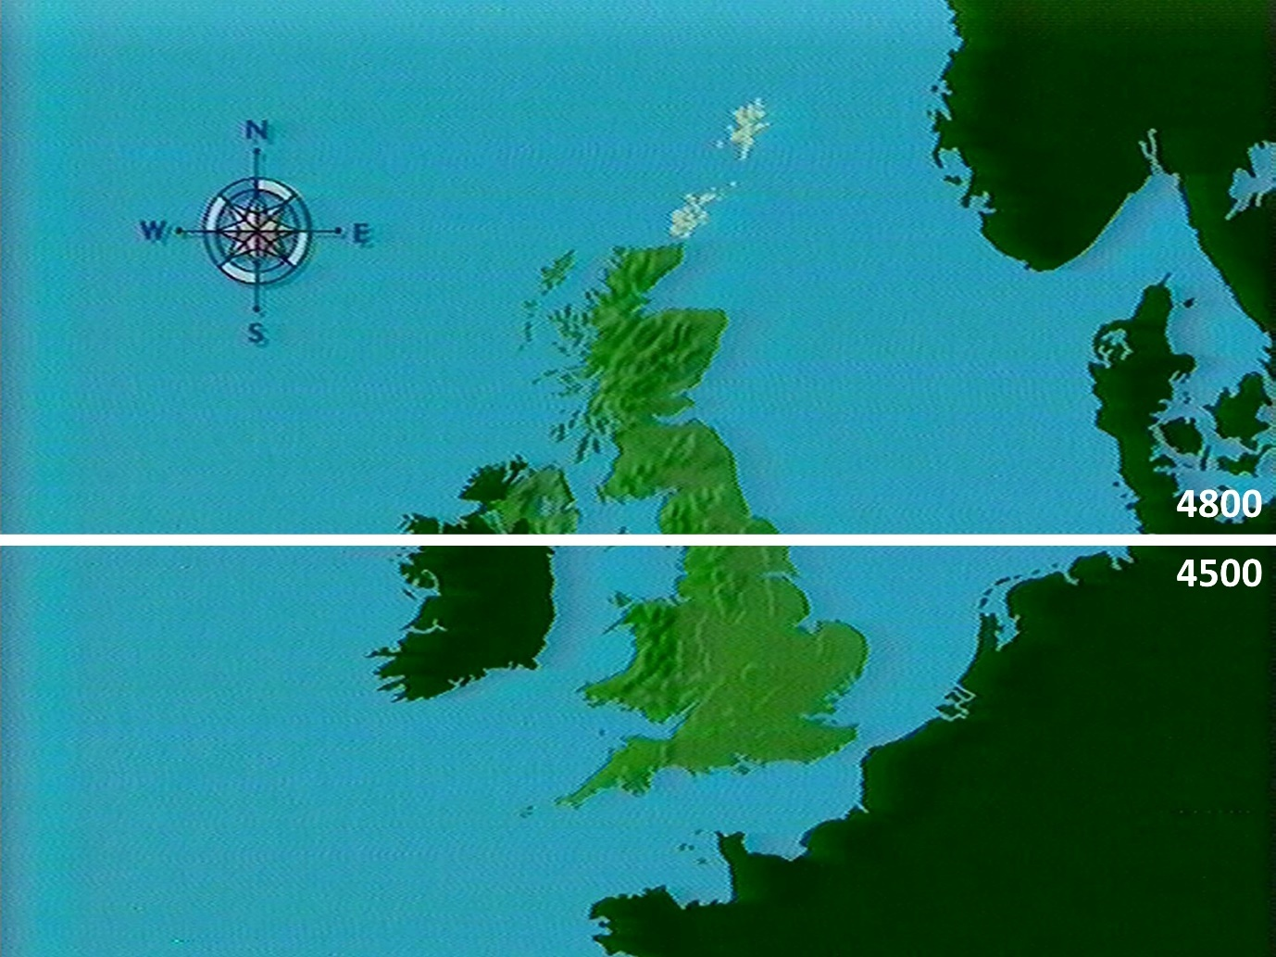

Figure 7 - The Domesday 'Wall'

The Southern Disc coverage extends up to Northing 4800. The Northern Disc coverage extends down to Northing 4500.

In practice, the need to turn the disc over should not be too irksome. The system will remember where you wanted to go as you turn the disc over, so you will not lose your place. Moreover, the highest levels of maps, pictures and text about the whole country are held on both sides of the disc. It is only the close-up detail that is on one side only. This is explained fully in the next section.

### The 4 top-level functions

The system of finding your way around the Community Disc is divided into four main functions:

1. Moving around the maps
2. Looking at the photographs
3. Reading the text
4. Using the main index

Each of these primary functions has its box on the right-hand side of the menu bar:

|  |  |  |  |  |  |  |
| --- | --- | --- | --- | --- | --- | --- |
| < | Help | Options | Map | Photo | Text | Find |

At any time, you are always within one of these four functions, with the other three available to you as alternative options. If, for example, you are reading text, the **Text** box will be empty and your options will be the other three.

|  |  |  |  |  |  |  |
| --- | --- | --- | --- | --- | --- | --- |
| < | Help | Options | Map | Photo |  | Find |

As you move about the country these functions stay linked together, so if you select **Photo** when you are in **Text**, you will see photographs of the place you were reading about, and so on.

The following four sections describe in detail how to use each of these four functions. These sections assume that you have understood the basic Domesday grammar (how to move the pointer etc.), but as a reminder these details are contained on the reference card. This should enable you to skip directly to a section if you need to without the feeling you have missed vital information on the way.

### Options and help

The four top-level menu bars also contain two other important boxes.

|  |  |  |  |  |  |  |
| --- | --- | --- | --- | --- | --- | --- |
| < | Help | Options | Map | Photo | Text | Find |

**Help** can be selected wherever you are on the disc. It will offer guidance on how to operate the function you are working on at the time. When you leave **Help** by selecting **Exit** you will return to exactly where you were before. You can always select **Help** if you are in doubt about anything, without being afraid that you will lose your place. Within the **Help** options you can select **Demo** if you want to sit back and watch a demonstration of the function you are working on being used in practice.

**Options** will bring up a new menu bar with specialised options on it for the function you are using. In the **Photo** operation, for example, it allows you to read the long caption belonging to a picture. To get back to the main menu bar with its other three top level operations, simply select **Main** from the menu bar. **Options** does not appear in the **Find** function.

### Booting up

The sequence for getting the Community Disc going (called "booting up") is fully described in the section “Controlling the system”. Briefly, you need to follow these steps:

1. Insert the disc with the label referring to the side you want uppermost.
2. Press [CTRL], [Q] and [BREAK] keys together.
3. Wait for the prompt symbol to appear.
4. Hold down the [SHIFT] key and press [BREAK] once.
5. The player and the micro will then initialise for about 40 seconds.
6. The disc will then begin to play - showing you the Domesday logo followed by a zoom out to the whole of the United Kingdom.
7. If you don't want to watch this zoom (which takes 65 seconds), then press [ESCAPE]. This will take you to the top level of the Community Disc - the map of the UK with the menu bar beneath, showing that you now have control and can decide what to do next.

Your options from this point in exploring the mass of material about every aspect of community life in Britain today are fully described in the sections that follow.

As we said at the outset, we hope you enjoy your exploration of the Community Disc. Because it is interactive and contains comprehensive **Help**, it should be easier to understand than most software systems.

On the other hand, there is a mass of material on the discs, so don't be surprised if you get lost at times. You can always press [ESCAPE] to reset the system back to the top - the map of the whole United Kingdom that you started with. Remember too that nothing you do from the keyboard or with the mouse can damage the system or erase any material on the video discs.

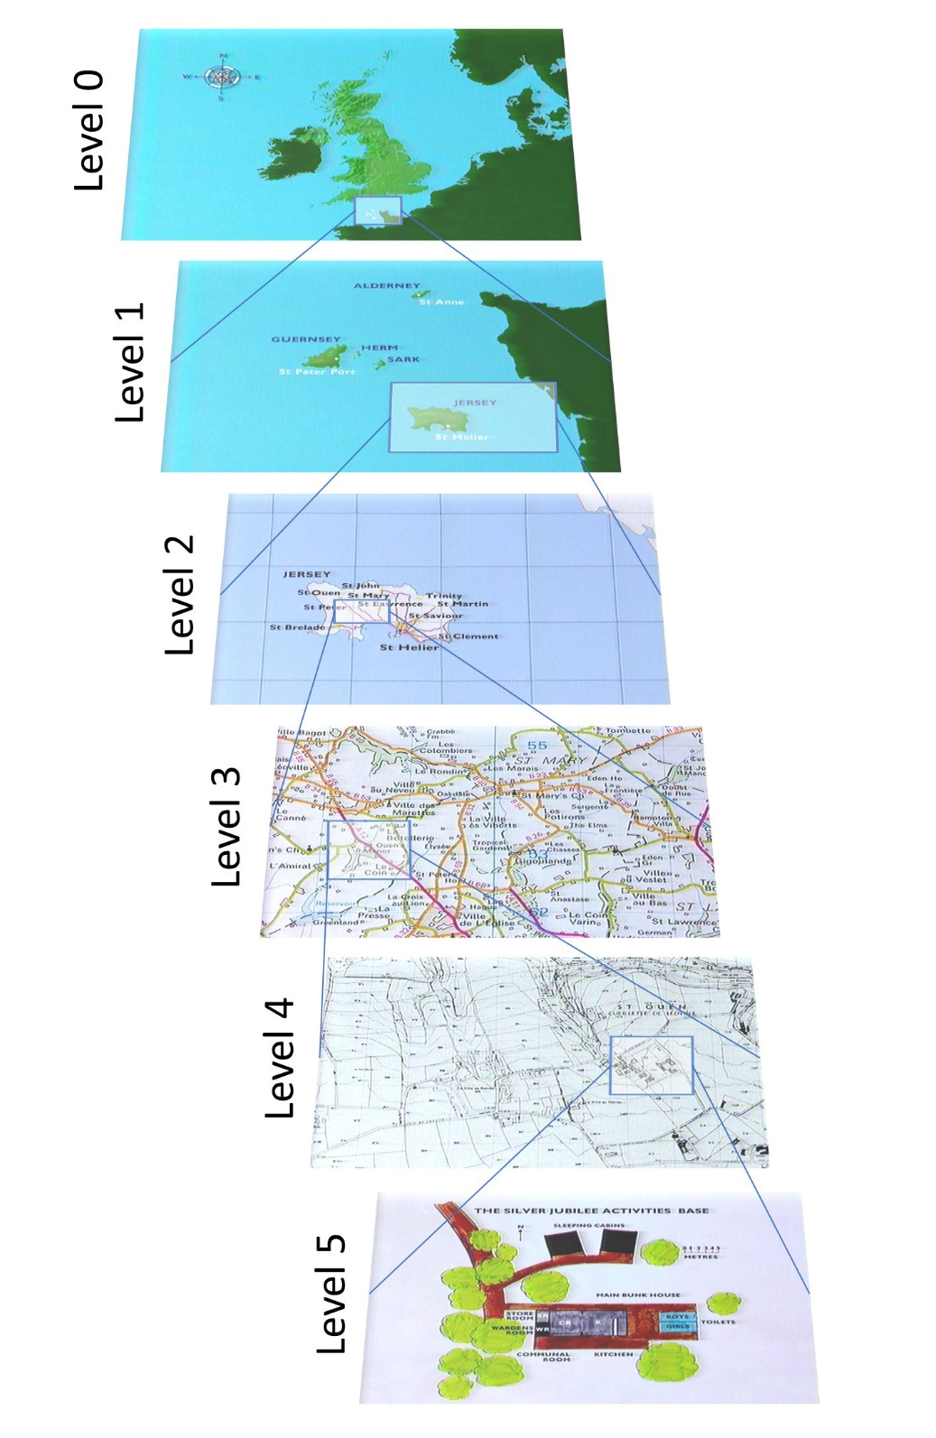

Figure 8 - Community Disc map levels

### Finding your way with maps

The Community Disc is built around maps. They cover the country completely at four scales and are available in limited numbers at two closer levels for city centres and some sites of special interest. The maps are linked together by the Ordnance Survey's National Grid system, which enables the user to move logically from level to level.

Two of the map series have been specially produced from Ordnance Survey data, the rest are existing O.S. map series.

Of course, the micro screen can only offer a tiny window onto any one of these UK-wide maps. Each of these map windows has been separately recorded as a single frame of the video disc - 25,000 frames in all. So apart from zooming in and out you can also move in any of eight compass directions by jumping from window to window. There is a slight overlap between maps so that orientation is not lost.

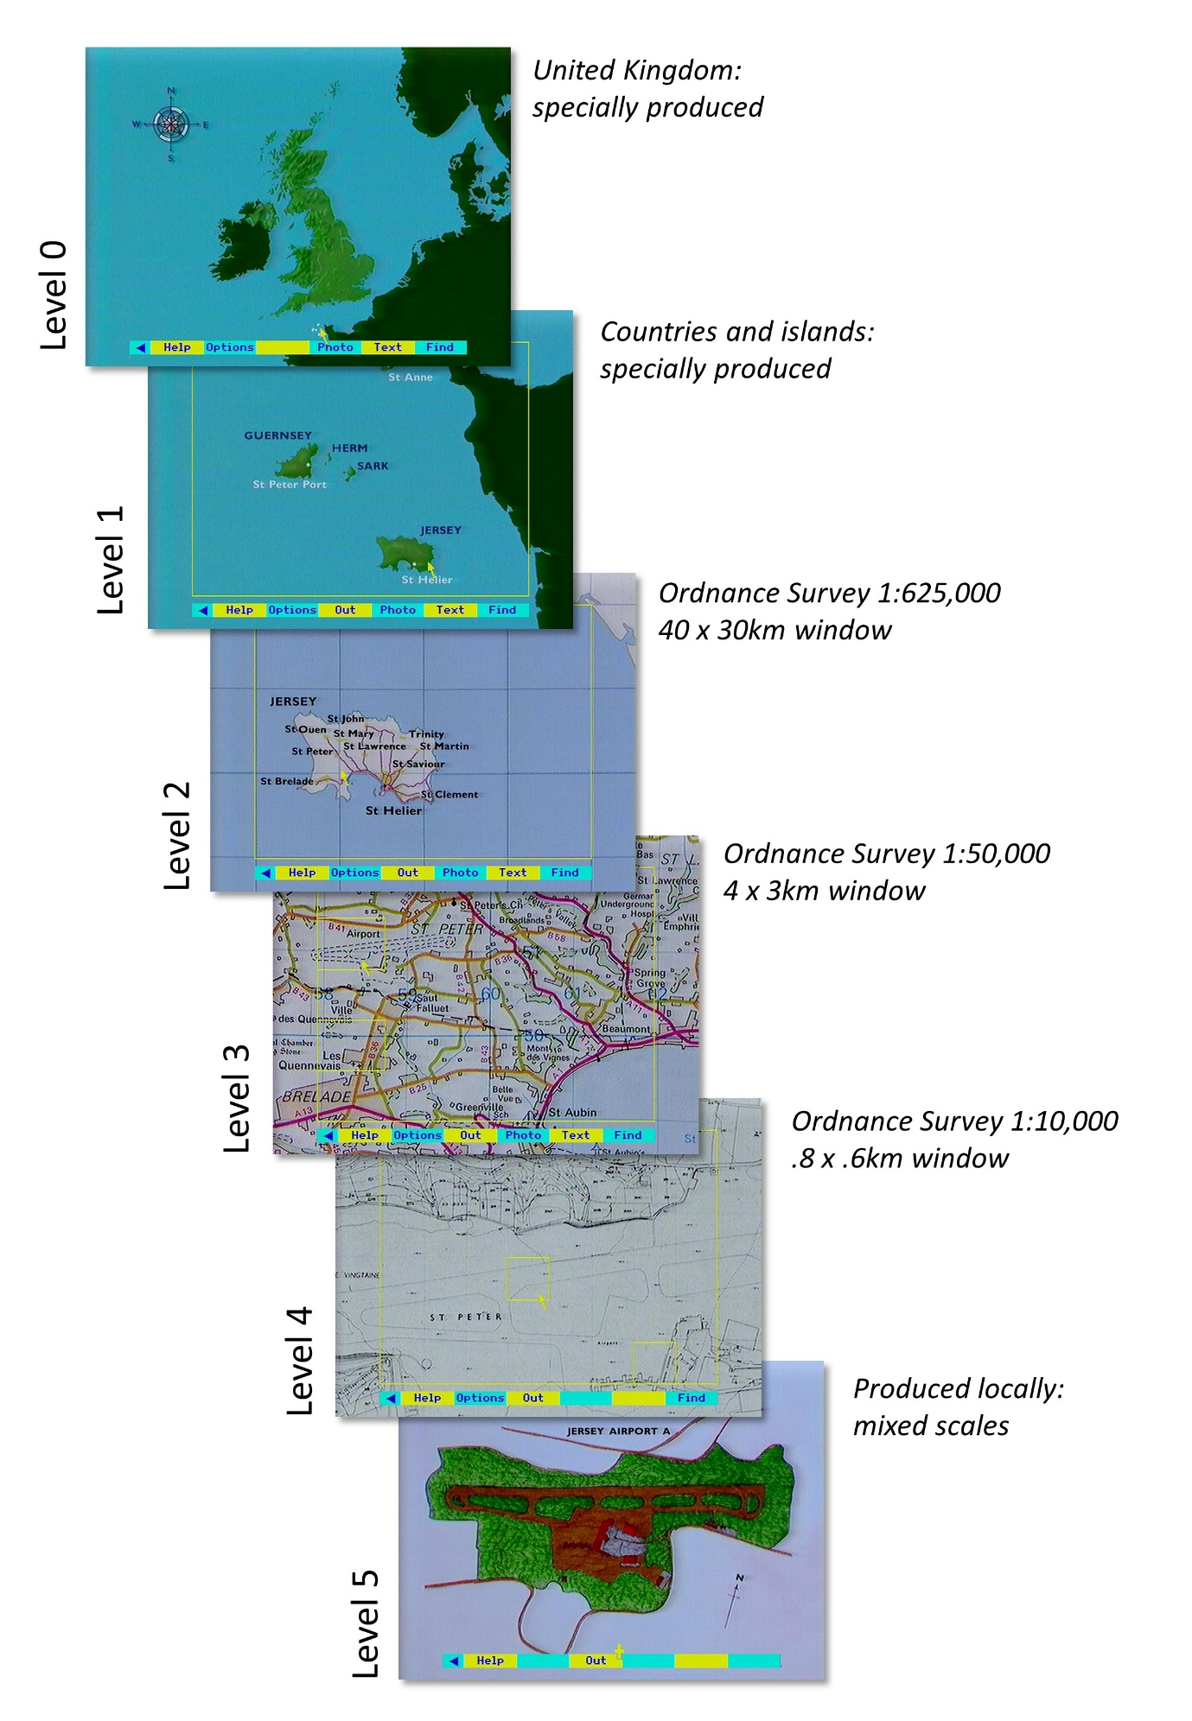

Figure 9 - Domesday level scales

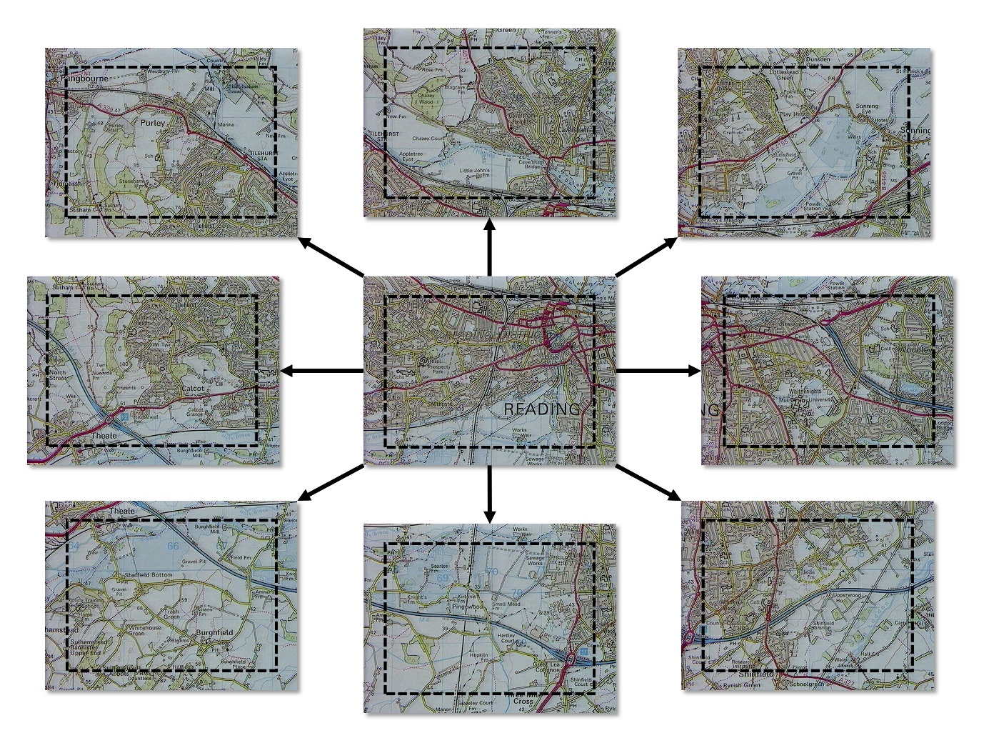

Figure 10 - Linked maps on the same level

Apart from providing mapping of the whole of the United Kingdom, the maps also act as a visual index to the rest of the material on the Community disc.

Text and pictures are related directly to their corresponding maps. For example, linked with every 4 X 3 kilometre window on the O.S. 1:50,000 series map (the system's level 3 map) there can be three photographs taken in that area and 20 pages of text about exactly that map area, written by local people.

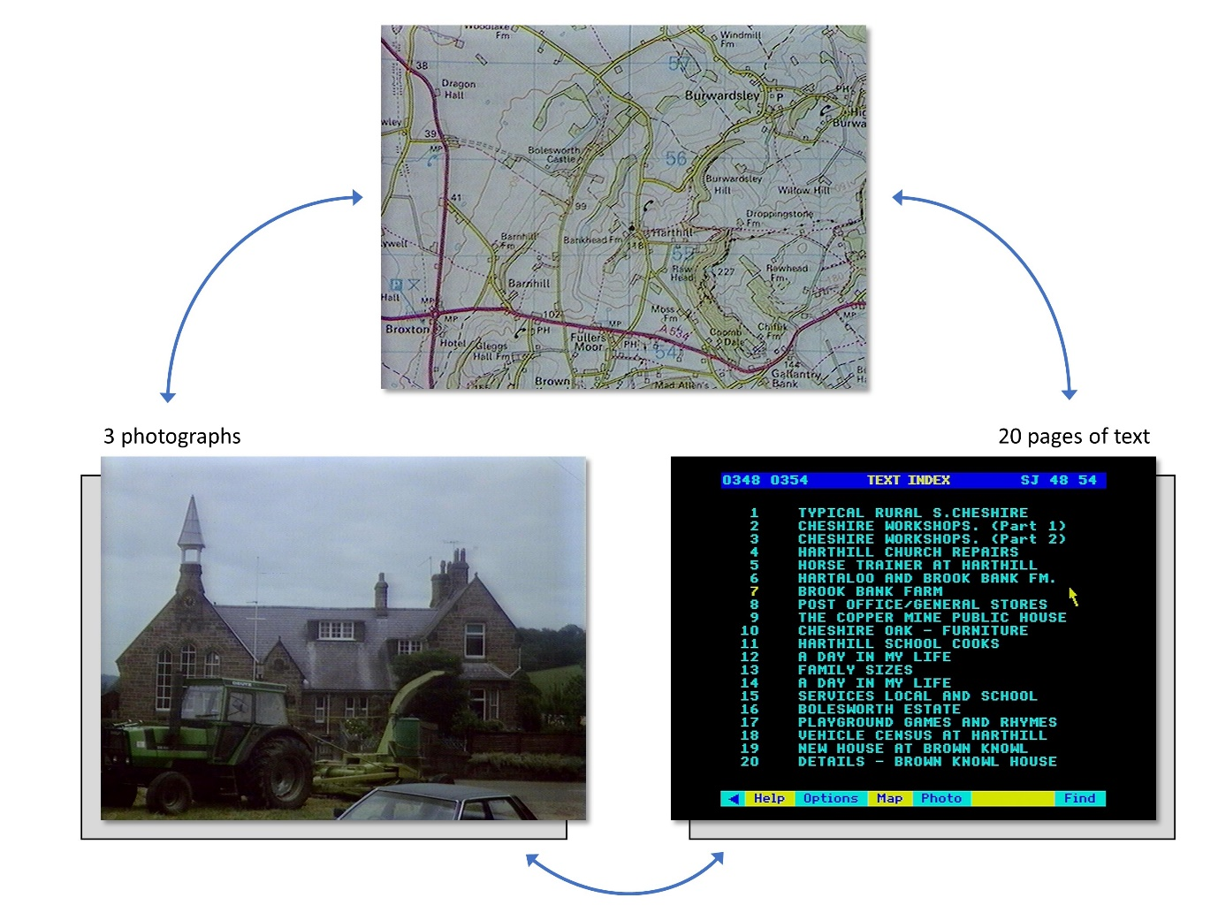

Figure 11 - Diagram of map linked to photographs and text

Move up to a higher-level map (a map of the whole of Northern Ireland, for example) and the pictures and text will be about Northern Ireland as a whole. This means that although there are more than 20,000 pictures of places on the disc, they are all arranged to be accessible directly from the map you are working with at any one time. Indeed, as will be explained later, the maps are even more powerful, since they define the scope of any index searches that are made on the disc.

What follows describes in detail how to manipulate the 25,000 maps on the disc. If you get stuck when using the disc, you can always select 'Help' from the menu bar for a full description and, if required, a short film demonstration of the map system being used in practice.

### Map walking

You can move around the maps directly in two ways: by zooming in and out and by moving sideways in any compass direction.

**Zoom** in by moving the pointer to the required position and pressing [ACTION]. You will then move to the closer-level map which includes the place you pointed to.

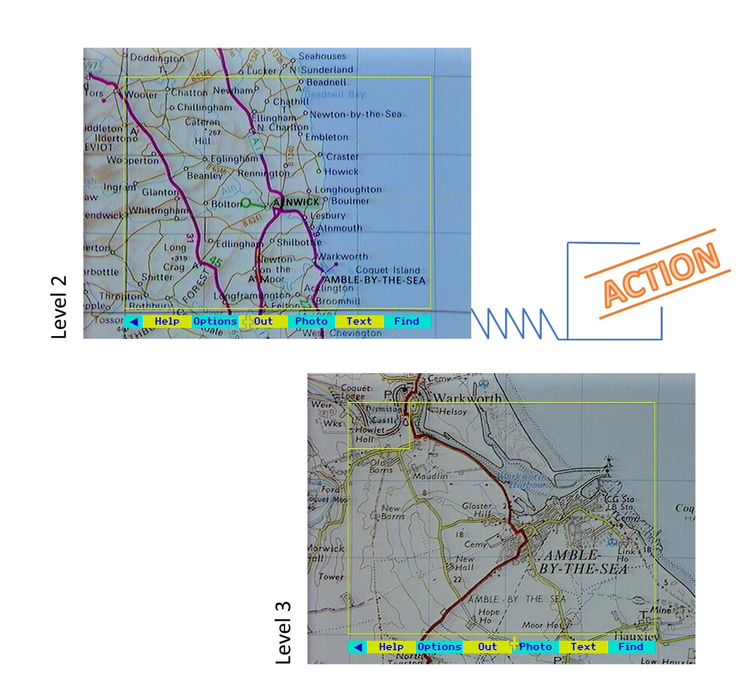

Figure 12 - Map zoom levels 2 and 3

If no further zoom is possible, a message to this effect will appear at the top of the screen for a few seconds.

In city centres and at points of special interest small **yellow rectangles** marked on the map show where a further zoom is possible. Position the pointer within the rectangle and press [ACTION].

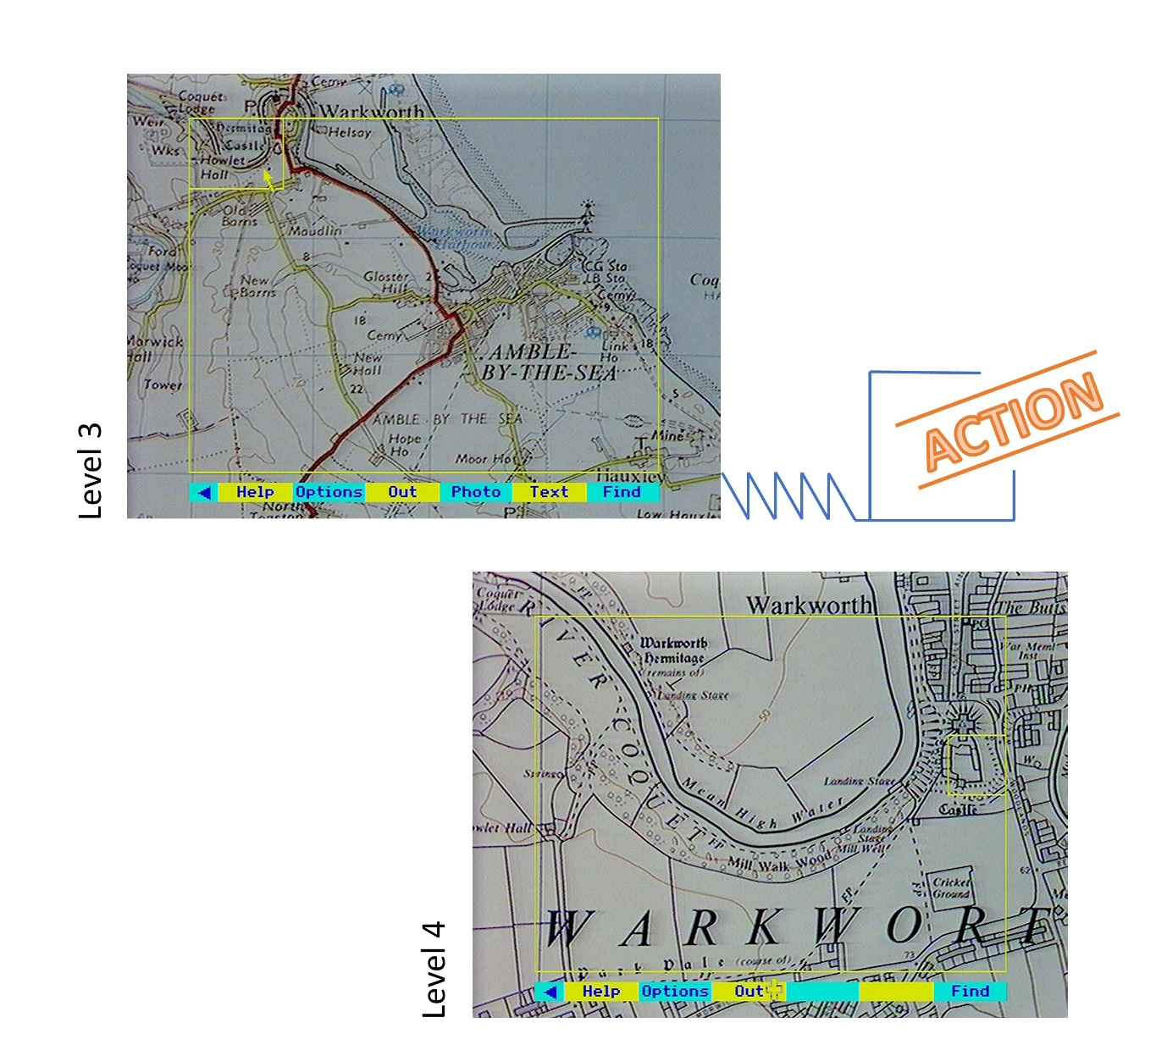

Figure 13 - Map zoom levels 3 and 4

The map of the UK as a whole is slightly different. As you move the pointer round, different discrete areas are highlighted. Each corresponds to one lower level map. This is necessary since the scales and the grid referencing systems of these maps are different.

The whole of the UK appears on both sides of the disc as far down as level 2: that is as far as the O.S. maps that are 40 km across. If you try to zoom in further on the 'wrong' side of the disc, you will be prompted by a message at the top of the screen to turn the disc over. Follow the prompts and you will be taken directly to the correct map on the other side of the disc. Do not try to anticipate the problem by turning the disc over without first attempting the zoom in. The system will then not know what it is looking for on the second side and you will have to boot up again from scratch.

**Zoom out** by selecting **Out** on the menu bar: that is, point to this box on the menu bar and press [ ACTION] or press [f3]. As the new map appears a yellow rectangle shows the position within it of the previous map. This disappears as soon as you move the pointer.

**Move sideways** by moving the pointer to the relevant edge or corner of the map and pressing [CHANGE]. Diagonal moves are possible and can speed up map walking considerably.

The following diagram shows you where to place the pointer to move in a direction over the maps:

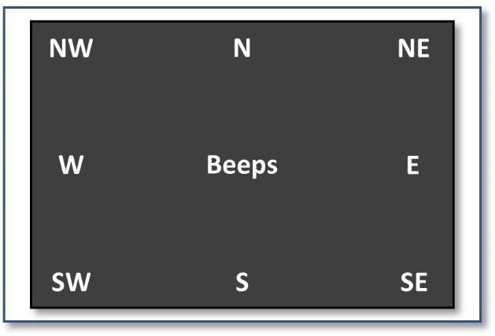

Figure 14 - Where to place the pointer to move in different directions

If you press [CHANGE] with the pointer in the centre of the screen, nothing will happen except that you will hear a beep.

Using the keyboard, there is an alternative and usually more appropriate method: press the cursor key pointing in the direction you want to go with the [SHIFT] key pressed at the same time. For diagonal movement, you will have to go back to the method described earlier: position the pointer in the corner of the screen and press [CHANGE].

When you move sideways between maps, a moving **blue arrow** gives a visual indication of the direction of travel. If it is not possible to move because there is only sea in this direction: you will be informed by a tone and an error message. If you need to cross the Domesday Wall, you will be prompted to turn over the disc.

The arrow pointer only has access to the **active area of the screen**. This is shown at most map levels enclosed in a yellow rectangle. If this does not line up with the grid lines on the map, it can be moved horizontally with a control on the video disc player (see the section on “Controlling the system” ). It is important that this registration is set as accurately as possible.

Around the active area is a border made up of the edges of the eight maps which appear in adjacent frames. This overlap is designed to help your orientation. It may help to think of moving to an adjacent map as putting the pointer near the part of the next map that you want to move to centre screen.

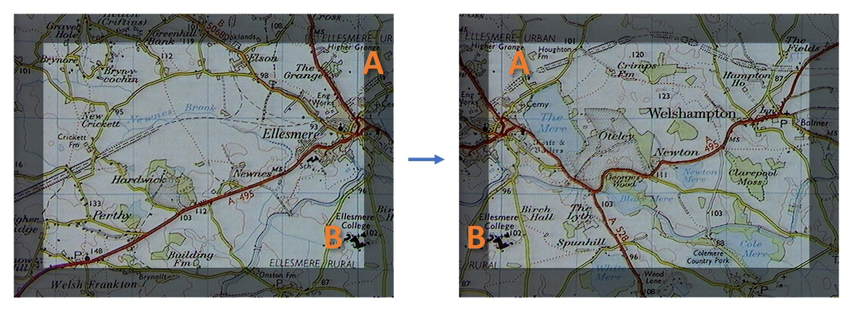

Figure 15 - Overlay between adjacent maps

Hint:

Moving from map to map is usually very quick and often instantaneous. From time to time, however, you will experience a short pause while the micro reads in new data from the disc. This happens when you move to a new area of the level 2 map and the system must read the corresponding data structure into its memory cache. If you are using a set of moves for a demonstration you can, if the sequence is not too wide-ranging, avoid even this slight delay by pre-caching. Make the required moves, then step back to your starting position. The micro will then have enough data to make the jumps again without pausing.

A quite different way of finding a map is by entering the name of a place or a grid reference number. This is part of the **Find** operation and is described fully in the section “Using the main index with find”.

Selecting **Text** or **Photo** from the menu bar will bring up text or photographs related to your current map area. You will then have moved out of the 'map operation' into either text or pictures. The menu bar, and therefore your options, will be different. This is described in the following two sections.

If the **Photo** and **Text** labels do not appear on the menu bar for a map, this means that no text or pictures exist for this map block. In broad terms, the first three map levels (0, 1 and 2) are all covered by pictures and text, as are the close-up special features at level 5. Coverage at level 3 is patchy, particularly in the remote rural areas. There are no pictures or text pages with level 4 city-centre maps.

If you wish to examine a map unencumbered with any yellow grid lines and menu bar, pressing function key [f9] will remove the complete output of the micro. Press it again to restore the micro overlay. Similarly function key [f0] or selection of the yellow triangle on the menu bar will toggle the menu bar only off and on.

The level 0 map of the whole United Kingdom is considered the primary state of the Community Disc. The program will always return you to this state after the opening film sequence or after you have pressed [ESCAPE] and confirmed the reset in response to the prompt.

### Map options

After you have selected **Options** from the main map menu bar, the following additional operations are opened. You may not need to use them every day, but they are part of what makes Domesday the most powerful personal map handling system in the world.

As with every new menu bar, a Help box with new text is available. This will give you notes like these about how each part of map options works.

#### Scale

Selecting **Scale** brings up a reference rule at the top of the screen showing units of kilometres or metres.

Select **Units** if you prefer to work in miles. Select **Units** again to go back to metric units. This toggle switch also works with the results of any calculations you make using the scale option.

The first of these is **distance measurement**. This is active as you enter the scale operation. If you wish to measure the distance from A to B within the active area of a map, move the pointer to A and press [ACTION]. Remember that it is the pixel at the tip of the pointer that is marked. A blue cross marks this as your starting position. As you move the pointer towards position B it carries with it a blue line. Press [ACTION] again at B. The blue line is fixed and the distance between A and B is displayed in the message area in your preferred units.

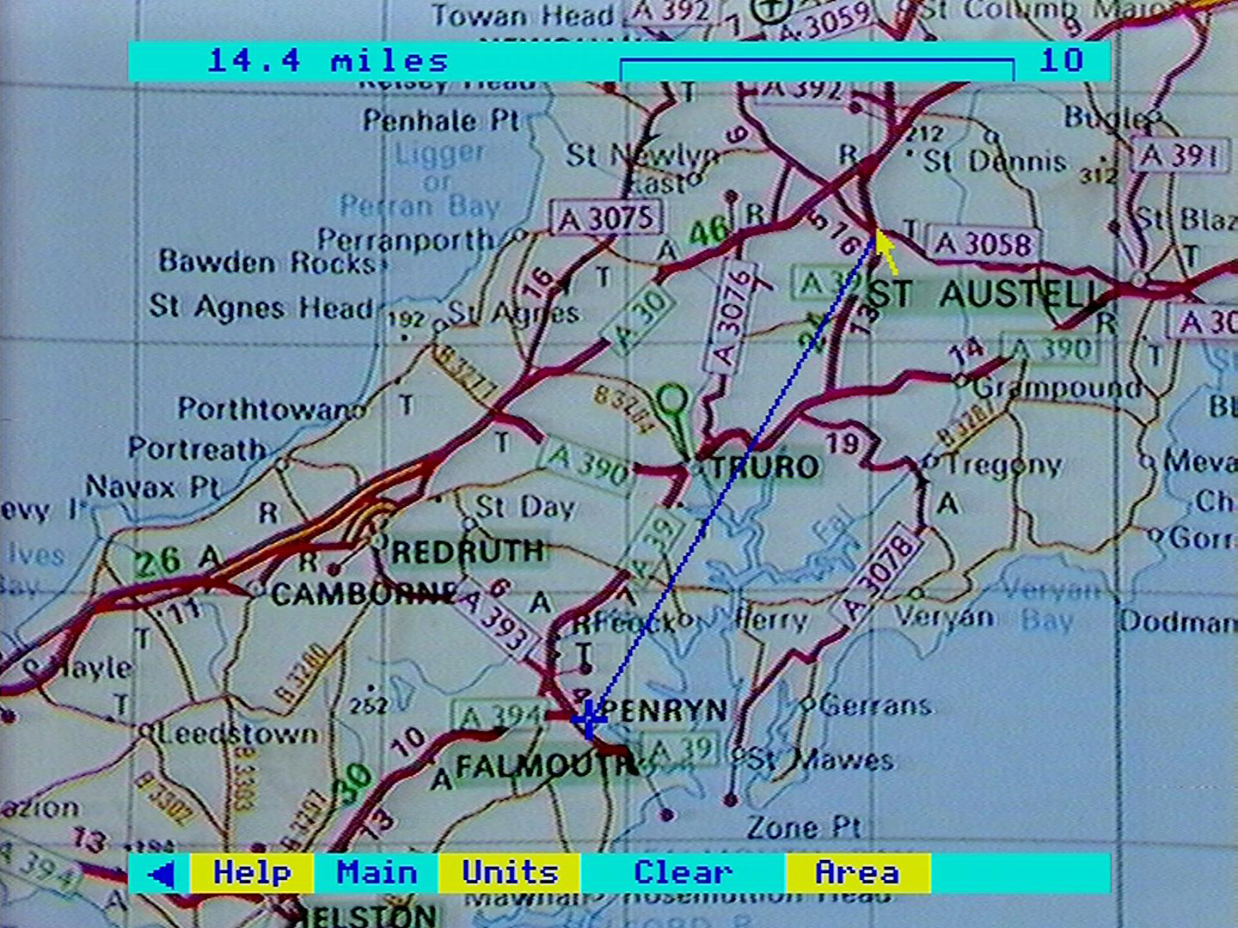

Figure 16 - St. Austell to Falmouth as the crow flies

Measurement can continue to points C, D and so on. This enables you to follow a twisting route by pressing [ACTION] at many points along the way. Obviously, you can choose how accurately you want this line to be drawn and calculated.

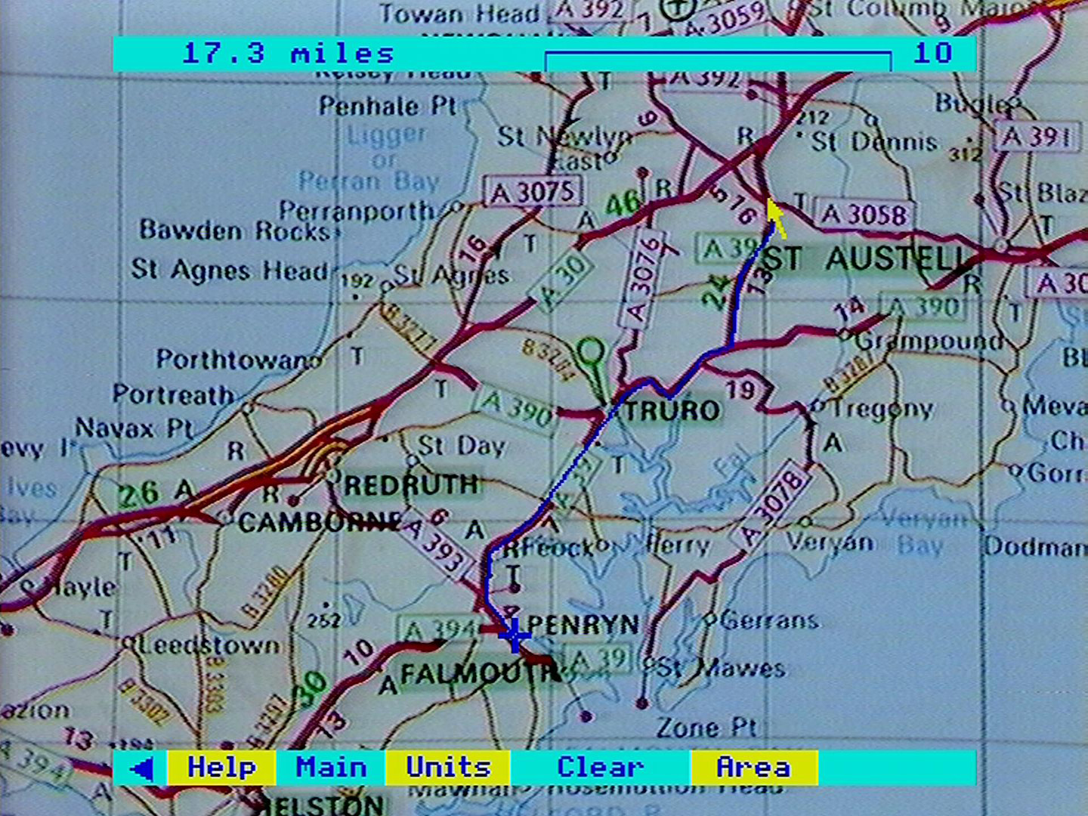

Figure 17 - St. Austell to Falmouth following the road

The accuracy of your calculation will also depend on the resolution of the micro screen and the accuracy of registration between the video disc player and the micro (see the section “Controlling the system”). This is reflected in the conservative number of significant figures given in the message area. Calculations should always be checked by traditional means where important conclusions need to be drawn.

Areas are calculated by selecting **Area** from the menu bar. If a distance measurement is already in progress, the blue lines will not be cleared from the screen in case you need to incorporate them into your area calculation. If these lines are not required, select **Clear**.

The area function works in the same way as the distance function, except that no result is shown until the shape you have drawn is "closed": that is, until a final point is plotted that lies in the centre of the blue cross marking the starting position. You may need to make one or two attempts before you succeed in pinpointing the centre of the cross. The cursor keys may help here: a light tap will move the pointer by a single pixel. The resulting area is shown in square miles, square kilometres, etc.

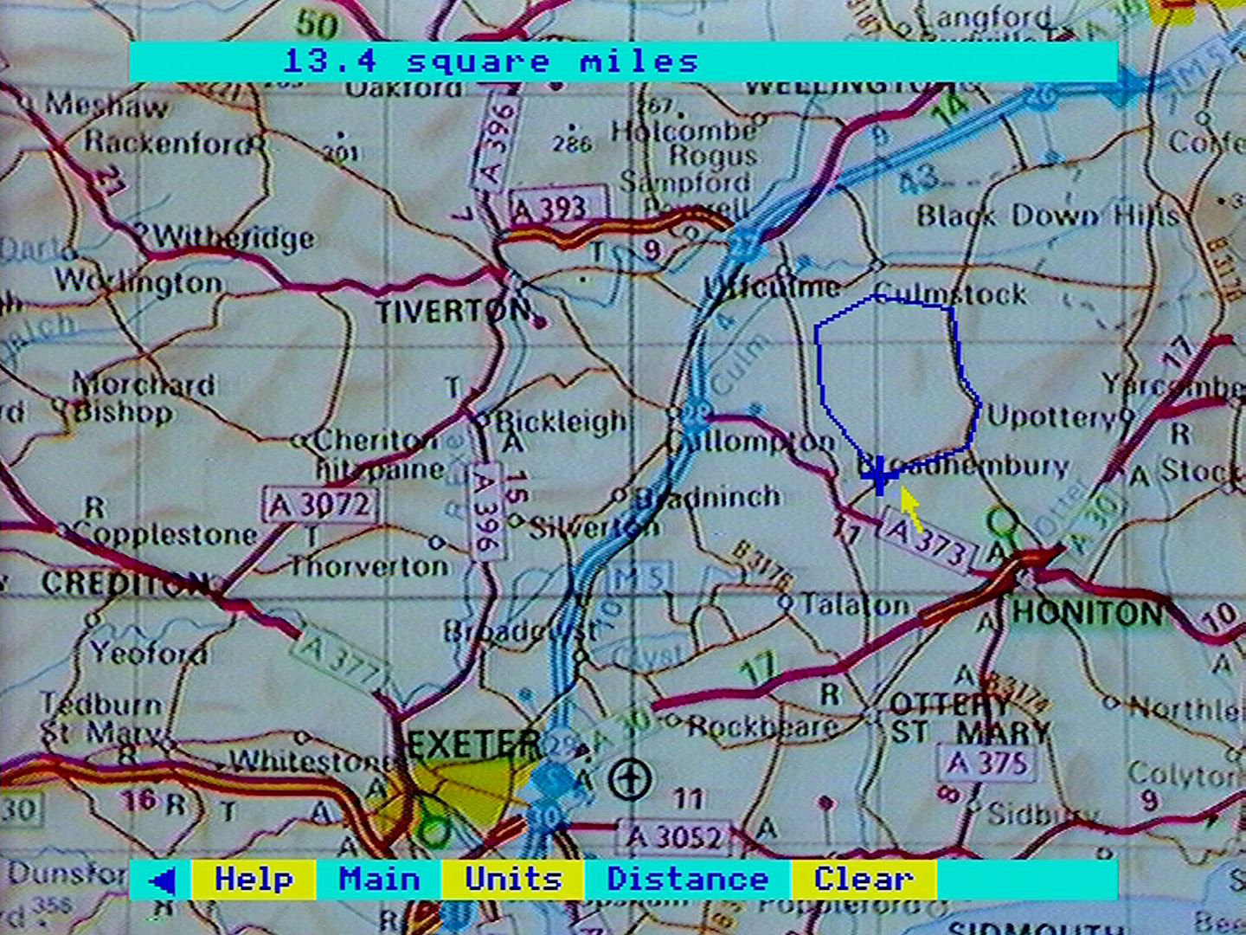

Figure 18 - Measuring an area

There are two limitations. Firstly, your area outline must not cross itself. A figure of eight outline will produce an apparent result, but an incorrect one. This is something that the software itself cannot check. Secondly, you are limited to 50 points with which to define your area. After 49 points have been plotted, the micro will beep and display an error message if you try to plot the 50th anywhere except at the centre of the blue cross.

In both distance and area operations, select **Clear** to begin a new calculation. You cannot change maps when in the scale option. Select **Main**, change maps in the usual way, then reselect **Options** and **Scale**. To measure across several maps, you must either work at a higher level (fixing your position by marking grid reference points if necessary - see below) or else add the results of many separate calculations by hand.

#### Grid Reference

Select **Grid Ref** if you want to know the Ordnance Survey grid reference of any point in the active area of the map on the screen. Simply point at the position you want identified and press [ACTION]. The grid reference of the point will appear in the message area in both the all-digits and the letters-and-digits formats. Selecting another point will produce its grid reference and so on. Sideways map moves are possible within this option, so that grid references can be taken from adjacent maps.

Grid referencing works on map levels 1, 2, 3 and 4. The level 0 map contains too many different national grids. The level 5 floor plans are not to a fixed scale.

#### Key

This will display many screens which describe the map that you are working on and the meaning of its Ordnance Survey symbols. These are different for each of the different map levels. As with any set of pictures or text pages on Domesday, you can page forwards or backwards either with the mouse or the function keys.

Note that the coloured versions of the level 4, city-centre maps use letter symbols that have a different meaning in different cities. These are listed at the end of the level 4 key.

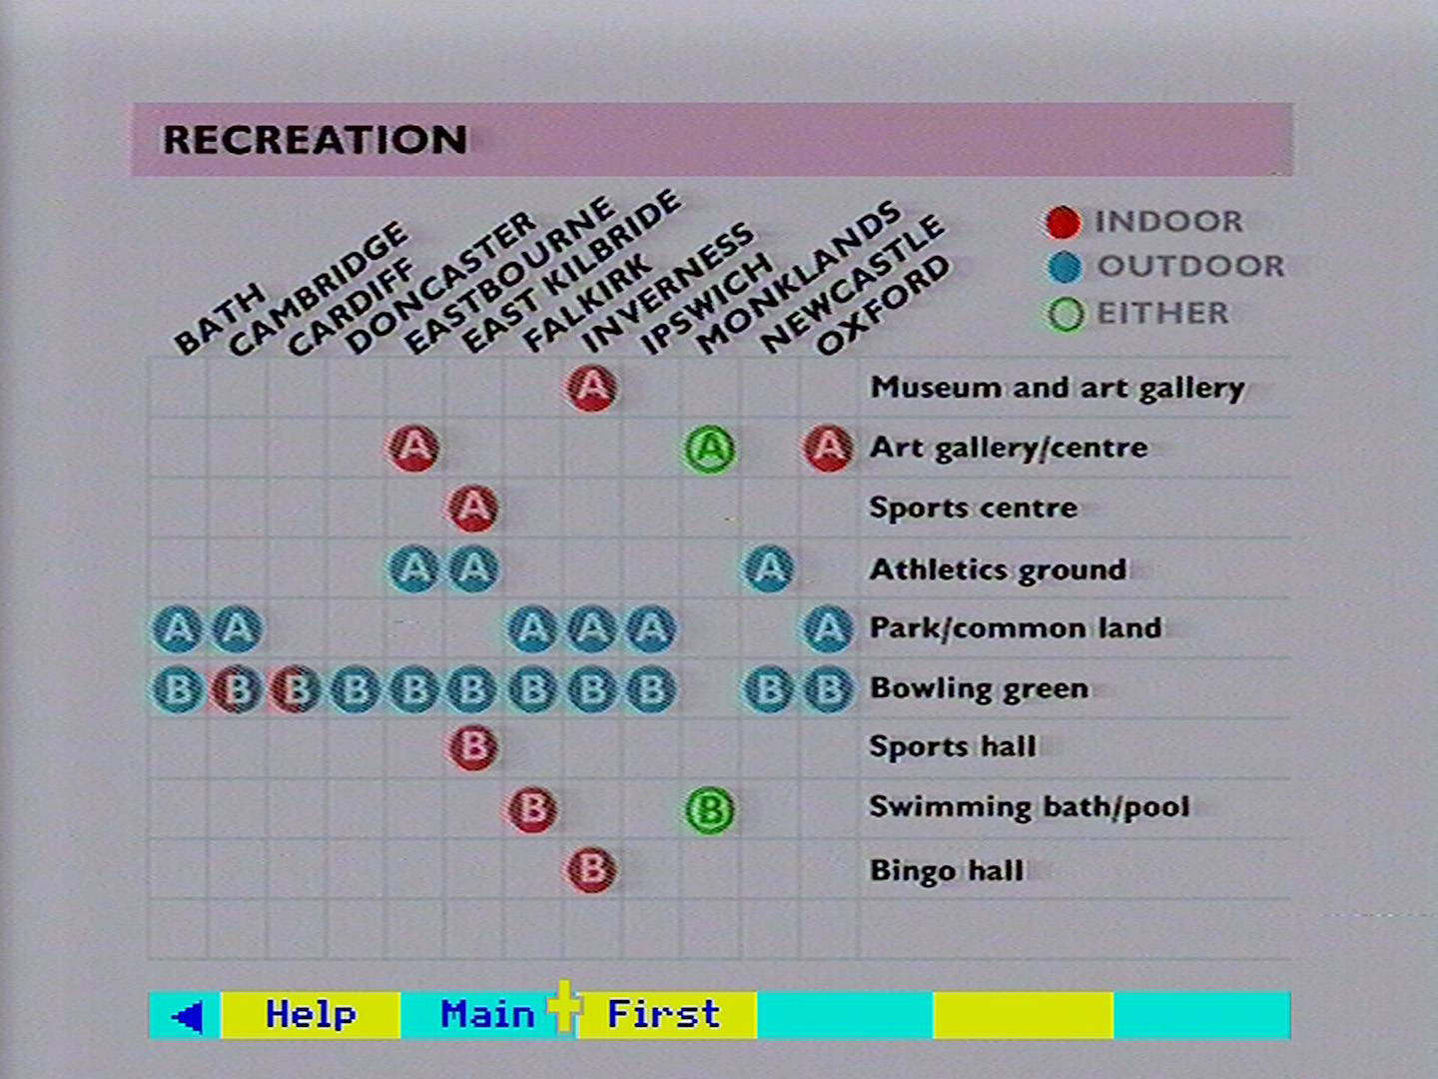

Figure 19 - The recreation key

After any of these specialised map operations, select **main** if you want to return to the main part of the map operation, either to change maps or to move on to a different operation altogether.

#### For example – To find the distance between Cherry Hinton and Fulbourn in Cambridgeshire

On the south-side of the disc, move the pointer to Southern Britain. When the map highlights press [ACTION] to zoom in:

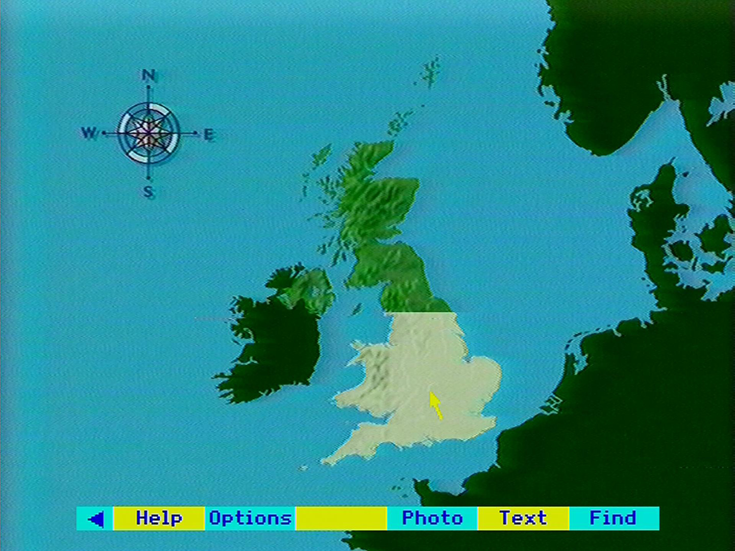

When the England map appears move the pointer to Cambridgeshire and then press [ACTION] to zoom in:

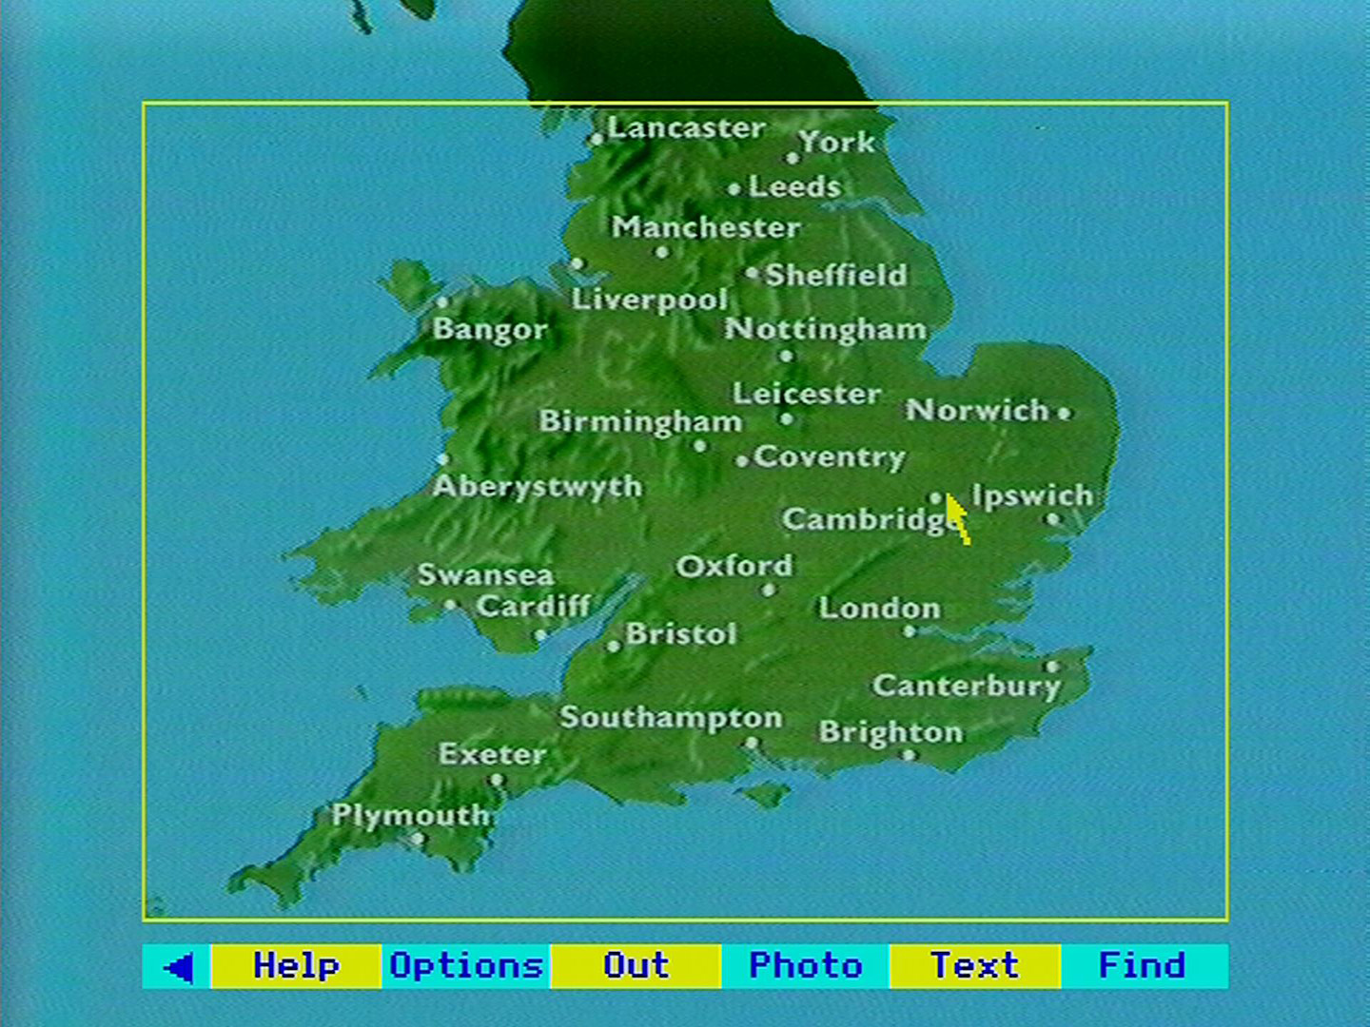

The level 2 map appears. Move the pointer due East of Cambridge and press [ACTION] to zoom in further:

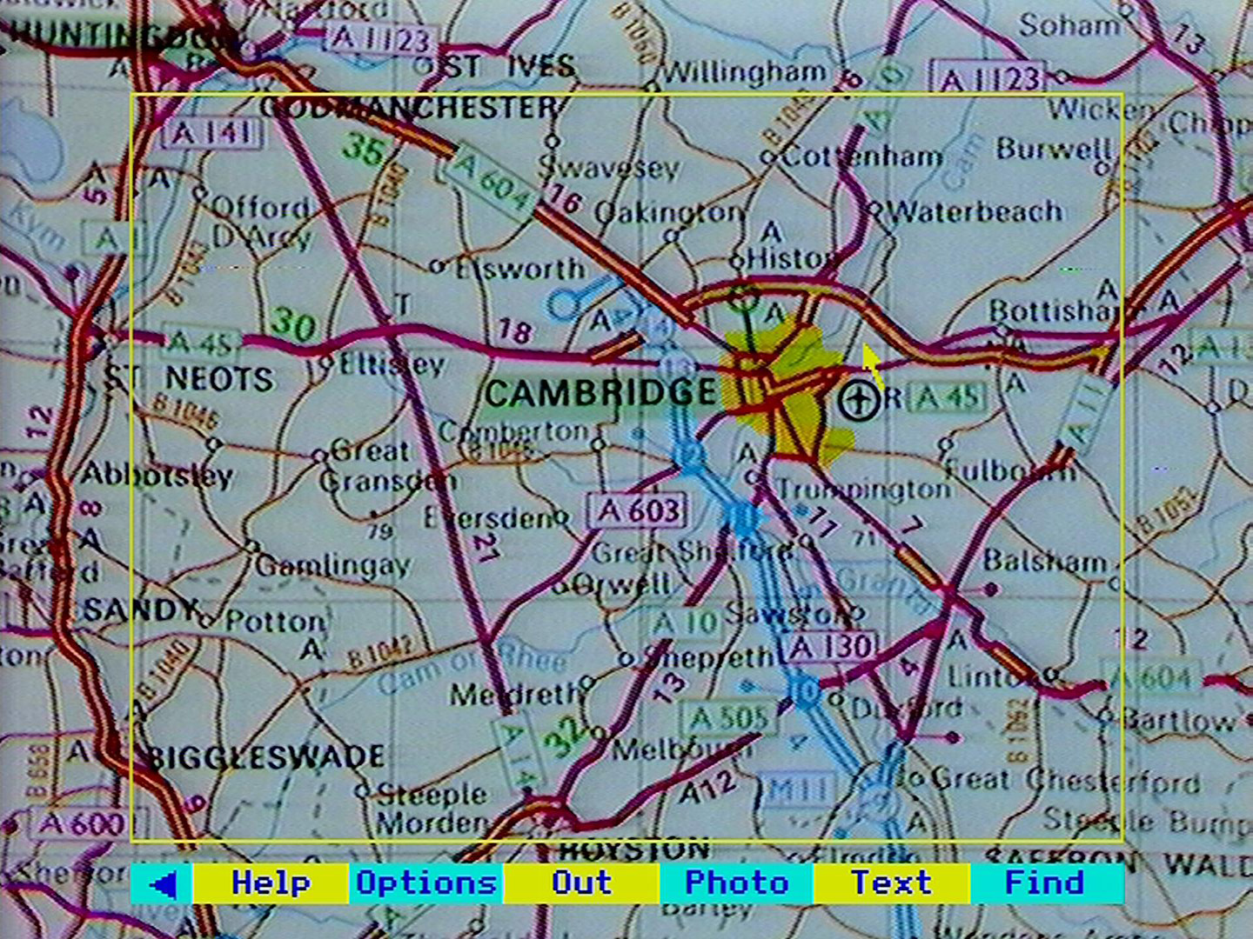

The map is too far North. Move the pointer to the Southern edge of the screen and press [CHANGE] to move South without zooming in:

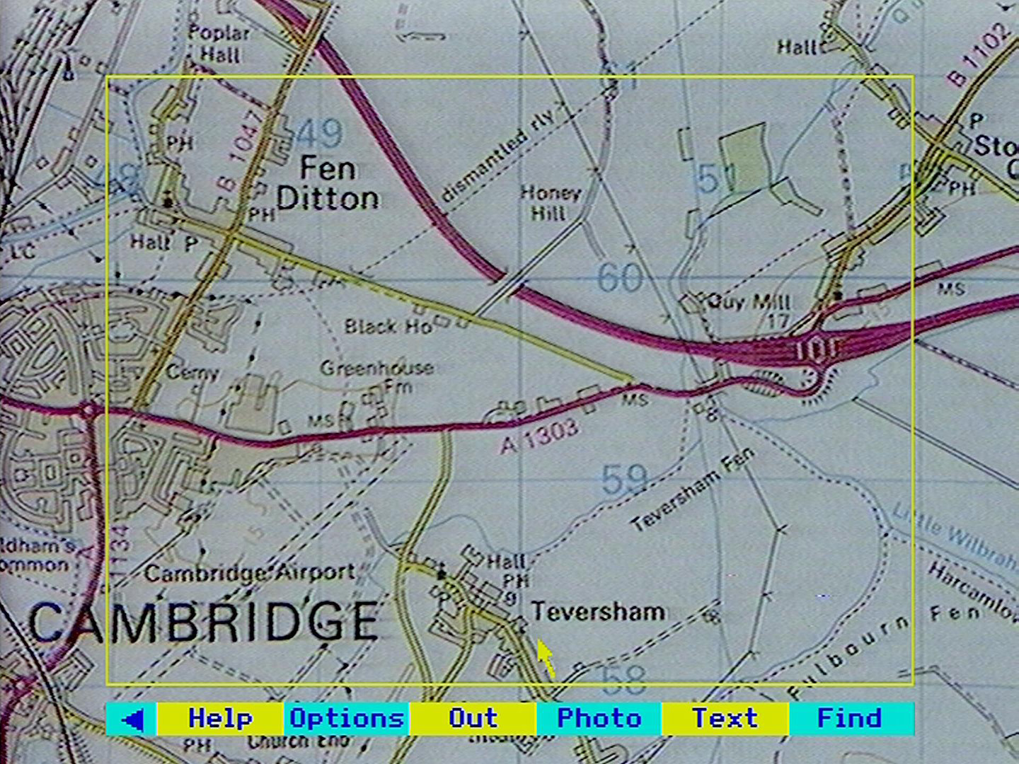

The Fulbourn area map appears:

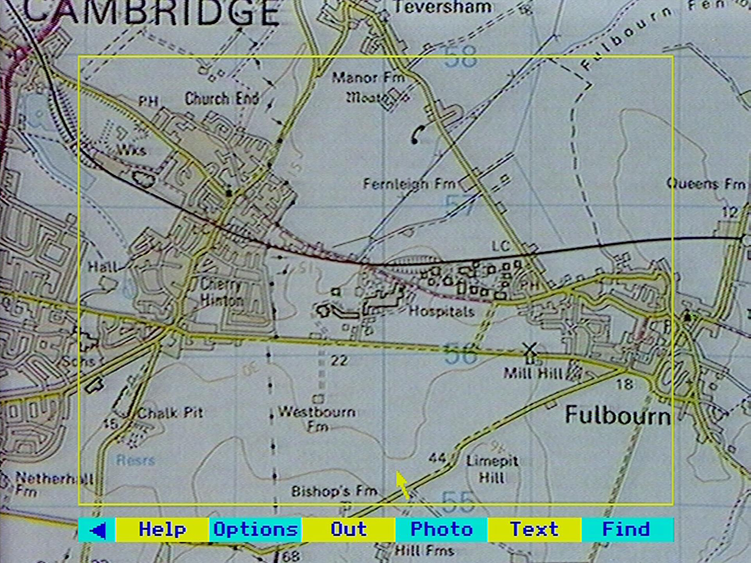

Select **Options** then **Scale** from the menu bar then position the pointer over the centre of Cherry Hinton and press [ACTION]:

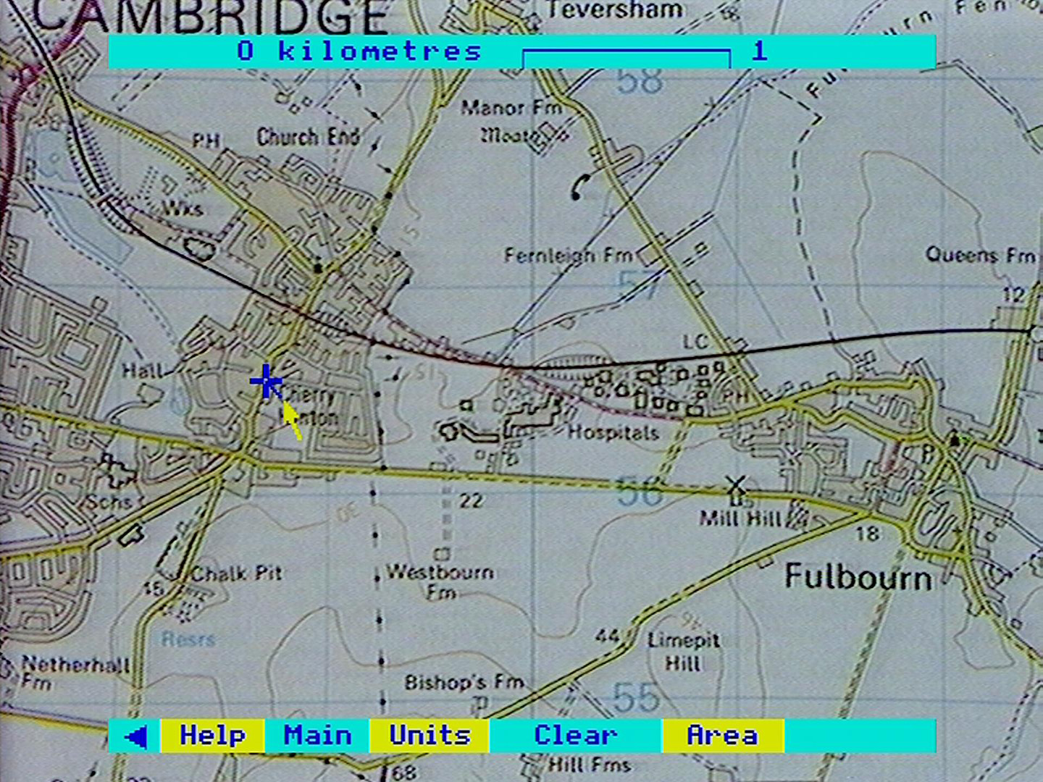

Continue moving the pointer and pressing [ACTION] to draw a line along the road to the centre of Fulbourn:

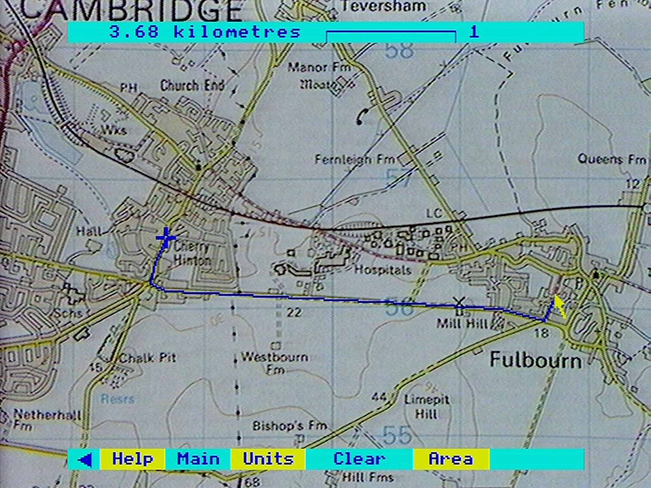

The display shows 3.6 kilometres. Select **Units** to convert the result to miles:

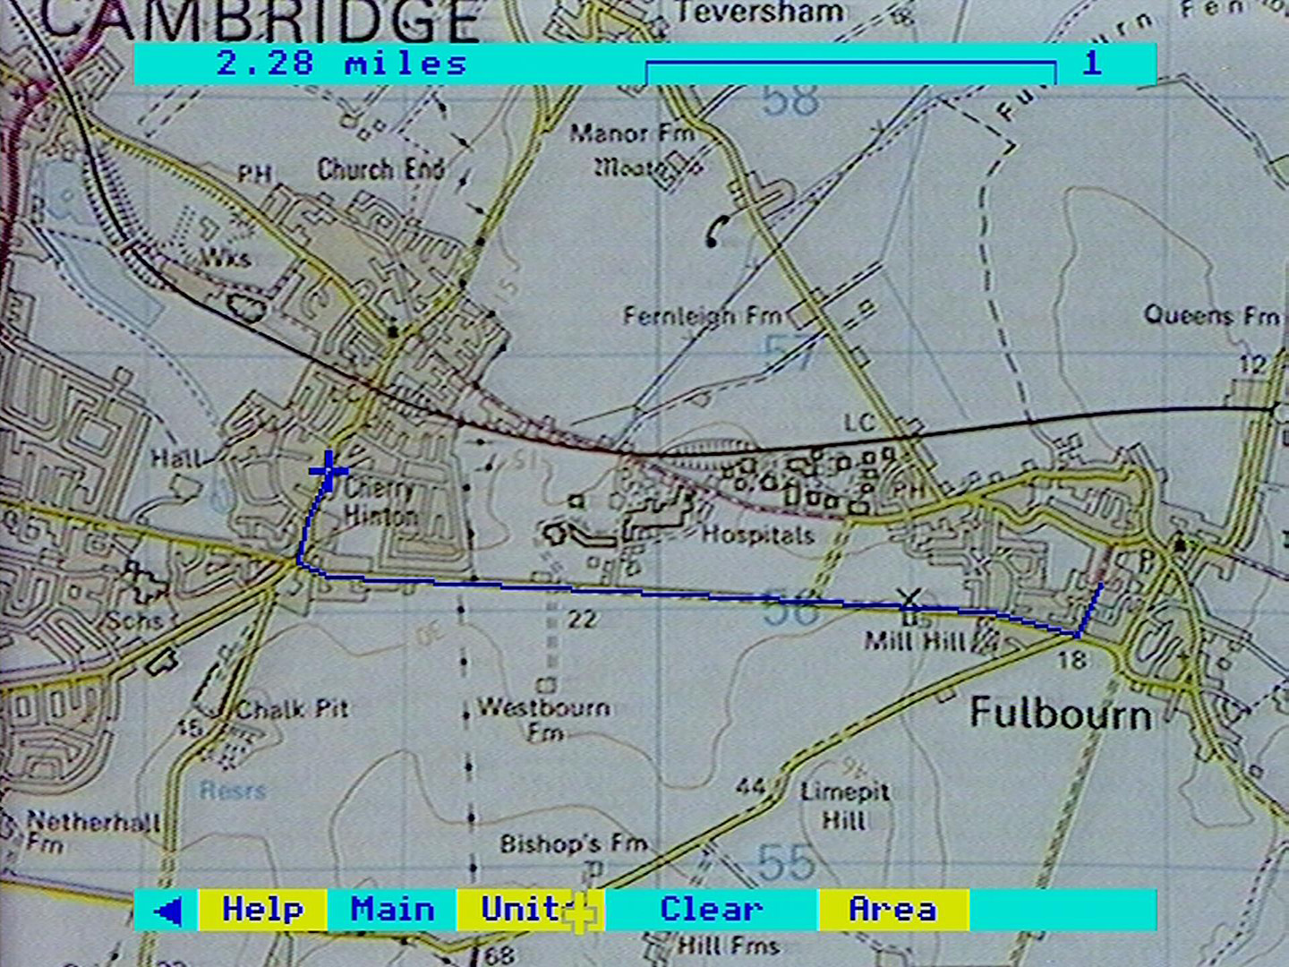

#### A guide to the images available at the various Domesday map levels

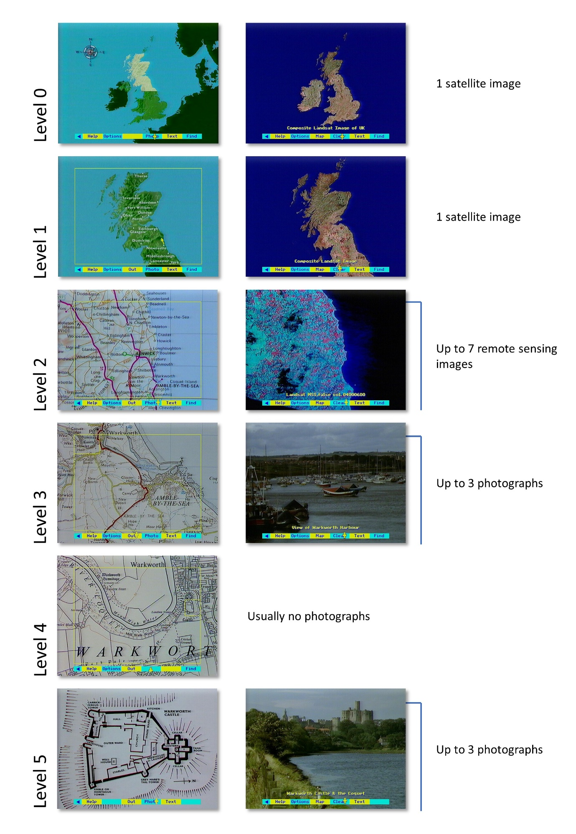

Figure 20 - Images available at the various Domesday map levels

## The local photographs

This section describes how to find the pictures you want from the tens of thousands of places in Britain that have been photographed for the Domesday Project. The pictures range from close-up scenes on the village green to satellite views of the entire United Kingdom. Unlike the photographs on the National Disc, most of the local photographs on this disc were taken by amateurs who live locally. They are designed to represent the local view of the countryside and of community life. Each picture is captioned and this section explains how to display the different captions as well as how to print them and record them on magnetic disc.

The community disc contains more than 20,000 local photographs in its first edition. In fact, it has the capacity for complete coverage of the country with 70,000 pictures and this may be achieved in subsequent editions.

The pictures are all arranged in strict relationship to the maps. This means that there are levels of picture coverage in just the same way as there are levels of maps. See diagram opposite.

### Viewing the photographs

For any map on the Domesday Discs there are associated photographs if the word **Photo** appears on the menu bar below the map. To view the photographs, select **Photo** (see the summary reference card if you are not sure about how to select items from the menu bar).

After a brief delay, the photograph will appear on the screen with a short caption beneath it. This caption can be removed if you wish to examine or display the picture without it. Do this by selecting **Clear**. Select **Caption** to re-display the caption.

If you want to go further and remove the menu bar, this can be done by **actioning** the pointer over the blue triangle at the left-hand end of the menu bar (or pressing function key [f0]). A reversed triangle is left on the screen. **Action** this (or press [f0] again) to bring the menu bar back.

To remove even the yellow triangle, use function key [f9] (there is no mouse equivalent). This will remove all micro output from the screen, leaving only the photograph. Press [f9] again to restore the triangle.

The picture quality of the photograph on the screen can be changed by adjusting the contrast, brightness and colour on your monitor. However, some monitors are set to receive a direct RGB signal and this may limit the amount of adjustment you can make. We have tried in producing the disc to keep the picture quality as uniform as possible.

To bring up the next picture you use the normal procedure for paging forwards or backwards. Move the pointer anywhere on the right-hand side of the screen (above the menu bar area) and press the [CHANGE] button. This is paging forward and will produce the next picture. It is designed to be like turning the page of a book by moving your hand to the right-hand edge of the page.

Conversely you can page backwards through the pictures by positioning the pointer on the left-hand side of the screen and pressing [CHANGE].

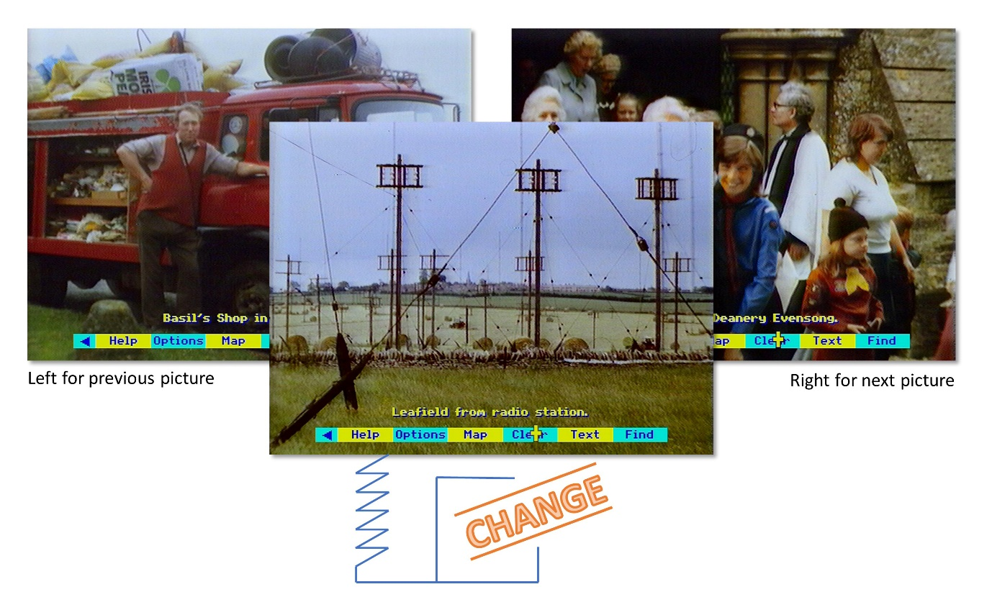

Figure 21 - Picture navigation

If there are no more pictures available as you page forward or back, you will hear a beep.

With the keyboard alone, you can page with the pointer in the same way. but it is much faster to use the two function keys marked "Backwards" and "Forwards" - [f7] and [f8]. In fact, these keyboard keys are the fastest way to move between pictures, even if you are using the mouse for most other functions.

This section has described how to find the pictures that relate to a map. You can also use the main Domesday index to search for pictures under any topic: for example, all the pictures of cathedrals. For this you need to select **Find**. Its use is fully described below in the section “Using the main index with find”.

### Picture options

Extra facilities are available for working with the pictures which you may need on some occasions. To use these, select **Options** from the menu bar and this will bring up a second menu bar with new options on it.

#### Description

Select this for a longer, descriptive caption to be superimposed over the photograph. This will often include more information about what is in the picture, who took it and so on. Select **Clear** to remove the description, and **Caption** to replace it with the short caption.

You can page through photographs with either no captions, short captions or long captions displayed.

#### Print

If you have set up a printer as described in the section “Controlling the system”, then selecting **Print** will produce a print out of whichever caption is on the screen. If you select **Print** without a suitable printer on-line, you will hear a beep and see an error message to that effect. A serial printer can be used after an appropriate operating system call in **Help**. The printer itself can be configured before the Domesday Discs are booted up or via a machine code printer driver called from **System** within **Help**).

Hint: No photograph print facility

The Print command will not, of course, reproduce the photograph. It is, nevertheless, a useful feature if you are, for example preparing a talk on a set of pictures from the disc. Only one, very basic printing format is supported. For more complicated results, first save the captions to floppy disc with the Write option.

#### Write

To record the text of the caption on the screen to magnetic disc, select **Write** from the menu bar. You are asked to confirm that the drive is ready with key [R] for "Ready". Pressing any other key will cancel the command. If you press [R] and a suitable drive and disc are not connected to the micro, the system will "hang": i.e. it will freeze and not respond to any more commands. If you cannot correct the problem (e.g. by closing the drive door), there is no alternative to booting up the video disc again. Downloading is only possible to an ADFS format disc. If a ADFS error occurs (e.g. "Disc full"), this will be displayed at the top of the screen for three seconds.

Text is stored in a simple ASCII format with no control characters. In this format, it can be read into VIEW or most word-processing systems. For details of this and the file names used, see “Appendix III - Formats of downloaded files”.

You can leave the photo-options sub-menu at any time by selecting **Main** from the menu bar.

### Specialised photographs

Most pictures on the disc represent scenes taken somewhere within the related map. There are, however, two kinds of more specialised photographs.

#### Satellite Images

Each level 2 map has one or two matched satellite images linked with it. The first is a "true colour" version (where this is available). The second is in "false colour", since this often cuts through haze, producing a clearer, though less natural looking, picture.

The technical details of each image are contained in its long caption. All the data from which these images are constructed comes from Landsat satellites. A full description of remote sensing is contained on the National Disc (indexed under "remote sensing"), together with many case studies showing how these images can be analysed to great practical effect.

The images have been manipulated so that they approximately match the position of the map on the screen. This manipulation is not exact, since the images were recorded at an angle from the vertical. It should, however, be close enough to enable you to identify features in the image more easily.

For the level 0 and 1 maps of large areas of the United Kingdom, we have used composite mosaics made up of from many individual Landsat scenes.

#### Aerial Photographs

For each level 2 map there are between one and five aerial views. Unlike the satellite images they are not wide enough to cover the map, but are designed to provide sample coverage of interesting areas within it. To locate them in relation to the map, note the grid reference in the long caption. This refers to the bottom left-hand corner of the photograph and is given to the nearest kilometre. Now return to the map and use the Grid Ref option (see the section “Finding your way with maps”) to locate this position. All aerial pictures are orientated with North at the top (except where otherwise specified in the caption.)

Some aerial photographs are in colour, but most are in black and white. Most are taken vertically downwards, though a few are obliques. The date of the photograph is noted in the long caption.

### Leaving photographs

You can leave the Photo operation at any time by selecting any of the other top-level operations from the menu bar. **Map** or **Text** will take you to the map or text that corresponds to the photographs you have been looking at. Find will take you to the main index, with the current map defining your scope of search (see the section “Using the main index with find”). You can also leave by pressing [ESCAPE]. This will take you (after a confirmatory prompt) right back to the United Kingdom map and reset the system to its starting condition.

### For example – To find the false colour Landsat image of the Portsmouth area and read the descriptive caption

Move the pointer to Southern Britain and press [ACTION] to zoom in:

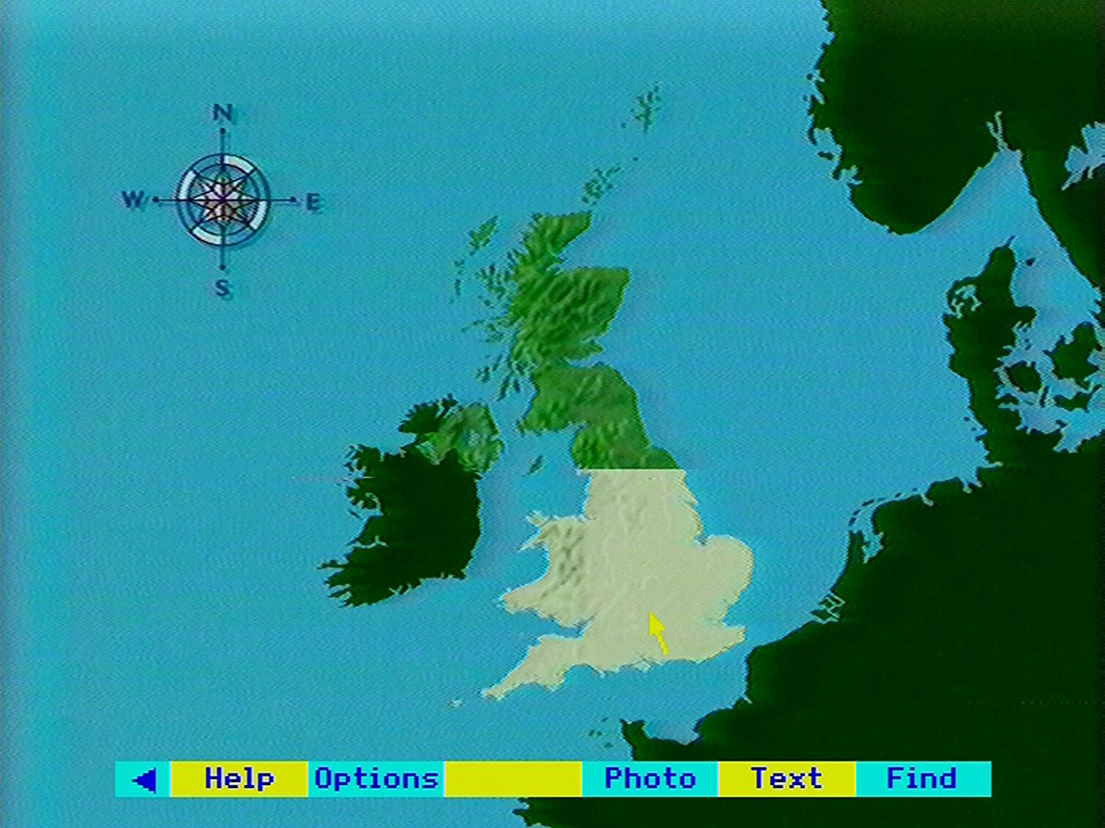

The Level 1 map appears. Move the pointer North of the Isle of Wight and press [ACTION]:

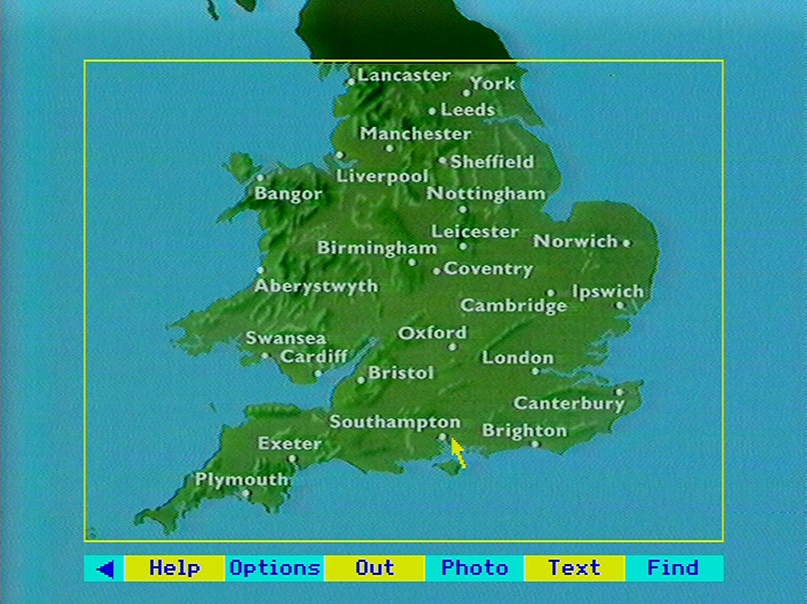

The Level 2 map appears including Portsmouth. Select the **Photo** option from the menu bar by moving the pointer over it and pressing [ACTION]:

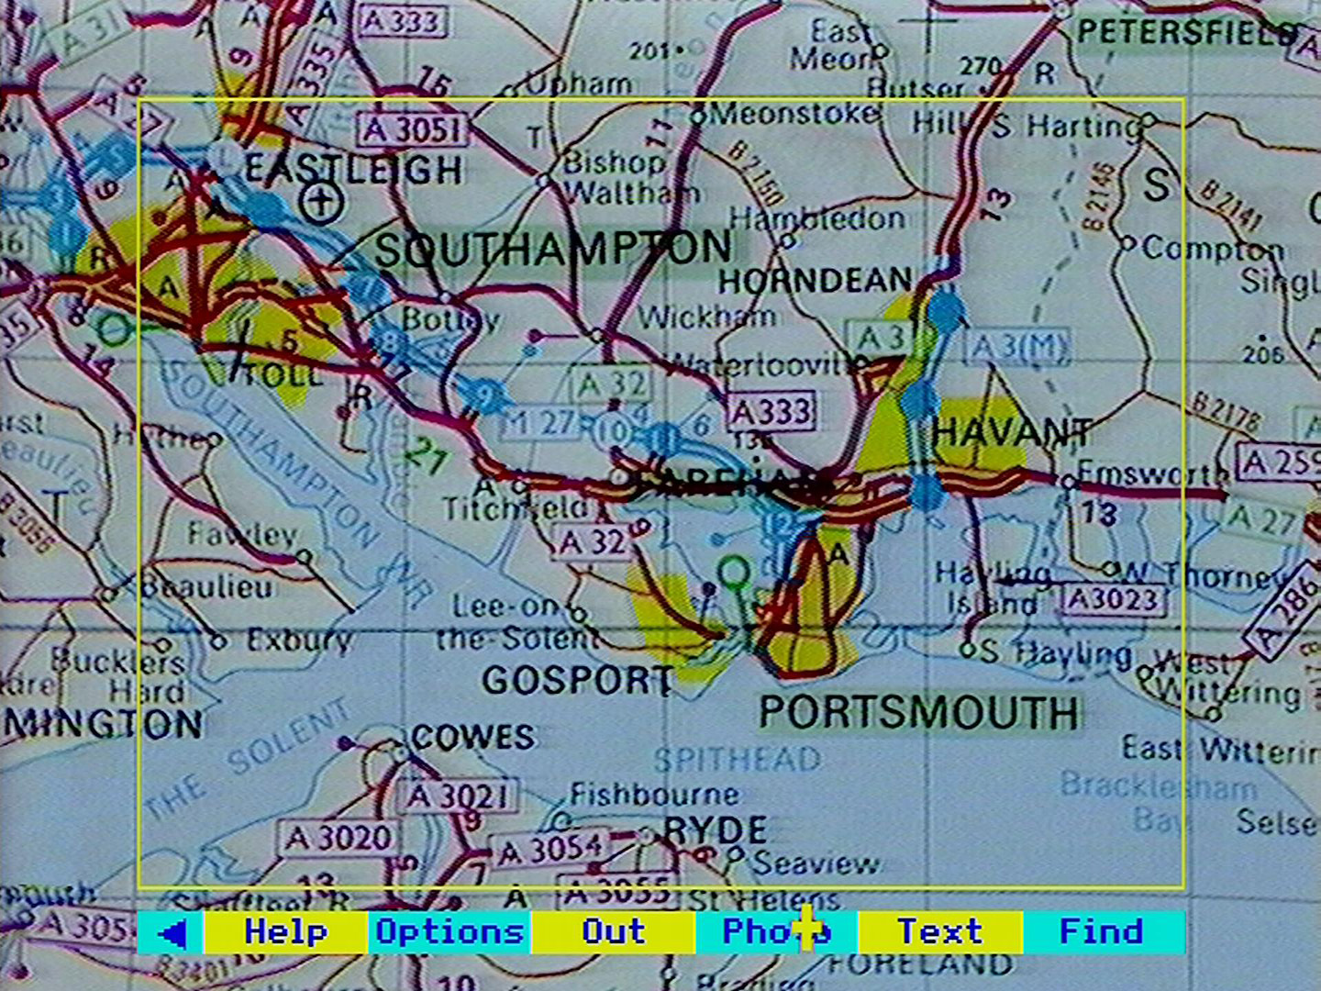

The true colour Landsat images appears. Move to the right side of the screen and press [CHANGE] for the next photograph:

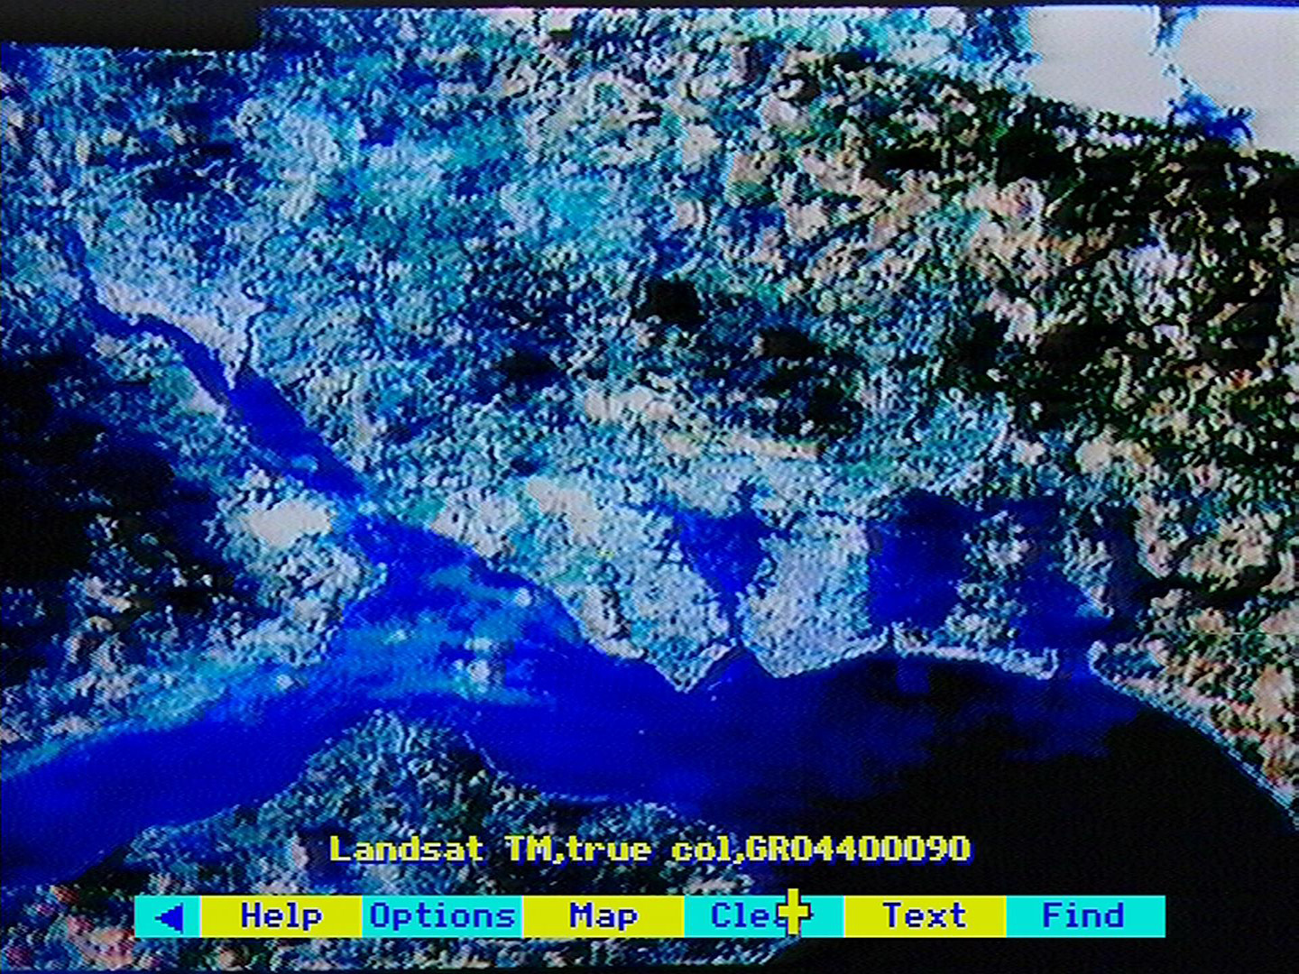

The false colour image appears. Select **Options** from the menu bar to bring up the option of the full descriptive caption. Select **Description**:

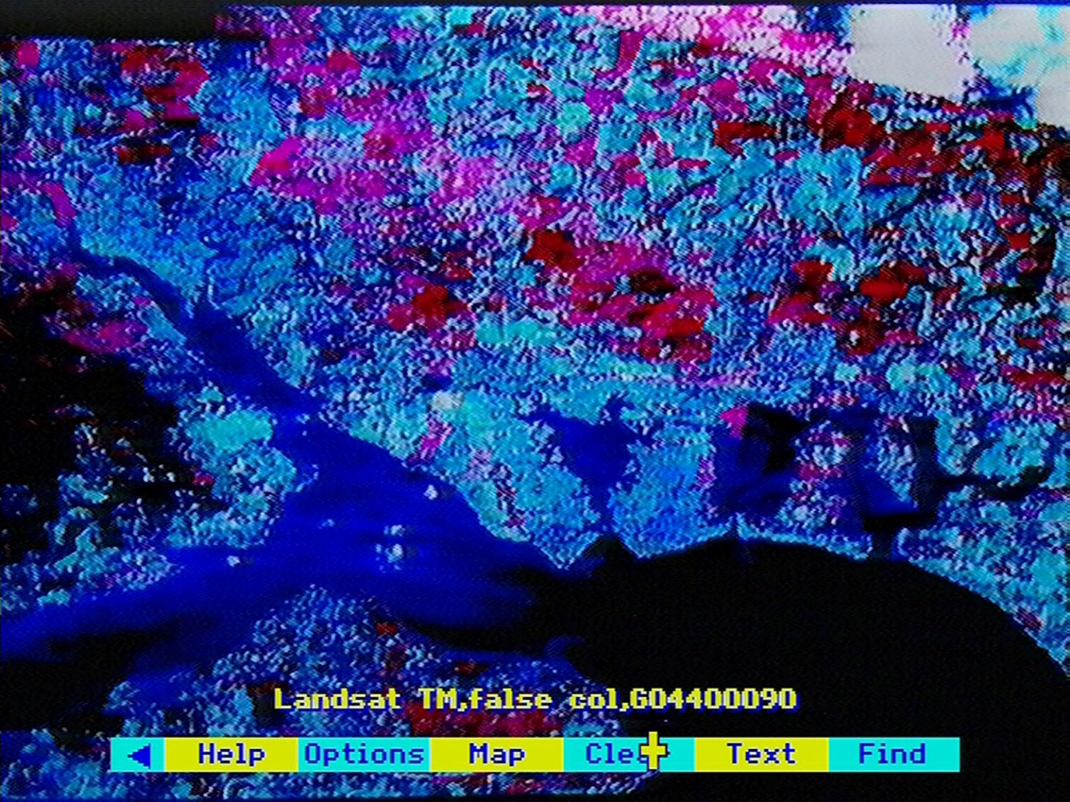

The full descriptive caption appears over the false colour Landsat image of the Portsmouth area:

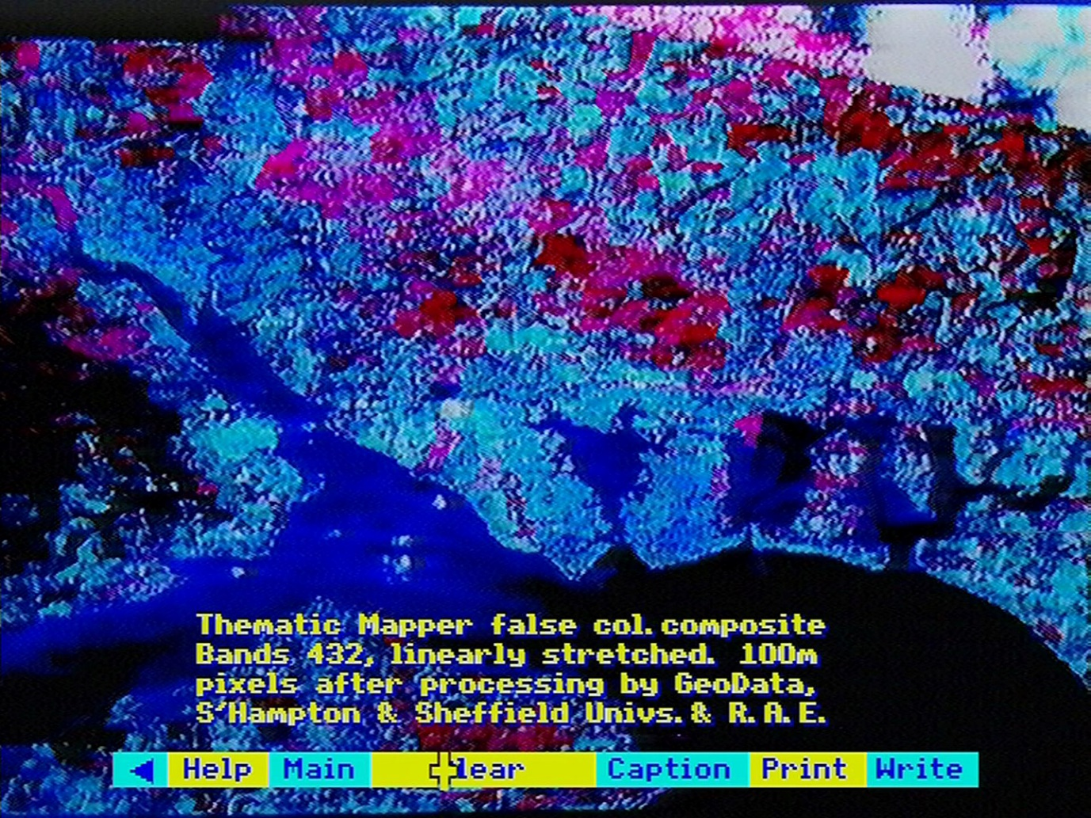

## Five levels of text

This section describes how to find and read all the text contained on the Community Disc. Like everything else on the disc, it is arranged hierarchically in strict relationship to the maps.

An article on the United Kingdom is linked to the level 0 map. Similarly, each of the six country or island groupings at level 1 is represented by a substantial article from a leading geographer.

At level 2, most of the 40 X 30 km areas have text essays associated with them. But because these blocks are artificial ones, we have also included 40 in-depth articles on the traditional, irregularly-shaped regions like the Grampians or the Yorkshire Moors. These are linked to the level 2 map text.

Most of the text occurs at map level 3. This consists of 200,000 screen pages of information about the places covered by 9,000 of the level 3 maps.

Written by local people - often school-children - it is designed to give their own picture of life in their community for our interest today and as a record for future generations. Local people have also written about some 100 special features throughout the country, which are usually represented by level 5 close-up maps or floor plans.

What follows describes how to find the text related to the maps. Don't forget, however, that all the text can also be accessed from the main Community Disc index by using the **Find** option. Its use is fully described in the section “Using the main index with find”.

### Reading the text

Having found the map which covers the area that interests you, select **Text** from the menu bar. This brings up on the screen the index of page headings for the text that follows.

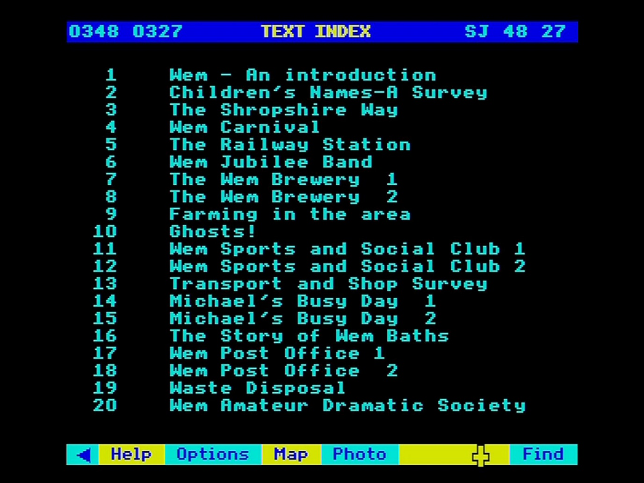

Figure 22 - Index page of headings

The grid reference shown at the top left indicates the map area to which the text refers. It is shown on the right in its "letters and numbers" form and on the left in its numerical form. In the case of a large area at level 0 or level 1, this may appear as 'Channel Islands' etc.

You can now page forward to the first screen of text. Move the pointer to the right of the screen and press [CHANGE], as if you were turning the page of a book. Alternatively, you can move directly to any page shown in the table of Contents. The usual **select** grammar applies: simply point to the item you want and press [ACTION]. You can point at the number of the item or anywhere along the line. You can be sure which item you are pointing at since its number will be highlighted as you move to it.

When you arrive at the page you want you will see the page heading you selected at the top of the screen, together with the page number. The text itself uses a narrower column than the whole screen and is proportionately spaced. This, together with the colours used, is designed to make it easy on the eye. Yellow is used for words that the authors wanted to emphasise - the equivalent of italics in a book or underlining in typescript.

Once you have read one of the pages of text, you can page on or page back in the usual way. Alternatively, you can select **Index** from the menu bar to return to the index of page headings.

The very large articles on the community disc (the regional essays) are presented in a slightly different way. Instead of beginning with an index of page headings, they have a contents page of section headings.

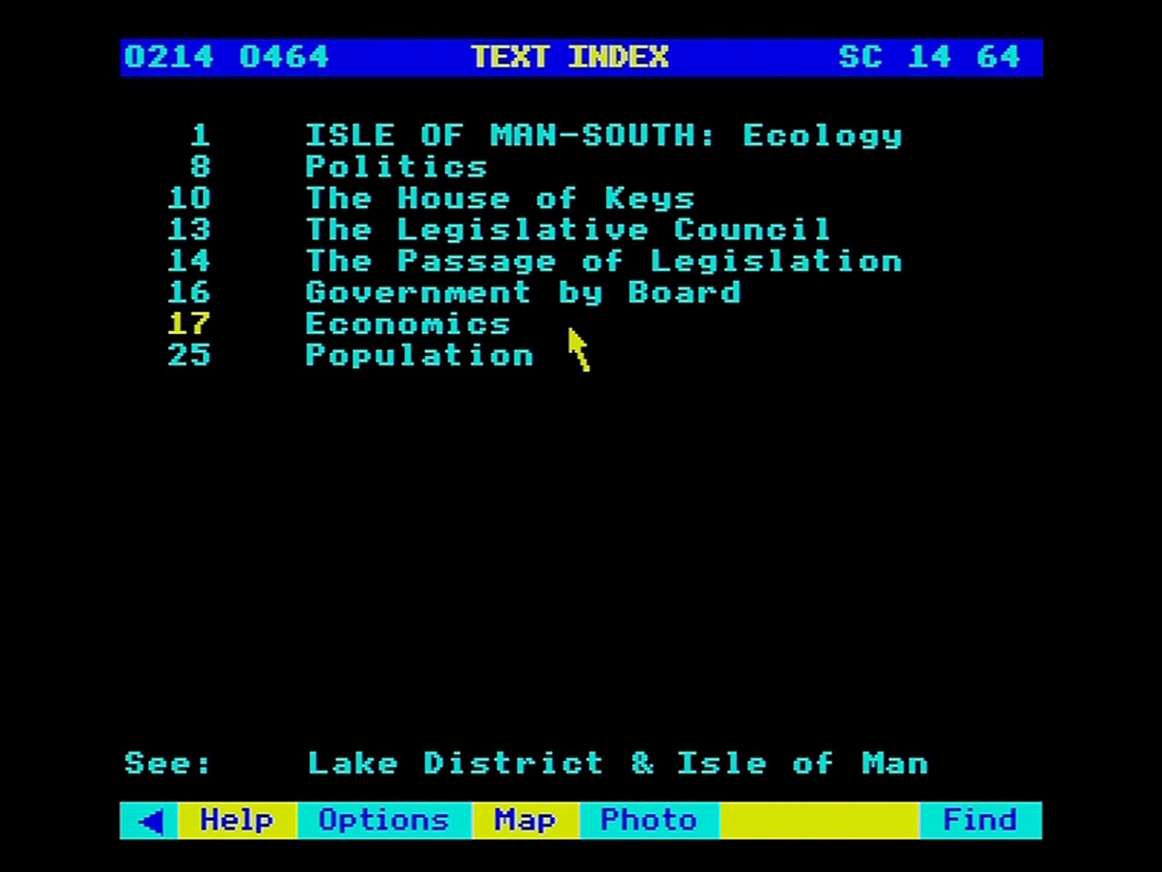

Figure 23 - Contents page of section headings

The page on which each section begins is shown on the right. You can select any section directly. When you are reading the section itself, you can page forwards and backwards or return to the contents page by selecting **Index** from the menu bar.

At any time, you can leave the text and move back to the map or on to the photographs or **Find** operation. Select the option you want from the menu bar. If you then come back to text, you will come in at the index or contents page.

### Cross references to regional articles

As we mentioned in the introduction, level 2 maps relate to text in two ways. There may be text about the exact 40 by 30 kilometre area covered by the map. There may also be text about the more natural, "irregular" region in which the map falls; for example, the Lake District or the Chilterns.

When you first select **Text** from a level 2 map, the Index you come to will first list the sections of article on the map block itself. Below this will appear, for example:

**see: The Lake District.**

Look back (to text contents screen) to see how this appears on the screen. You can access this article by selecting it with the pointer. This will take you to a new (very substantial) article, with its own contents page. If you want subsequently to read the article about the 40 X 30 block, you must reach this via the map again.

### Text options

Also available are some specialised functions for text handling which you may occasionally need. Select **Options** from the menu and a second menu bar appears with the new options. Return to the main text menu by selecting **Main**. Under text options you have the following extra functions:

#### Print

If you have set up a printer as described in the section “Controlling the system”, then selecting **Print** will produce a print-out whatever text is on the screen. If you select **Print** without a suitable printer on-line, you will hear a beep and see an error message to that effect. A serial printer can be used after an appropriate operating system call in **Help**. The printer itself can be configured before the Domesday Discs are booted up or via a machine code printer driver called from **System** (within **Help**).

To print out the next screen, page forward and re-select **Print**. Only the most straightforward type of printing is produced, without, for example, highlights. For more complicated results, first save the captions to floppy disc with the **Write** option.

#### Write

To record the text on the screen to magnetic disc, select **Write** from the menu bar. You are asked to confirm that the drive is ready with key [R] for "Ready". Pressing any other key will cancel the command. If you press [R] and a suitable drive and disc is not connected to the micro, the system will "hang": i.e. it will freeze and not respond to any more commands. If you cannot correct the problem (e.g. by closing the drive door), there is no alternative to booting up the video disc again. Downloading is only possible to an ADFS-format disc. If a ADFS error occurs (e.g. "Disc full"), this will be displayed at the top of the screen for three seconds.

Text is stored in a simple ASCII format with no control characters. In this format, it can be read into VIEW or most word processing systems. For details of this and the file names used, see “Appendix III - Formats of downloaded files”. Please take note, however, of the copyright warning in the section “Printing, downloading and copyright”.

#### First and End

This takes you directly to the first or last page in the article. You can then page forwards or backwards from there. Note, however, that if you page backwards to the Index, you will not be able to use it until you have selected **Main**.

#### For example – To print the text about Caerphilly Castle

Move the pointer to Southern Britain and press [ACTION] to zoom in:

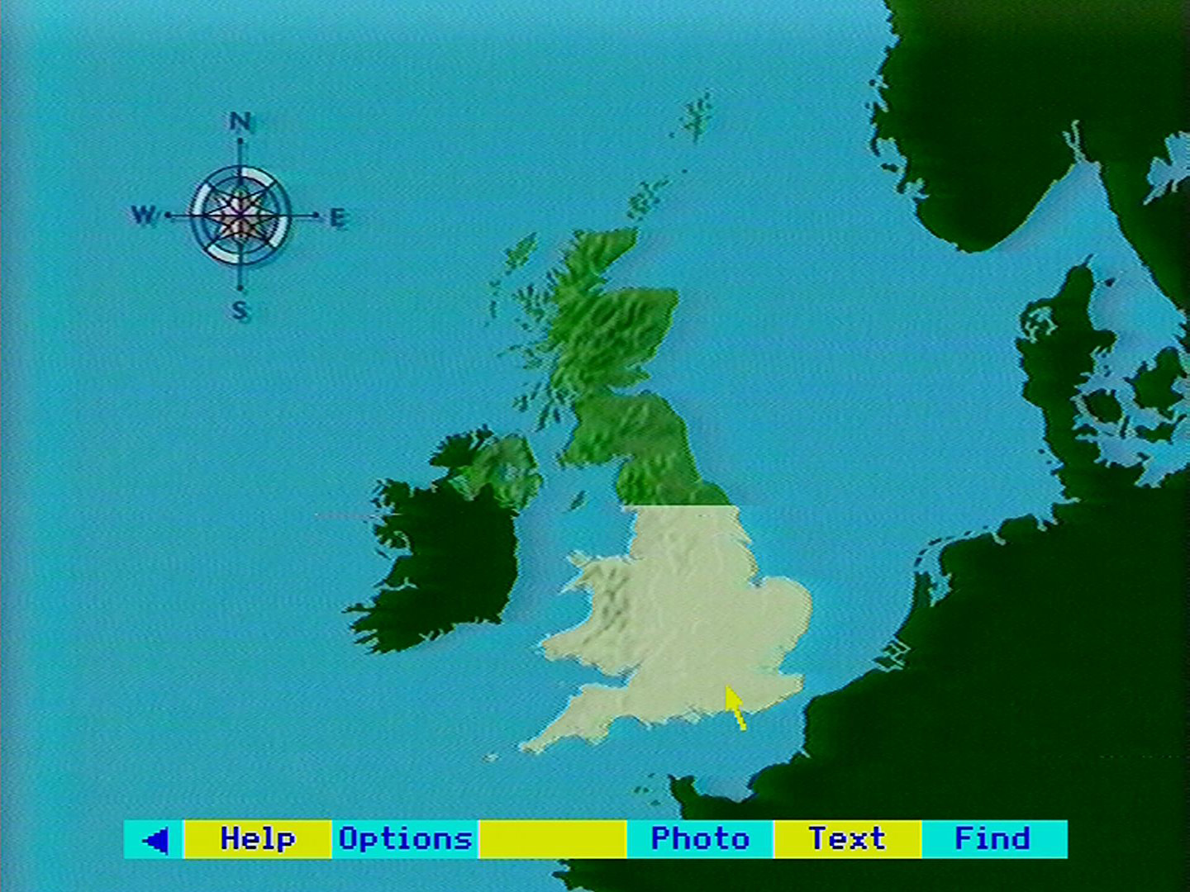

The level 1 map appears. Move the pointer to South Wales and press [ACTION]:

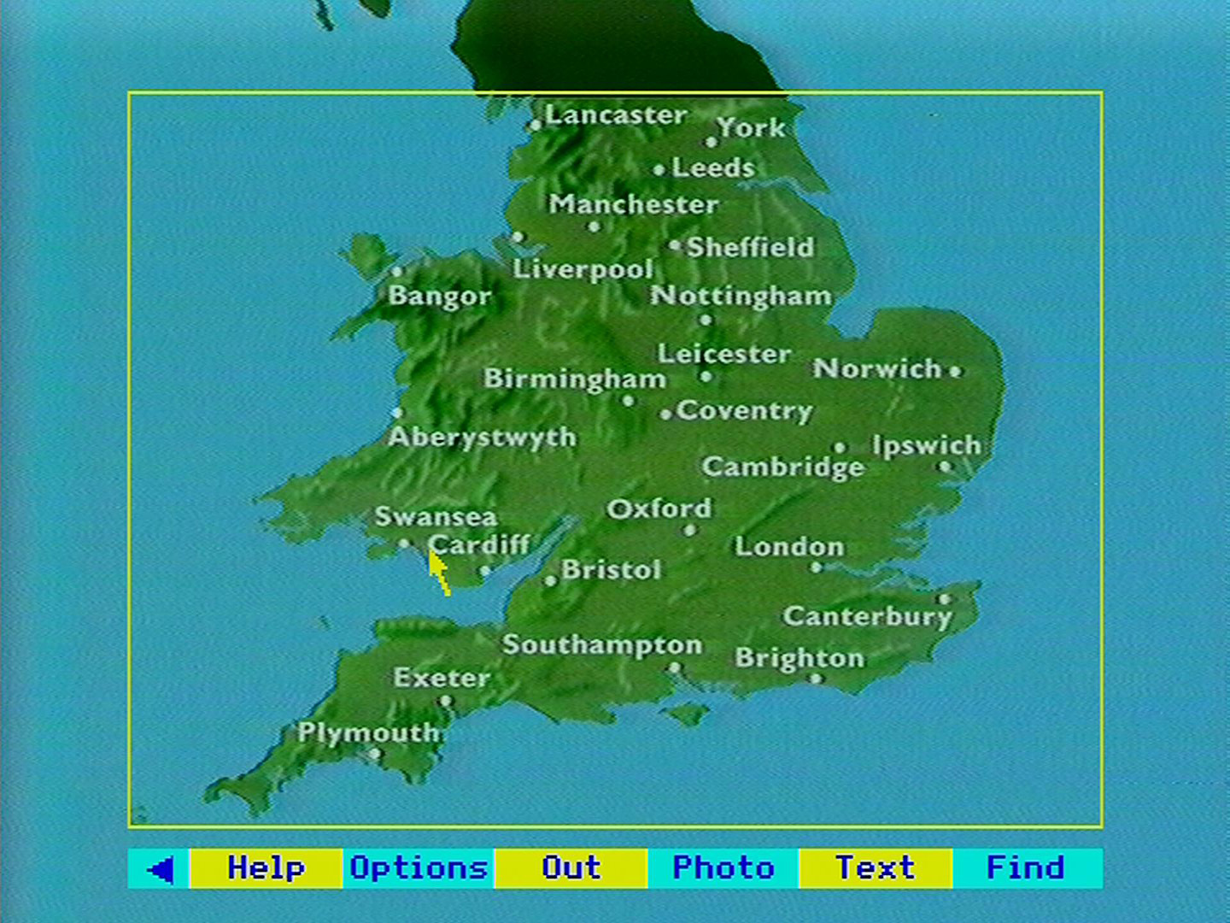

The level 2 map appears. Move the pointer to Caerphilly and press [ACTION]:

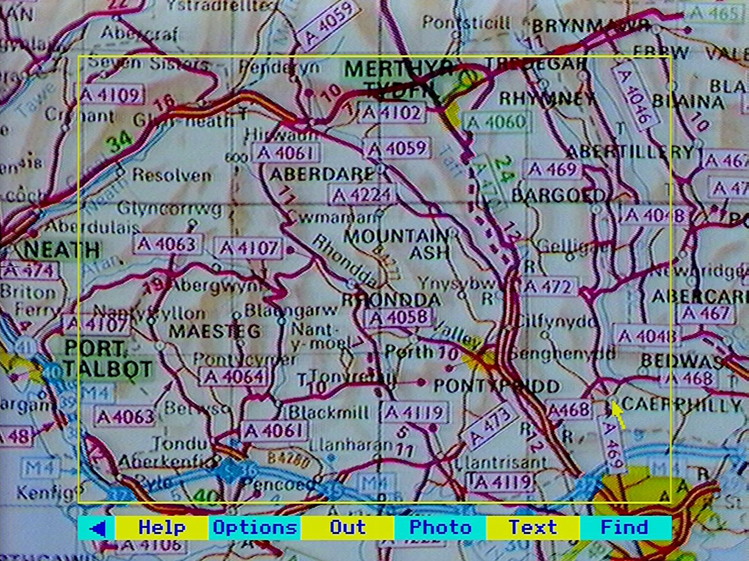

The level 3 map appears. Select **Text** from the menu bar:

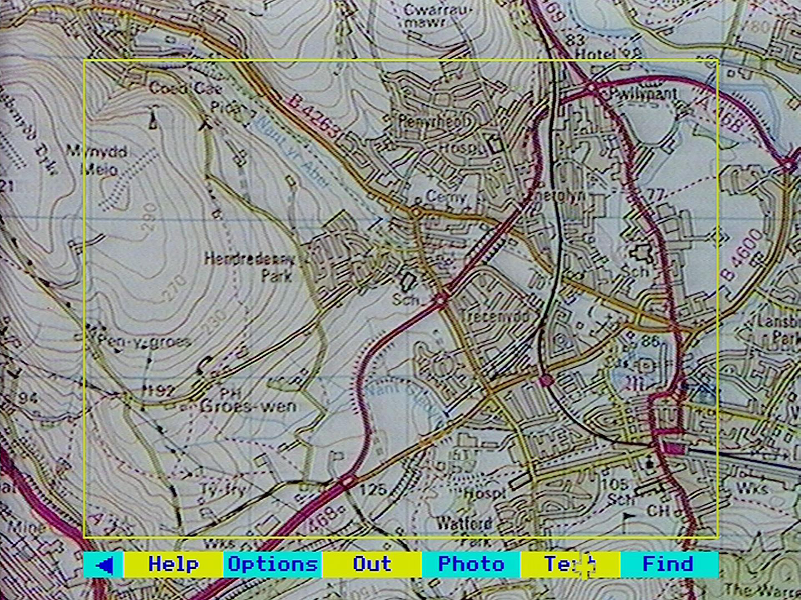

The text index appears. Move the pointer and press [ACTION] to select item number 6 “Caerphilly Castle – History”:

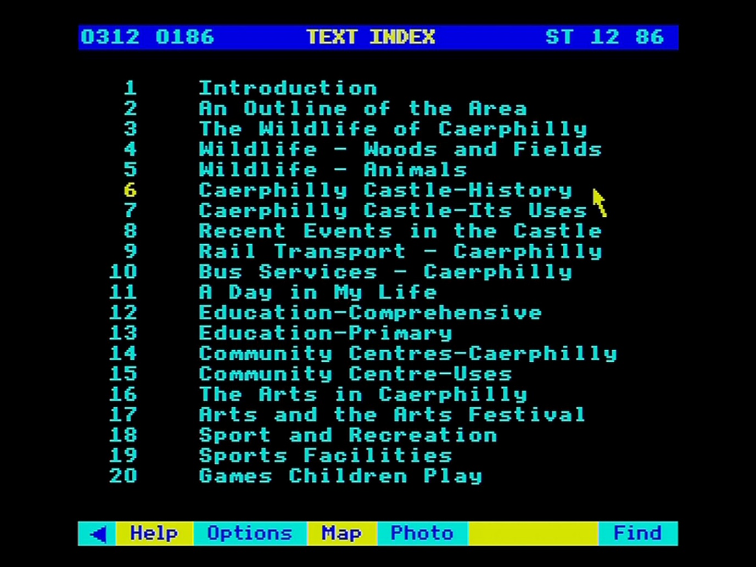

A page of text appears. Select **Options** and then **Print** (make sure your printer is online):

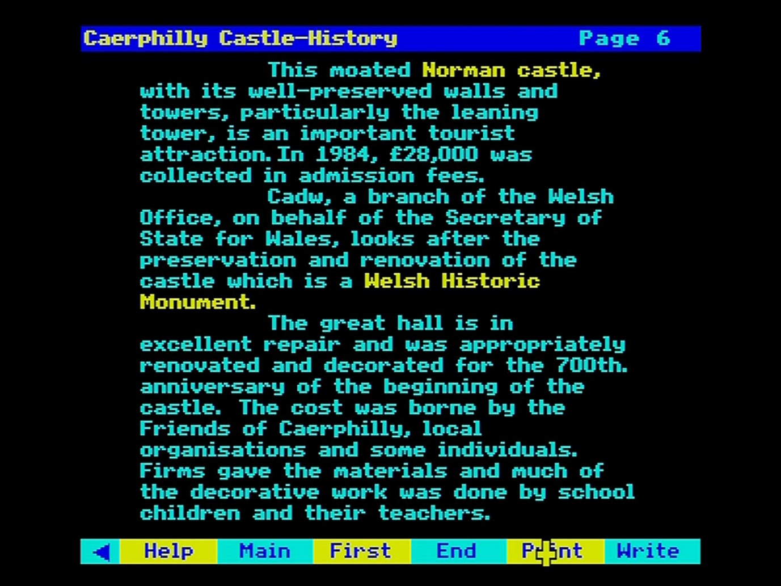

Once the page of text is printed out, move the pointer to the right-side of the screen and press [CHANGE] for the next page:

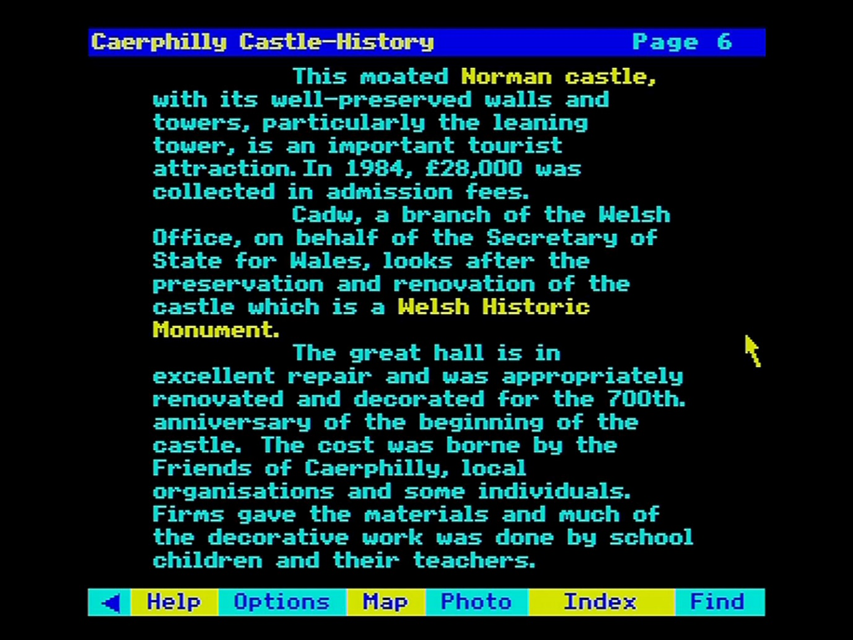

A new page of text appears “Caerphilly Castle – its use”. Select **Print** again:

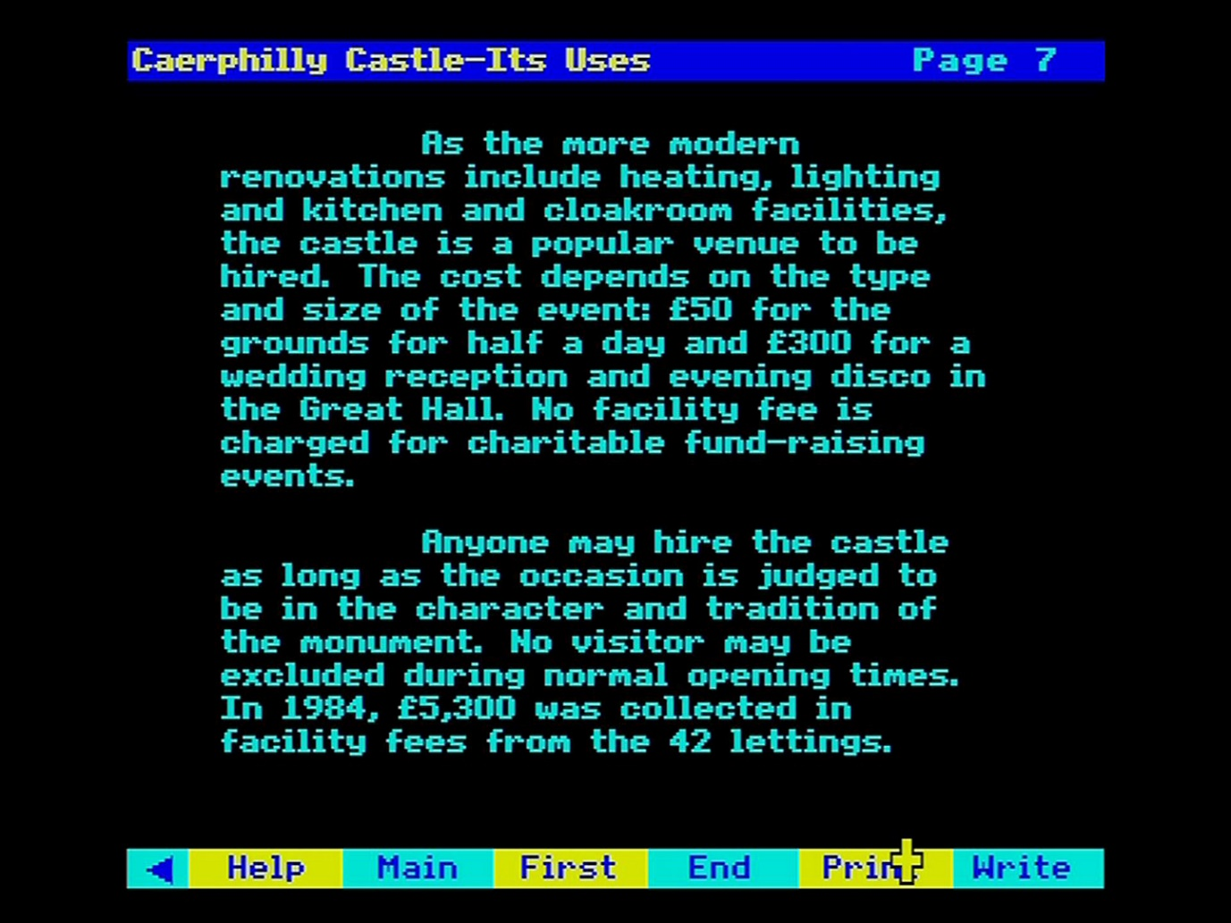

## Using the main index with find

This section describes how to use the **Find** option to search the two sides of the Community Disc for maps, photographs and text. This is the way to find material on a topic from anywhere in the country rather than looking at everything about a place. The two sides of the disc are separately indexed, although, as described above in the section “Introduction to the people's database”, the two sides do hold a certain amount of material in common.

This is a more detailed section, not because it is hard to find material in this way, but because one tends to find more than one can handle - often thousands of items that match an enquiry. The system therefore has many features to make searching more powerful and easier to use.

You will come into the **Find** operation after selecting **Find** from the menu bar anywhere in the system.

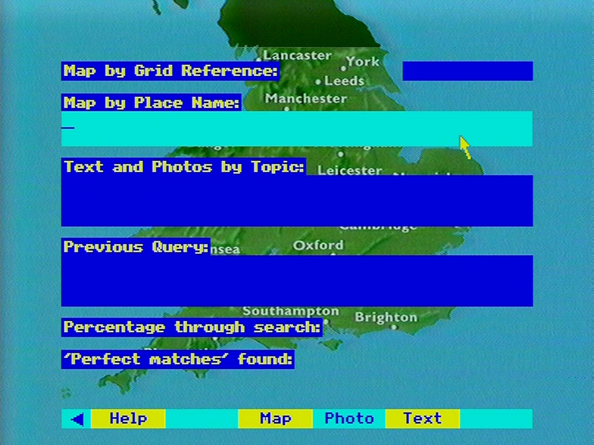

Figure 24 - The find screen

Your current map is shown behind the main **Find** screen. Its relevance is discussed below. The **Find** screen contains four dark blue boxes. The three at the top are used to enter enquiries and highlight as you move the pointer to them. The type of search you can make depends on the box you choose to highlight. The first two boxes are alternative ways of finding maps - either by grid reference or by place name. The third box allows you to search the photographs or text by topic enquiries. These alternatives are described in the following sections.

To make an entry in a box, move the pointer until the box is highlighted in cyan, a light blue colour. Enter your text from the keyboard. You can use the cursor keys back over text you have entered. Use the [DELETE] key to erase mistakes, working from the end. As you reach the end of a line, the word you are typing will move to the next line. Don't use the [RETURN] key to move to the next line: this acts as [ACTION] and will enter your enquiry. When your entry is complete, then press [ACTION] to enter your enquiry.

### Finding maps

The first two boxes on the **Find** screen are used for finding maps.

#### Grid Reference

Grid references can be specified in either of two formats. For a full discussion see the section “System structure”. In this case you can enter the reference either in an all-numbers or in a letters-and­ numbers form. How much resolution you enter depends on how specific you want your reference to be. Here are some examples of valid grid references:

|  |  |  |  |  |
| --- | --- | --- | --- | --- |
| Resolution | 100km | 05 01 | or | TQ |
| Resolution | 10k | 052 015 | or | TQ 2 5 |
| Resolution | 100m | 05268 01583 | or | TQ 268 582 |

If you don't leave a space between the first and second group of numbers, the system will simply divide any even group of digits into two groups.

If the reference you entered is invalid or does not fall within the Domesday area, you will see an error message like this:

"Grid reference has invalid format"  
or "This grid reference is in the sea".

Northern Ireland has a different grid system, using many of the same numbers as Great Britain. If you enter one of these ambiguous grid reference numbers in the all-numbers form, you will see in the message area:

"Do you mean GB or N. Ireland (G/N)?"

Enter the corresponding letter in upper or lower case to make your selection - e.g. press [G] and then [ ACTION] if you want Great Britain. The Channel Islands are on the French national grid which the Domesday software recognises automatically.

When your enquiry has been processed, you will be taken to the appropriate level 3 map. A yellow cross will indicate the exact grid reference position. If the level 3 map for the reference you entered is on the other side of the disc, the cross will be superimposed on the corresponding level 2 map.

#### By Place Name

The Domesday System has a complete database of all the quarter of a million place names that occur on the Ordnance Survey 1:50,000 maps and on the equivalent maps for Northern Ireland: that is, on all our level 3 maps. This gazetteer includes, as well as town and village names, city districts, farm names and even archaeological sites. River names are the only ones we have not included as their positioning is arbitrary.

Highlight the second box and enter the place name you want to locate. If the name exists and is unique, you will be taken straight to the level 3 map that contains it. As the map appears, the square kilometre closest to the centre of the village or town, is highlighted. There may be some discrepancy in Northern Ireland where the gazetteer of place names has had to be derived from an earlier series of maps than the one used on the discs. If you are on the "wrong" side of the disc for the level 3 map containing your place name, the one-kilometre highlight will appear over the corresponding level 2 map. You will then be prompted to turn the disc over if you try to zoom in.

If the place name you entered does not exist or is not unique, you will see a display like this:

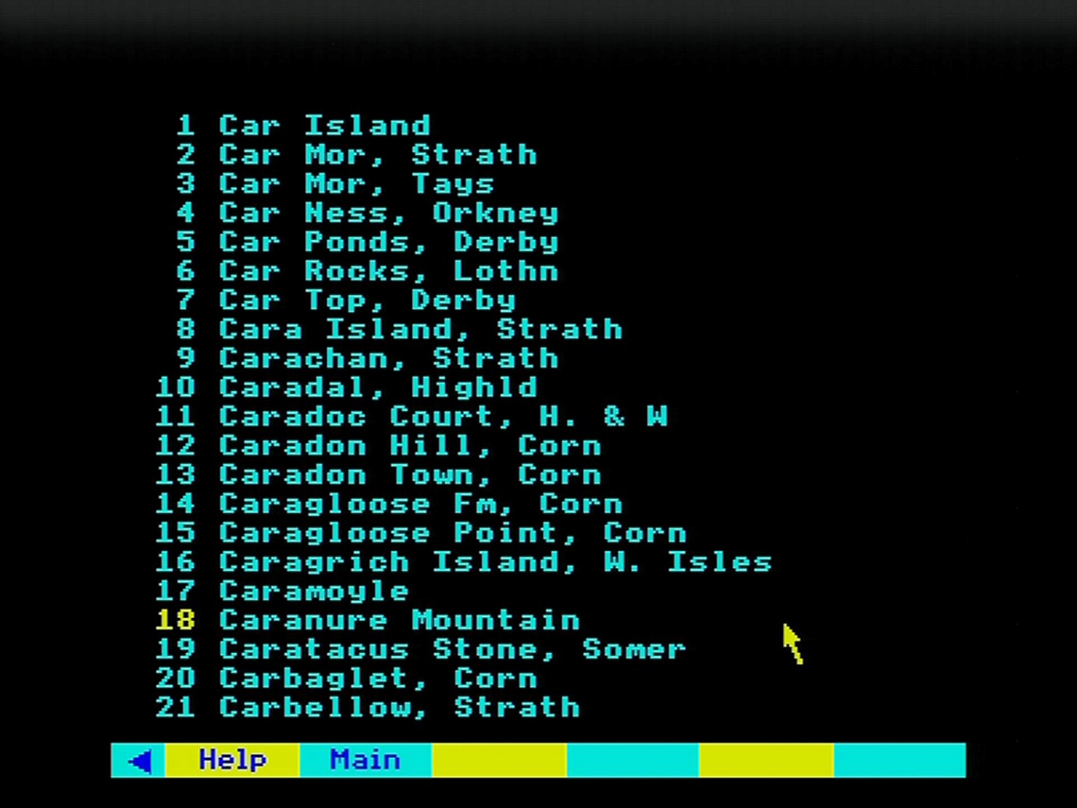

Figure 25 - Place name index

This is the relevant page of the complete alphabetical listing of UK place names. The item number immediately highlighted reflects only where you have left the pointer. Select the place name you want in the usual way with the pointer or page backwards or forwards through the complete list.

Numbers are allocated to the place names for screen display only: other pages use the same numbers.

Hint: Searching Strategies

There are two useful searching strategies. If you want to move straight to the map, be sure you know an unambiguous form of the place name and enter it in that form – e.g. 'Bledlow Ridge, Bucks.' You also need the correct county abbreviation. Alternatively, you may find it easier to type only the first few letters of the name (e.g. 'Bled') and make your actual selection from the list.

By this stage your **Find** operation has been successfully concluded and you are put into the **Map** operation, to allow you to move round the maps in the usual way. If you want to make another **Find** enquiry, select **Find** again from the menu bar.

### Finding text and photographs

Although this has been designed to be an easy part of the system to use, it is more difficult to explain exactly what is going on. Unlike the map index, where there is an exact correspondence between a place and its name, the relationship between a topic and the keywords in the index that refer to it is much looser. All photographs and sections of text have many keywords recorded with them and it is these that you will be searching. But it goes without saying that a keyword we have chosen may not be the one that comes first into your mind.

First highlight the third box on the **Find** screen that is headed "Text and Photos by Topic". Then enter your topic - say, "sheep". You can use upper or lower-case characters or a combination without affecting the result. If your topic word is not in the index, you will see a message to that effect. If it is, it will be highlighted in yellow and a message will tell you that all the references to this keyword are being collected. You can follow the progress of the search in the boxes at the bottom of the screen. This stops when the 100 per cent of the search has been completed (though it will sometimes stop slightly under this figure) or when the first hundred items have been found. There will then be another short pause while the menu of items found is prepared. This is then displayed as a list of titles for you to choose from. We call this the 'hit list'.

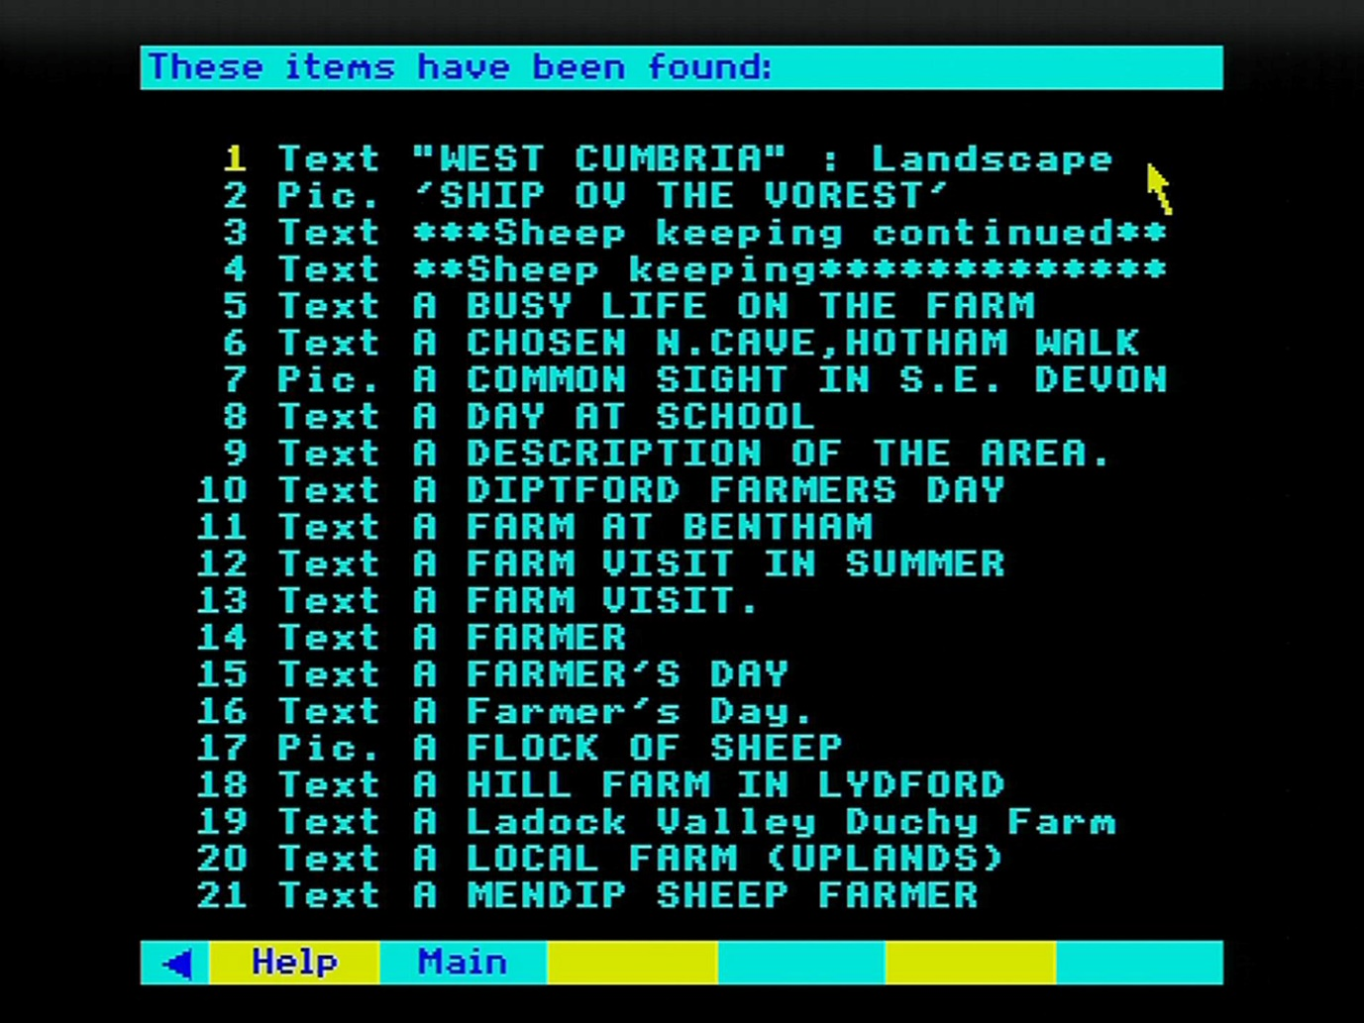

Figure 26 - A "hit list"

Each title is prefixed by either "Text" or "Pic." Only the first 21 items can be shown on the screen, but there may be hundreds or thousands more to choose from. They are arranged alphabetically within each type of match (see below). You can page backwards and forwards through the list in the usual way. After each 100 titles, there will be a pause while the next batch of 100 are collected. It is not however, possible to move back to a previous batch. The query must be re-entered.

Choose the item you want displayed in the usual way by pointing and actioning. You will then move out of the **Find** operation and into either **Text** or **Photo**. The reference will be to a single photograph or to a page or section of text. You can, of course, move to surrounding material by paging in the usual way. Or you can select **Find** to return to the hit list to look at other references.

That was the simple case when only one keyword was used to define the topic. Suppose instead of "sheep" you entered "sheep dogs". The system looks for both words separately. If it finds both in the index then "sheep" and "dogs" will be highlighted. It is important to the success of the search that the software uses this strategy. If the phrase was stored as a whole, retrieval would fail when you entered a variant like "sheep (collie) dogs". So, the phrase is first taken apart (for the search) then put together again (in the order the items are presented). This is how it works.

Your enquiry may produce 75 items which are referenced by "sheep" and 50 items referenced by "dogs". Of these three may be referenced by both. These are called "perfect matches" and will almost certainly be what you are looking for. The number of these perfect matches is displayed while the search is going on and, more importantly, they always appear as the first items in the menu list of titles. So, the simple rule is: the most relevant items to your query are always presented first.

But do not neglect the other items retrieved. Looking through them is very likely to produce some relevant entries. For example, some of the items under "dogs" may happen to have been indexed with the word "collie" rather than "sheep", but will still be relevant to your search.

Conversely, don't be surprised to see some very odd-looking items in the list. There may, in this example, be a text reference to fire dogs. It is important to realise that this is not an error by the system. It may be irrelevant to you this time, but you may be glad on another occasion when you enter "fire dogs" to have references to both kinds of dogs. Of course, you'll then have fire engines as well - and so it goes on! The point is that all the hits displayed are not necessarily "right answers" to the query in the sense in which you intended it. They are simply offered as suggestions for you to take up or ignore.

Now we can look at the case where many topic words are entered, including whole sentences. Suppose you enter "sheep dog trials". "Sheep", "dog" and "trials" are all highlighted. The final list of titles found will be in the following order:

References to: sheep/dog/trials  
dog/trials  
sheep/trials  
dog/sheep  
trials  
dog  
sheep

In other words, it is in order of decreasing relevance to your enquiry. In practical terms, this means - keep browsing through the list until the titles have become irrelevant to your interest. The decision on the order of topic words (within a certain number of matches) is made based on their comparative rarity in the index. So, a more unusual term like "trials" is promoted over a common one like "sheep".

Although you can enter whole sentences, the system responds to them only as a list of words, without regard to any overall meaning. This means it is no use entering a sentence like: "Cathedrals except those in a Gothic style." This will produce a list that is headed by Gothic Cathedrals, since the idea of "except" is not understood. The same is true of all negatives. The best strategy in most cases is to enter a reasonable number of relevant keywords in the form of a list: e.g. "Cathedrals modern architecture stained glass".

### Synonyms and word stems

Some synonyms are internally cross-referenced in the index itself. For example, it doesn't matter whether you use "teachers" or "schoolteachers", you will get the same references. However, comparatively few words are close enough to cross-reference automatically. All churches are not chapels, although some pictures may have been keyworded as churches that you may be looking for as chapels. If in doubt include both words in your enquiry.

A different form of common meaning is that between "fish", "fishes" and "fishing". To avoid you having to enter a form of a word like this, every reference in the index is held as a word-stem. In this case it would be "fish". In other words, you will be offered the same items whether you enter "fish", "fishes" or "fishing". This makes retrieval much simpler and more reliable, though it can occasionally produce results that will seem surprising. If you tried "batting" you might get references not only to cricket, but also to the mouse-eared bat, etc. Even more puzzling, enter "organic farming" and you will be offered, as well as organic farming text, pictures of church organs, since both have the common stem - 'organ'. This doesn't happen often.

### The specific keywords

Every item on the Community disc - whatever its other keywords - should have been indexed by one of the following words:

|  |  |
| --- | --- |
| Armed Forces | Industry |
| Arts and Crafts | Information Systems |
| Attitudes | Landscape |
| Biography | Language |
| Clubs | Law and Order |
| Communications | Life Styles |
| Customs | Local History |
| Ecology | Media |
| Economics | Politics |
| Education | Population |
| Employment | Recreation |
| Energy | Religion |
| Entertainment | Science and Technology |
| Events | Social Concerns |
| Farming | Supernatural |
| Government | Tourism |
| Health | Trade |
| Home Life | Transport |
| Housing |  |

Using one of these keywords with a wide map will result in a long search, followed by a very long hit list. But used carefully within smaller areas, it can offer a way of ensuring that virtually everything under that topic will be found.

### Scope of search

Since the Community Disc is a geographically based system, you can confine your topic index search to the area of any of the maps. This feature adds enormously to the power of the system, but can confuse you if you forget that it is operating: that you are only searching the part of the index that relates to your current map. Therefore, your current map is shown behind the **Find** entry screen. If you have difficulty seeing it behind the **Find** boxes, remember that [f9] can be used to switch these off temporarily.

Obviously, this "scope of search" feature, and everything that follows in this section, does not apply to finding maps themselves by grid reference or place name.

Suppose your current map (the last map you moved to and the one defining the pictures and text available) was of Southern Britain. If you now ask for references to "synagogues" you will get hundreds of hits from all over the South of the UK. Return to the **Map** option and zoom in to North London. Now when you make the same enquiry you will get a much smaller and more closely defined result - just the synagogues that were covered in North London. The result at different map levels could be something like this:

Level 1 300 hits

Level 2 75 hits

Level 3 2 hits

It is not possible to achieve the same result by entering "North London synagogues", since very few place names have been used in the topic index.

The scope of search is also limited by the side of the disc you are working on. The index on the Northern side, for example, covers everything north of the Domesday Wall, but the only references to items south of the Wall are to the few, highest level pictures and text pages that are held on that side. This covers text and pictures at levels 0, 1 and 2 - i.e. down to the 40 x 30 km block size. You will be given a warning at the top of the screen when you are using **Find** on the "wrong" side of the disc at the top three levels that your scope of search is limited - for example, if you are working on the Northern side of the disc with a level 1 map of the Channel Islands defining your scope of search.

In summary, always set the map you want to define the scope of your search before selecting **Find** and entering your query.

### The art of retrieval

Finding items from a huge data-base with software like this is certainly an art rather than an exact science. It becomes even more important on the National Disc to learn how best to use it. It is not like the index of a book, where a small number of index words refers to a small number of pages where that word occurs. On the Domesday Discs, a word can occur many millions of times and a keyword may reference many thousands of items. Nor is it like a typical on-line text database, where almost every word is held in the index and a search can be progressively narrowed down by specifying more words.

If you are searching over the level 0 map and you use a very wide term (like "landscape" or "farming") you will get more than ten thousand references that will be impossible to handle. If you use a very narrow and term (e.g. "Barclaycard") you may get no references, although there may be many references to it in the text itself. Prefer the more medium range term, like 'credit cards' in the latter case and "dairy" in the former.

The number of words you enter is also important. A single word will probably produce too many hits, many of which are irrelevant to your enquiry. A twenty-word entry will be very slow to process. A three or four-word entry will probably result in the pictures and text you want appearing at the top of the list.

Remember to include synonyms in the list and to exclude negatives. Remember too that you are only searching on your current side of the disc, and within the area of your current map.

This scope of search facility can be very powerful indeed. For example, if you have made an enquiry which is producing useful results, you can apply it to different parts of the country to make comparisons. Leave **Find** and go to **Map** to select a new area to search. Go back to **Find**, select the topic query box and press [COPY] to move your previous query into the topic query box. Press [ACTION] and the search will begin in the new area.

Be on the look-out for new words to add to the query. These may be suggested by reading the text and captions. So, for example, if you have entered "show jumping" and some of the pictures are captioned "gymkhana", then try adding "gymkhana" to the rest of your query (using [COPY]) and you will probably be offered many relevant items that were previously missed.

### Leaving find and returning later

If none of the hits offered is of interest, you can leave your **Find** enquiry by selecting **Main** from the menu bar. You can then leave **Find** altogether by selecting **Map**, **Text**, or **Photo**. However, the more usual way of leaving **Find** is by looking at one of the items it has offered. Suppose, for example, you are looking at a picture of one of the cathedrals you have previously found. Now select **Find** again and you will return to your hits list. so that you can make an alternative selection. To recall the query entry boxes, select **Main**.

If you have looked at any maps in the meantime, then (because you have changed your scope of search) you will be taken straight back to the **Find** entry screen. You will see that your previous query is shown in the lowest box. You can use the [COPY] key on the keyboard to transfer this into the topic enquiry box if you want to repeat the query for your new map area (after first highlighting the box.) But if you want to move to your list of previous hits, you can select the **Old** option on the menu bar. This will put you back at the position you were working at before in the hits list when you selected the cathedral picture. Note, however, that it will not restore the map area that you were working with then.

This system should give you the flexibility you need to follow up topic queries as well as making new ones.

### For example – To find pictures and text on Steam Trains in Northern Britain

With the Northern side of the Community disc inserted, move the pointer to Northern Britain and press [ACTION]:

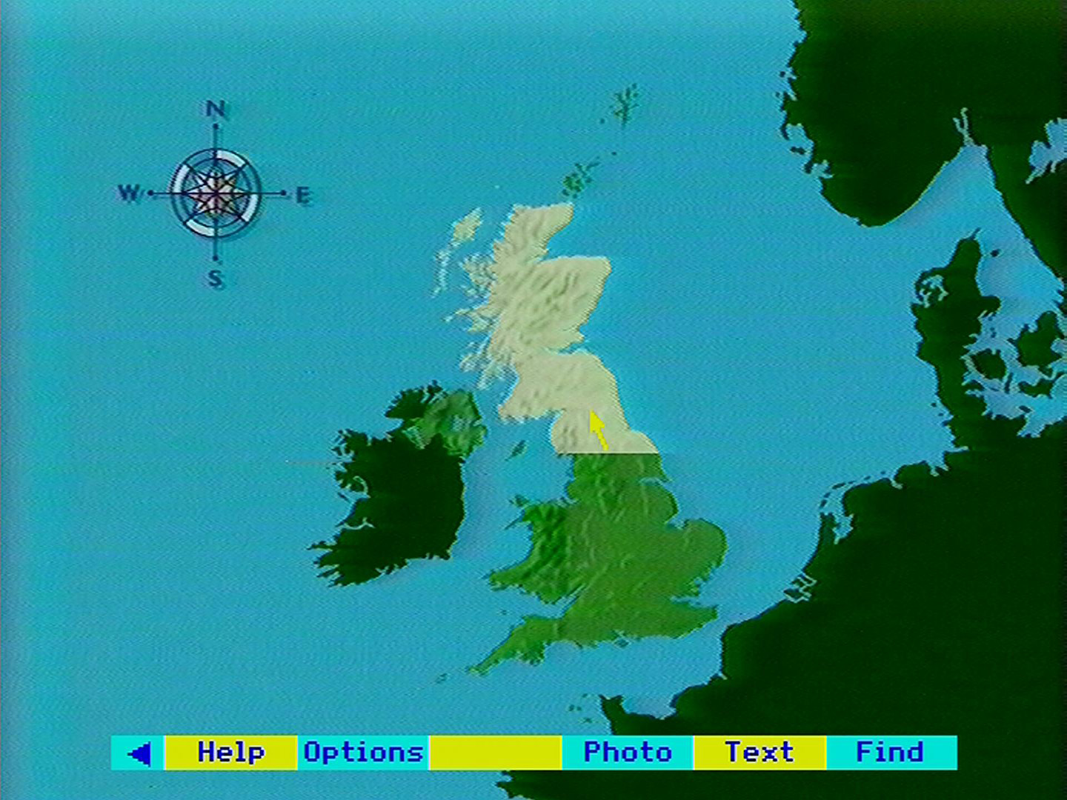

The level 1 map appears. This defines the scope of the search. Select **Find** from the menu bar:

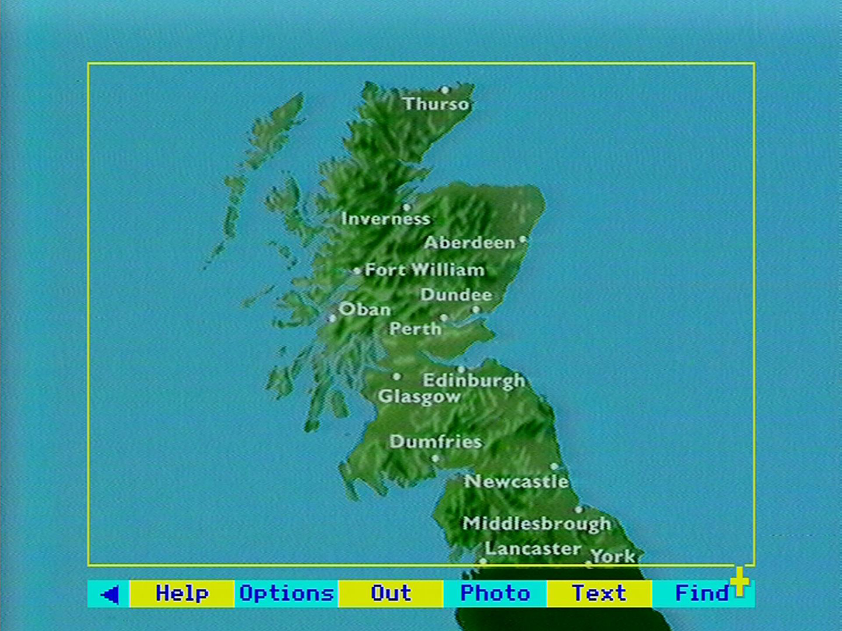

The Find screen appears. Move the pointer to highlight the ‘Text and Photos by Topic’ box:

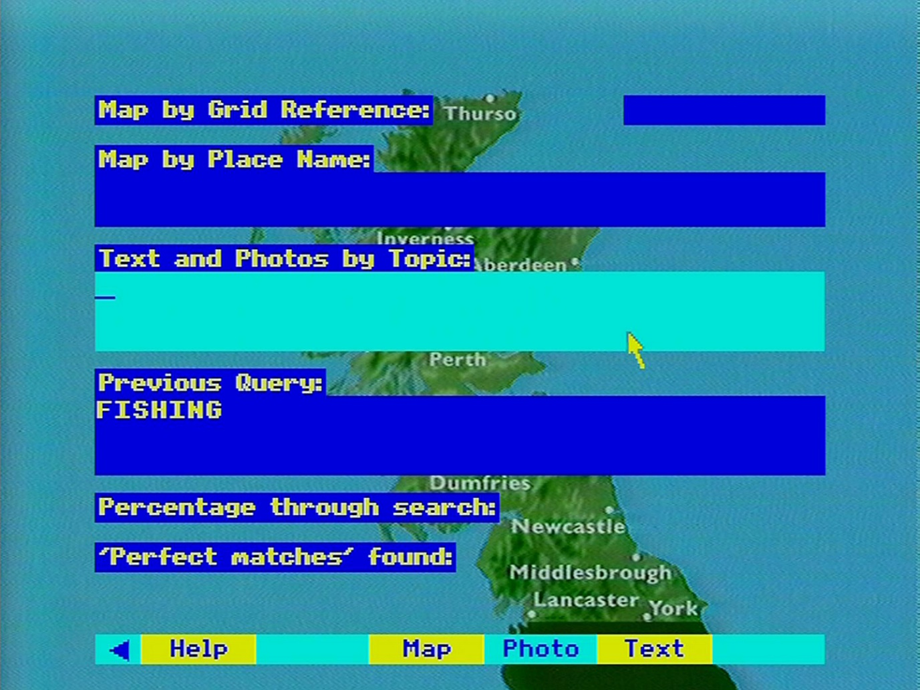

Type in “STEAM TRAINS” from the keyboard and press [ACTION]:

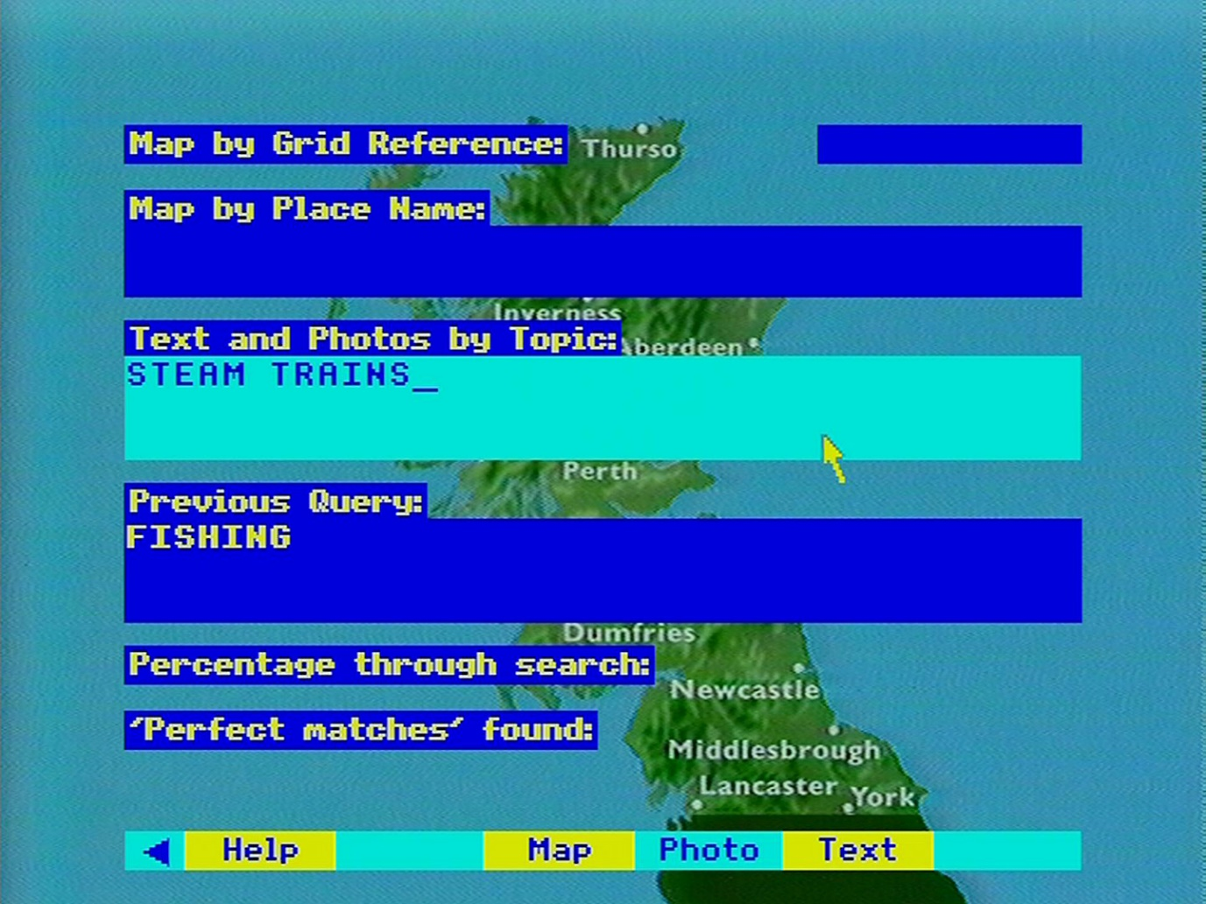

The number of words found in the index are highlighted. The screen remains until the first 100 hits are found:

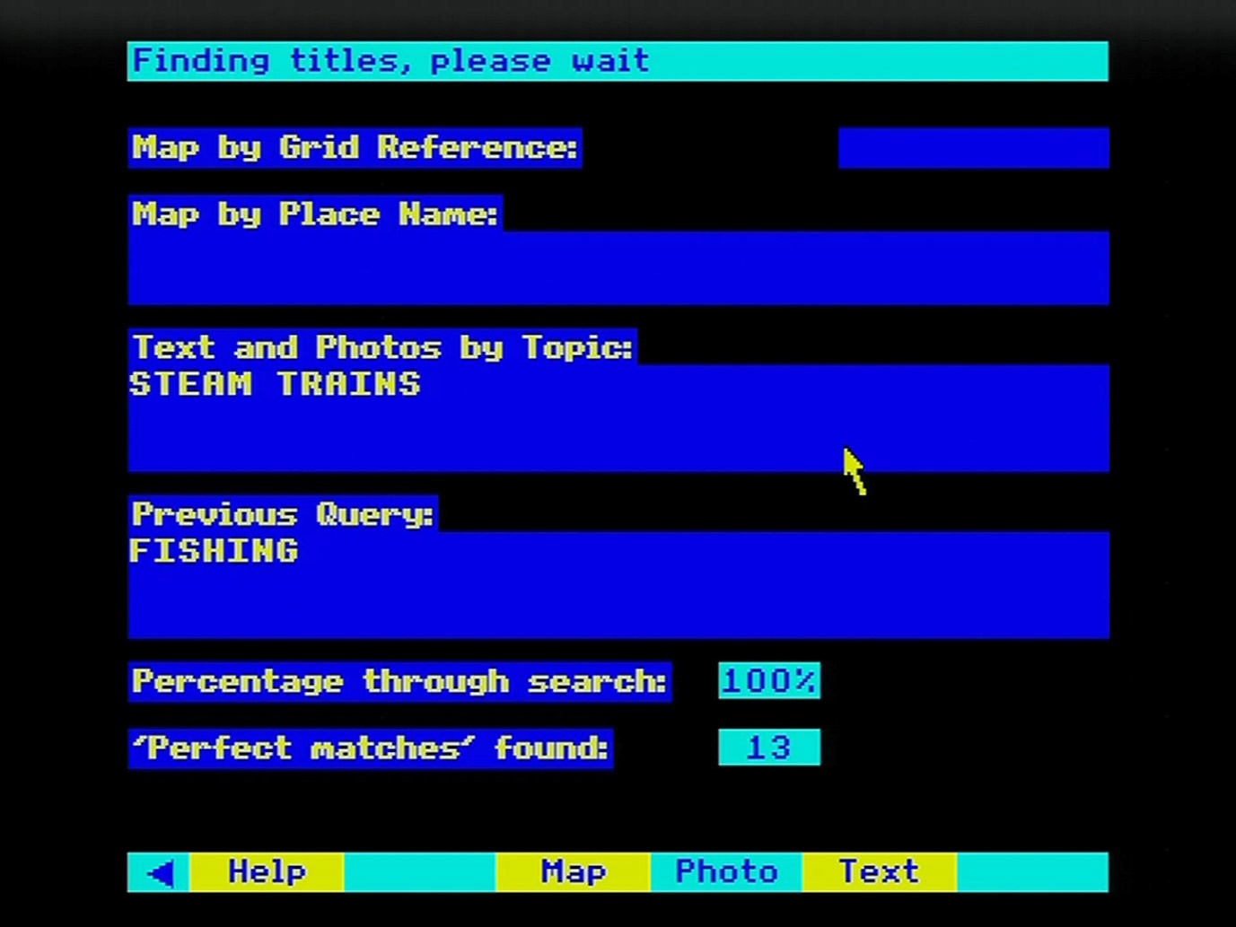

Once the search is complete the system displays a list of the first 21 hits. In this case, the first 13 items are relevant. Move the pointer to select item 5 and press [ACTION]:

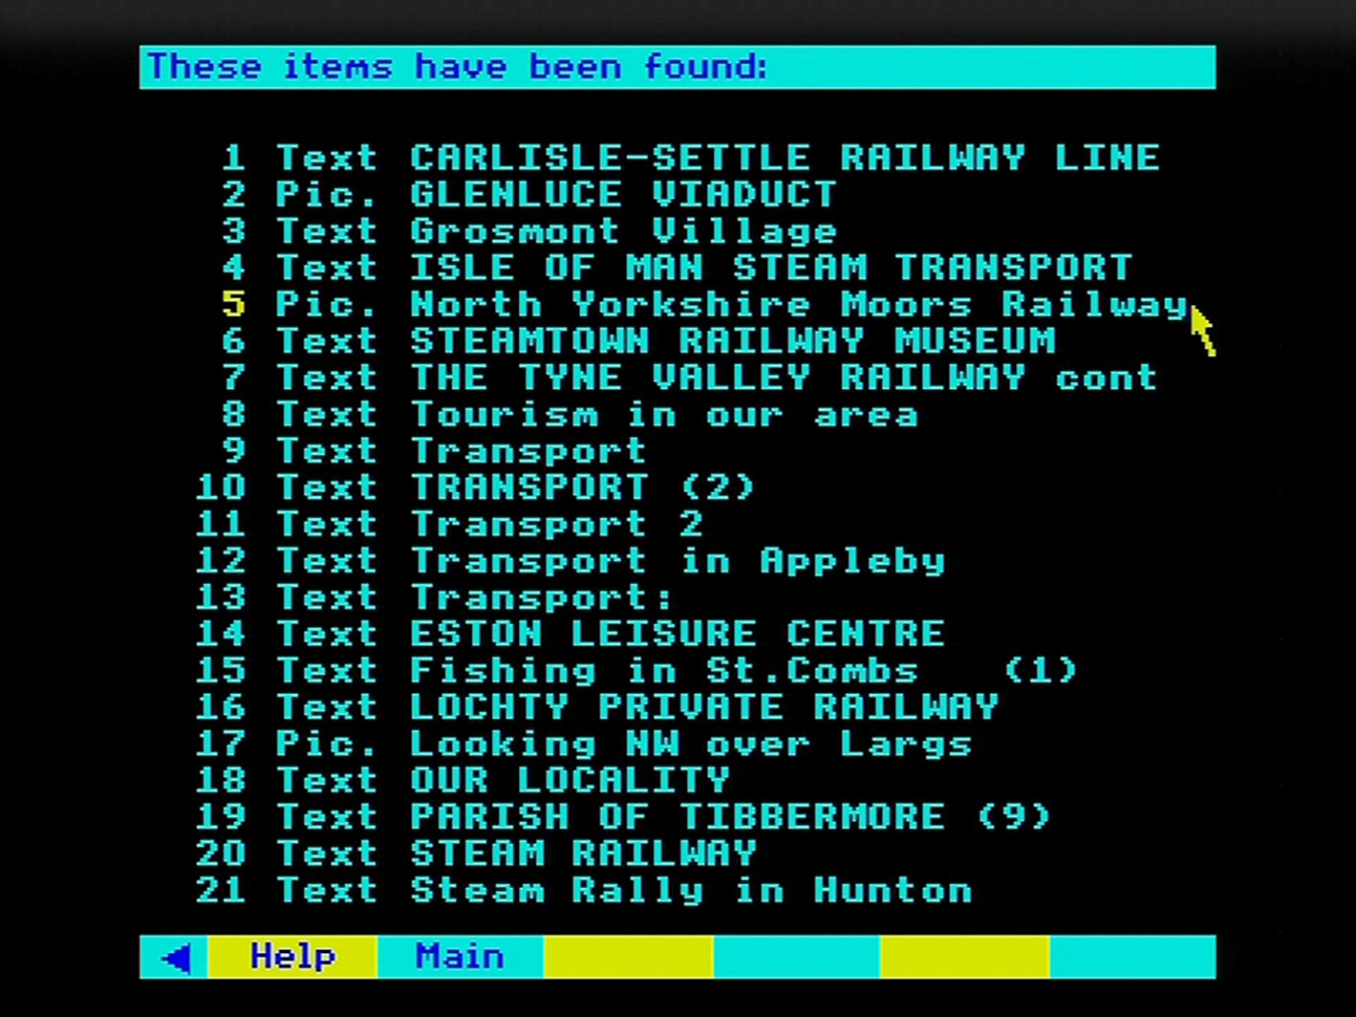

A photograph of a train is displayed. All the usual caption options are available. Select Find to return to the item list:

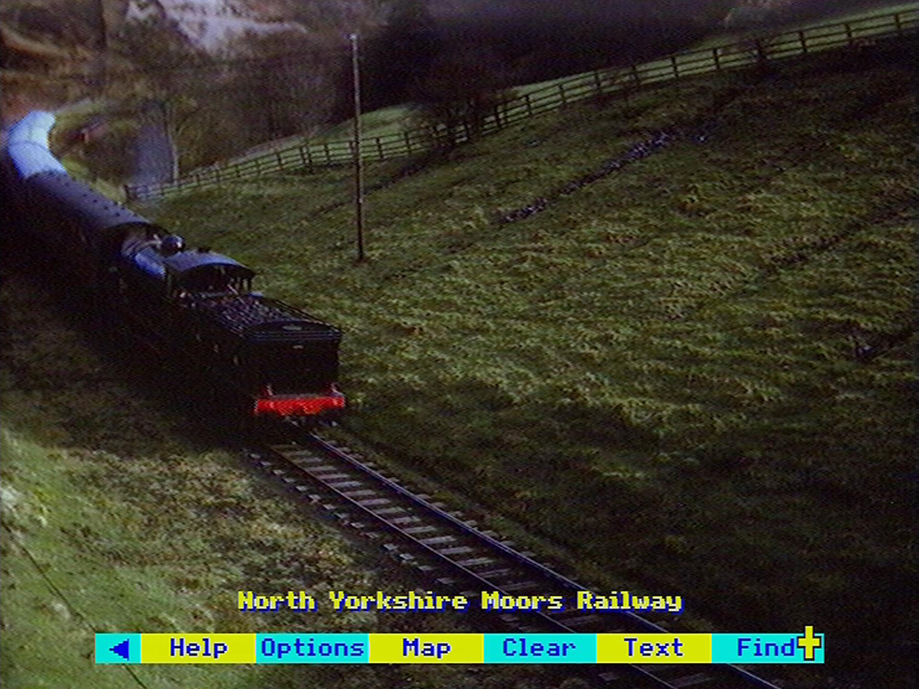

Your previous hits list reappears. Select item number 6:

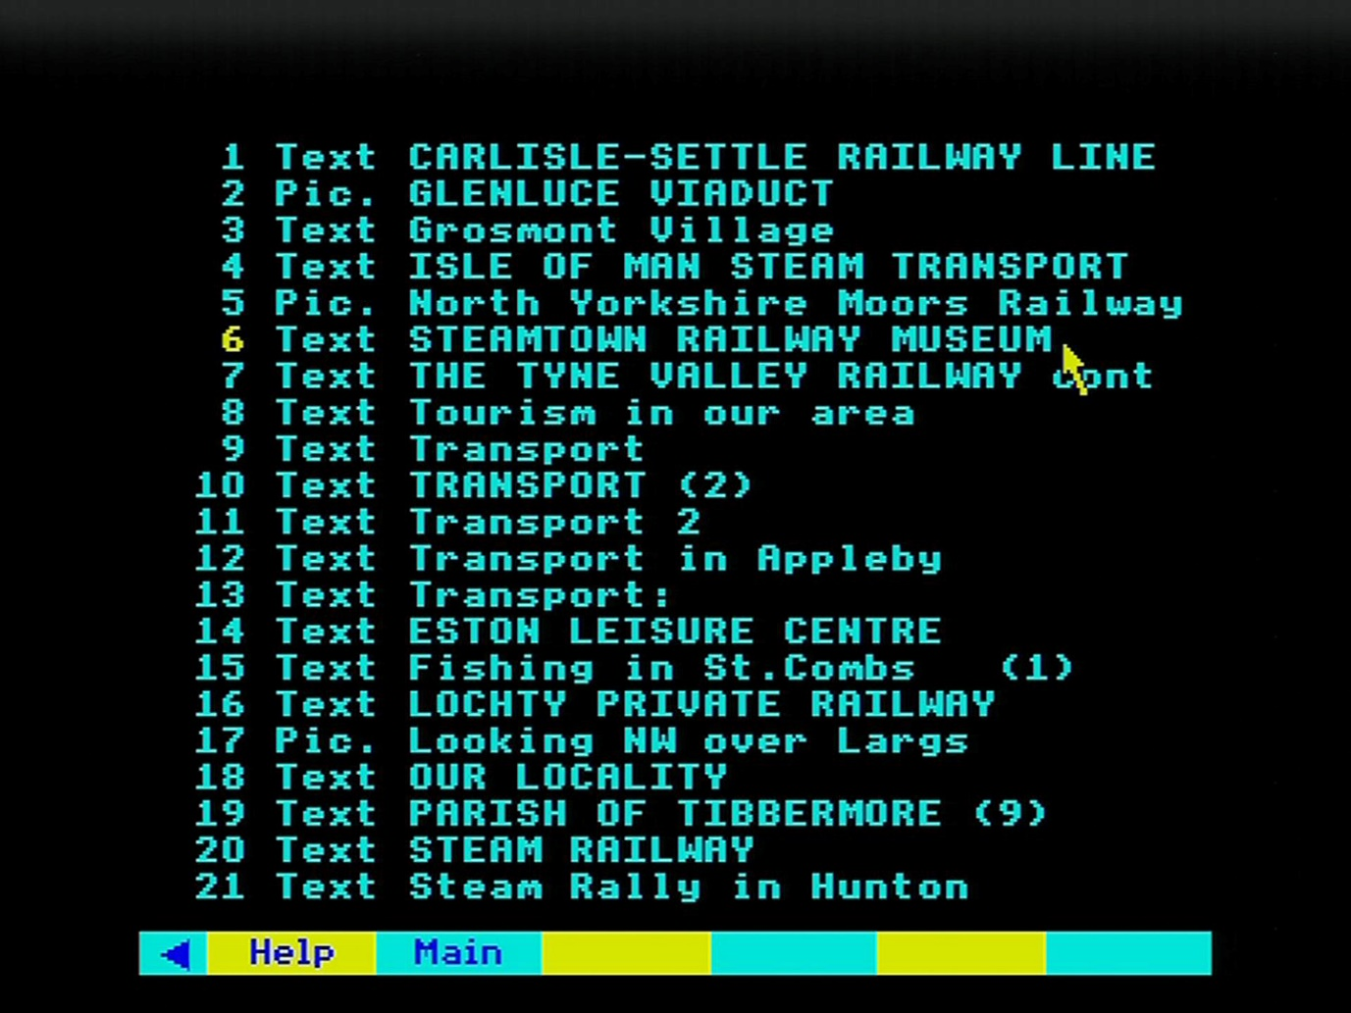

The text on Steamtown Railway Museum is displayed:

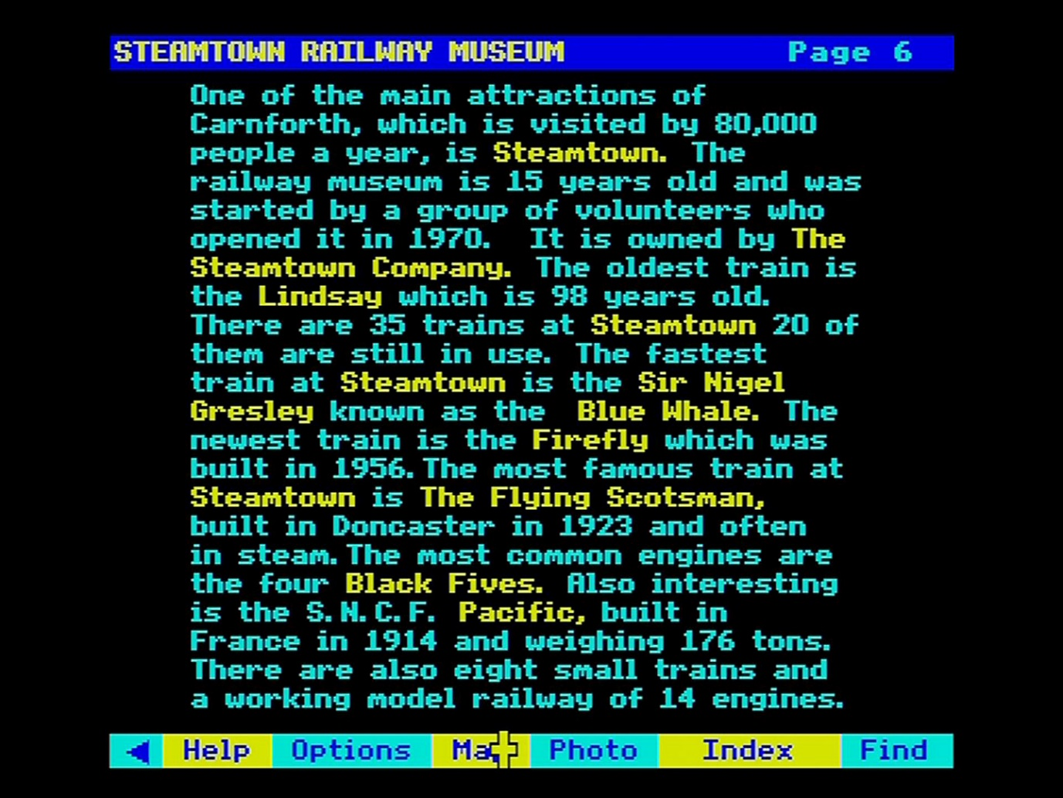

# The National Disc

## Introduction to the National Disc

The Domesday National Disc aims to represent 1980s life in the UK as portrayed by the "official" data available from the country's recognised sources of data. These sources include the major government reports and surveys, but a wealth of material on the National Disc comes from libraries, archives, research establishments, university departments, private companies, commercial agencies, associations, individual professionals, published sources and from the BBC's own holdings.

### The two sides of the National Disc

Most of the National Disc material is stored on one side of the disc. The second side is reserved for moving film clips with sound. The reason for this separation is to maximise the amount of moving film which can be included in the system. By reserving one whole side for moving film, we can store up to 60 minutes. If we were to mix it in with still frames and other material then this capacity would virtually be halved.

### The organisation of material

Whereas the Domesday Community Disc was centred around maps, the contents of the National Disc are organised by topic. There is a hierarchical structure of subject-headings under which everything on the disc is stored. For example, there are four major headings at the top level of the hierarchy: SOCIETY, THE ECONOMY, CULTURE, ENVIRONMENT. Everything on the National Disc is stored under one of these categories. Of course, each category is broken down into smaller headings, and each of those is split into still smaller, more specific groups. At the end of each branch of the hierarchy, however, are the actual items themselves. See the section “Contents - The hierarchical approach” for more details of the hierarchical approach.

The items stored on the National Disc can be in several forms:

* **Picture set**: a sequence of still photographs, up to 100 or more, all dealing with the same basic subject, e.g. butterflies.
* **Text essay**: a sequence of text pages which could be an article reproduced from a newspaper or journal, a paper from a professional publication or an essay commissioned by the Domesday Project from an eminent authority.
* **Surrogate walk**: a set of photographs portraying a physical environment from every viewpoint and stored on the disc in an organised sequence so that the user can "walk" at will through the environment and the system will always display the correct view from the current position.
* **Film clip**: a film or video sequence showing an item of news or a major sporting event.
* **Mappable data set**: a set of numerical data relating to geographical areas.
* **Tabular data set**: a set of general statistical data.

As far as the National Disc system is concerned, all these different forms are just items and all can be retrieved in the same way.

### Retrieving data from the disc

There are four distinct ways of accessing data on the Domesday National Disc:

#### Accurate name

You can call up an item directly by name if you know with absolute certainty that it is there and have the accurate spelling of its name, perhaps because you have called up the item before.

#### Associated keywords

You can call up an item by means of its associated keywords. Every item on the disc has a series of keywords attached, referring to the possible subjects to which it might have relevance. You can supply the system with a set of the keywords which are of interest to you and the system will search for matches among the keywords attached to items.

#### Subject-heading hierarchy

You can locate items by following the branching structure of the subject-heading hierarchy. Whilst this is an imperfect method of locating everything on a given subject (which is better accomplished by keyword) this is a good method of reviewing the scope of the disc contents when you do not have a precise idea of your target subjects.

#### "Gallery"

You can explore the contents of the National Disc by wandering around an artificial "gallery" which has been created in video graphics and stored on the disc as a special kind of surrogate walk. In the "Gallery" you will see all the picture sets and text essays displayed on the walls, as in an exhibition, and doors from the gallery will take you out into the disc's surrogate walks.

Before getting down to serious work with the National Disc, by all means explore and experiment with its contents. However, you will find that the power of its functions and the complexity of its contents are far greater than on the Community Disc and you need to have a fairly clear purpose in mind to get useful results.

### The four top-level states of the National Disc

Whilst the National Disc has a complex system of functions and processes which allow you to display and work with a wide variety of material, there are four top-level "states" and you are always in one of these until you explicitly change to another.

These states are **Find**, **Gallery**, **Contents** and **Area**. When you select one of these, its place on the menu bar will become blank but the others will all remain available.

Except for **Area** (see the section “Displaying and manipulating data maps”), these are index-searching functions. You use one of these to identify items which are of potential interest to you and then select lower-level functions to display and manipulate the items themselves. After you have finished processing items you can move back up the system levels by repeated selections of the option **Main** from the menu-bar, until you find yourself back in the top-level function from which you started.

#### Starting off in the National "Gallery"

When starting up the National Disc you will find that it immediately takes you into the top-level option **Gallery** allowing you to explore the video "gallery" of its contents. Perhaps this is the best way to gain a first impression of the kind of material you will find on the disc. As shown at the top of the screen you turn 45 degrees to your left or right in the gallery by placing the pointer to one side of the screen or the other and pressing [CHANGE]. You move forward by placing the pointer in the middle of the screen and pressing [CHANGE]. Moves backwards and "crab" moves sideways are made by selecting them from the menu bar when they are shown to be available. If in doubt, consult **Help**.

## Using the National index

This section describes how to use the **Find** option to search the National Disc for pictures, text, data and film. It is the most direct method of access to use if you know the topic you want to pursue. It enables you to enter, for example, "Interactive video" and get a list of everything that the National Disc holds about that subject.

All items held on the disc, whether they are articles, sets of pictures or data maps, have many keywords recorded with them and it is these that you will be searching. You can also enter the name of an item directly if you know it.

This is a more detailed section, not because it is hard to find material in this way, but because one tends to find more than one can handle - often thousands of items that match an enquiry. The system therefore has many features to make searching more powerful and easier to use.

You will come into the **Find** operation after selecting **Find** from the menu bar anywhere in the system. It follows the same principles as the topic part of the **Find** option on the Community Disc. The main points do, however, bear repeating.

### What do you want to know about?

This is the screen display you are presented with:

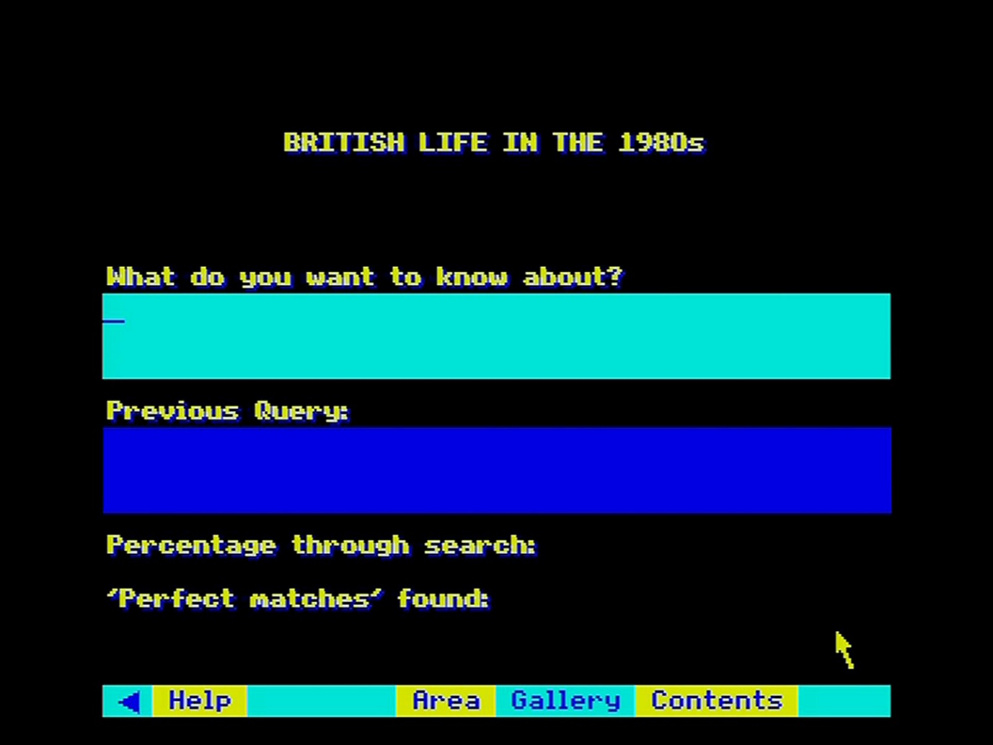

Figure 27 - Find screen on National Disc

The prompt question is phrased in this way to encourage you to enter your topic of interest, rather than ask a question. It's no good entering "What is the circulation of the Sun?". The answer to that question is indeed buried in the Domesday data, but the system is not intelligent enough to know that it knows it. You must enter a general topic - "newspapers" in this case - and wait to see what the system comes up with that is relevant.

Remember too that the domain of your search is reflected at the top of the screen - "British Life in the 1980s". It is no use entering a topic like "Russian History". The Domesday Discs are emphatically not encyclopaedias and make no claim to systematic coverage of human knowledge. Do not expect to find more than passing references to theoretical topics like "Astronomy" or "The Theory of Evolution". Domesday is an exhibition of life as it was lived in the 80s - what we did, how we looked, what we owned and so on.

To make an enquiry, enter your text from the keyboard. You can use upper-case or lower-case characters or a combination without affecting the result. You can use the cursor keys to move from side to side across text already entered, in order to correct it. Use the [DELETE] key to erase mistakes, working from the end. At the end of a line the word you are working on will move to the next line. Don't use the [RETURN] key to move to the next line: this acts like [ACTION] and will enter your enquiry. When your entry is complete, then press [ACTION] to enter your enquiry. Be careful as you do this that the pointer is not in the menu bar area. If it is you will find you have made a menu selection instead of entering your enquiry. If you have left the pointer in a blank box, nothing will happen except that you will be very mystified.

Suppose you have entered the topic "opera". If this word is not in the index, you will see a message to that effect. If it is, it will be highlighted in yellow and a message will tell you that all the references to this keyword are being collected. You can follow the progress of the search in the boxes at the bottom of the screen. There will then be another short pause while the menu of items found is prepared. This is then displayed as a list of titles for you to choose from.

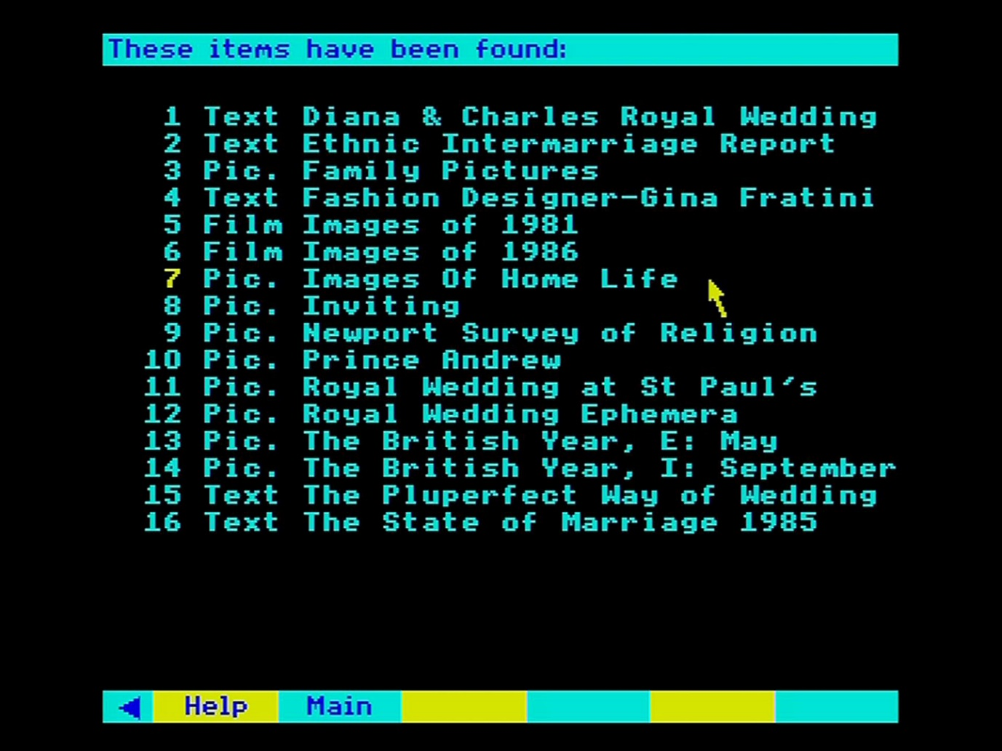

Figure 28 - Results of a search for "WEDDINGS"

Each title is prefixed by either "Text", "Pic.", "Data", "Walk" or "Film", so that you have an indication of what type of item it is. Only the first 21 items can be shown on the screen, but there may be hundreds or thousands more to choose from. You can page backwards and forwards through the list in the usual way. After each 100 titles, there will be a pause while the next batch of 100 is collected. It is not, however, possible to move back to a previous batch. The enquiry must be re-entered. So, it's a good idea to examine the first 100 hits carefully before moving on.

Choose the item you want displayed in the usual way by pointing and actioning. You will then move out of the **Find** operation and into the appropriate display routine. When you have finished examining it, you have the option of selecting **Find** again to return to your hit list to look at other references.

That was the simple case when only one keyword was used to define the topic. Suppose instead of "opera" you entered "country music". The system looks for both words separately. If it finds both in the index then "country" and "music" will be highlighted. It is important to the success of the search that the software uses this strategy. If the phrase was stored as a whole, then retrieval would fail when you entered a variant like "country style music". So, the phrase is first taken apart (for the search) then put together again (in the order the items are presented). This is how it works.

Your enquiry may produce 50 items which are referenced by "music" and 75 items referenced by "country". Of these 2 may be referenced by both. These are called "perfect matches" and will almost certainly be what you are looking for. The number of these perfect matches is displayed while the search is going on and, more importantly, they always appear as the first items in the menu list of titles. So, the simple rule is: the most relevant items to your query are always presented first.

But do not neglect the other items retrieved. Looking through them is very likely to produce some relevant entries. For example, some of the items under "music" may happen to have been indexed with the word "Western" rather than "country", but still be relevant to your search.

Conversely, don't be surprised to see some very odd-looking items in the list. There may, in this example, be pictures of hunting, shooting and fishing, following the keyword "country" in its broader sense. It is important to realise that this is not an error by the system. It may be irrelevant to you this time, but you may be glad on another occasion when you enter "country pursuits" to have references to both fishing and country music. Of course, you'll then have town pursuits as well - and so it goes on! The point is that all the hits displayed are not necessarily "right answers" to the query in the sense in which you intended it. They are simply offered as suggestions for you to take up or ignore.

Now we can look at the case where many topic words are entered, including whole sentences. Suppose you enter "country and Western music". "Country", "Western" and "music" are all highlighted; "and" is not. The final list of titles found will be in the following order:

References to: country/ Western/ music  
Western/music  
Western/country  
country/music  
Western  
music  
country

In other words, it is in order of decreasing relevance to your enquiry. In practical terms, this means - keep browsing through the list until the titles have become irrelevant to your interest. The decision on the order of topic words (within a certain number of matches) is made based on their comparative rarity in the index. So, a more unusual term like "Western" is promoted over a common one like "country".

Although you can enter whole sentences, the system responds to them only as a list of words, without regard to any overall meaning. This means it is no use entering a phrase like: "Computers other than micros." This will produce a list that is headed by micro-computers, since the idea of "other than" is not understood. The same is true of all negatives. The best strategy in most cases is to enter a reasonable number of relevant keywords in the form of a list: e.g. "computers optical research".

### Synonyms and word stems

Some synonyms are internally cross-referenced in the index itself. For example, it doesn't matter whether you use "teachers" or "schoolteachers", you will get the same references. However, comparatively few words are close enough to cross-reference automatically. All churches are not chapels, although some items may have been keyworded as churches that you are looking for as chapels. If in doubt, include both words in your enquiry.

A different form of common meaning is that between "fish", "fishes" and "fishing". To avoid you having to enter a form of a word like this, every reference in the index is held as a word-stem. In this case it would be "fish". In other words, you will be offered the same items whether you enter "fish", "fishes" or "fishing". This makes retrieval much simpler and more reliable, though it can occasionally produce results that will seem surprising. If you tried 'batting' you might get references not only to cricket, but also to the mouse-eared bat etc. Even more puzzling, enter "organic farming" and you will be offered, as well as organic farming text, pictures of church organs, since both have the common stem - "organ". This doesn't happen often.

### Entering item names directly

If you know - because of an earlier enquiry - the exact name of any item, then you can bypass the index and save time by moving straight to the item itself. To do this simply enter the name within quotes (double inverted commas). For example, if you enter "mammals", you will be taken straight to the picture set of that name. This only works, however, if you enter the name in its exact form - letter for letter, space for space. Otherwise the message "item name not recognised" will be displayed.

### The art of retrieval

Finding items from a huge database with software like this is certainly an art rather than an exact science. It is even more important on the National Disc to learn how best to use it. It is not like the index of a book, where a small number of index words refers to a small number of pages where that word occurs. On the Domesday discs a word can occur many millions of times and a keyword may reference many thousands of items. Nor is it like an on-line text database, where almost every word is held in the index and a search can be progressively narrowed down by specifying more words.

If you use a very wide term (like "employment") you will get many thousands of references that will be impossible to handle. If you use a very narrow term (e.g. "Barclaycard") you may get no references, although there may be many references to it in the text itself. Prefer a more medium range term, like "credit card" in the latter case and "textile manufacture" in the former.

The number of words you enter is also important. A single word will probably produce too many hits, many of which are irrelevant to your enquiry. A twenty-word entry will be very slow to process. A three or four-word entry will probably result in the pictures and text you want appearing at the top of the list.

Remember to include synonyms in the list and to avoid negatives.

### Leaving find and returning later

If none of the hits offered is of interest, you can leave your **Find** enquiry by selecting **Main** from the menu bar. You can then leave **Find** altogether by selecting **Contents**, **Area**, or **Gallery**. However, the more usual way of leaving **Find** is by looking at one of the items it has offered. Suppose, for example, you are looking at a picture set on opera that you have previously found. Now select **Find** and you see that your previous query is shown in the lowest box. You can use the [COPY] key on the keyboard to transfer this into the topic enquiry box (once this has been highlighted) if you want to change it before putting the query again. But if you want to move straight to your list of previous hits, you can select the Old option on the menu bar. This will put you back at the position you were working at before in the hits list.

This system should give you the flexibility you need to follow up topic queries as well as making new ones.

### For example – Finding pictures about Flowers with special reference to Liverpool

Having selected **Find** and arrived at the Find screen, enter LIVERPOOL FLOWER and press [ACTION]. Ensure the pointer is not on the menu bar:

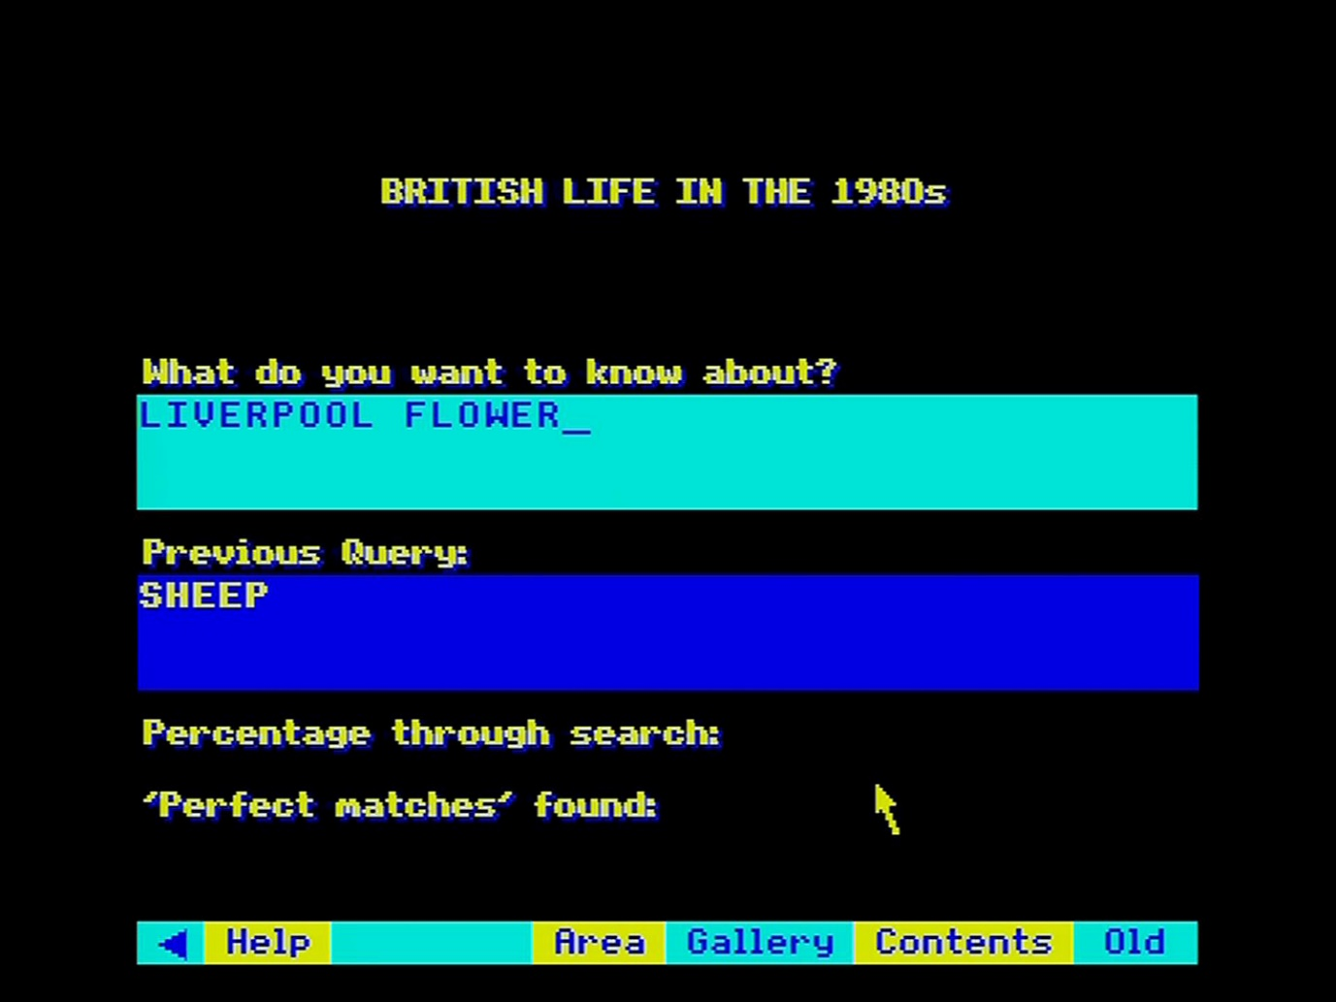

After starting the search, the hit list is displayed. The most relevant hits are at the top of the list. Select 12 “Pic. The Liverpool Garden Festival 86” and press [ACTION]:

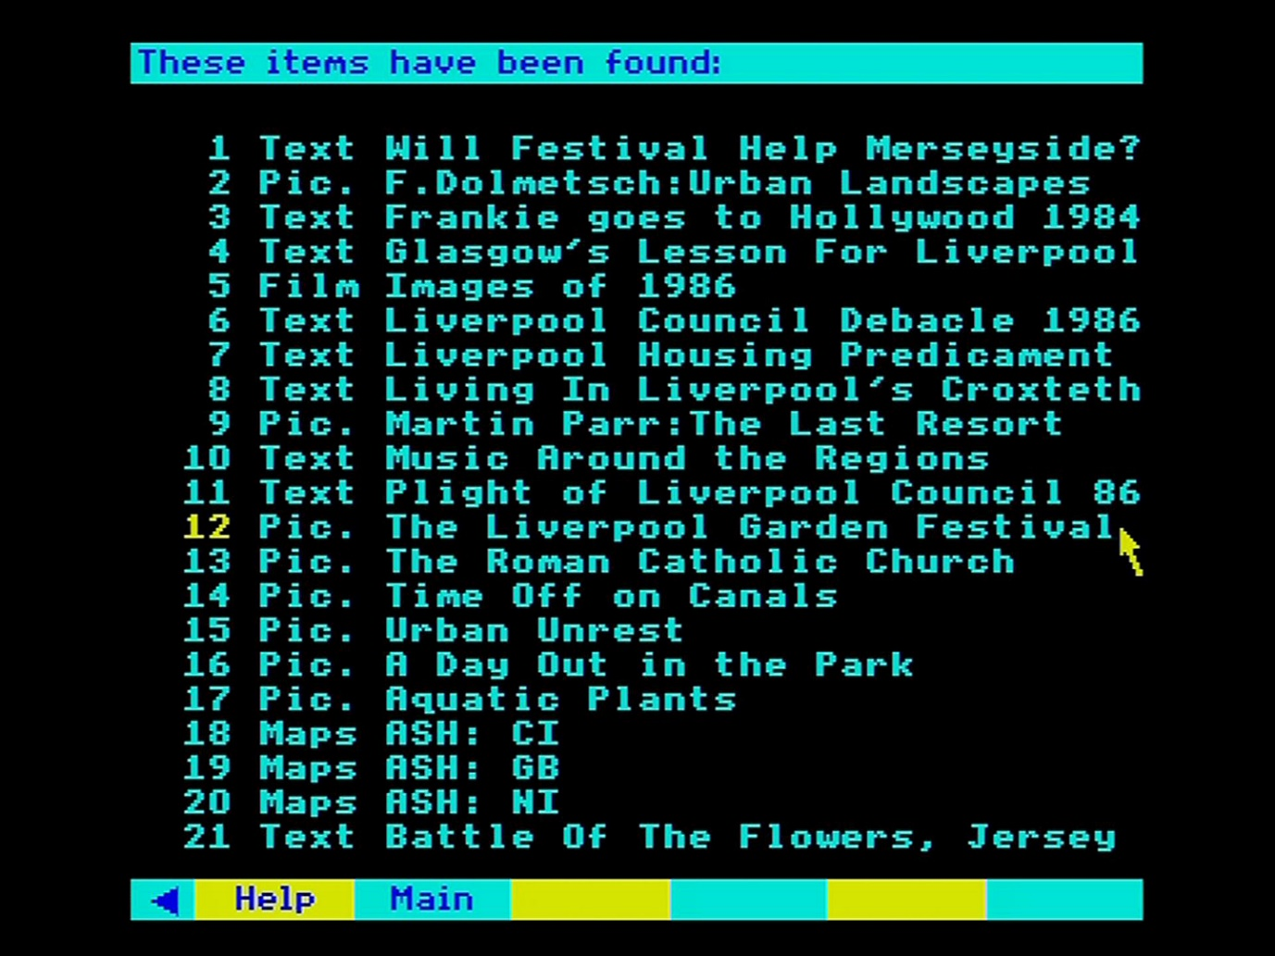

The title slide appears. You can look though the pictures in the normal manner. Select **Main** to return to the hit list:

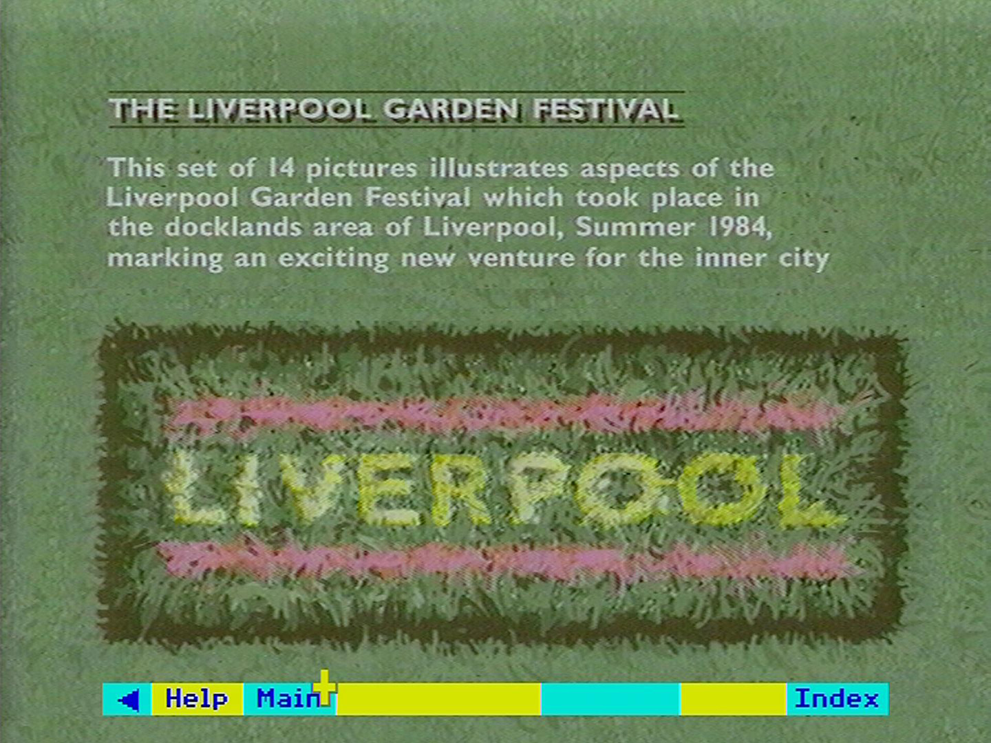

The hit list is displayed again. Select item 1 “Text: Will festival help Merseyside?” and press [ACTION]:

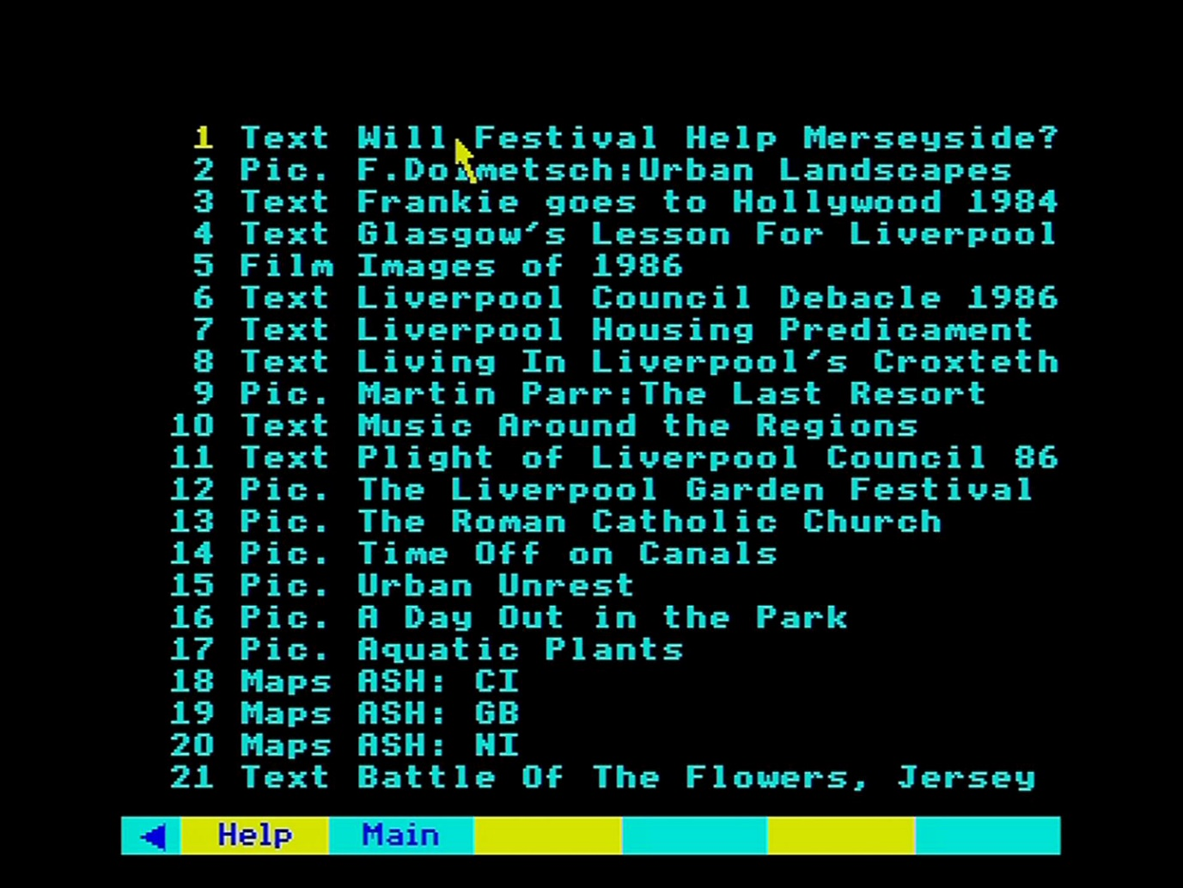

The selected article appears and can be read in the usual manner:

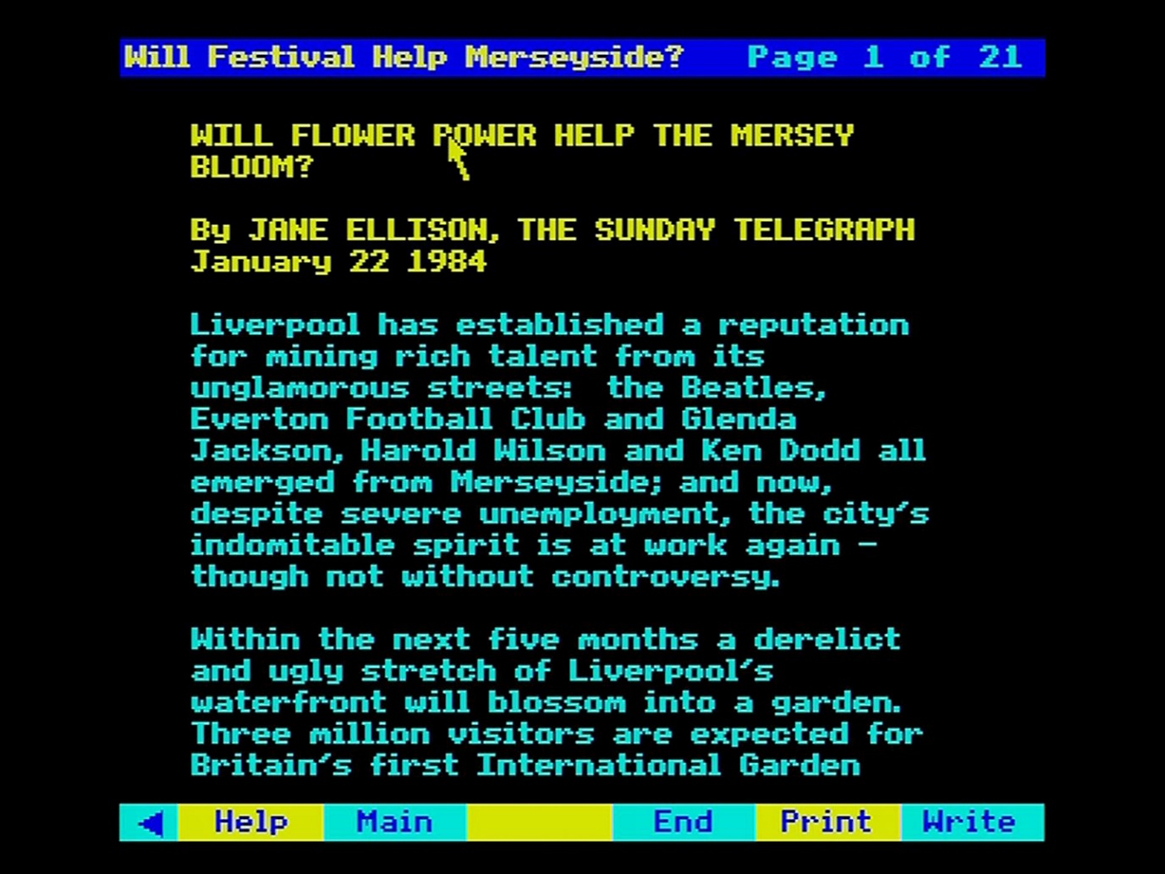

## Contents - The hierarchical approach

Everything on the National Disc is organised within a hierarchy of subject headings and this hierarchy can be used as a means of locating information on the disc. It is an imperfect method of retrieving all the National Disc has to say on a subject, which is better achieved via keyword-association, but the hierarchy is very useful to clarify what sort of subject areas the National Disc is likely to cover.

### The branching hierarchy

The hierarchy starts at its top level by classifying everything under four main subjects: SOCIETY, THE ECONOMY, CULTURE and ENVIRONMENT. Each of these is sub-divided into further subject headings and each of these is subdivided further until eventually, at the bottom end of each "twig" of this tree are the names of the actual items stored under this set of subject headings.

The use of the hierarchy to locate items begins with the selection of the **Contents** option from a top-level menu bar on the National Disc. This will produce a display of the top four subject headings:

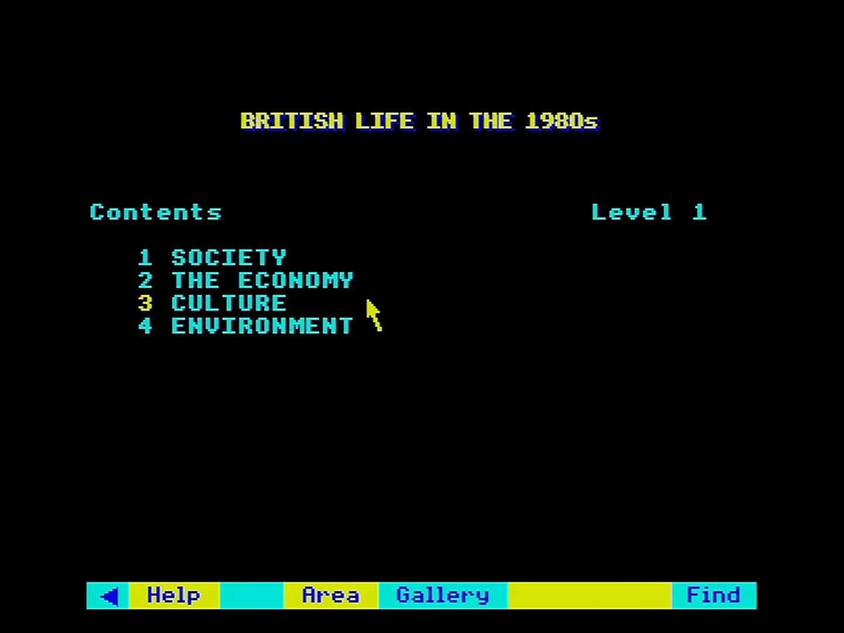

Figure 29 - The top 4 subject headings

You select one of these to examine further by moving the screen pointer over the item required until its number changes colour to yellow and then you press [Action]. Immediately the subject you chose will become the heading of a new screen display showing the sub-headings under your nominated choice.

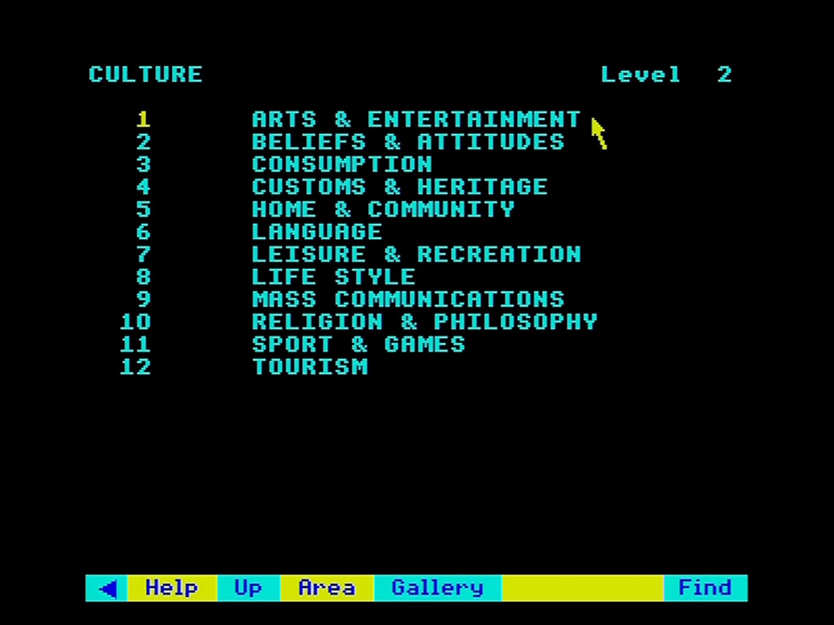

Figure 30 - Second level sub-headings

You continue to select a subject from the screen display at each level until eventually you arrive at a list of bottom-level item names.

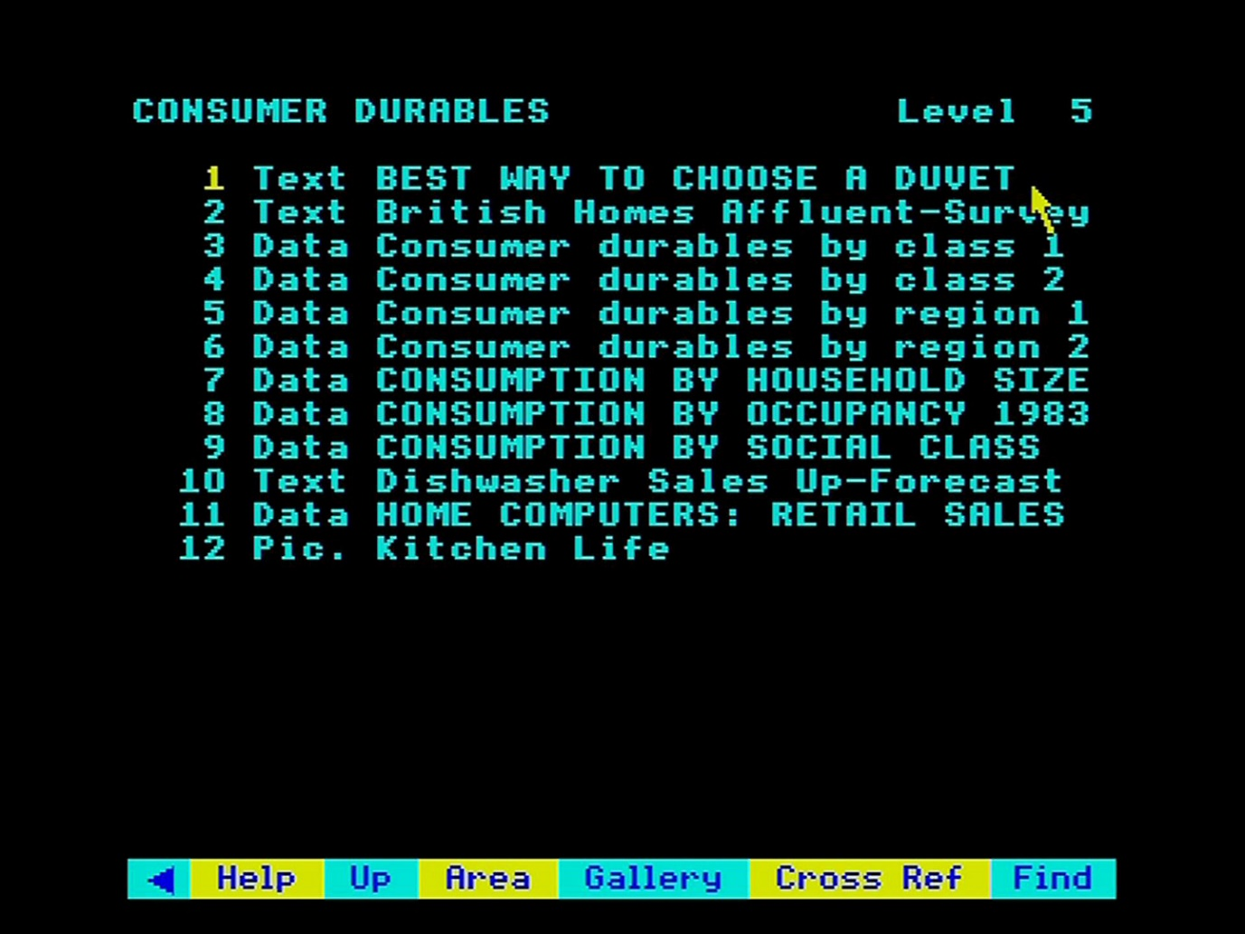

Figure 31 - Level 5 items

At this stage, you can choose to display one of the actual items, in which case you will be taken out of the **Contents** system into the system which handles the type of item you have selected.

### Retreating up the hierarchy

After you have moved on from the first screen of subject headings you will find that the menu bar becomes:

|  |  |  |  |  |  |  |
| --- | --- | --- | --- | --- | --- | --- |
| < | Help | Up | Gallery | Area | Find |  |

If you feel you have "taken a wrong turn" in your progress down the hierarchy, you can step back up the tree by selecting the **Up** option from the menu bar. This will display the previous screen from which you descended to the current list of headings. You can then make a different selection at some higher level to move down a more suitable branch.

### Reviewing cross-references

Every item in the hierarchy is cross-referenced by our indexers to other parts of the hierarchy where there may be material on similar subjects. Having threaded your way down a branch of the hierarchy and achieved a list of item names, you will find that the menu-bar becomes:

|  |  |  |  |  |  |  |
| --- | --- | --- | --- | --- | --- | --- |
| < | Help | Up | Gallery | Area | Find | Cross ref |

You can display the names of all the other items cross-referenced from items on your basic list by selecting **Cross ref** from the menu bar. The list of cross-references may extend to many screens and you page back and forth through them in the usual way, by placing the pointer towards the right or left of the screen and pressing 'Action' to move respectively forwards or backwards, or press [f7] for "previous" and [f8] for "next". The first screen will always show your primary list of item names.

Hint:

Don't be surprised if very occasionally you find an empty items-list at the bottom of a branch of the hierarchy. This simply means that there are no items stored directly under this part of the tree, but there are still cross-references to items stored elsewhere. Selecting Cross ref, from the menu bar will call up the related items for you to review.

### The special case of overview essays

In general, you will not come across any actual items in the hierarchy until you reach the very bottom of each branch. The only exception to this rule are the "overview essays" which are attached to the 45 second-level subject headings. The Domesday Project has commissioned a special essay in each of these subjects from appropriate experts and these essays can be called up during stepping through the hierarchy by selecting them directly from the second level display screen. They will give you an opportunity to review the whole of this subject-area prior to delving further into sub-headings and the items themselves. Overview essays are presented in the normal way for text essays and selecting **Main** from the menu bar when they are displayed will take you back into the **Contents** hierarchy at the point where you left it to call up the overview essay.

### Exiting from contents

On completion of your exploration of the hierarchy, you simply select one of the items in your final list and the system will invoke the procedure to display this type of data and let you manipulate it further. Alternatively, if there is no item you wish to work with immediately, you select one of the other index-search routines from the menu-bar: either **Gallery** or **Find**.

Don't be surprised if you go off to work with an item found via **Contents** and then find yourself suddenly re-presented with your old items list. Whenever you use an index-search routine the system hangs on to the items list you end up with in case you want to make more than one selection from it. Thus, while you went off to work with one item, after you have finished with that, the system will immediately bring you back to the items list with the option to display another item. The items list will not be lost until you have generated a new list by one or other of the index-search procedures.

## Looking at picture sets

The 22,000 pictures collected together on the National Disc must represent one of the largest collections of pictures ever offered to the general public. They cover all those aspects of life in Britain in the 1980s that we felt were essentially visual: contemporary art, street fashion and wildlife are obvious examples.

Most of the pictures were chosen after research in the BBC and other picture libraries. These include the work of some of this country's leading photographers and artists. For example, we have portfolios from 30 contemporary photographers. But we also wanted to capture the more every day and intimate moments from the lives of individuals and families up and down the country. So, we have included some 5,000 photographs from our Domesday Photographic Competition, covering topics like "Leisure in the 80s" or "Street Life in the 80s".

The pictures can be called up by the micro in all sorts of different contexts, but for most purposes they are shown in sets. There are over 500 sets, each containing an average of 500 pictures. Most are in colour, some are in black and white. All of them are captioned and we explain below how the captions can be called up, as well as printed and saved on magnetic disc.

### Viewing the pictures

You can arrive at a picture set in four main ways:

1. by choosing it from its title in a Find list;
2. by choosing it from the hierarchical Contents list;
3. by entering its name directly in the Find option;
4. by selecting it from the Gallery (as described below in the section “The Domesday gallery”).

As you arrive at any picture set, the first thing you see is the title page of the set.

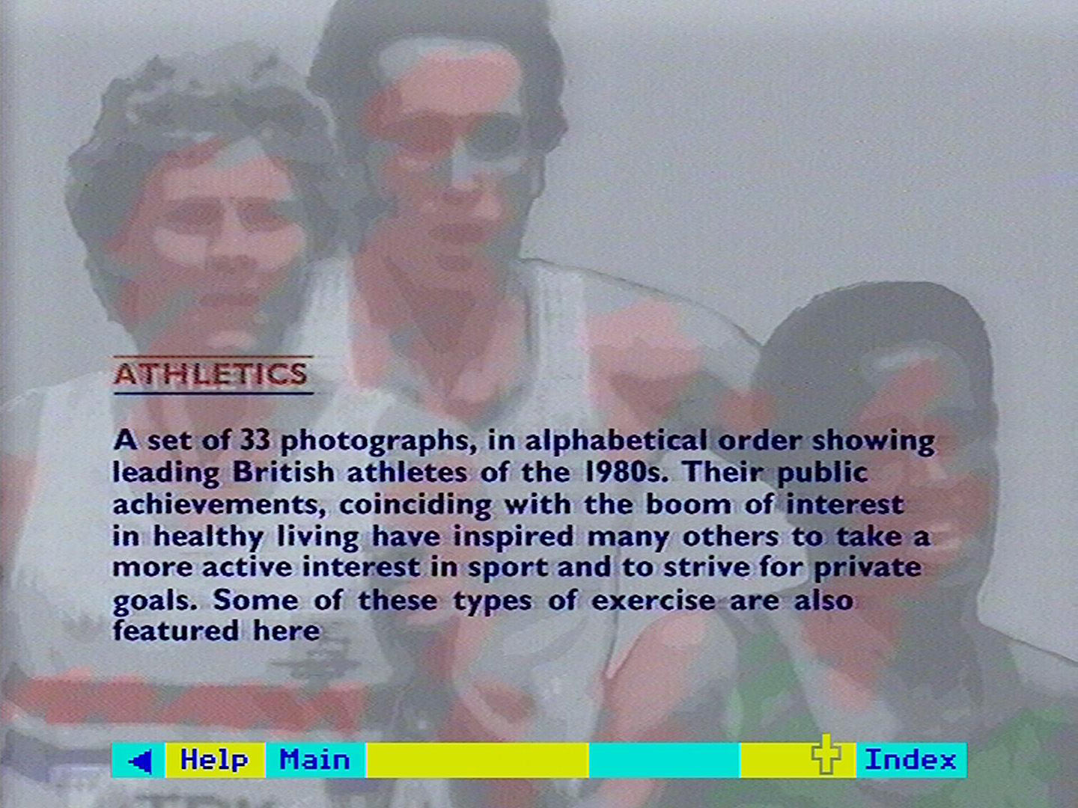

Figure 32 - The Athletics picture set title slide

This is like the cover of a picture book. It tells you something about what is in the set, the order the pictures are arranged in and often the number of pictures in the set.

To see a list of the pictures in the set, select **Index** from the menu bar. This shows you in item order the short captions of each picture in the set. They are set out 22 to a page and look like this:

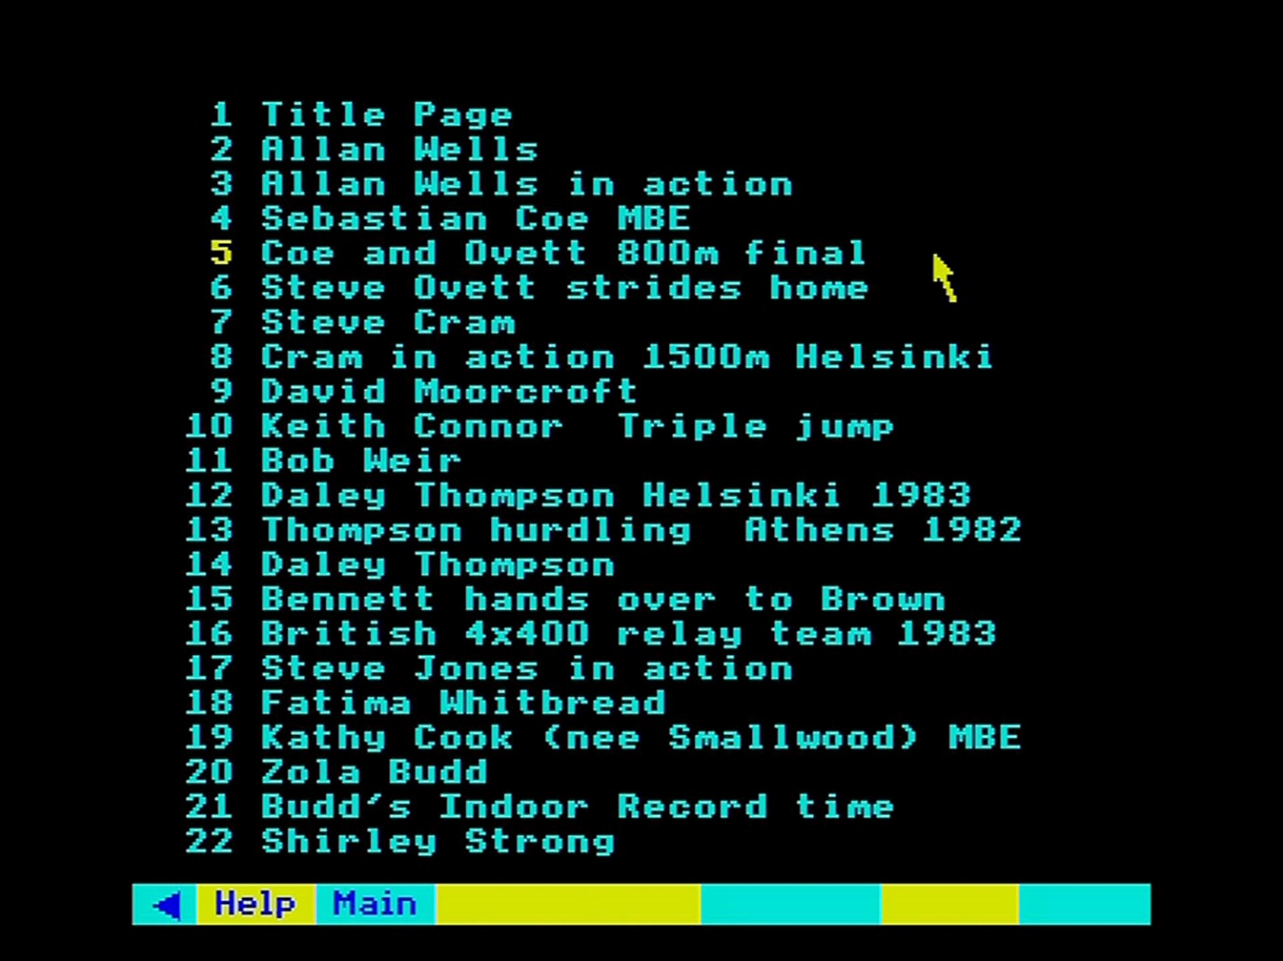

Figure 33 - The Athletics picture set index

Page on to the list of the second 22 pictures in the usual way. Select any picture by pointing to it and pressing **action**.

You should note that there are three picture sets with more than 100 pictures in each that are too large to have a front index.

These are:

* On the Shelf: Grocery packaging
* Drink and be Merry: Pubs and Wine Bars
* Design Council Awards, 1980-85

In the case of these sets you can only view individual pictures by paging through the set either from the beginning or from the end.

From here on the procedure is almost the same as looking at pictures on the Community Disc. We'll repeat the main principles. A picture is first shown with its short caption. This can be removed, if you want to use the picture on its own for demonstration purposes, by selecting **Clear** from the menu bar. Select **Caption** to bring it back.

If you want to go further and remove the menu bar itself, this can be done by actioning the pointer over the blue triangle at the left-hand end of the menu bar (or pressing function key [f0]). A reversed triangle is left on the screen instead of the menu bar. Action this (or press [f0] again) to bring the menu bar back.

To remove even the yellow triangle, use function key [f9] (there is no mouse equivalent). This will remove all micro output from the screen, leaving only the photograph. Press [f9] again to restore the triangle.

The picture quality of the photograph on the screen can be changed by adjusting the contrast, brightness and colour on your monitor. However, some monitors are set to receive a direct RGB signal and this may limit the amount of adjustment you can make. We have tried in producing the disc to keep the picture quality as uniform as possible. If you are not sure how well your monitor is set up, there are some standard test frames around frame number 1500. You can select these with the **FRAME** command (from the **System** option within **Help** – see the section “The help sequences”). More simply, you can find these frames by using the video disc player handset before you boot up the Domesday program.

We have not wanted to restrict our choice of pictures to those that are ideal for video display. You may have problems with some pictures that contain very fine lines, unless you are using a very high-resolution monitor.

To bring up the next picture you use the normal procedure for paging forwards or backwards. Move the pointer anywhere on the right-hand side of the screen (above the menu bar area and below the message area) and press the [CHANGE] button. Conversely you can page backwards through the pictures by pressing [CHANGE] with the pointer on the left-hand side of the screen. Keyboard paging, as usual, is with function keys [f7] and [f8].

If there are no more pictures available as you page forwards or backwards, you will hear a tone.

Remember that all references to pictures on the National Disc are to whole picture sets. Individual pictures are not indexed until you get to the set itself. However, each picture set is associated in the main index with up to 20 keywords, so an important picture or subject within a set may well be found as the result of a **Find** query using this word.

In this case you will still be brought from the index search to the front of the picture set. You will then have to find the picture you want within the set from the front index to the set itself. For example, there is no picture set devoted exclusively to deer, but the picture set "Mammals" does contain five pictures of deer. If you enter "deer" from **Find** you will be offered the "Mammals" set as a whole. When you have called this up and consulted its own front index, you will find the five pictures of deer.

### The other functions on the menu bar

#### Description

Select this for a longer, descriptive caption to be superimposed over the photograph. This will often include more information about what is in the picture, who took it and so on. For a few photographs, long captions may not be available. Select Clear to remove the description, and Caption to replace it with the short caption.

Hint: Faster paging through picture sets

You can page through photographs with no captions, short captions or long captions displayed. However, paging forward with the long captions active produces a slight delay between pictures as the caption information is picked up from the disc. It is, therefore, faster to page with the short caption only, and pick up the full description only when you need it.

#### Print

If you have set up a printer as described in the section “Controlling the system”, then selecting **Print** will produce a print out of whichever caption is on the screen. If you select **Print** without a suitable printer on-line, you will hear a beep and see an error message to that effect. A serial printer can be used after an appropriate operating system call in **Help**. The printer itself can be configured before the Domesday Discs are booted up or via a machine code printer driver called from **System** (within **Help**).

The **Print** command will not, of course, reproduce the photograph. It is nevertheless a useful feature if you are, for example, preparing a talk on a set of pictures from the disc. Only one, very basic printing format is supported. For more complicated results, first save the captions to floppy disc with the **Write** option.

#### Write

To record the text of the caption on the screen to magnetic disc, select Write from the menu bar. You are asked to confirm that the drive is ready with key [R] for 'Ready'. Pressing any other key will cancel the command. If you press [R] and a suitable drive and disc are not connected to the micro, the system will "hang": i.e. it will freeze and not respond to any more commands. If you cannot correct the problem (e.g. by closing the drive door), there is no alternative to booting up the video disc again. Downloading is only possible to an ADFS-format disc. If an ADFS error occurs (e.g. 'Disc full'), this will be displayed at the top of the screen for three seconds.

Text is stored in a simple ASCII format with no control characters. In this form, it can be read into VIEW or most word processing systems. For details of this and the file-names used, see section “Appendix III - Formats of downloaded files”.

### Leaving photographs

You can leave the **Photo** operation at any time by selecting any of the other top-level operations from the menu bar. **Find** or **Contents** will take you back to those two ways of choosing new items to look at.

**Gallery** will allow you to browse through the picture collection as a whole. You can also leave by pressing [ESCAPE]. This will take you (after a confirmatory prompt) back to the Gallery and reset the system to its starting condition.

### For example – Finding a photograph of the Clouded Yellow butterfly and displaying it without the caption or menu bar

Select the **Find** option, type BUTTERFLIES and press [ACTION]:

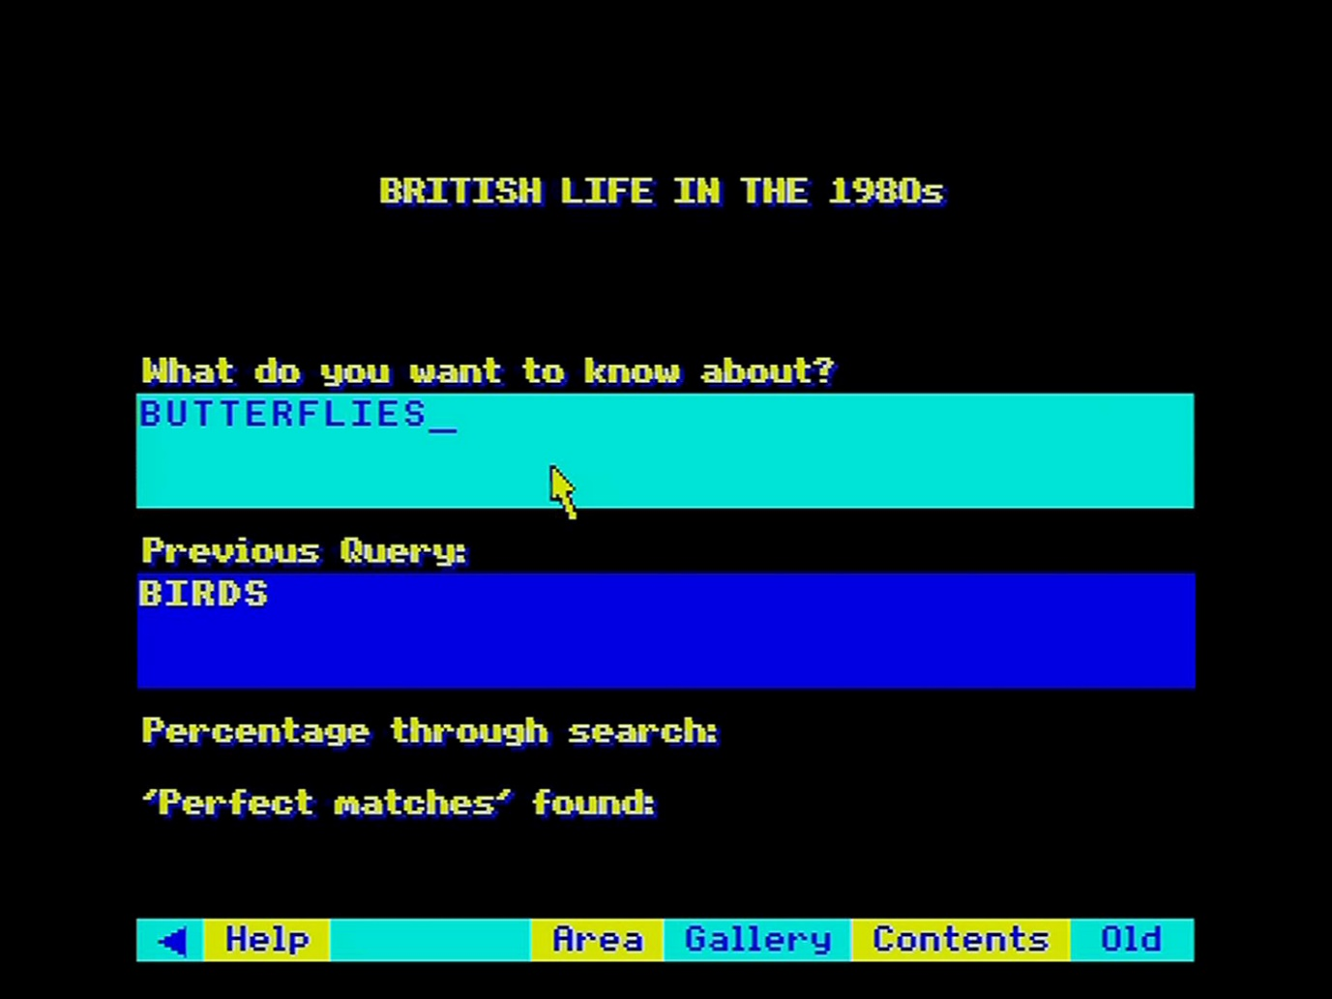

The hit list is displayed. Select “Pic. Butterflies”:

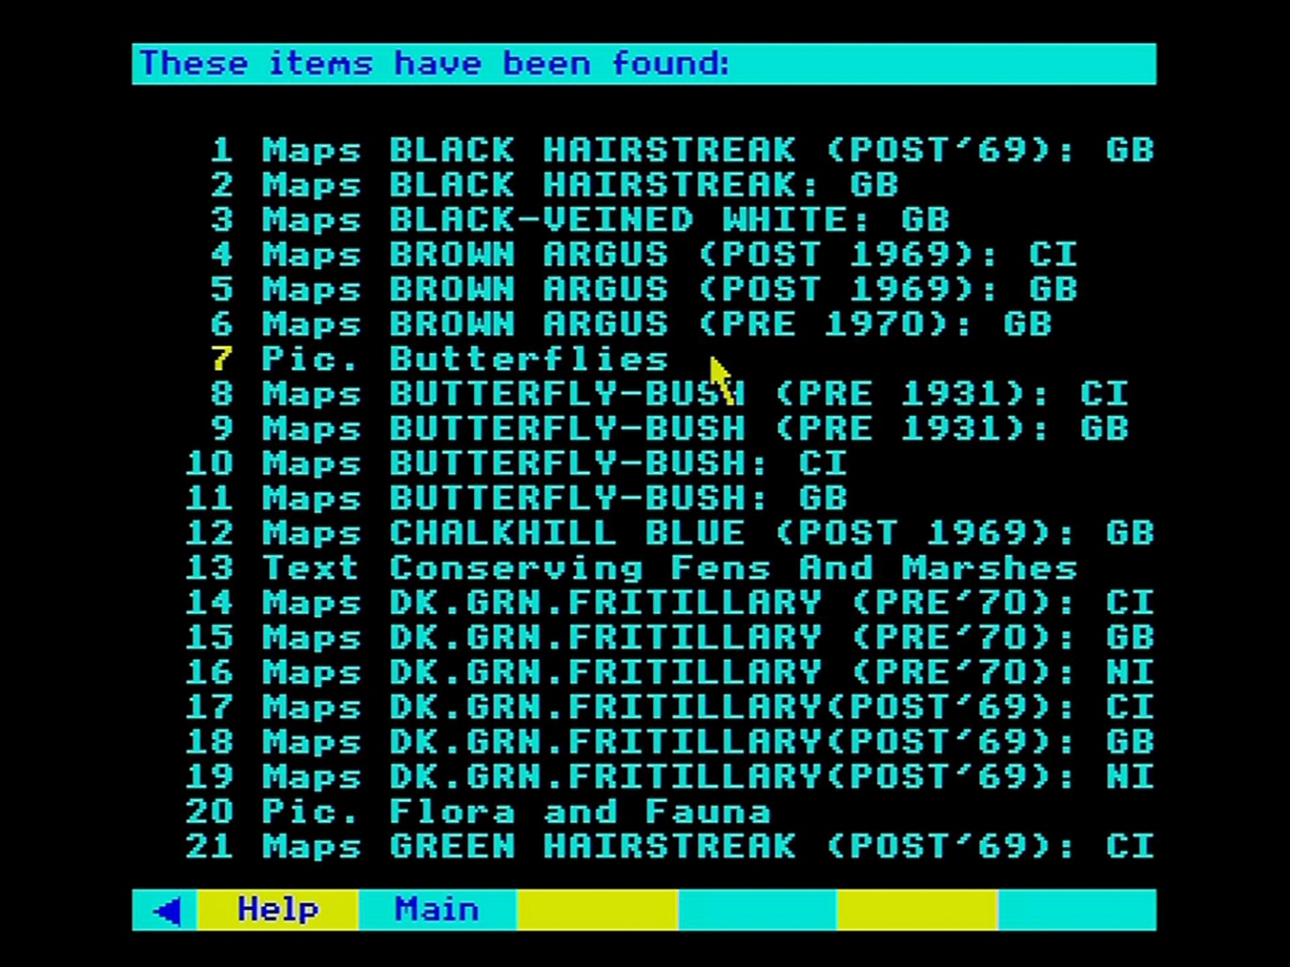

The title page is displayed. Select **Index** from the menu bar:

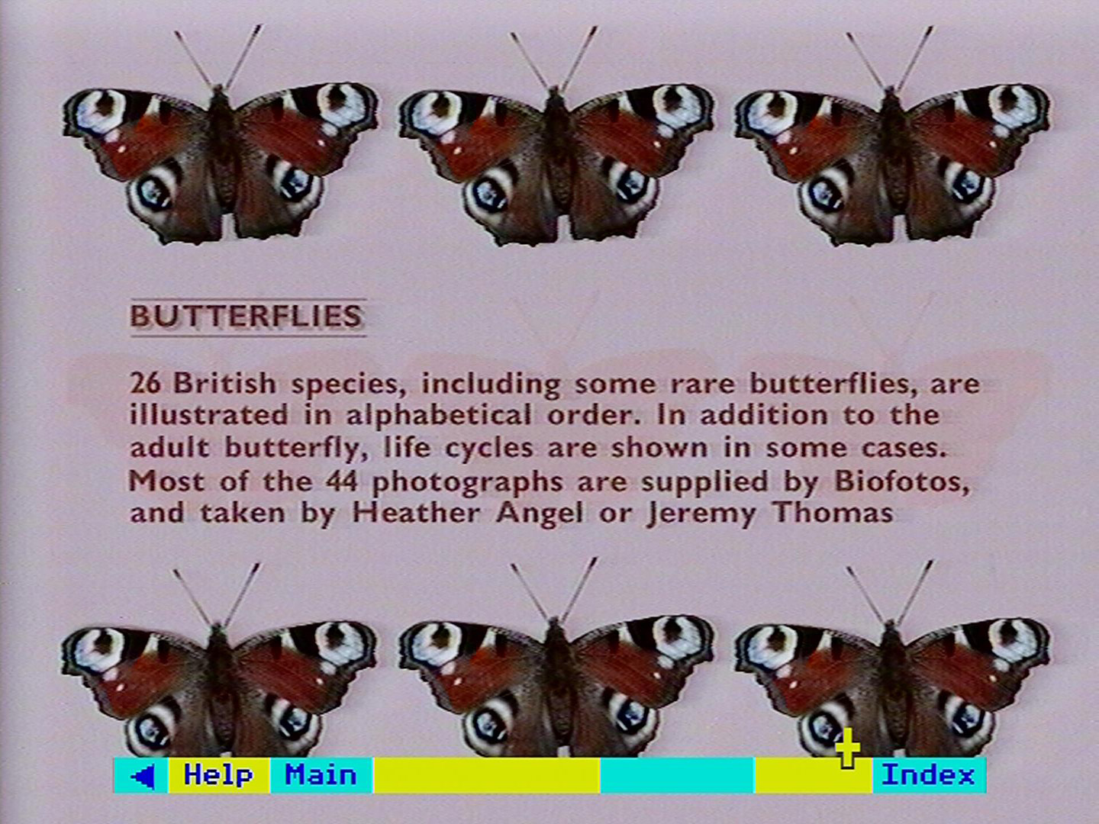

A list of the pictures in the set is displayed. Select number 6 “Clouded Yellow”:

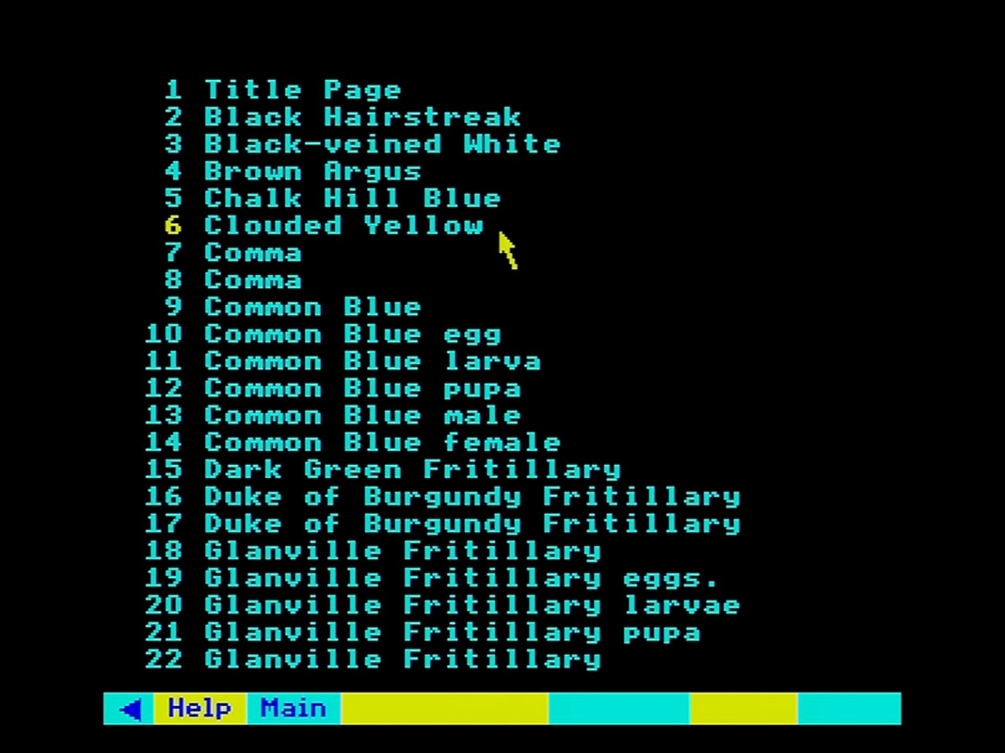

The picture of the Clouded Yellow butterfly is displayed along with a short caption. Select **Clear** from the menu bar:

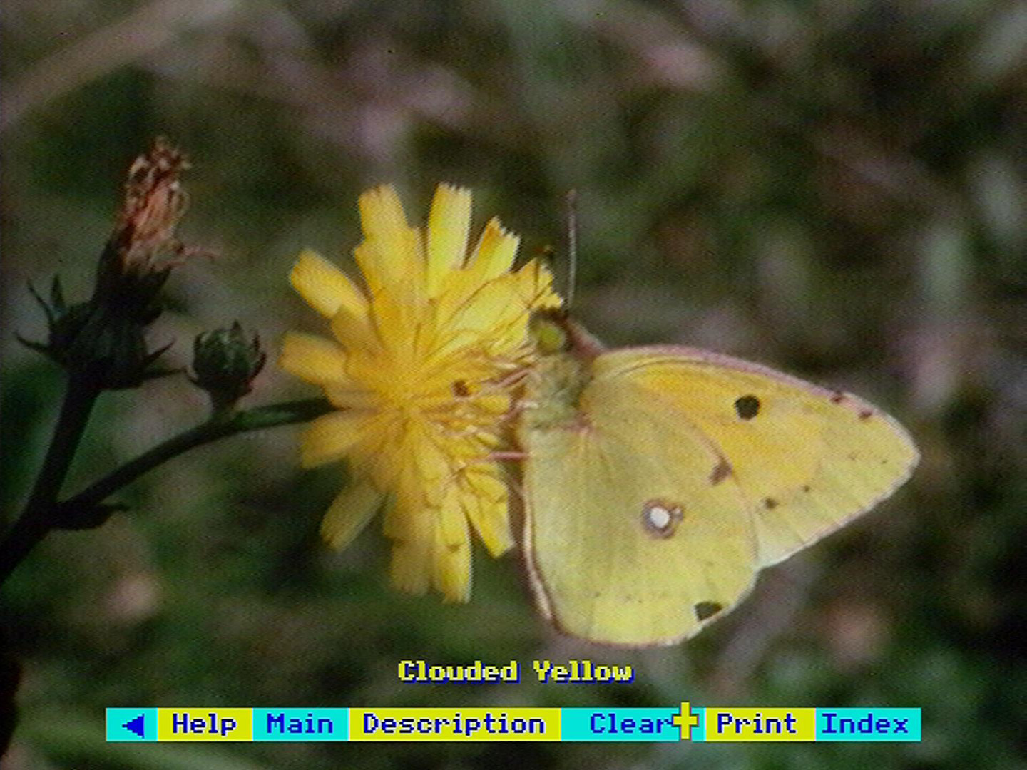

The Clear option removes the short caption from the display. Next select the blue triangle from the menu bar:

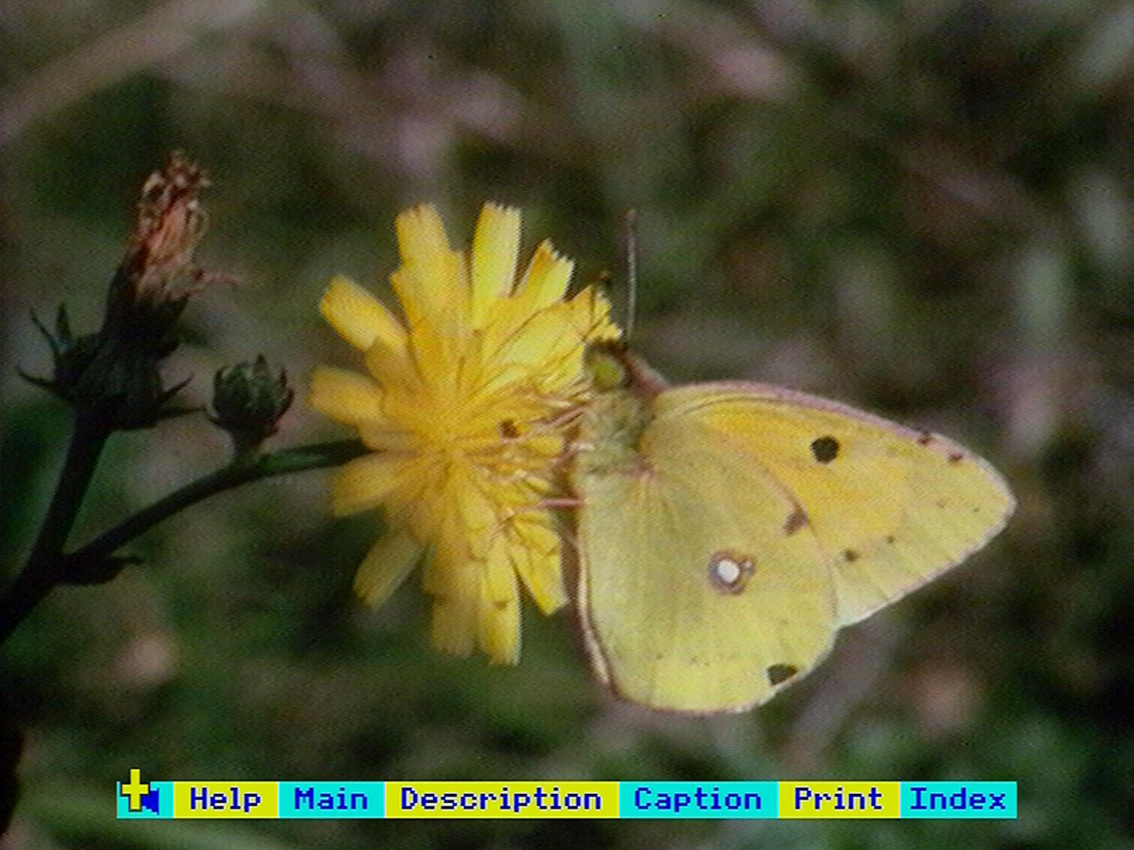

The photograph is now displayed without the menu bar:

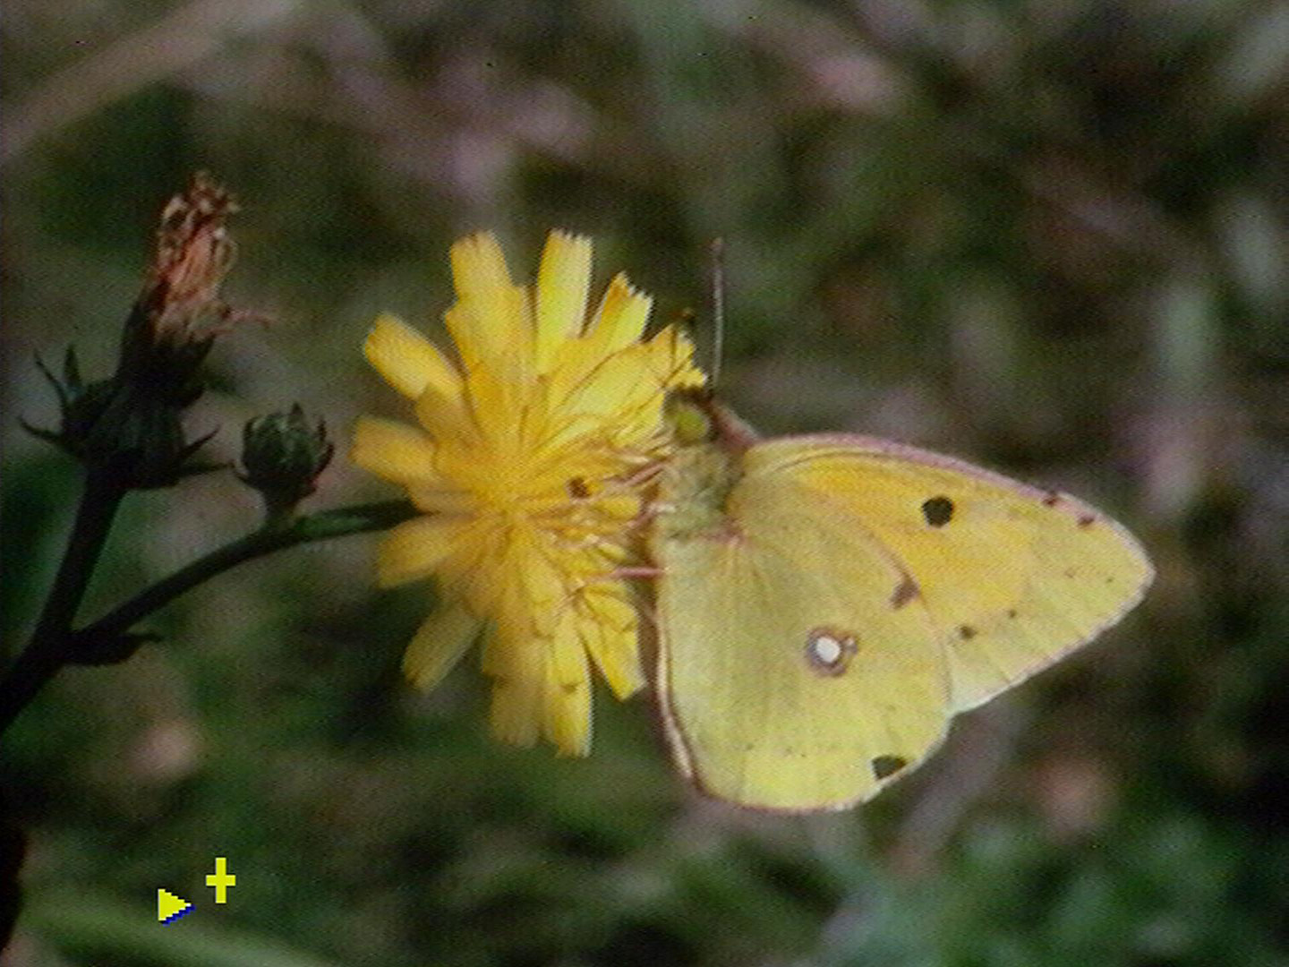

## Reading text

This section describes how to find and read all the text contained on the National Disc. This begins with the 45 specially commissioned articles on each of the main Domesday topics. The main body of text, however, comes from existing sources: around 2,000 articles from newspapers, journals, Government reports, press hand-outs and so on. This is designed to serve a double purpose: to give information on a topic and to show how that topic was covered by a publication in the 1980s.

These articles do not represent any one person's views - they come from all points on the political and ideological spectrum. On a controversial topic, we have tried to include contrasted pieces on the same theme. Nor are these articles offered with any guarantee of accuracy. Their source is carefully recorded and it is up to you to accord to them whatever credibility you choose. They stand as evidence of what was written in the 1980s. Of course, it is impossible to represent more than the tiniest fragment of the printed output of this country over six and a half years. We have tried to offer a balanced and colourful mixture on the major topics of our time. We are very much open to suggestions for important pieces that we have missed and that we could include in our second edition.

Whatever its source, all the text looks the same as it is presented on the screen. It is not possible at present to preserve all the nuances of presentation adopted by different publications. An interesting exception is the local paper front pages. These are described below.

What follows describes how to find and read the text you want on any topic. Remember that it is articles as a whole that are indexed. This means that there may be a reference to a point in one paragraph of an article that is not reflected in the index. The best strategy, as elsewhere on the discs, is to use medium range keywords like 'nutrition' rather than very specific terms like 'polyunsaturated fats'.

### Reading the text

You can arrive at a piece of text in four ways:

1. by choosing it from its title in a **Find** list:
2. by choosing it from the hierarchical **Contents** list:
3. by entering its name directly in the **Find** option:
4. by selecting it from the **Gallery** (as described below in the section “The Domesday gallery”).

Notice that the 45 overview articles on our main topics have a special place in the hierarchical contents list. They occur on the second level of the hierarchy and can be selected straight away, offering you an overview of the whole topic before you move down more levels to the rest of the items. They also have titles in the same format - 'Agriculture in the 1980s', 'Education in the 1980s' and so on. This is designed to make them more recognisable after a keyword search using **Find**.

An article with no internal section divisions simply begins at page one. Articles made up of sub-sections begin with a contents page with section headings.

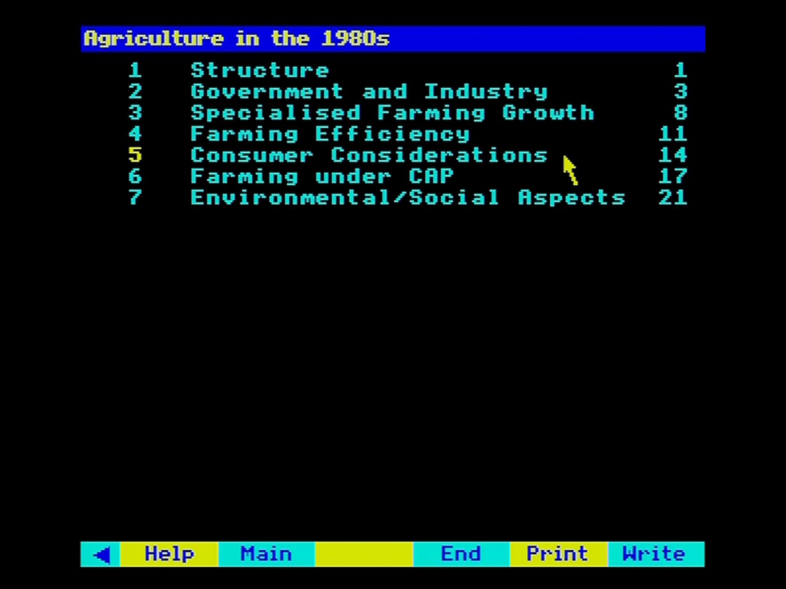

Figure 34 - Overview articles

The page on which each section begins is shown on the right. You can select any section directly. When you are reading the section itself, you can page forwards and backwards or return to the front contents page by selecting **First** from the menu bar.

When you arrive at the page you want you will see the page heading you selected at the top of the screen, together with the page number. The text itself uses a narrower column than the whole screen and is proportionately spaced. This, together with the colours used, is designed to make it easy on the eye. Yellow is used for words that the authors wanted to emphasise - the equivalent of italics in a book or underlining in typescript.

At any point, you can leave the text by selecting **Main** and moving back to the **Find**, **Contents**, or **Gallery** option.

As you read the text, you may come upon a reference like (see Figure 3). You can select this illustration by moving the pointer within the square brackets and pressing [Action]. Return to your text by selecting **Main**.

### The local paper front pages

We have recorded on the National Disc one front page story from each of many local newspapers, which the editor sent us as an example of a typical news story for the area. For example, there is an item called 'Western Morning News' which is headlined 'Young men in fury over MP's attack'. To give an idea of the layout and look of each story, these are held on the disc as a series of images moving down the column of text. They therefore operate more like a picture set than a text article - indeed they are labelled on hit lists as pictures, not text. To read them, simply page backwards and forwards in the usual way.

### Text options

These are like the text options on the Community Disc, but they are available on the main text menu bar.

#### Print

If you have set up a printer as described in the section “Controlling the system”, then selecting **Print** will produce a print out of whatever text is on the screen. If you select **Print** without a suitable printer on-line, you will hear a beep and see an error message to that effect. A serial printer can be used after an appropriate operating system call in **Help**. The printer itself can be configured before the Domesday Discs are booted up or via a machine code printer driver called from **System** (within **Help**).

To print out the next screen, page forward and re-select **Print**. Only the most straightforward type of printing is produced without, for example, highlights. For more complicated results, first save the captions to floppy disc with the **Write** option.

#### Write

To record the text on the screen to magnetic disc, select **Write** from the menu bar. You are asked to confirm that the drive is ready with key [R] for 'Ready'. Pressing any other key will cancel the command. If you press [R] and a suitable drive and disc is not connected to the micro, the system will 'hang': i.e. it will freeze and not respond to any more commands. If you cannot correct the problem (e.g. by closing the drive door), there is no alternative to booting up the video disc again. Downloading is only possible to an ADFS format disc. If an ADFS error occurs (e.g. 'Disc full'), this will be displayed at the top of the screen for three seconds.

Text is stored in a simple ASCII format with no control characters. In this form, it can be read into VIEW or most word processing systems. For details of this and the file names used, see section “Appendix III - Formats of downloaded files”. Please take note, however, of the copyright warning in the section “Controlling the system”.

#### First and End

These take you directly to the first or last page in the article. You can then page forwards or backwards from there.

### For example – Finding the overview essay on housing and read details about the author

Enter the **Contents** operation and select option 4 “Environment”:

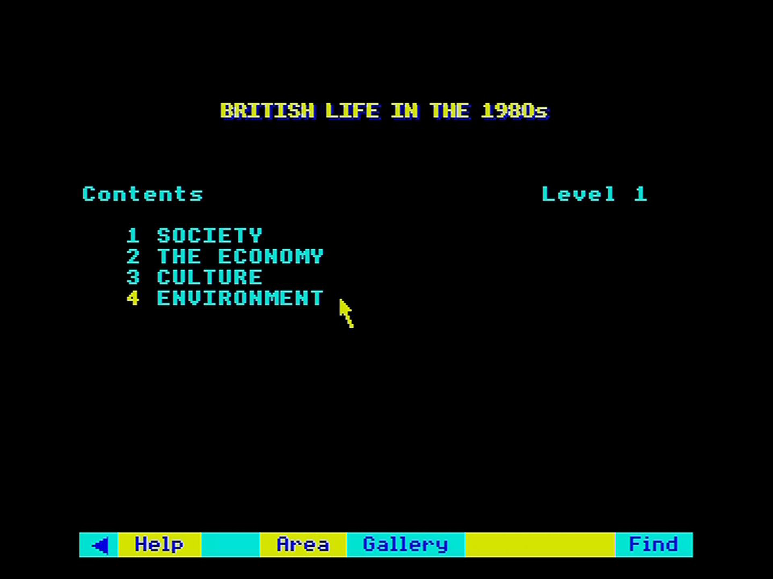

The Environment menu appears. Select 2 “Climate”:

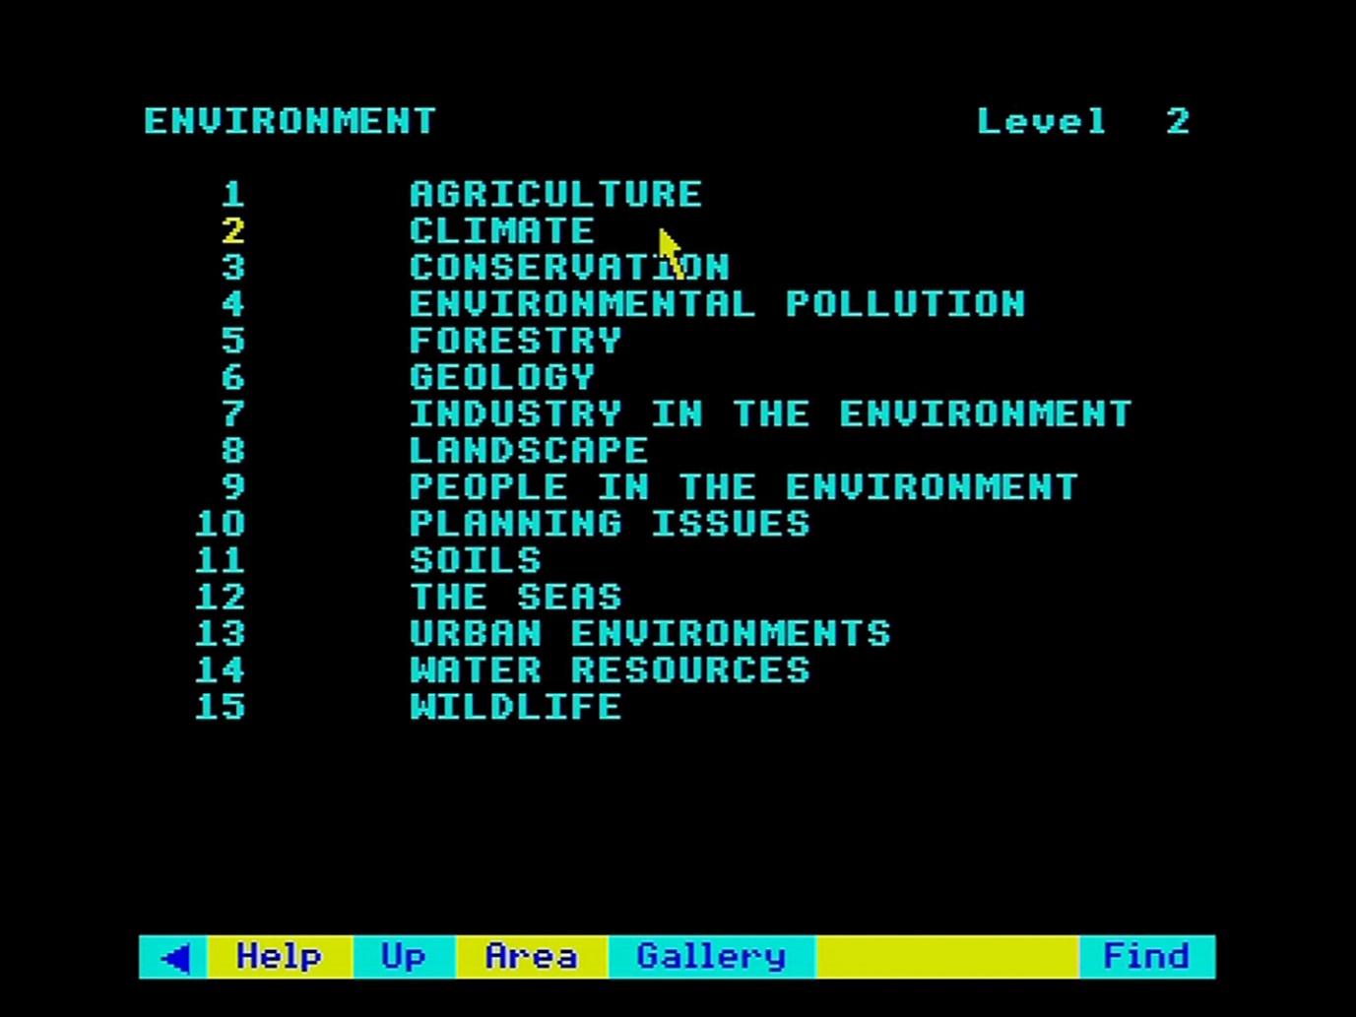

The Climate menu appears headed by the overview article. Select 1 “Text Climate”:

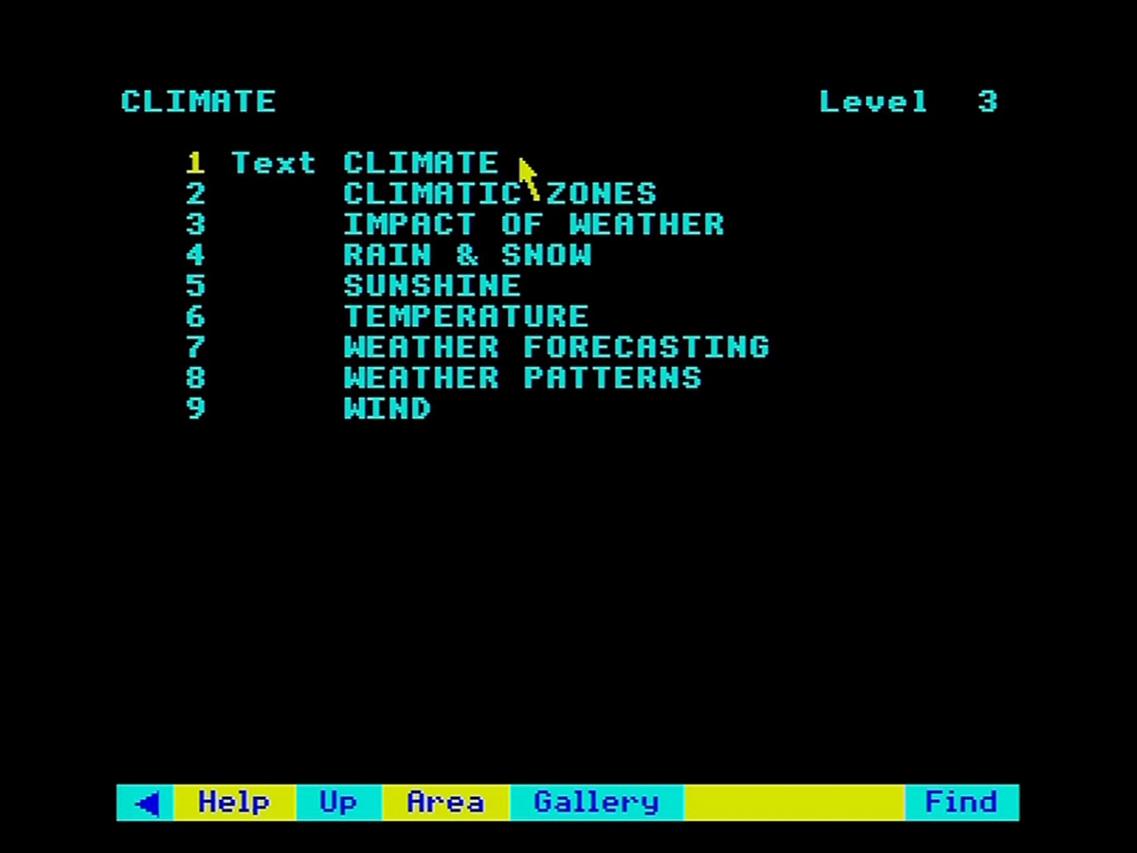

The contents page of “Climate in the 1980s” appears. Select **End** from the menu bar:

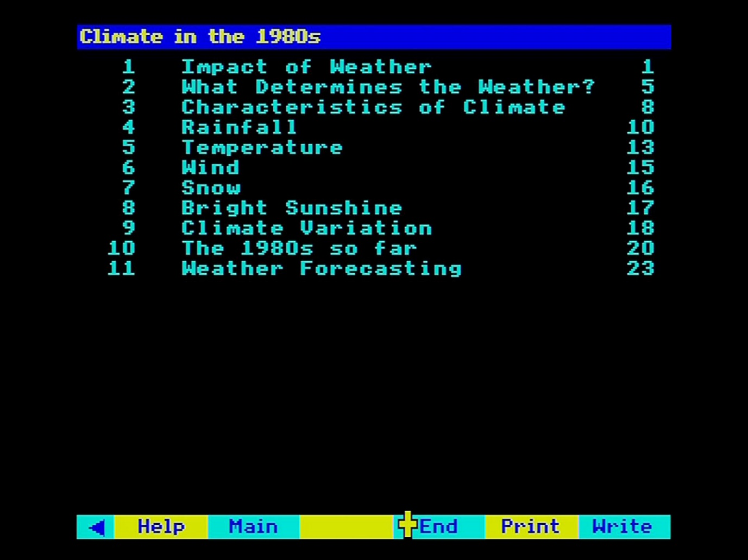

## Taking surrogate walks

This is an experience unique to the video disc medium: an environment photographed so comprehensively that you can walk around it almost as if you were there. At any spot, you can turn in all directions and you can follow several paths to explore the place. Doors open before you. The contents of cupboards and drawers can often be examined in minute detail.

Because of your freedom to move and look around as you like, you can re-visit these places on the disc again and again without feeling you've seen it all before.

We have put nine walks on the Domesday Discs:

1. a farm and farmhouse
2. a stone cottage
3. a council flat
4. a show house
5. a terraced house
6. a detached house in the outer suburbs
7. the town centre of Brecon
8. an industrial city area
9. a loch-side walk in Scotland

We do not identify the places any more closely, to protect the privacy of the people who were kind enough to let us photograph their houses in such detail.

Our hope is that these walks will become of increasing interest as time goes by - imagine being able to walk round a house from the 1880s.

This section explains how the walks are constructed and how you can explore them in different ways. In practice, the walks are very easy to use - much easier than they are to explain.

### Finding the walks

All the walks are displayed in **Find** hits lists with a **Walk** prefix. They all have among their keywords 'surrogate walks', so entering this in **Find** will produce the complete list. Alternatively, if you know the exact name of the walk you want, you can enter this within quotes in the **Find** option and you will be taken straight to it.

The most intriguing, if not the fastest, way to embark on one of the walks is through the **Gallery**. As will be explained fully in the section “The Domesday gallery”, you can walk out of any door of the **Gallery** straight into one of the walks.

### Beginning the walk

Your first view of the walk includes an extra prompt message at the top of the screen.

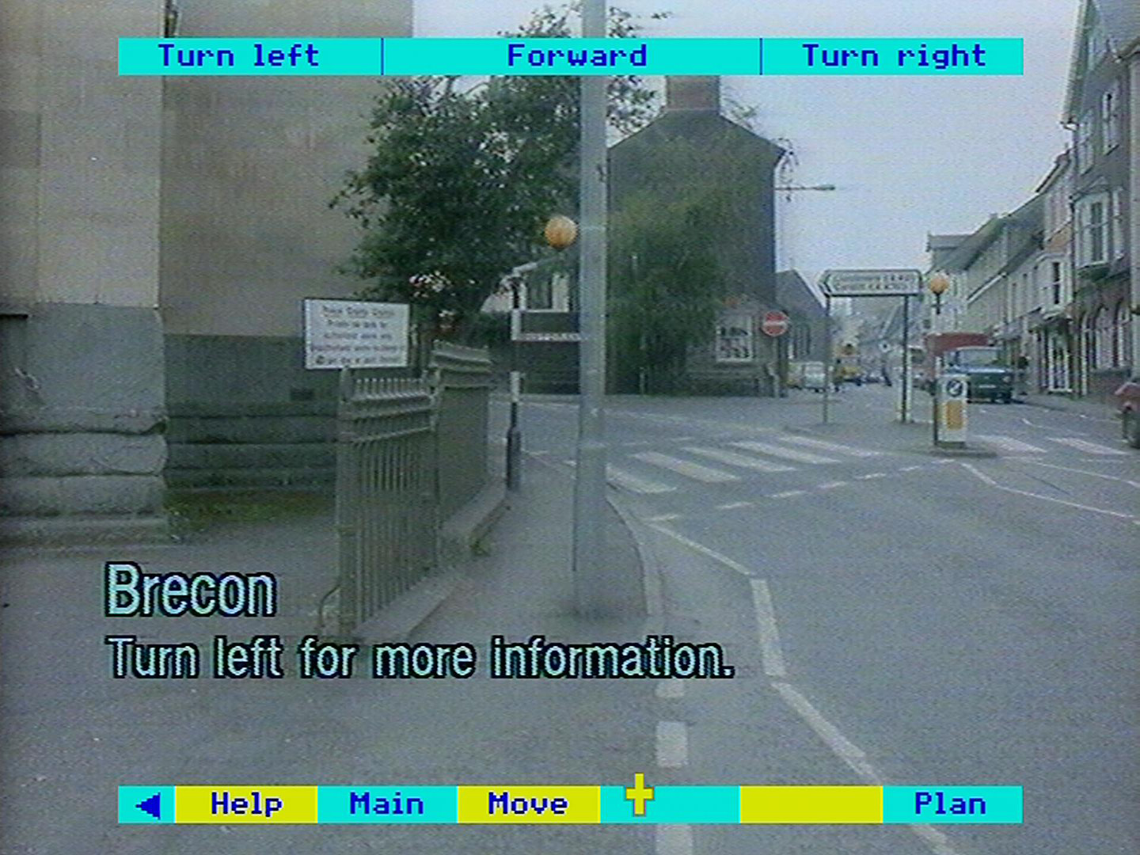

Figure 35 - The Brecon walk

This introduces a slight variation on the usual 'page-turning' grammar, in that the centre of the screen is here used for 'move forward'. In all that follows it is important to be clear of the distinction between **turning** (staying at the same position but facing in a different direction) and **moving** (stepping forwards, backwards or sideways by a given amount). All turns are through 45 degrees. All moves are by one 'step', though this can vary in size depending on the nature of the environment. 'Steps' along a road are much longer than steps inside a room.

Consider first how to **turn**. Move the pointer to the right or left of the screen and press [Change] and you will turn through 45 degrees in that direction. There will be a slight overlap between the two pictures to help your orientation. You can think of the process as pointing to the part of the scene that is to the side and pressing [Change] to bring it into the centre. If you keep pressing, you will continue to turn until, after eight presses, you will have turned full circle.

The centre third of the screen is used for **moving** forward. Position the pointer anywhere there, press [Change] and you will take one step forward. If, for reasons of geography, it's not possible to move forward, a message to this effect is shown briefly at the top of the screen.

If you are using only the keyboard, you can move and turn as follows:

turn left [SHIFT] with cursor key left  
turn right [SHIFT] with cursor key right  
move forward [SHIFT] with cursor key up  
move back [SHIFT] with cursor key down

This can be the fastest way to turn and move. Don't be tempted to set the [SHIFT LOCK] as this will disable the function keys.

You may like to continue the walk using only these three functions: you can get anywhere by turning and walking forward. The system will also work fastest in this mode. You may also prefer to turn off the menu bar (select the blue arrow on the bar or use [f0]) to add realism.

When you are at the first position of the walk (and only when you are there for the first time), you also see some title text about the walk. If you turn once to the left, there is more detailed text. This is the only background information available about the walk. It is not a picture set, so there are no captions with individual views.

### Plan and help

Selecting **Plan** or **Plan/Help** from the menu bar will take you to a plan of the walk you are on:

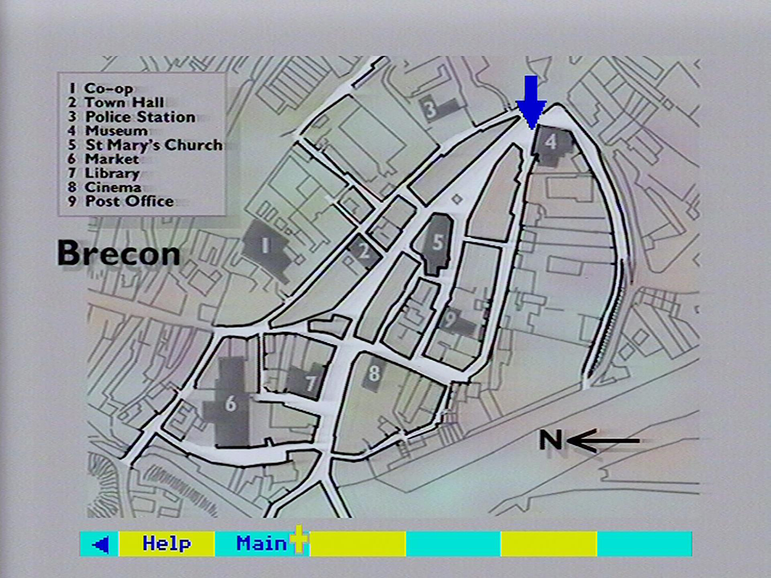

Figure 36 - The Brecon walk plan

Your position is marked by a blue arrow (in fact, by the centre of the arrow head). The direction of the arrow shows the way you are looking at that point.

Select **Main** on the plan's menu bar to return to your position on the walk.

For the larger walks, there are a series of plans. You will be taken to the appropriate one depending on your position.

For the usual **Help** status page and **Help Text** choose these options from any of the menu bars. There is one tiny point to bear in mind for those using the status page to collect video disc frame numbers for their own purposes. If you go to **Help** via **Help/Plan** then the frame number displayed as last visited will be the frame of the plan. To register the last frame of the walk, select **Help** from the first menu bar (before you have selected **Move**, where **Help**, is displayed on its own. The 'last frame' will then be the last frame of the walk.

### The full move options

If you walk in the simple way described above, you will soon discover some limitations. To take a step backward, you must turn four times, step forward, then turn back four times. Again, you will find yourself bumping into things, since you have no visual clues as to which way you can walk. To overcome this, you can call up a second menu bar with specialised move options on it by selecting **Move**.

Now you can move using the new options shown on the bar as well as with the grammar described above. But remember a crucial difference: moving with the screen needs the [Change] button, while selecting moves from the menu bar needs the [Action] button.

Hint: Menu bar displays possible moves

You will soon find that this menu bar serves a second, equally Important, function. Because it only shows the moves that are possible from the position you are in. It serves as a visual indicator of which way you can move. You won't bump into the wall by trying to move forward if you notice that there is no forward option on the bar. More subtly, a Move suddenly appearing (on the menu bar) shows a path opening on your right; you could move along it by turning twice to your right and then walking forward.

There are the new moves accessible from this menu bar:

* **<Move:** This means a side-step to the left while still looking forwards.
* **Forward:** Select this to move forward in the same way as using the centre screen. It is repeated both as a direction aid and for completeness, so that you can make all your moves from the menu bar if you prefer.
* **Back:** This allows you to take one step backwards, while still looking forwards.
* **Move>:** This means a side-step to the right while still looking forwards.

None of the move options on the bar affect the direction in which you are looking. All changes of direction (turns) are made via the left or right side of the main area of the screen with [Change].

### Close-up details

Superimposed on certain views will be one or more icons representing a magnifying glass. These indicate that close-up views are available - for example, inside a cupboard. Move the pointer over the icon and press [ACTION]. The first of the detail shots will be displayed. You can page forwards and backwards through this set of pictures in the usual way until you hear a beep, which indicates that there are no more shots. Return to your position on the walk by selecting **Main**. To look at a view without the icons, use function key [f9].

### Ending your walk

When you have finished exploring one of the walks, you can move directly into any of the main National Disc operations by selecting them from the menu bar (via **Main** if you have been using the **Move** option).

Alternatively, you can press [ESCAPE] to reset the disc to the top of **Gallery**.

### For example – To explore the stone cottage and examine the ornaments on display in the living room

In the Find option enter COTTAGE WALK, press [ACTION], then select the walk from the hit list:

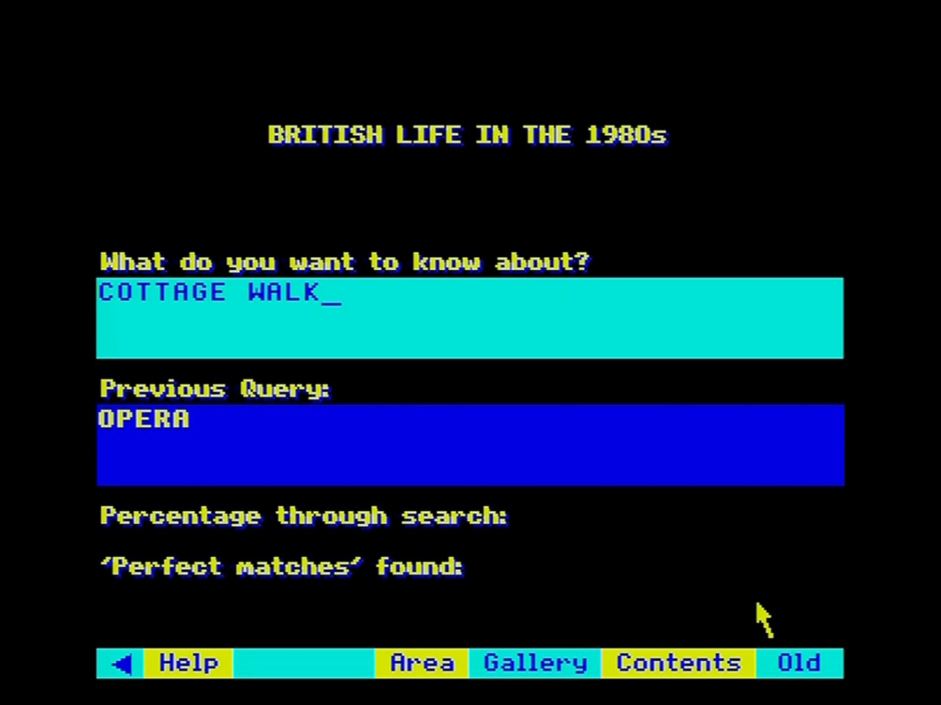

The walk begins at the front path. Select **Move** from the menu bar to bring up the move menu bar at the top of the display:

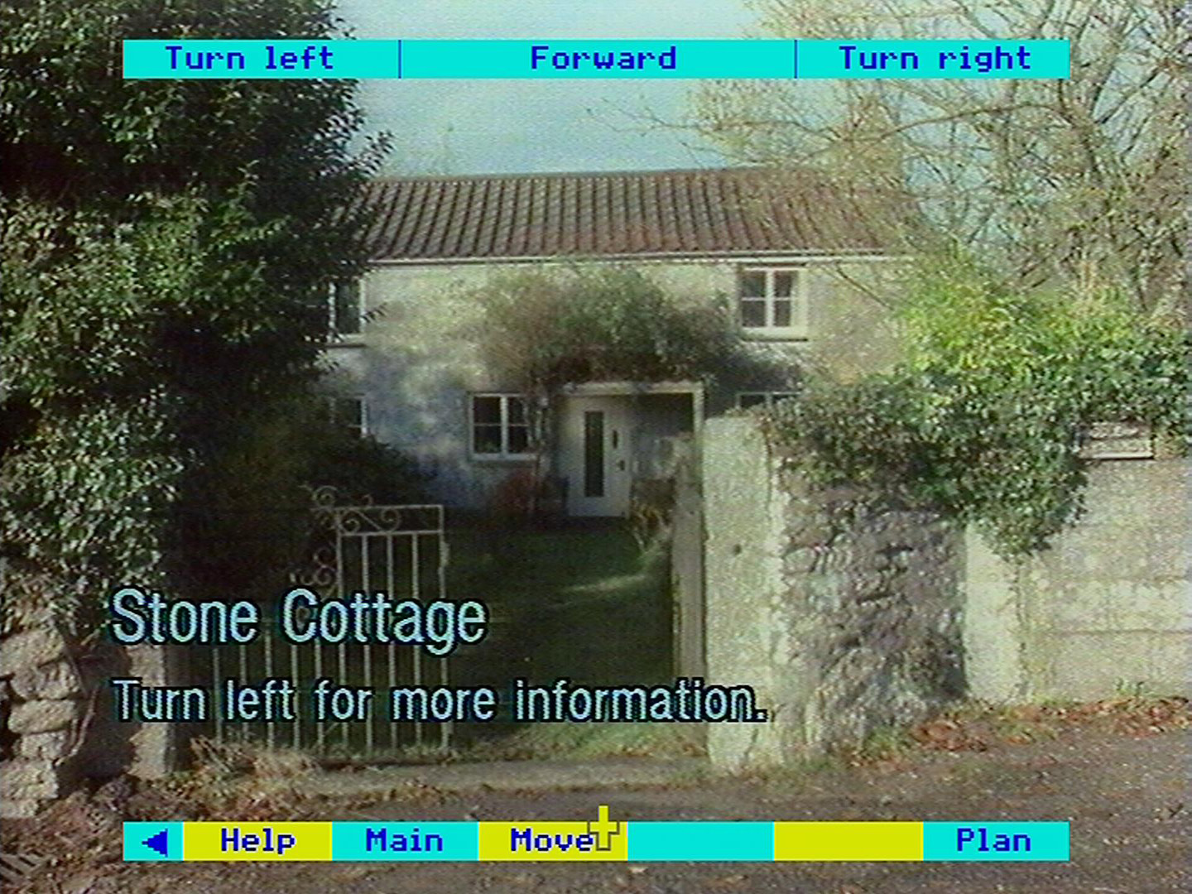

Point at the centre of the screen and press [CHANGE] five times to move forward into the hall:

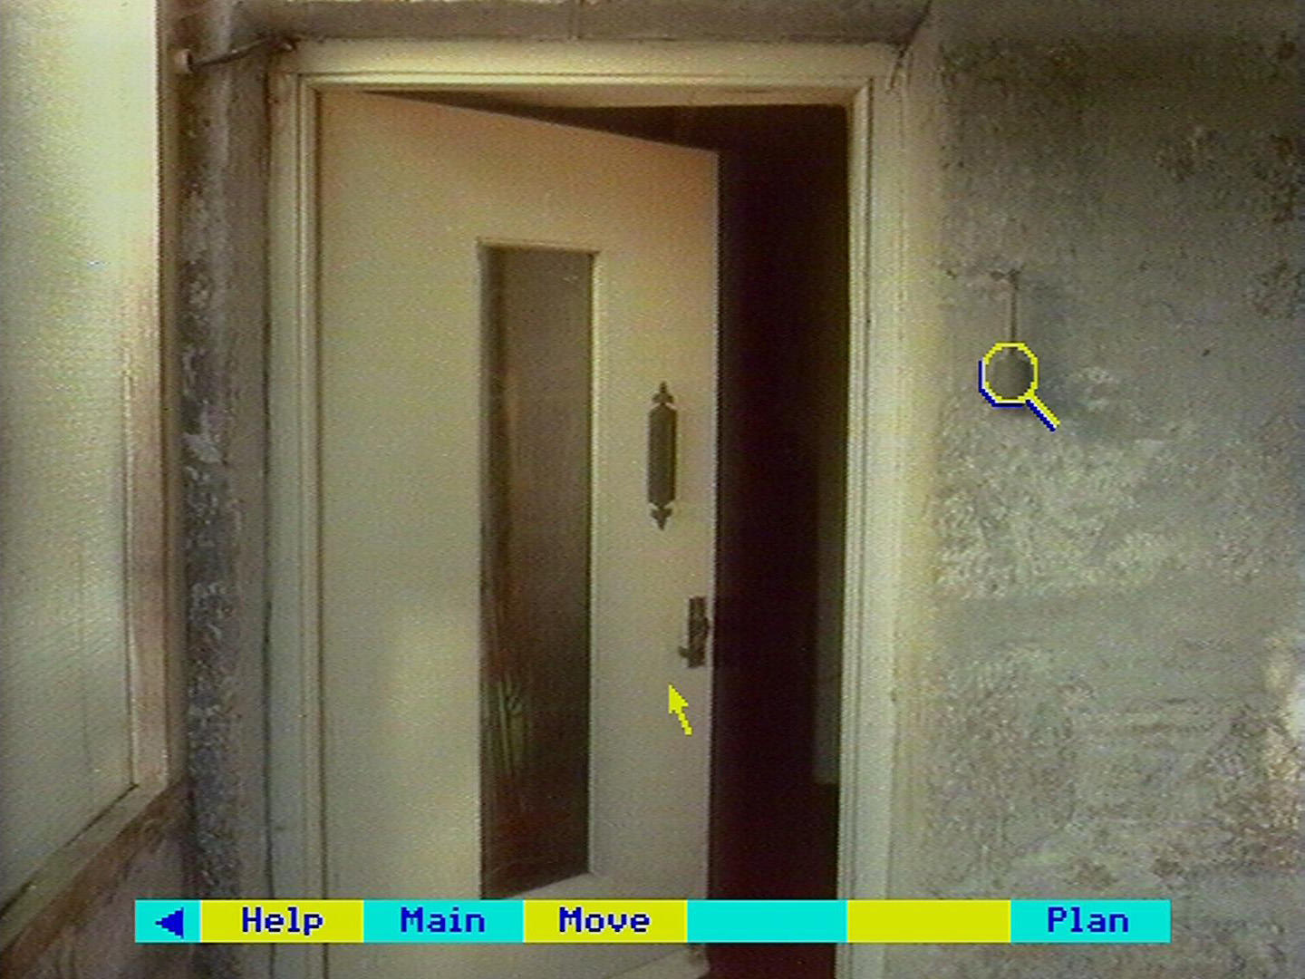

Select **Plan** from the menu bar to display the plan of the walk:

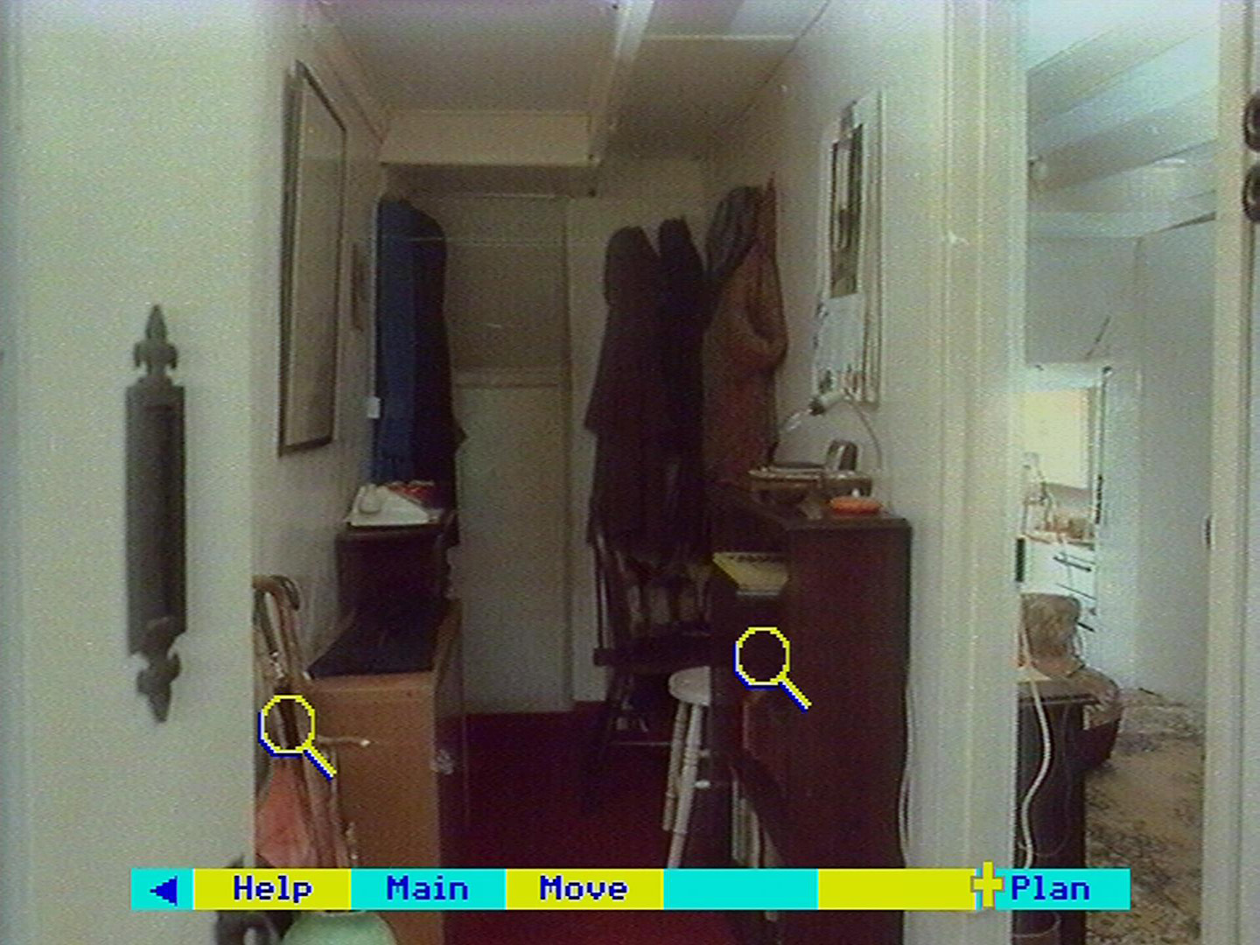

The plan appears with a blue arrow showing your current position. Note the position of the living room. Select **Main** to return to the hall:

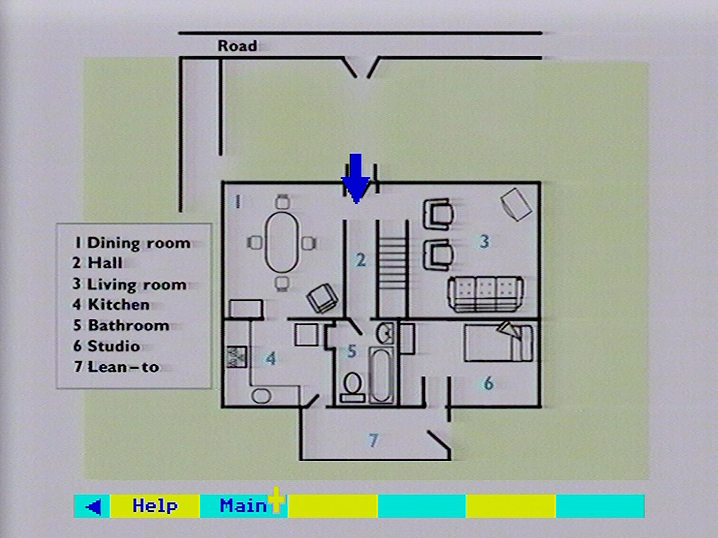

Point at the right of the screen and press [CHANGE] twice to turn through 90 degrees:

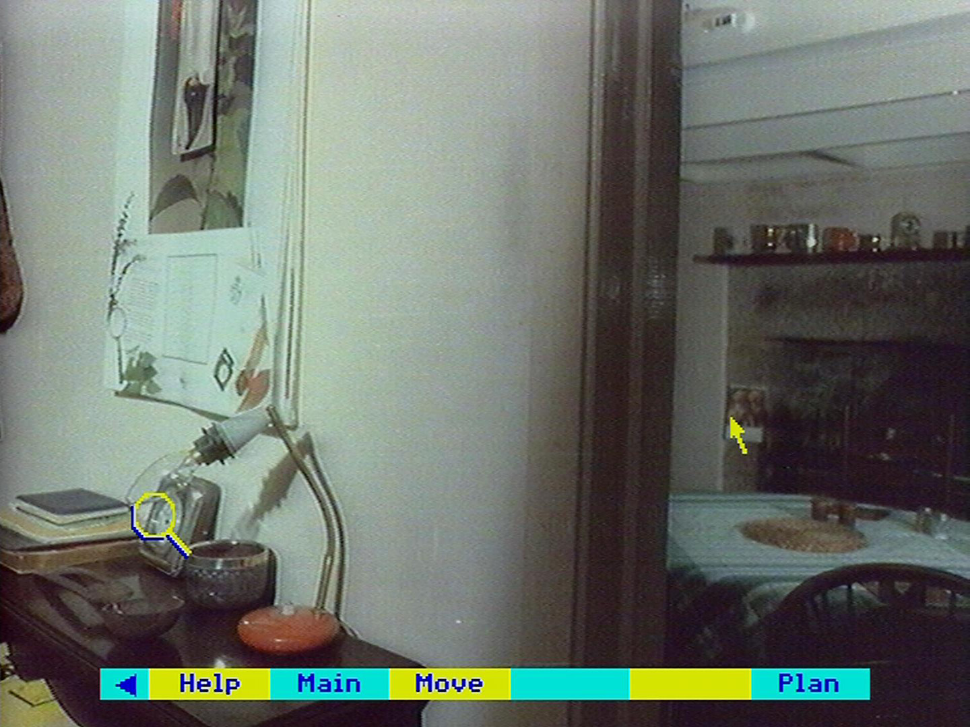

Point at the centre of the screen and press [CHANGE] to move into the living room:

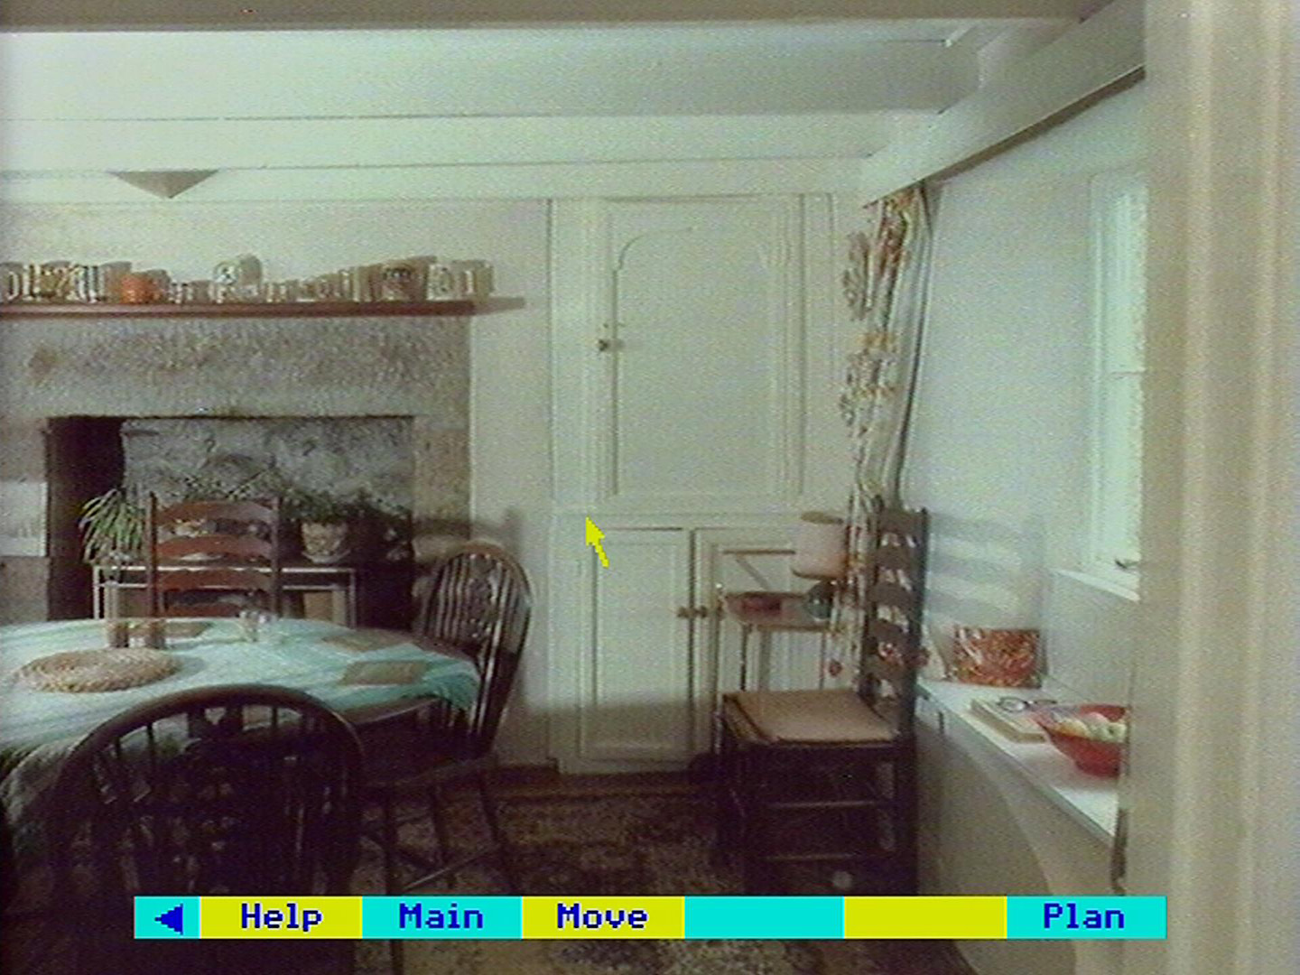

A magnifying glass appears over the mantelpiece. Move the pointer over to the magnifying glass and press [ACTION]:

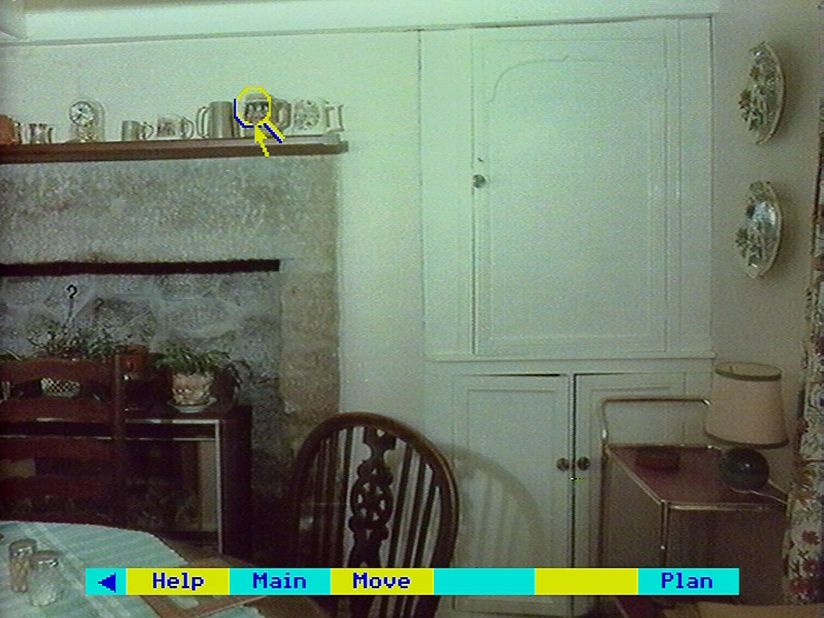

The first detailed shot of an ornament is shown. You can look to the right of this by pointing to the right of the screen and pressing [CHANGE]:

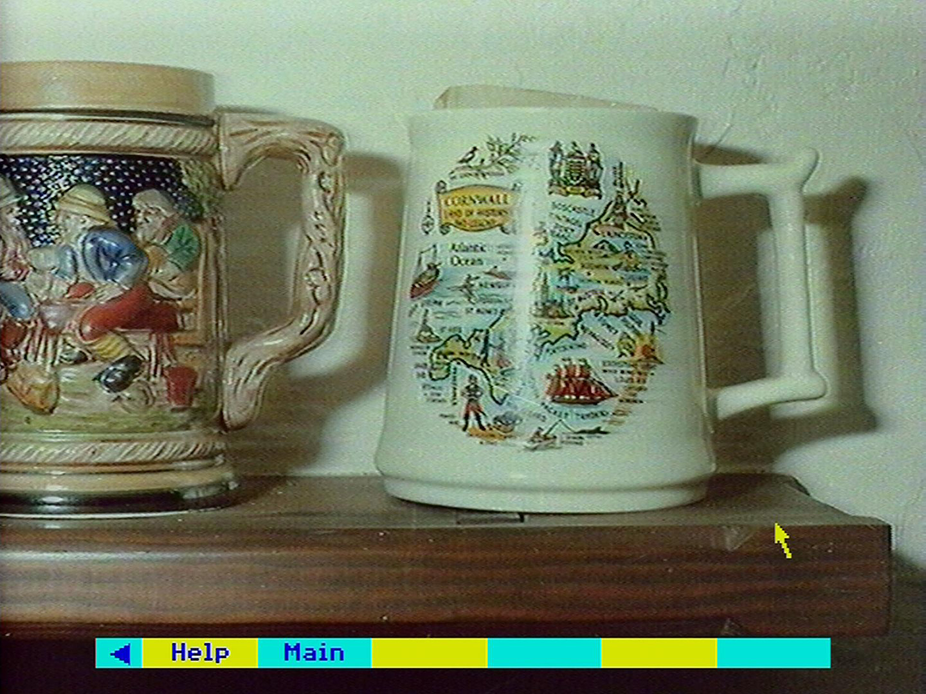

The ornament to the right is displayed:

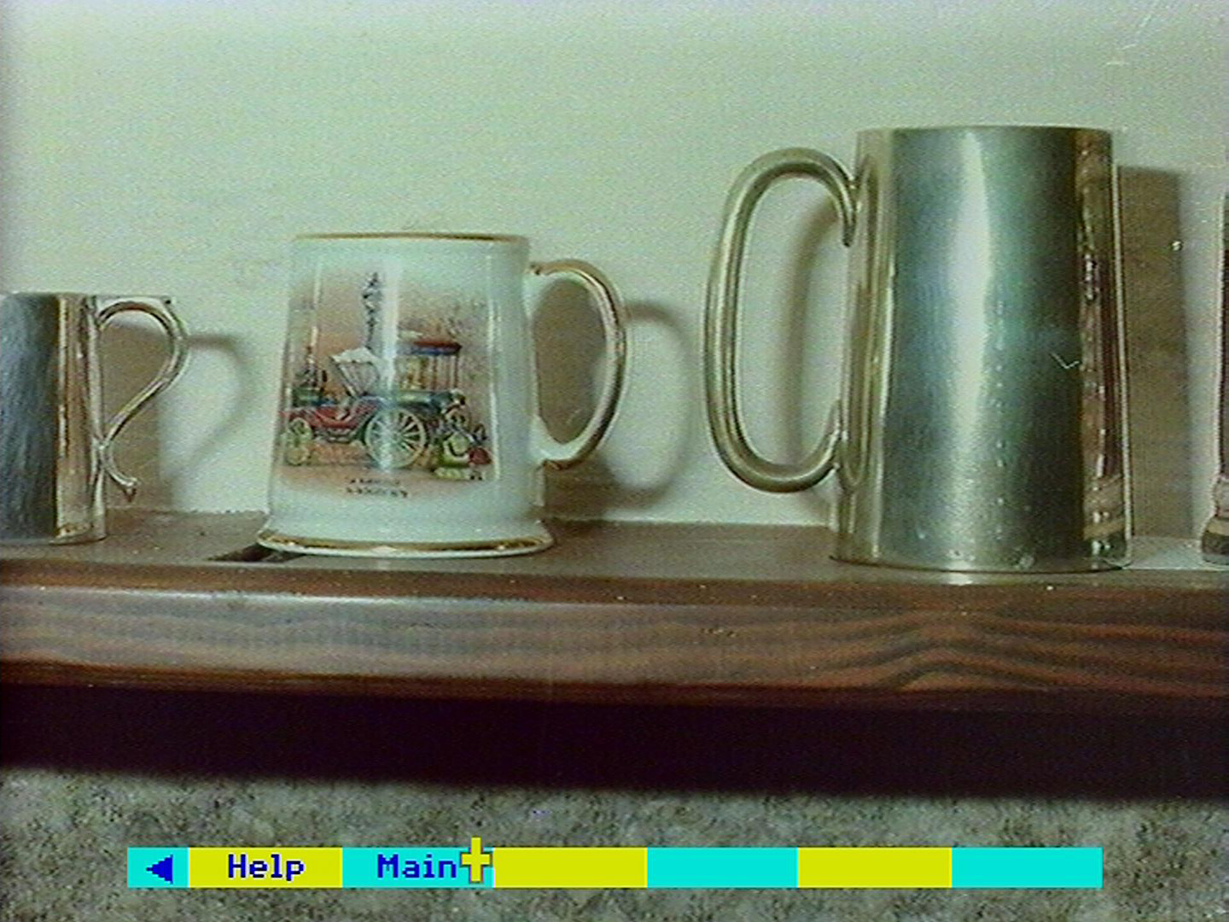

## Viewing the film and video clips

Film and video sequences with sound are held on side B of the National Disc. This section describes how to find and view them.

About 120 short clips have been assembled as a record in moving images of the 1980s. Most are news or sporting events that were familiar and memorable during those years. Because they are so short individually, we have linked them into seven montages - one for each of the seven years from 1980 to 1986. Within each montage the events are arranged chronologically.

Each montage appears in **Find** or **Content** lists as "Images of 1980" etc. However, it is keyworded by the major topics that are included within it. Thus "Images of 1983" can be found by entering the keywords "Miners' Strike". When you reach the montage, it will be shown from the beginning and you may have to wait for a few minutes for the first clip on the miners' strike to appear. Each year-montage lasts about 10 minutes.

This side of the National Disc has been recorded 1n a long-play format (CLV) to increase the playing time from 34 to 60 minutes. This does, however, mean that the sophisticated superimposition and control by the micro is not possible on this side. It also means that you cannot boot up the system from this side of the disc. Begin with side A, find the film items you want, then turn the disc over when prompted. Alternatively, you can run this side of the disc without the Domesday software at all or even a micro. The video disc player will play through the complete side or you can select chapters one to seven with the handset.

### Viewing the video clips

A video clip can be found in four ways:

1. by choosing it from its title in a **Find** list
2. by choosing it from the hierarchical **Contents** list
3. by entering its name directly in the **Find** option

The point to note is that these access options only operate on side A of the National Disc. Once you have turned over the disc to watch a piece of video, you cannot use these methods again until you have selected **Main** and turned the disc back to side A. While on side B, the only access path you have is to the other video sequences by:

1. choosing from a list of the seven video sequences.

This is the usual sequence of events. You come to an item marked as "Film" in an item list from **Find** or **Contents** (everything is referred to as "film" even if it's strictly video, since "film" is the shorter word!) Select this item with the pointer in the usual way.

You will now see a message telling you that this sequence is on the other side of the disc. You are then asked: "Do you want to eject the disc (y/n)?". If you enter "N" (or make any other response than "Y" or "y"), then the prompt disappears and you are free to make another selection from the list or the menu bar. If you enter "Y" or "y", then the disc will stop spinning and the drawer will open. You can then turn the disc over and shut the drawer. The disc will then spin up to speed and the video section you have asked for will be played. Putting in any disc side except side B of the National Disc will produce an error message. At this point you must either put in the correct side or re-boot the system.

While the film sequence is playing, no menu bar is displayed on the screen because you have very little control. In fact, the only key that will affect this display is [ESCAPE]. As usual this means "reset" to the primary state on this side of the disc. In this case this is the simple menu of the seven video sequences. So, if you press [ESCAPE] the video sequence will stop and you will be taken back to this screen:

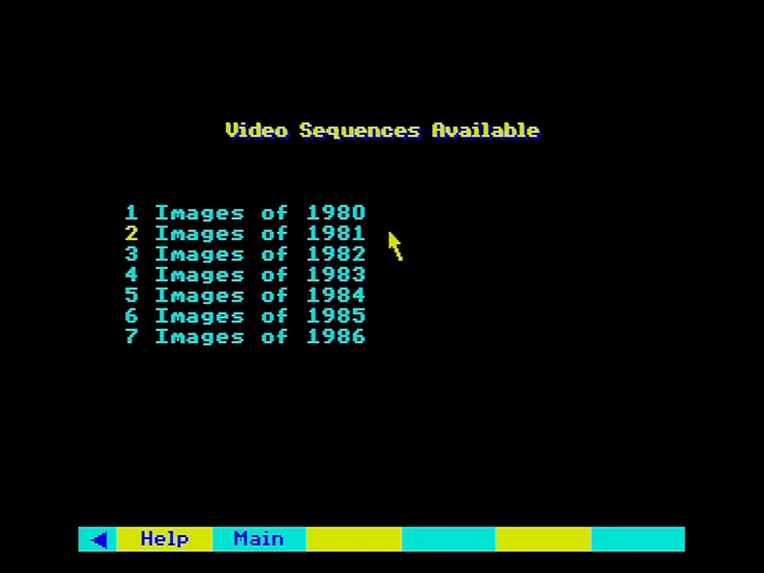

Figure 37 - Video sequence selection

Now the menu bar and the pointer have returned. Use the pointer in the usual way to select any of the video items you want to watch. Alternatively, select any of the boxes on the menu bar.

**Help** will give you a simplified page of text describing how this operation works. It must be limited in size and cannot include all the usual **Help** features. For example, there is no option to bookmark a film sequence. A wider help text is available on side A. You can select it after choosing a film item and before turning over the disc.

**Main** will prompt you to turn the disc back over. If you do so, you will be taken back into the access path you came from and you can move on from there.

### For example – To watch the first London Marathon

Select the Find option and enter “London Marathon”:

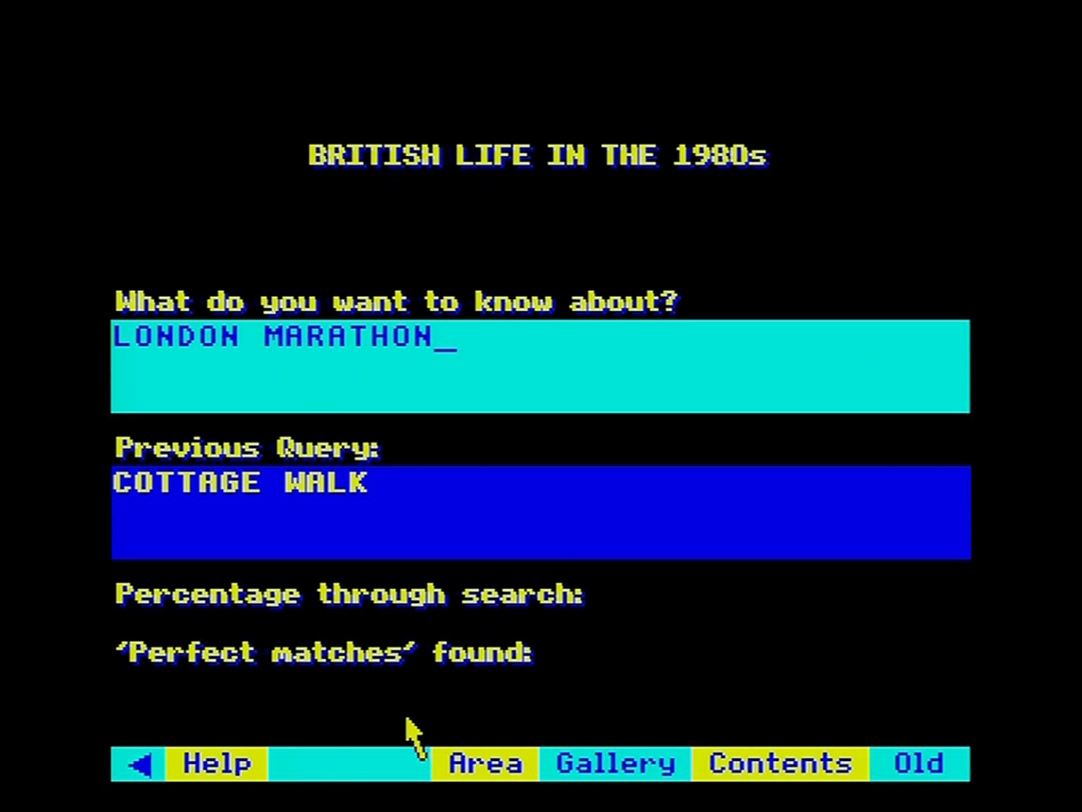

The hit list appears. Choose item 2 “Film images of 1981”:

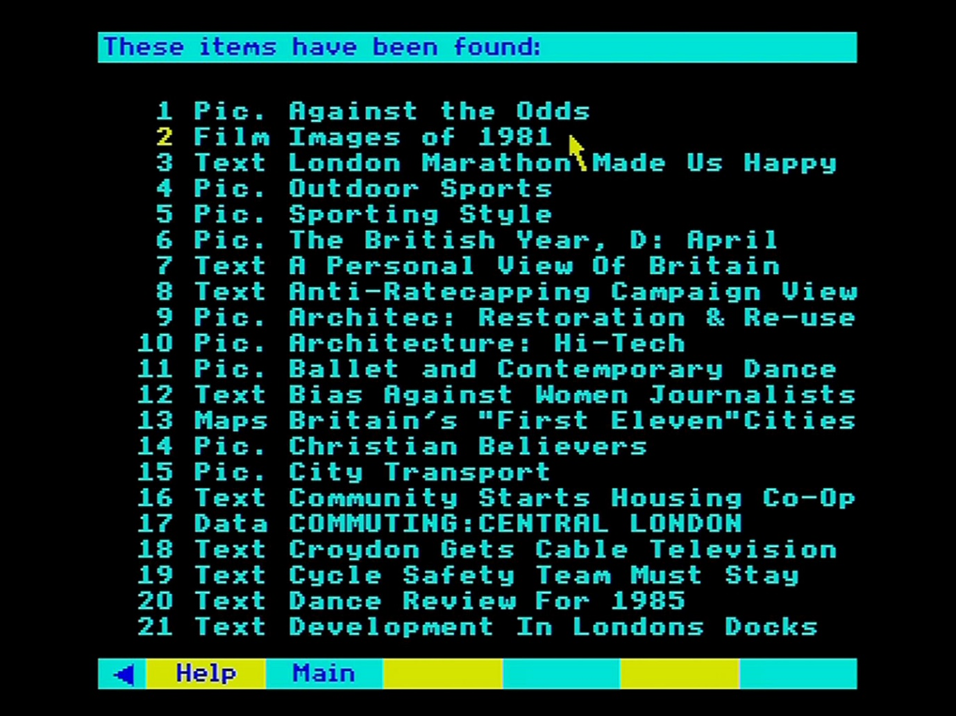

When the prompt appears requesting you to turn over the disc, enter [Y] and then turn over the National disc once ejected:

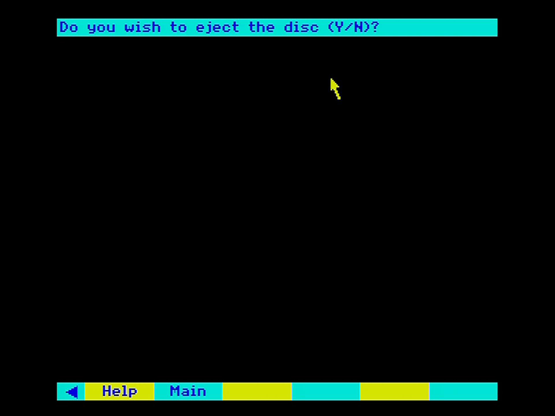

After the disc has finished spinning up to speed the video sequence “Images of 1981” is shown:

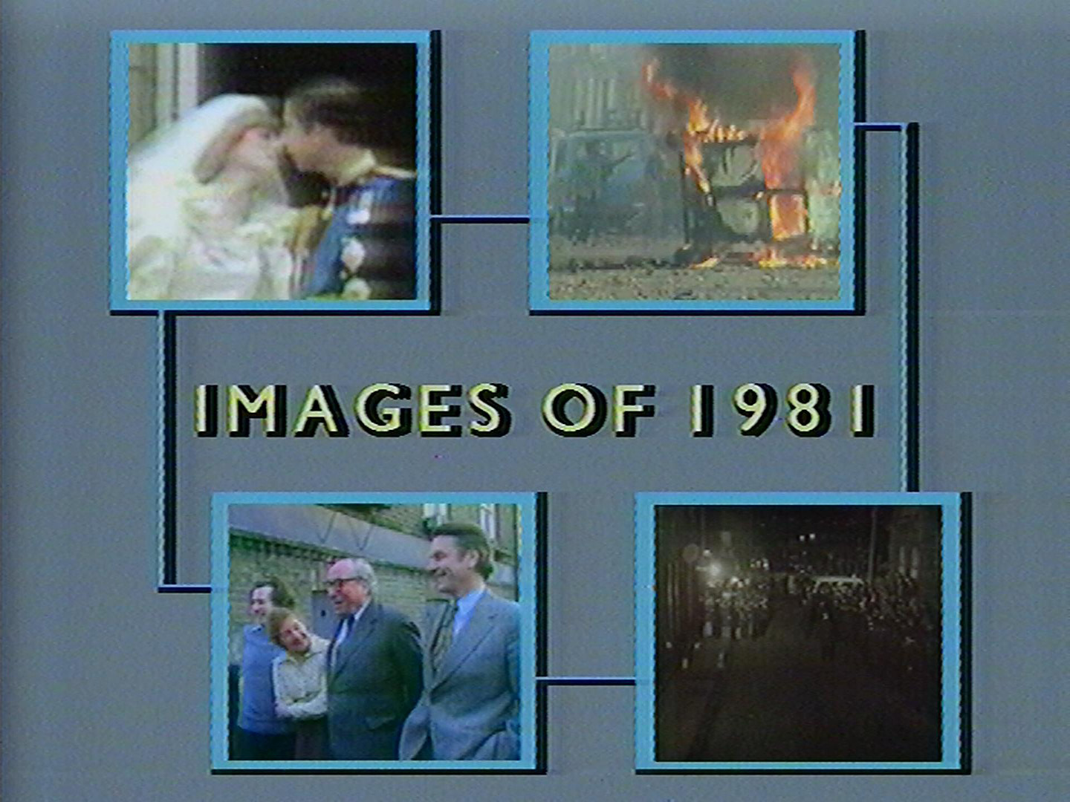

This segment will include the section on the London Marathon (there is no method to go directly to the section; you will need to watch the preceding sections first):

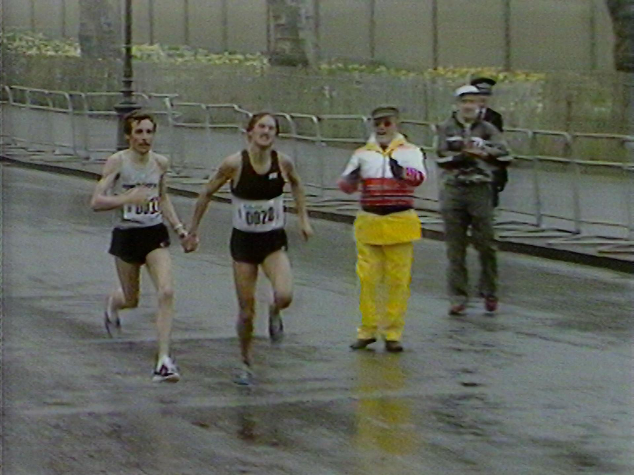

Once you are finished press [ESCAPE] to leave the video sequence and return to the menu. From there select Main with the pointer and press [ACTION] to return to the National Disc (side A):

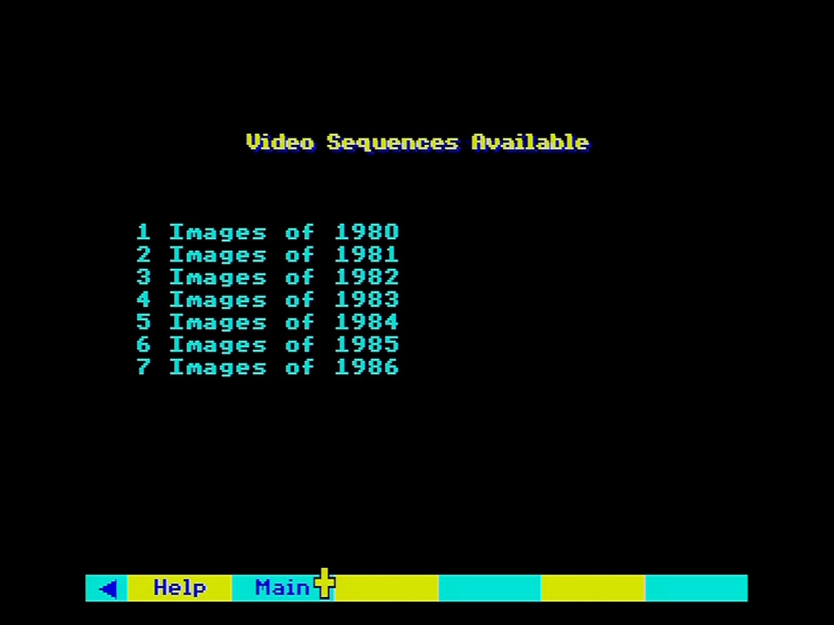

## An introduction to numerical data on the National Disc

This section outlines the nature of the numeric data held on the Domesday National Disc. It does not go into the ways this data is displayed on the screen, which are dealt with in detail over the two sections following.

### Sources

The statistical data on the National Disc is a cross­ section of the "hard" information about the UK currently held in the public domain. It is drawn from virtually all the country's recognised sources of quantitative information, both in the public and private sectors. The major government reports and surveys are represented, including the 1981 Census, together with a very wide range of specialised studies from public bodies and research institutions. Information has also been contributed by commercial research agencies, companies and from the BBC's own holdings.

The spread of topics covered in the National Disc data, and the level of detail available for each subject, is broadly representative of the relative attention each subject has received in the UK's research programmes over the early 1980s. Inevitably there are imbalances and gaps. For example, there is a very large number of statistics on employment from the currently intense activity by government and researchers in this area. A similar depth of statistical coverage in other subject-areas, such as natural history, is harder to achieve. Environmental data is not monitored to the same extent and whilst the Domesday Project includes results from a wide range of studies in progress, many are limited in the areas and detail they cover. Finally, some subjects do not lend themselves to monitoring in numerical terms. There is comparatively little statistical data on fine art, for example, which is better covered in pictures and text.

The National Disc cannot provide exhaustive quantitative information on all subjects. Its scope, nevertheless, is an informative reflection of how the UK chose to measure itself and its progress in the 1980s.

### Different types of data

There are various types of numeric data on the Domesday National Disc and the system handles each of them slightly differently. It is therefore important to be aware what kind of data is currently being dealt with, as the options available to you will be limited by the type of data you are using.

#### Mappable versus tabular

Mappable data consists of statistics which relate to geographical areas. The population of each county, the presence of a certain species of butterfly in each 10-kilometre square and expenditure on library services in each Local Authority are all examples of mappable data. These items are shown in hit-lists with the prefix "Maps".

Tabular data consists of general statistics which are not particularly related to geographical areas, but classified according to a variety of other general factors. TV viewing preferences broken down by type of programme, age-range and demographic group is an example of tabular data. They are shown in hit-lists with the prefix "Data".

#### Grid-mappable versus areal-mappable

Within the broad category of mappable data there are two sub-types, according to the kind of geographical unit to which the data refers.

Grid-mappable data is mappable data recorded for regular map-squares either 1km squares or multiples up to 10km squares.

Areal-mappable data is mappable data recorded for irregular areas of the map. There are twenty-two standard types of irregular area recognised by the Domesday system, including Standard Regions, Counties, ITV Regions, Postcode Areas, etc. These are referred to as "areal units". When you come to use areal units, for example in the **Area** function, you can see a list of their standard names by calling up the **Help** sequence.

Hint:

Where a data set appears in both forms, we have used the conventions of ending the name of the grid-mappable version with a full stop.

#### Incidence and category versus quantitative

Quantitative data is the normal situation where the numeric values recorded measure a quantity of some sort and the relative magnitude of each value is meaningful against an understood scale, e.g. 10,000 people, 55% car-owning, £9,500 per annum, etc.

Incidence and category data is a special kind of mappable data where the values recorded are not quantitative measurements but simply an indication of the presence or absence of some feature (INCIDENCE) or are acting as references to a series of discrete categories (CATEGORY). For example, data on the distribution of species are often incidence data sets, with the species either being observed or not observed in each geographical area. This type of data consists of the numeric values 0 and 1, but these are purely nominative and have no arithmetic value.

Similarly, the Domesday Community Survey assessed land-cover in 20 standard categories. This data is recorded as numbers between 1 and 20, but the quantitative values are meaningless.

#### Additive versus non-additive

Data is additive when different values recorded in the set of data can be added together to produce a meaningful total.

Data is non-additive when adding up values from the set is not meaningful.

For example, if a set of data includes the statistics that 8,000 new council houses were built in one Local Authority and 10,000 in another, then it is meaningful to say that 18,000 new council houses were built over the two Local Authorities. This data is obviously "additive". By contrast, if another data set records that in one Local Authority 90% of homes are owner-occupied whilst the percentage is 30% in another Local Authority, then it is nonsense to add these two values and say that over the two Local Authorities 120% of homes are owner-occupied. Such data is "non­ additive". By definition, "incidence" data is non-additive since the values recorded are indicators rather than real numbers and so are incapable of arithmetic totalling.

Hint:

A word to sceptical readers who think it would be trivial to solve the percentage-combination problem quoted above by averaging the 90% and 30% to a meaningful 60%. Not so: we can only produce a meaningful combination if we know the underlying absolute numbers, which is a totally different set of data. To illustrate this, suppose the first Local Authority has 5 million homes and the second has 1 million. The 90% of the former therefore works out at 4.5 million; the 30% of the latter at 0.3 million. The total of owner-occupied homes therefore is 4.8 million which over the total of 6 million homes over the two areas represents a combined 80%!

#### Counts versus ratios

This is a slight variation on the additive/non-additive distinction with relevance to mappable data.

Mappable COUNT data is additive data of the type discussed above, recording the absolute number or amount of a real commodity measured over the area, for example the total number of cars in an area.

Mappable RATIO data is non-additive data as described above, recording a relative value, e.g. the number of cars per household in the area.

The importance for data mapping is that to draw a map of COUNT data, whilst apparently reasonable, is usually meaningless in practice. For example, if you were to draw a data-map showing the number of cars in each county you would simply be demonstrating the trivial fact that the larger counties tend to have more cars than the smaller counties. You will argue that you are in fact looking for an anomalous county, i.e. a large county with few cars, but this is far better achieved by plotting RATIO data, i.e. the number of cars per household. In general, unless you really know what you are doing, it is best never to map COUNT data. The difference between count and ratio data is often clear from the item name, e.g. "% CAR OWNERSHIP" indicates ratio data; "BANKS: AMENITIES COUNT" indicates count data. When there is doubt, the data text accompanying every data set will clarify the situation. To access this text, see the sections on the TEXT option in the two following sections.

### Organisation of data in data sets

Numerical data on the National Disc is organised into many data sets, each identified with an item name of up to 30 characters and accompanied by control information informing the Domesday System what kind of data this is, how it has been indexed and classified within the system, and parameters which the system will need when it comes to access this data.

You can forget about the control information; it is there for the system's use and won't concern you in practice. Note, however, that it includes default specifications for an initial display of the data on which you can begin to work with minimum preamble.

Hint: Check data text pages

Don't worry if the initial display of a data map seems to be rubbish, for example, all the same colour. The default is usually set to cope with the spread of data over the whole country and the section of this displayed initially for you may not look all that sensible. But if you get a strange map, you can change it immediately to something more meaningful. See the section on the LOCAL/NATIONAL options in the next section.

As mentioned earlier, each data set also has a set of associated text pages written by the experts who prepared the data for the disc and offering important guidance on the use of this data. Most surveys have specific objectives and quirks in both methodology and results. It is important to appreciate these factors if the data is to be interpreted sensibly and the value of studying the data text carefully cannot be overemphasised.

Each mappable data set contains values of a single statistic listed for all the geographical areas in which it is available. Thus, the percentage of unemployed people who are aged under 24 will be held in one mappable data set, with all the percentages listed for Counties, Standard Regions, kilometre-squares of various sizes, etc., depending on what areas have been measured for under-24 unemployment. Similar data on unemployment in the over-24 age group will be held in a quite separate mappable data set, as will each mappable statistic on climate, economy, and so on.

By contrast, TABULAR data sets are compiled as large, multi-dimensional tables which contain statistics for many different groupings.

The main effect of the limited scope of each mappable data set, as compared with the much broader scope of tabular data sets, is that comparisons of mappable data will involve a great deal of comparison between data sets. Comparisons of tabular data will all take place within the one data set, comparing one subset with another.

### Meaningful displays of raw data

The National Disc system concentrates on displaying numeric data in colourful and meaningful screen displays rather than as tables of figures. This absolutely does not mean that you are only receiving a pre­arranged presentation of the data each time, as you would in a reference book or report. The basic philosophy of Domesday is to give you access to the raw data you need to construct your own displays of the data and enable you to draw your own conclusions about its meaning. Therefore, the data on the disc is stored as raw values and there are ways to display these actual numbers. However, the main emphasis is on revealing patterns in the data and allowing the user to change and refine the screen display.

Mappable data is usually displayed as a transparent coloured overlay on top of a video map. We call this a **data map** and it looks like this:

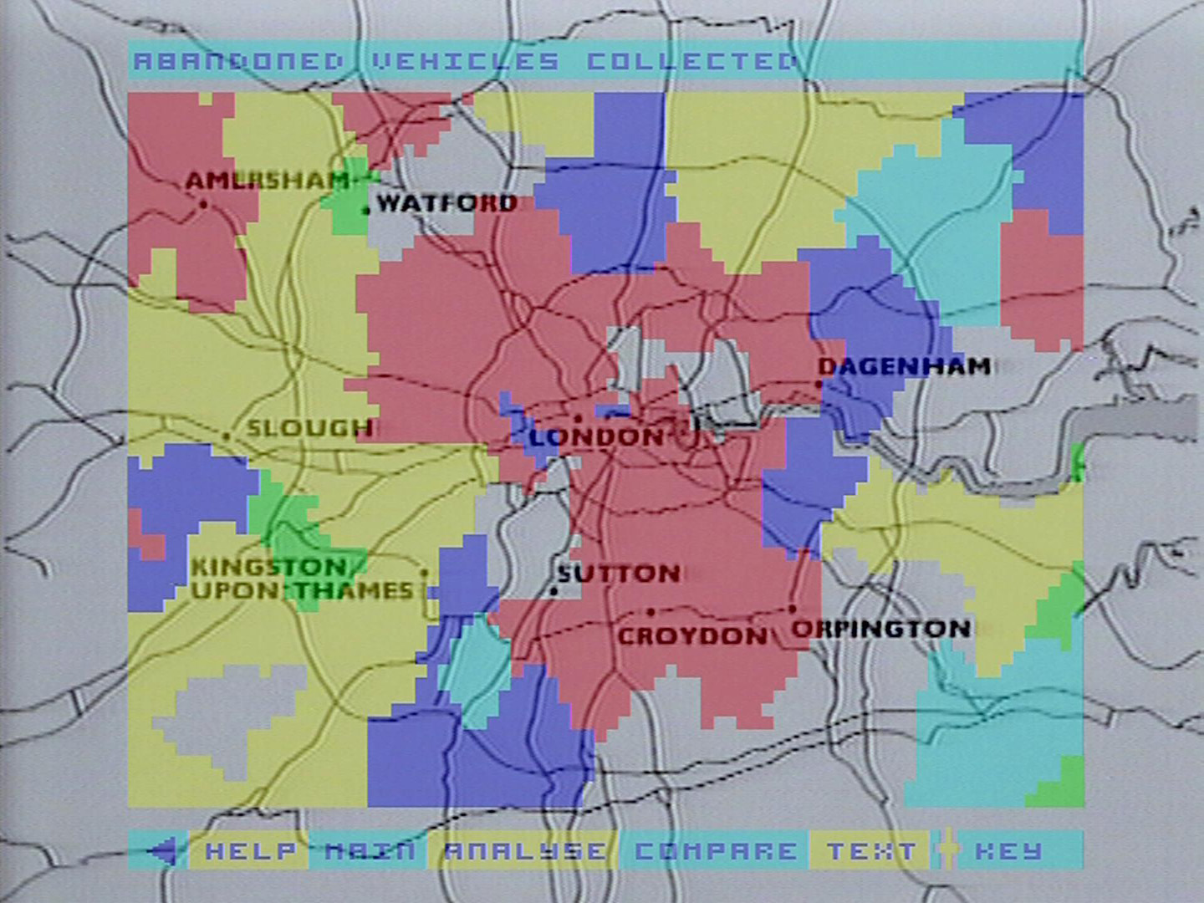

Figure 38 - Data map example

Tabular data is displayed in a range of statistical diagrams such as bar-charts, pie-charts and line -graphs. We call these **data-charts** and they look like this:

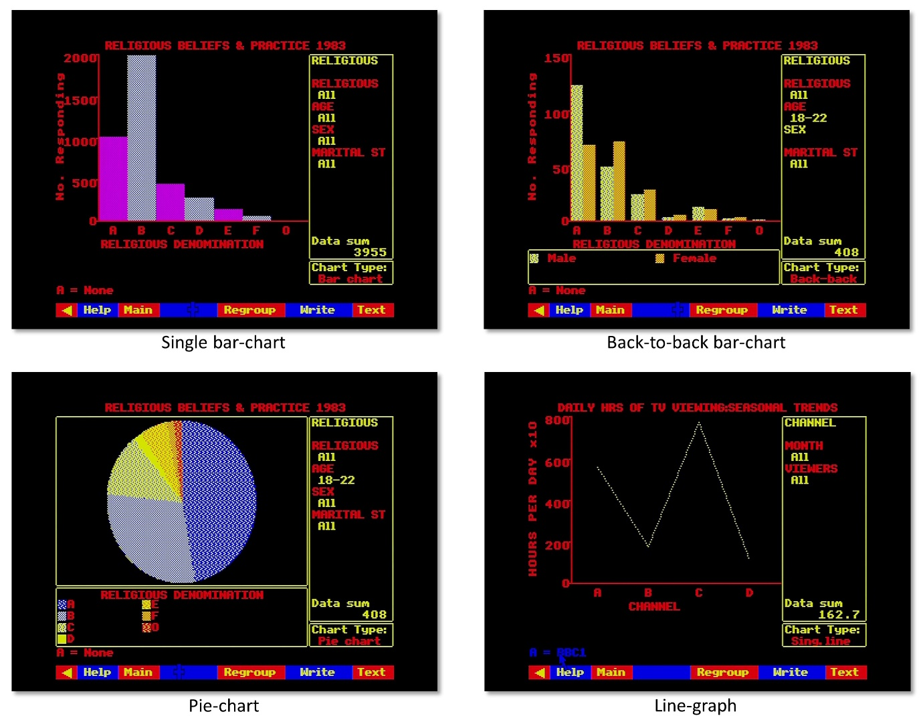

Figure 39 - Data chart examples

The next two sections describe how to build and work with these displays.

You need not worry about which display procedure handles which type of data. The system automatically adopts the correct mode when you select a numeric data set of any kind. Equally, you need not try to remember what processes are possible with different kinds of data. The system will monitor your chosen data set and guide you through what is available.

### Reprocessing to enable comparison: your chance to be a pioneer

In many cases, particularly in mappable data, the actual statistics recorded on the National Disc, though still an accurate representation of the original raw data, are the results of expert re-processing to enable comparison of data from different sources. For example, Domesday's own community survey counted amenities in each kilometre-square. Population statistics, by contrast, are collected in irregular areas known as "enumeration districts". Amenities per head of population, therefore, can only be calculated by converting these two statistics to a common basis.

Wherever possible, the Domesday system uses the kilometre-square or its multiples as the common basis for mappable data. Thus, raw data has been re-calculated by kilometre-square for the National Disc. This re-processing of vast banks of data is so time-taking that much of it has never been done before. You should be aware, therefore, that many of the comparisons you will make between Domesday data-sets could be for the very first time and it is impossible to predict what new relationships may be waiting for you to find.

### Rasterization of irregular areas

To understand how the Domesday System copes with irregular areal units, you need to be aware of a process known as rasterization.

Hint:

If you already know about this concept, simply skip through this section to see how we use the terminology.

As an example, let us take an irregular geographical area. It might be an ITV Region, a Postcode Area, etc., but this is immaterial. Mapped conventionally, it could look as follows:

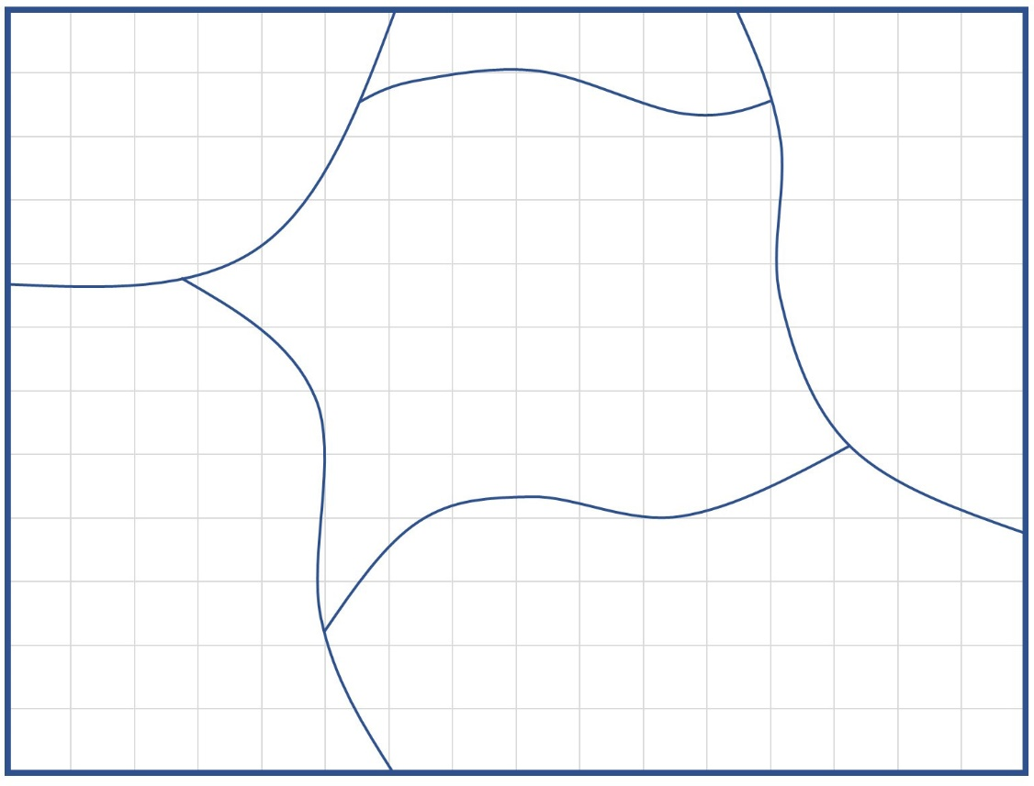

Figure 40 - Example areal unit

Notice that, as in a real map, the areal unit we are interested in, though central on the map, is not the only area shown. Bordering our area are parts of all the neighbouring areas of the same type.

Now, let us say that the grid lines on this map represent 1km squares. We could approximate the boundary of our area as a series of small vertical and horizontal steps along the edges of grid squares. The resulting approximate boundary compares with the original as follows:

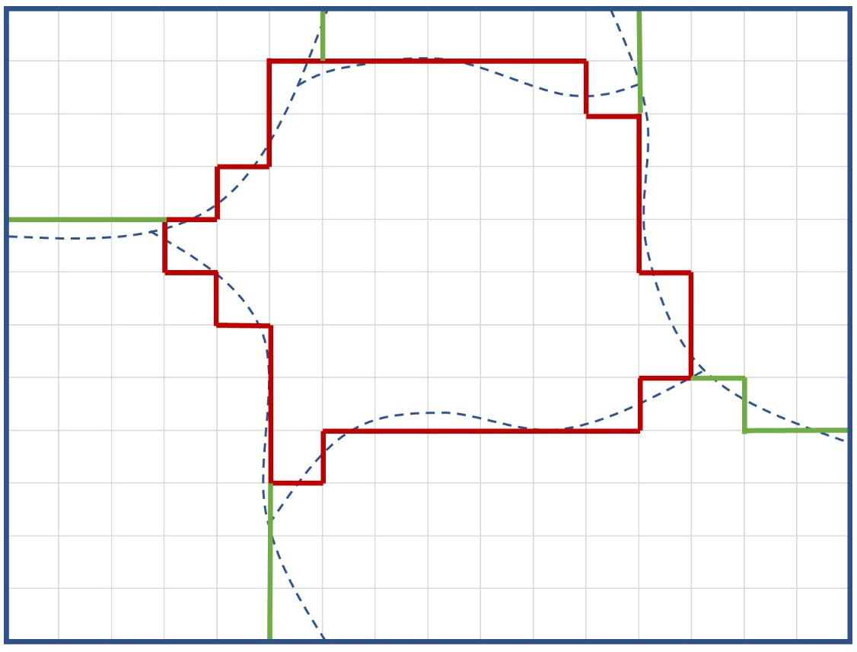

Figure 41 - Approximation using 1km squares

This process of approximating smoothly curved outlines by a series of vertical and horizontal steps is called rasterization. In our example, the resolution of the raster is 1km. That is, the size of the elementary steps making up the rasterised boundary is 1km. We could coarsen the resolution by using larger steps, for example 2km:

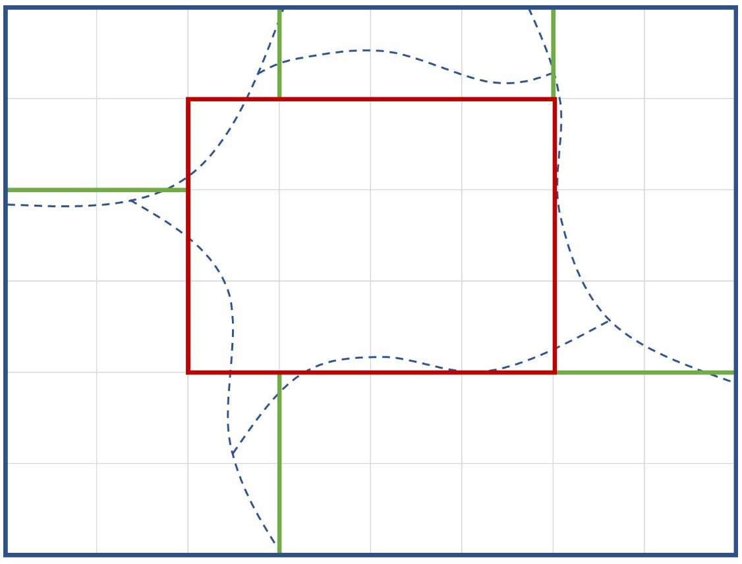

Figure 42 - Approximation using 2km squares

This new outline is a very much worse approximation to the original. On the other hand, it uses a much smaller number of elementary line segments which would allow faster computation.

All irregular areas on Domesday data maps are in rasterised form and the range of possible resolutions depends on the data set. For example, much environmental data is only available at the coarsest 10km resolution. Again, you need not worry about this: the system guides you.

## Displaying and manipulating data maps

Mappable data is displayed as a coloured overlay on top of a video background map, with the overlay made transparent so that the details of the map can be read through it. This is in some ways the Domesday System's most powerful means of data analysis, with literally thousands of statistics presented and manipulated in a single type of screen display.

It is worth bearing in mind as you build a Domesday data map that you are accomplishing in a few minutes what would take a professional cartographer or statistician perhaps weeks of work by conventional means. In fact, you will often be producing data displays which have never been seen before, simply because of the prohibitive amount of work required.

### Three main elements of a data map

There are three main components of every data-map:

1. The mappable data set you want to examine
2. The area of interest
3. The elements which make up the overlay: either grid squares or areal units

The **mappable data set**, as seen in the section “An introduction to numerical data on the National Disc”, is a series of values for a single statistic which you have identified as being of interest to you, listed for all the geographical areas over which it has been measured.

The **area of interest** is the geographical area over which you wish data to be mapped and therefore determines the background for your data map.

The elements of the overlay are the individual colour-coded areas which represent the actual data. They might be **grid squares** of between 1km and 10km or one of the standard areal units recognised by the Domesday System.

Perhaps these concepts could usefully be illustrated in an example:

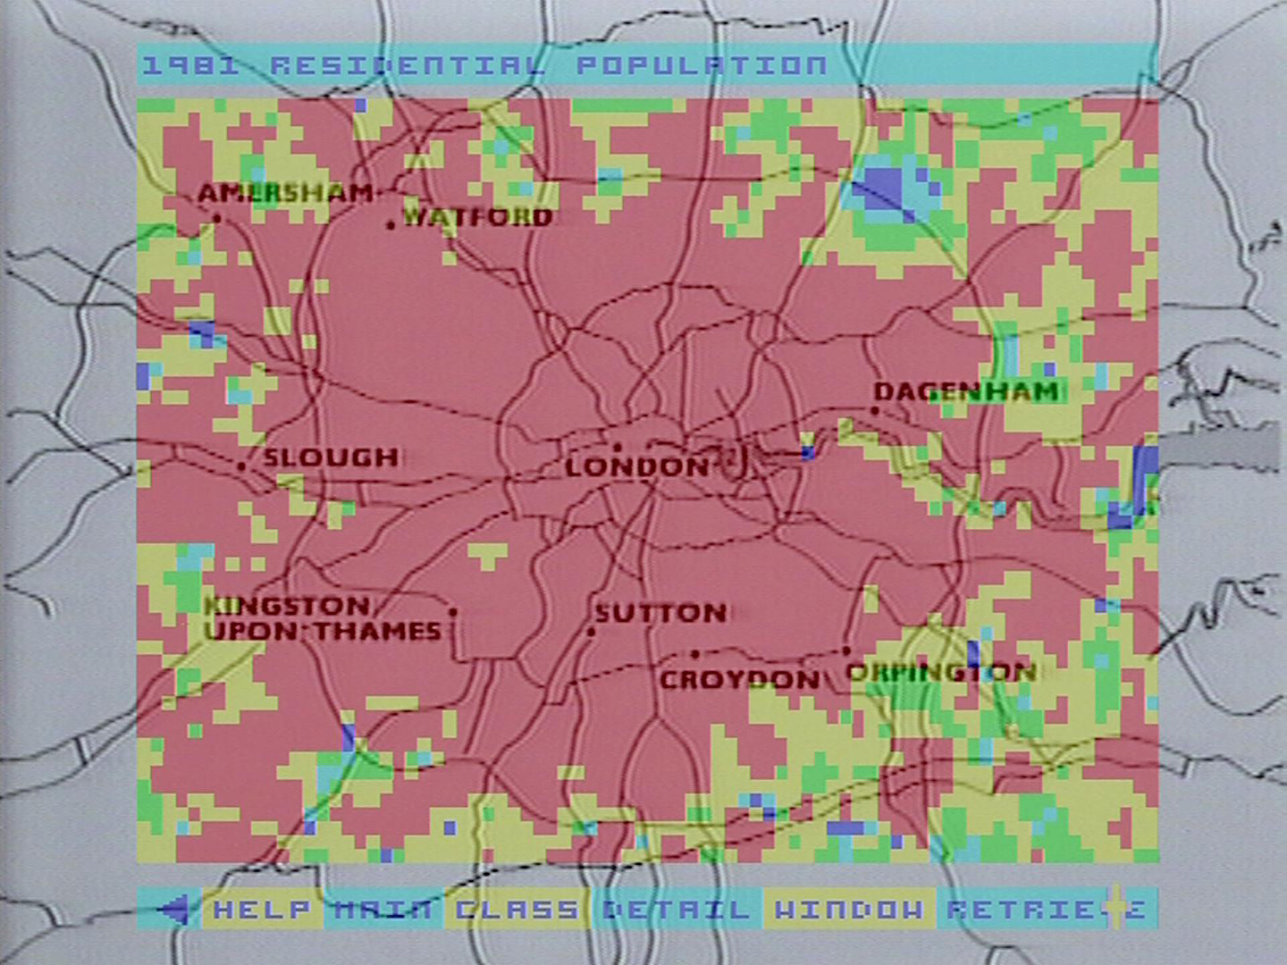

Figure 43 - London population map overlay

In this display the background video map shows the Greater London area. The boundary of this map is a rectangle which covers the area of interest. The mappable data set displayed in the overlay is population data derived from the 1981 Census. The overlay is made up of coloured squares 1km x 1km. Thus, the elements of this overlay are 1km grid squares.

### Entering the data-mapping procedure

You get into the data-mapping system by using one of the index-search methods (either **Find** or **Contents**) to identify a hit-list of items which refer to the subjects in which you are interested and then select a mappable data set which you would like to display. These have the prefix "Maps". The system will automatically invoke the data-mapping procedure.

When it comes to display a mappable data set for you, the system will assess what instructions it has. From your index-search it knows the name of the new data set you want to see, but how does it decide on an area of interest to show you? In fact, the system will always remember the last area of interest you specified and immediately use that again. Thus, if you have previously drawn a data-map during this session of using the disc, then your new map will be drawn over the same area of interest as last time. This allows you to map several different data sets over the same area of interest without having to repeat the control specifications each time. In fact, it can even be easier than that. If you want to build a string of map overlays, one after the other, then you can do them all without ever leaving the data-mapping system, as will be described later in the **Name** sub-option.

Suppose, however, that this is the first data map you have drawn during this session with the disc and you have not previously specified an area of interest. In these circumstances, the system will force you to provide this information before going any further.

Similarly, if you have a previous area of interest, but you know it is not appropriate to the new data you want to see, then you can explicitly invoke the system to change the specification. Finally, if you have completed a data-map display and would like to replot the equivalent overlay for a different area of interest then you can invoke the re-specification procedure.

This procedure is called **Area** and it is described in detail in the following section.

Hint: Time saving for Data Maps

It is never a good idea to let the system go ahead and build a redundant map overlay using an old set of parameters, thinking you will change them as soon as it gets on the screen. You will waste a lot of time as there is a huge amount of processing involved and a finely detailed map could take minutes to plot.

Also, if you expect to draw data maps of several mappable variables, it is a good idea to identify all their item-names during your index-search and before electing to display any of them. This will allow you to call them up from the data-mapping procedures without having to come back to the index all the time. It will save you a lot of time. Keep a notebook handy and note down the names of items letter-perfect: punctuation, spaces and all. There is more detailed explanation of this in the section on the Name option later.

### Area

#### Specifying your area of interest

**Area** is not strictly part of the mappable data system at all, being a main branch of the Domesday System in its own right. You will therefore see it offered on top-level menu bars alongside the primary index-search procedures: **Find**, **Contents** and **Gallery**.

The system invokes **Area** automatically if you attempt to display mappable data without having previously specified any area of interest. However, if you know you will use data maps in a session with the disc then it will be convenient to get this out of the way by explicitly selecting **Area** right at the start to set up your initial area of interest. Also, if you know you need a new area of interest for your next data map then you should always explicitly invoke **Area** to change the specification before drawing a new map. Explicitly selecting **Area** is known as the unforced condition, whereas the automatic invoking of **Area** by the system is known as the forced condition. This affects what happens when **Area** is finished.

#### The Area screen

However, it is invoked, **Area** first presents the user with a video map of the whole of the UK, oriented towards the right of the screen. On the left the system displays a series of data-entry boxes, as follows:

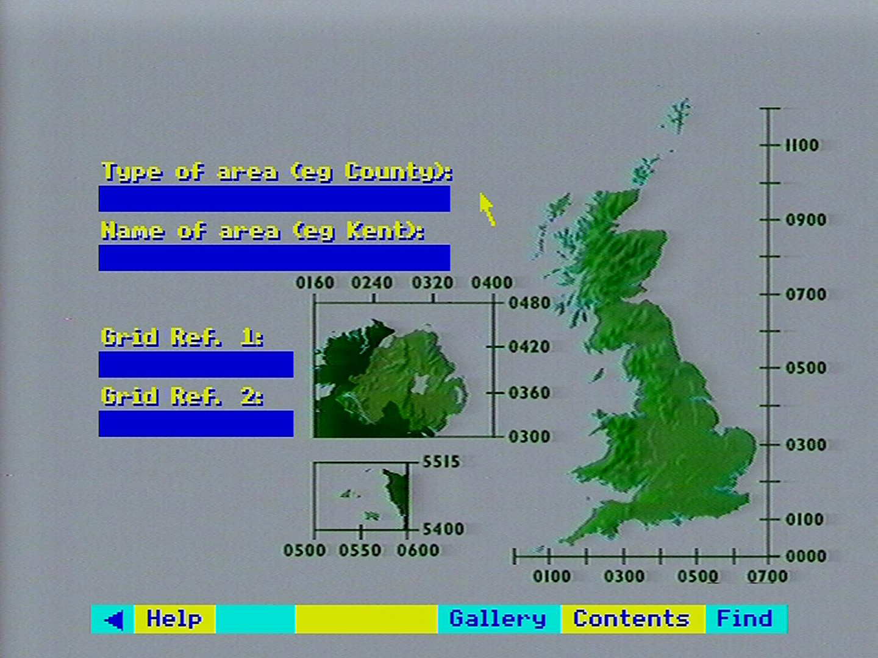

Figure 44 - The Area main screen

You will see that the other top-level index search options are available on the menu bar: **Gallery**, **Contents** and **Find**. Thus, if you find yourself "forced" into **Area** and decide not to proceed, selecting **Find** or **Contents** from the menu-bar will take you back to the list of items found in your last search, from which you can select a new item, or make a new search.

You may also see a blue rectangle already superimposed on the UK map, but only if you have specified an earlier area of interest and the system is reminding you of the boundary of the background map which enclosed it.

#### Using areal units to specify a new area of Interest

The two upper data entry boxes on the **Area** screen are designed to receive details of the area of interest for your next data map, specified as one of the standard areal units recognised by the Domesday System. You make an entry in either box by moving the screen pointer into it. It will highlight indicating that it is active and you key the entry in the normal way, ending with [ACTION].

A full list of recognised areal units is available from the system **Help**. There are 22 main unit types shown in the following list:

1. National Aggregate
2. Country
3. Standard Region
4. ITV Region best fit
5. ITV Region n/o 1
6. ITV Region n/0 2
7. ITV Region n/0 3
8. EEC Level 2 Region
9. Regional Health Authority
10. Police Authority Area
11. County
12. European Assembly Area
13. GPO Postcode Area
14. Local Education Authority
15. CURDS Functional City
16. CIPFA Library Area
17. District Health Authority Area
18. CURDS Local Labour Market Area
19. Travel-to-work Area
20. District
21. Parliamentary Constituency
22. Amalg. Employment Office Area

After one box has been keyed then the system will prompt you for the second entry. For example, having entered a "type" then a prompt will appear in the message area that a "name" is also required.

Having received both entries, if the system cannot recognise your areal unit it will beep and display an error in the message area:

**Area type not recognised - see Help**  
or **Area name not recognised - see Help**

This usually arises when you have not used the exact spelling of either entry, as used in Domesday. However, the system is referring you to the fact that the menu bar, as always, carries a **Help** option and at this stage the **Help** system includes a special option: **Areal** which will give details of the types and names of areal units, showing you the expected spelling. After reference to the **Help** pages, you can correct any error by selecting **Reselect** from the menu bar and re­ entering the specification from scratch. You should note that the data-entry boxes are not always long enough to take the full name of the areal unit. In these cases, be sure to type all the first 20 characters of the areal unit name, even the spaces, so that the system can make an exact match.

When the system recognises that a valid "areal unit" area of interest has been specified it calls up two important elements needed for the data map:

1. A specially drawn background map, stored in one of the video frames, which completely encloses the boundary of the areal unit.
2. A digital representation of the boundary of the areal unit so that the system can determine whether any point on the map is inside or outside the areal unit in question.

Given a recognisable areal unit, therefore, the system can immediately find a background for your data map and knows the region within that background which constitutes the actual area of interest.

#### Using grid references to specify a more general area of interest

Sometimes you might wish to specify an area of interest which does not match any of the standard areal units. In this case you use the lower data-entry boxes to specify your area of interest by grid references.

An area specified in this free-form way can only be a rectangle, defined by the grid references of the South-Western and North-Eastern corners. Please note that this rectangle does not have to be the same shape as the screen. It can be square, flat and wide or tall and thin.

As with the upper boxes, you "activate" either of the lower boxes to receive input by moving the mouse pointer into the box, causing it to change colour. You then key the appropriate grid reference, expressed according to either of the standard methods:

An all-numeric reference comprising a simple Easting and Northing from the National Grid origin, each in up to five digits, with a space separating the two co-ordinates, e.g.

05268 01583 (Resolution 100m, 526.8km East, 158.3km North)  
0527 0158 (Resolution 1lm, 527km East, 158km North)  
053 016 (Resolution 10km, 530km East, 160km North)  
05 02 (Resolution 100m, 500km East, 200km North)

Or the other system in which the first two digits in each part are recoded as a pair of letters.

Repeating our examples:  
TQ 268 583  
TQ 27 58  
TQ 3 6  
TQ

Please note that around each part of the UK map shown on the **Area** screen a pair of calibrated axes has been placed to help you find appropriate grid references.

You press [Action] after each entry. It does not matter which you enter first, but after one is keyed successfully, the system will remind you in the message area that the second is required. The system may also use the message area to report problems:

**Grid reference has an invalid format** means that your input is not a valid reference in either of the schemes. The entry must be re-keyed using the correct grid reference.

There are also problems arising from the fact that across the UK three different National Grids are used. The bulk of the country is on the UK National Grid, but Northern Ireland is on a separate Irish Grid and the Channel Islands are on the French National Grid.

Fortunately, Channel Islands references are always distinctive but other references are ambiguous. If interpreted on the National Grid, then they are in Great Britain but if interpreted on the Irish Grid, they are valid Northern Ireland references. To sort out any such confusion the system will ask in the message area: Do you mean Great Britain or N. Ireland (g/n)? Keying [n] will nominate Northern Ireland whereas keying [g] will nominate Great Britain.

A further error results if the two references belong to different grid systems: **Different grid systems specified.**

Please note that when an area of interest is specified by grid references, the system will not use a video background map, as the chance of finding one which adequately matches the customised area is small. Instead the data map will be plotted on a black background and the user will work with the coloured overlay alone. Other aspects of the system operate normally.

#### How you can have second thoughts

Your area of interest, whether specified by areal unit or grid references, will be drawn as a yellow rectangle over the UK map on the screen.

If you specified an areal unit then the rectangle shows the boundary of the background map which encloses the area of interest and the total background area over which the data map will initially be plotted. (Note: you can restrict the map to your precise area of interest using the **Window** function described later). Also for areal unit specifications, the system will display in the lower data-entry boxes on the screen a pair of grid references which pinpoint the South-Western (lower left-hand) and North-Eastern (upper right-hand) corners of the yellow rectangle.

If you specified your area of interest by grid references then the yellow rectangle exactly represents the defined area.

If for any reason you are unhappy with the area of interest you have specified then you can select **Reselect** from the menu bar and the system will return you to the start of the **Area** operation to begin again.

#### Return from a “forced” Area operation

You will remember that your use of **Area** will be "forced" if you asked to display a mappable data set without having previously specified an area of interest. In this case, after you have specified a satisfactory area, the menu bar will carry the option **Main** and selecting **Main** will immediately complete the data map display you originally asked for.

#### Return from an “unforced” Area operation

The use of **Area** is "unforced" if you explicitly chose to specify an area of interest in preparation for drawing later data maps. In this case, after you have specified a satisfactory area of interest, you exit from **Area** by selecting one of the main index-search options which will be offered on the menu bar: **Gallery**, **Contents** or **Find**.

These alternative options can be selected at any time during your work with **Area**, in which case your current attempt to specify a new area of interest will be abandoned and any previous specification will continue in force as the current area of interest to be used in data-mapping.

#### For example – Specification by areal unit. Aim: to specify the county of Cumbria as an area of interest

Move the screen pointer into the top entry box. The box will highlight. Type in “COUNTY” then press [ACTION]:

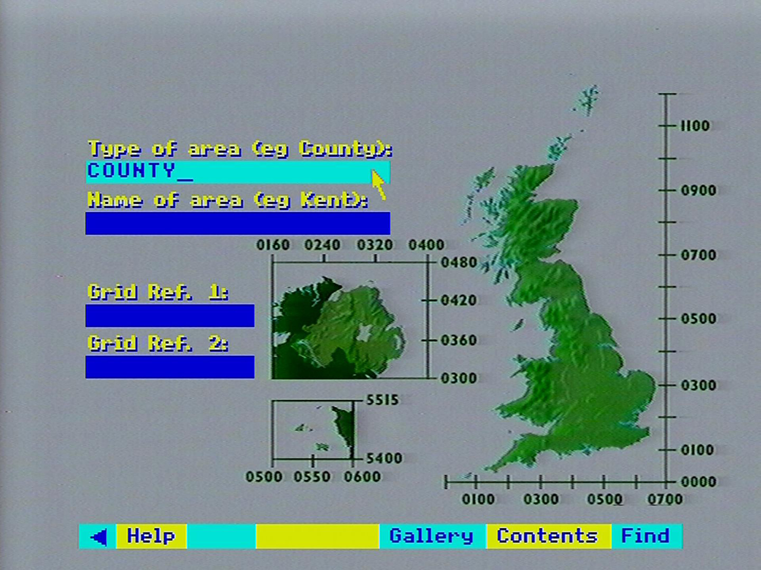

Move the screen pointer to the second entry box and type in “CUMBRIA” then press [ACTION]:

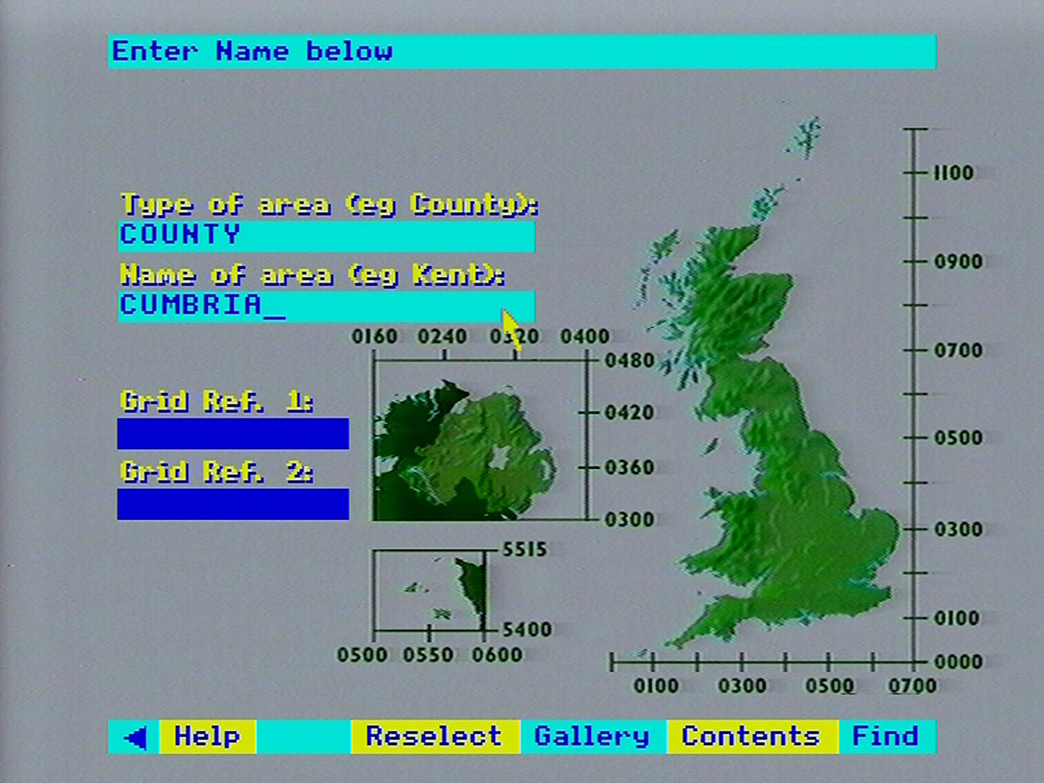

You will now see a yellow rectangle on the UK map (indicating the selected area) and grid references in the lower entry boxes:

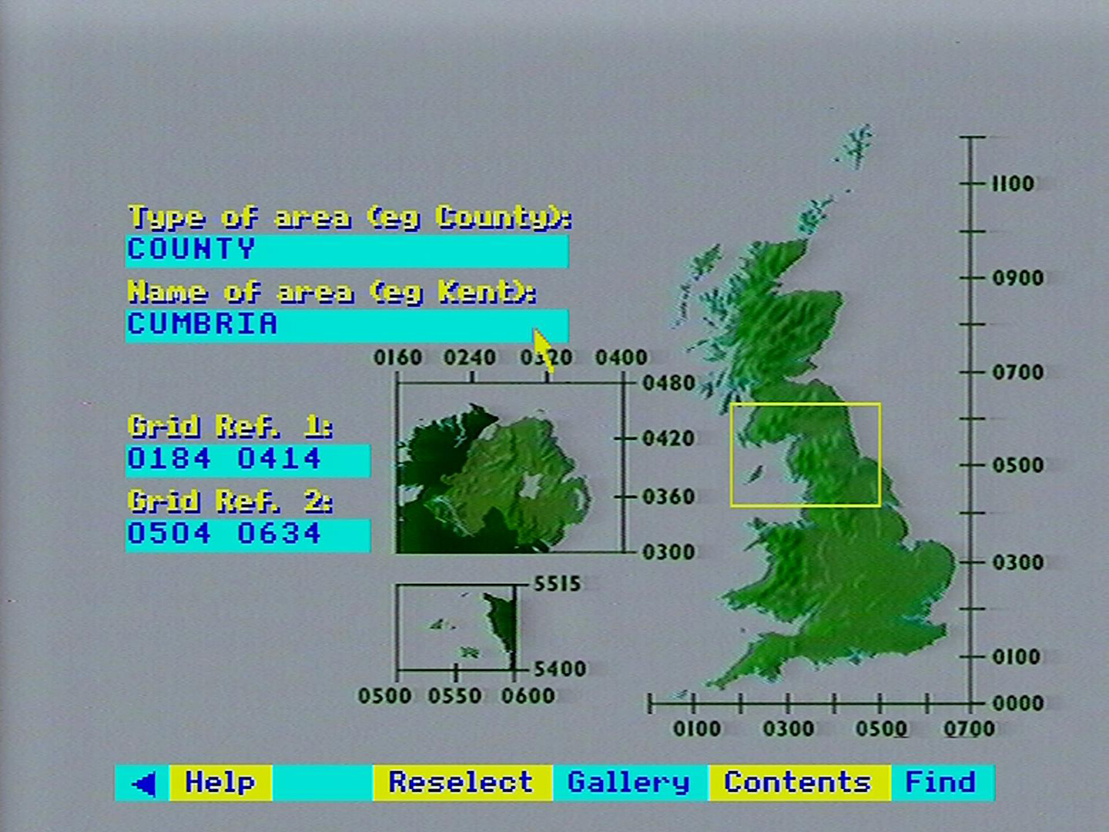

After a brief pause the system will replace the UK map with the background map enclosing your area of interest:

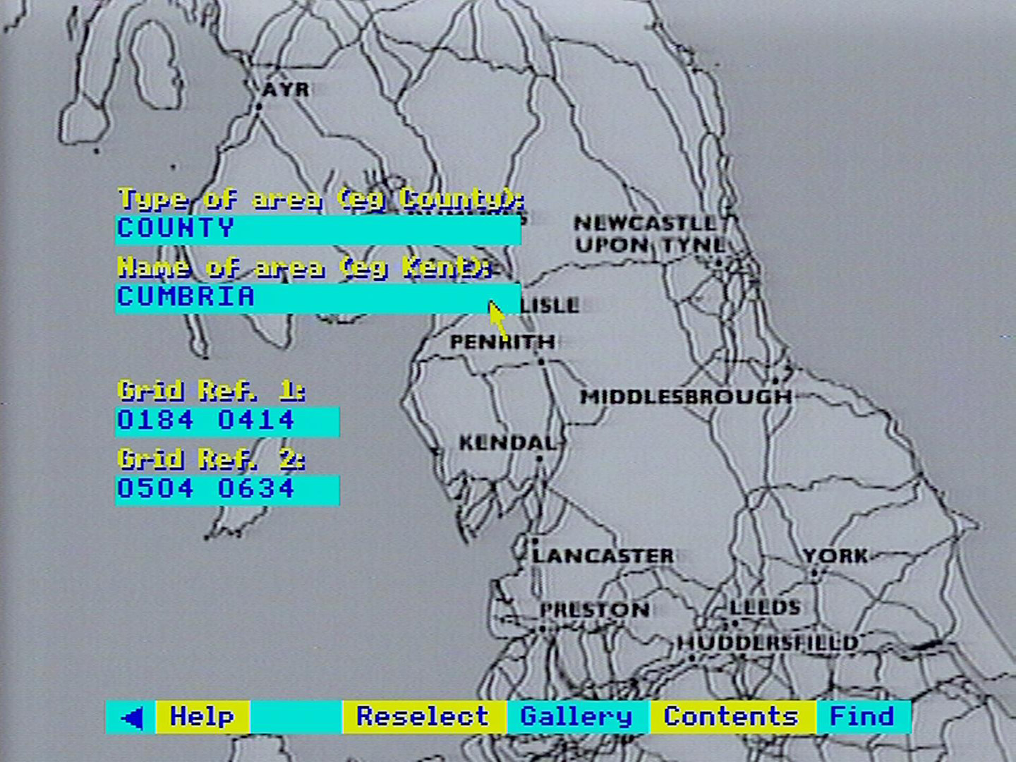

#### For example – Specification by grid reference. Aim: to specify an area of interest from 0297 0327 to 0367 0424

Move the screen pointer to the first lower entry box. The box will highlight. Enter “0297 0327” and then press [ACTION]:

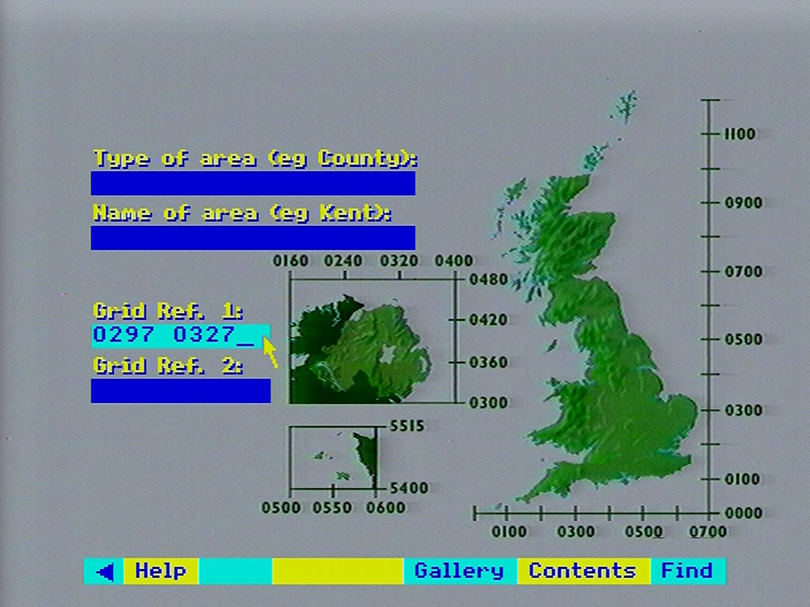

Take note of the query in the message area (at the top of the display). Press [G] for Great Britain and then press [ACTION]:

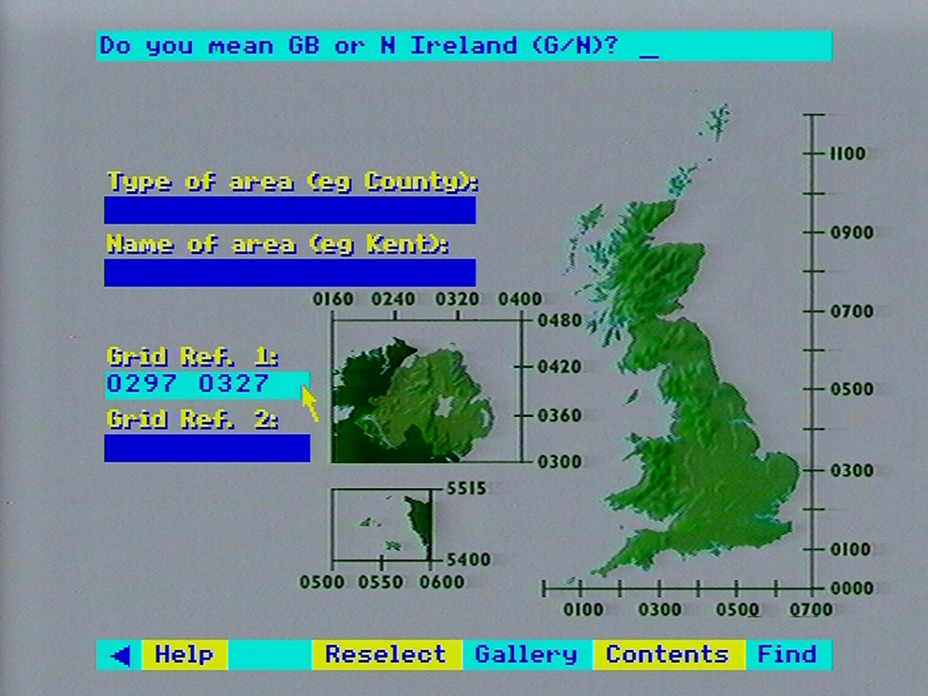

Move the screen pointer to the second lower entry box. The box will highlight. Enter “0367 0424” and then press [ACTION]:

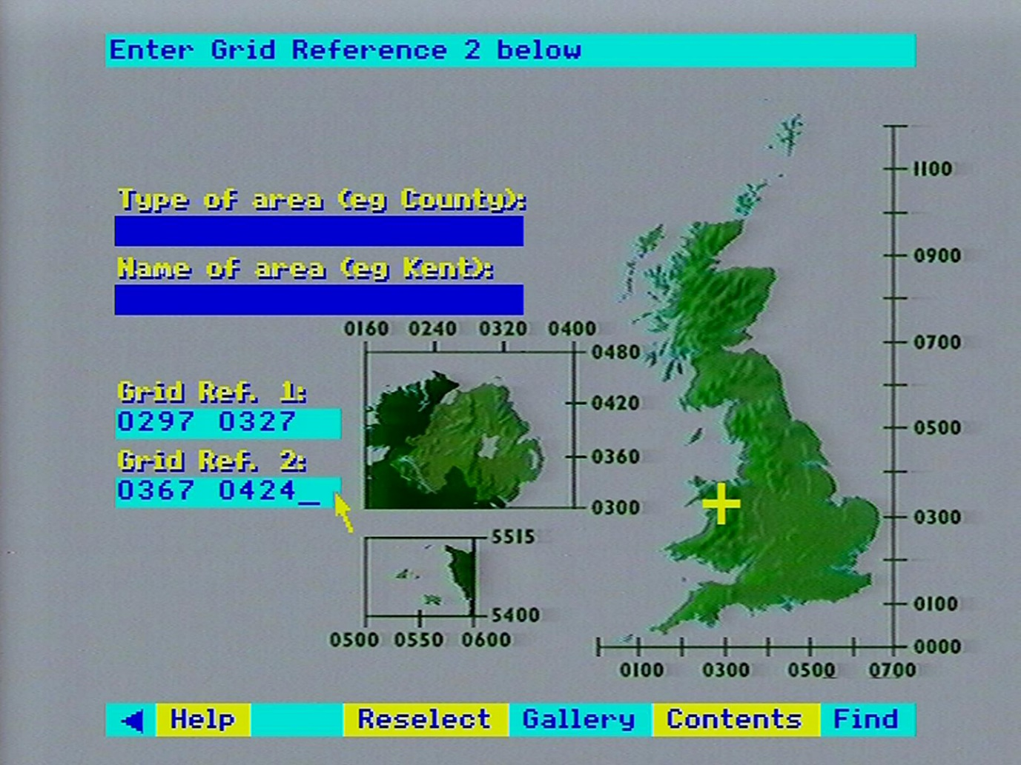

A yellow rectangle will show the specified area of interest on the UK map:

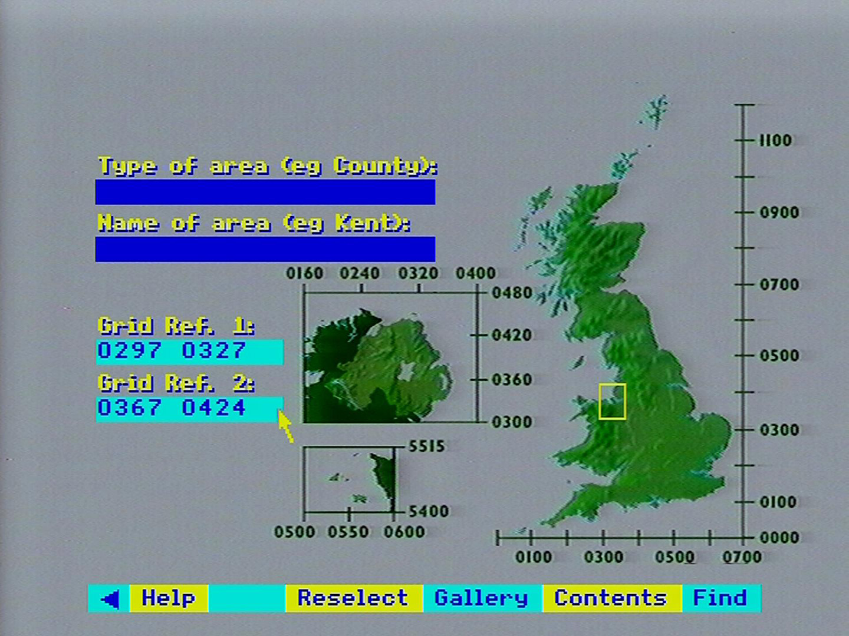

### Plotting the initial data map

You will have arrived at this point in one of two ways:

Either you selected a mappable data set to display and the system forced you into **Area** to specify an area of interest, were selecting **Main** brought you back to complete the plot.

Or

You selected a mappable data set to display and the system immediately went ahead based on an area of interest which had previously been specified, either because of a previous mapping operation during this session with the disc, or your explicit selection of Area to set up the area of interest.

Either way, the plotting of the data map is now in progress.

#### A change in the screen pointer and character set

This is very minor point, but explained for completeness. Probably the first thing you will notice is that the screen pointer changes to a coarser resolution. This is the effect of the different screen mode the plotting operation uses in which the pointer icon must be re-defined, but can only approximate the shape of the normal pointer. Similarly, the character set must be re-defined for data-maps, allowing only upper-case characters and coarse approximations for some special characters.

#### Data loading phase

The system will now display a message in the message area:

**Loading data**

This is to reassure you during the pause while it retrieves data from the video disc. It is going through the entire set of values stored for the variable you have chosen and selecting those which are within the background area enclosing your area of interest. There will be no video display during the data-loading operation.

#### Building up the overlay

The map overlay will now begin to build up on the screen. Depending on whether it is plotted in many small or fewer larger "patches", this may be a time-consuming process, perhaps lasting some minutes. You will see that the overlay is plotted in regular blocks and in coastal areas the sea appears as a single colour. You will also notice that the graphic output of the micro is converted to transparent form during the plotting of the overlay. There will be no video display of the background map until the overlay is complete.

#### Adding the background (maybe)

When the coloured overlay is complete, the system will display under it the video background map enclosing your area of interest, providing this was specified as one of the system's standard areal units. If you specified the area of interest by grid references then, as noted earlier, no background map will be displayed.

Hint: Brightening the Transparent Overlay and Menu

When the map overlay "goes transparent" the message area and the menu bar go with it and this can make them difficult to read. When you come to perform interactive manipulations on the overlay, you may prefer to toggle off the background map by pressing [CHANGE], which will also bring up the micro output in solid colour, making it easier to read. A further press of [CHANGE] will restore the background map and the transparent overlay.

Note that this toggling on and off can only be done in the top-level state of the data-mapping system, as when the overlay is initially built up. If you are in the middle of a sub-option when you want to toggle off the video, then you will have to back out to the main level by selections of Main from the menu bar. Beware. of making too many selections which will back you out of the data-mapping system altogether. The system will help you avoid this by asking for confirmation if you appear to want to abandon data-mapping.

#### What have we got?

At this stage, let's pause to review what we've got on the screen. We'll assume that you have a typical display, background map and all, like the example illustrated above.

We've discussed the background map and the general nature of the overlay. Two new elements have also appeared: a display in the message area showing the title of the mappable data set displayed in the overlay, and a new set of sub-options in the menu bar at the bottom:

|  |  |  |  |  |  |  |
| --- | --- | --- | --- | --- | --- | --- |
| < | Help | Main | Analyse | Compare | Text | Key |

### The key option

Selecting Key from the menu bar displays a key to the colour-coding of the map overlay. The message area now consists of coloured strips:

|  |  |  |  |  |  |  |
| --- | --- | --- | --- | --- | --- | --- |
| **N/A** | **<** | 100 | 200 | 400 | 600 | **>** |

Each colour along the key-bar corresponds with a colour used in the map overlay and displays the range of data values it represents. In our example above, the colour blue represents data values up to and including 100; cyan represents data values greater than 100 up to 200; green up to 300 and so on, with red representing all values greater than 600. The choice of colours here follows the conventional "temperature scale" of colours where cool colours like blue tend to represent low values and hotter colours like red represent high values.

The segment at the left-hand end containing the symbol "N/A" over a black background (which appears completely transparent in the translucent form of the overlay), represents areal units where this data is "not available". This caters for surveys which have not recorded data for certain areas. In very exceptional and unlucky circumstances it is possible that you have specified an area of interest for which all the data is non-available. In this case, rather than plot an entirely invisible overlay which is bound to confuse you, the system reports in main display area:

**All data in this area is missing**

Please also note that the key-bar is surrounded by a white border. This becomes an important signalling device later in the **Class** function.

The values shown in the key-bar are known as the "class intervals" since they define the colour-classes into which the range of values for this mappable statistic have been divided.

When **Key** is selected, this option is immediately replaced on the menu-bar by **Title**. Selecting **Title** simply goes back to the original display of the title of the mappable data set in the message area and, of course, **Key** reappears on the menu bar.

### Where did the initial class intervals come from?

Every mappable data set is stored with information which includes some "starter" class intervals to get an initial display on to the screen as quickly as possible.

You will also notice that so far you have had no influence over the size and shape of the "patches" making up the overlay. The system also picks these up as a default specification.

Both the class intervals and the overlay parameters can be changed and manipulated, as described in the rest of this section.

### The special case of incidence data maps

You will remember that an incidence data set is a mappable set where the values stored are not numerical quantities but simply indicators (1/0) of the presence or absence of some phenomenon. For incidence data, the key-bar is slightly different:

|  |  |  |  |
| --- | --- | --- | --- |
| **N/A** |  | Absent | Present |

You will see that there are only two colours in the data map and these represent "presence" or "absence". There are no class intervals in this data map, since they are meaningless.

#### What now?

The menu bar at the bottom of the screen now contains several sub-options for working with the data map.

|  |  |  |  |  |  |  |
| --- | --- | --- | --- | --- | --- | --- |
| < | Help | Main | Analyse | Compare | Text | Title |

The sub-options are:

* Text: Display the explanatory text attached to this data set.
* Analyse : Explore the data map further.
* Compare: Compare this data map with another.

These are described fully in the following sections.

#### The Text option

Selecting this option displays the first page in a series of text pages written by the specialists who compiled this data set to give you more information about this data set.

Hint: Read the data text before mapping data

We strongly recommend that you read this text if you wish to draw conclusions from the information in the data set All surveys have anomalies, as well as methods and aims. These are described in the data text and they are vital for correct interpretation of the data.

The display and manipulation of data text pages operates exactly like the main system for displaying Text ESSAYS from the National Disc. Please refer to that section for more details on moving around the data text.

Selecting **Main** from the menu bar after finishing with the data text will replot your data map in its latest form.

#### The Analyse option

Selecting this option allows you to examine and manipulate the data map more closely. It allows you to narrow down the map to the precise boundaries of your area of interest, change the class intervals of the map and their colour-coding, change the areal units of the overlay and interrogate the data map for further information. These functions are described in more detail below.

#### The Compare option

Selecting this option allows you to compare this data map with another variable mapped over the same area of interest. It allows you to make a simple visual comparison or calculate a correlation statistic between this map and another and has a special technique for making comparisons between incidence data sets.

#### The Main option

Selecting this option from the menu bar on a main data map display will take you out of the data-mapping procedure back into the top-level index-search functions. You may be re-presented with the "hit-list" of item names which resulted from your last search of the index, from which you can select another item to examine. Alternatively, you can initiate a whole new search of the index using **Find** or **Contents**.

#### Analyse in more detail

This function allows you to manipulate the overlay part of your data map. Upon selecting the Analyse option from the menu bar on a main data map display, the menu bar becomes:

|  |  |  |  |  |  |  |
| --- | --- | --- | --- | --- | --- | --- |
| < | Help | Main | Class | Detail | Window | Retrieve |

**Window** is only offered if you specified your area of interest using one of the standard areal units recognized by the system. It will not be offered if your interest was specified by grid references. When available, this option allows you to confine the overlay to the region which lies inside the precise boundaries of the areal unit which is your area of interest. You will see the extraneous areas being "nibbled away", leaving a data map exactly fitting your area of interest. Once selected, this option will disappear from the menu bar. Often, this will be the only way to see the actual boundaries of your area of interest.

**Detail** allows you to re-define the areal units which make up the coloured overlay. You can vary the resolution of the areal units on the data map or change them completely. This option is described more fully below.

**Class** enables you to alter the class intervals by which the data map is plotted. It offers facilities to do this automatically, offering a choice of methods, or allows you to re-specify the intervals manually. You can also ask the system to deal exclusively with the data in your area of interest, or consider the broader national context for this data. This option is discussed more fully below, together with hints and examples.

**Retrieve** allows you to interrogate a data map for more information. You can ask for the name of an areal unit making up part of a map-overlay, the grid-reference of any part of the map, the actual numeric value represented by any of the colour-coded areas or the total of several areas, and you can download the data from the map onto a magnetic disc.

**Main** selected within Analyse, takes you back to the main data map.

#### Detail in more detail

This function allows you to vary the level of detail shown in your data map. It is important here to remember the distinction described in the section “An introduction to numerical data on the National Disc” between the two kinds of mappable data: areal mappable and grid-mappable. Areal mappable data is recorded for areal units other than simple grid squares, e.g. counties or standard regions. Grid-mappable data is recorded for grid squares of various sizes.

Upon selecting **Detail**, the menu bar will become:

|  |  |  |  |  |  |  |
| --- | --- | --- | --- | --- | --- | --- |
| < | Help | Main | Resolution | Areas |  |  |

**Areas** is only available if your data set is areal-mappable.

**Resolution** enables you to change the size of the squared pattern making up the overlay. Smaller squares (i.e. increasing the resolution) will result in smoother looking boundaries, but will increase the number of squares to be plotted. Larger squares will coarsen all the boundaries, but speed up plotting. The size of these squares is called the "raster" size. Each data set holds data recorded for certain raster sizes only and within each data set, there is a limit to the level of rasterization the system can cope with, depending on the size of your area of interest. When you want to alter the resolution, the system will report in the message area at the top of the screen the raster sizes available for your data set over the current area of interest, as follows:

For grid square data:  
Grids available: 1 2 3 4 5 6 7 8 9 10 km

or for areal unit data:  
Raster size: 1 2 3 4 5 6 7 8 9 10 km

Most numbers are shown in blue, with the current size shown in red. To select a new size, you place the screen pointer over the required new size and press [ ACTION]. The new size is highlighted in yellow. The menu bar at this stage has changed to show:

|  |  |  |  |  |  |  |
| --- | --- | --- | --- | --- | --- | --- |
| < | Help | Main | Replot | Areas |  |  |

**Replot** asks the system to replot your overlay at the new resolution. This will leave you still in the **Resolution** sub-option in case you wish to make more adjustments.

**Main** abandons your work on resolution and, keeping your original data map, takes you back to the top of the **Analyse** function.

**Areas** allows you to change the type of areal units by which an areal-mappable data map is plotted. For example, you may have a data map in which the colour-coded elements of the overlay are Postcode Area and you would now like to see it mapped by Standard Region. On selecting **Areas**, the message area will display the current type of areal unit for example.

### District

You select alternative types of areal units by placing the mouse pointer in the message area and pressing [CHANGE]. This will cause the type to change to the next areal unit type in the list of types which are available for this data set provided there is an alternative to the type of areal unit displayed.

Repeated presses of the button will allow you to scroll through all the available areal unit types. You will notice that the current areal unit type was shown in red whereas all the others are shown in blue. When the required areal unit is shown in the message area you instruct the system to use it by selecting the **Replot** option from the menu bar. The menu bar at this point has changed to:

|  |  |  |  |  |  |  |
| --- | --- | --- | --- | --- | --- | --- |
| < | Help | Main | Resolution | Replot |  |  |

Main abandons your work on areal units and, keeping your original data map, takes you back to the Analyse function.

Replot replots your data map using your new areal units. This can automatically cause a change in resolution, too, if the combination of your current resolution and the new areal units is more than the system can cope with. In these circumstances, the system will try to find a suitably coarser resolution at which it can plot this data using your new areal units. If there is none available then the system will object with a caption in the message area:

**No suitable resolution for this area**

If, however, the replot succeeds then the system displays the new areal unit in red in the message area and leaves you in **Areas** in case you wish to make further changes.

**Main** selected within **Detail**, takes you back to **Analyse**.

#### Class in more detail

This option allows you to change the class intervals and colours by which the overlay is colour-coded. This option will not be offered if your data map is of incidence data, since class intervals are meaningless in that context. Incidence data is always mapped with only two classes: "present" (coloured red) and "absent" (coloured blue). You also should be aware that whenever you change the class intervals of a data map, the map will not automatically replot. Instead the system will wait for you to change and re-change intervals until you are satisfied. However, as soon as you alter the original intervals the white border around the key in the message-area will begin to flash reminding you that your data-map no longer reflects the current classes. To action a replot you need to select Replot from the menu bar, as described later.

When available, selecting Class will change the menu bar to:

|  |  |  |  |  |  |  |
| --- | --- | --- | --- | --- | --- | --- |
| < | Help | Main | Manual | Automatic | Local |  |

**Local** allows you to re-plot the data map, considering only the data within the scope of the screen. When the system first displays a data map using the "starter" parameters stored with the data set. the image on your screen acts like a "window" showing a small section of a larger map plotted over the whole country. The default class intervals are therefore chosen to give a reasonable spread of colours over the whole of this national map. They may not look reasonable over the small section you have plotted, depending on how the part of the data in your area of interest differs from the national norm. Automatic methods of recalculating class intervals, described in detail below, will continue to operate on a national basis until you instruct the system to the contrary. Local allows you to make that instruction and calculate class intervals and colours considering only the data in your area of interest. When you select **Local** then this section of the menu bar will immediately be replaced by **National** which allows you to revert to the previous basis. Nothing else will happen on selecting **Local** or **National**. The system makes a note of the required spread of data when calculating new class intervals, but needs a further instruction to make the recalculation.

**Automatic** offers several methods of recalculating class intervals automatically. Please note that this is not available for category data sets where the numbers are category labels rather than actual values. Also, the properties of certain data sets make automatic recalculation of intervals impossible. In these cases, a warning is displayed in the message area and the old class intervals are reinstated. On selecting Automatic the menu bar becomes:

|  |  |  |  |  |  |  |
| --- | --- | --- | --- | --- | --- | --- |
| < | Help | Main | Equal | Nested | Quantiles |  |

**Equal** recalculates class intervals on an equal interval basis. The highest and lowest values in the data set are found (bearing in mind whether we include data for the whole country or only that within the scope of the screen: see Local/National above) and the range between them is divided into equal parts. Say a data set had values from 20% to 60%: Equal calculates the five class intervals as:

|  |  |
| --- | --- |
| 1 | 20-28% |
| 2 | 29-36% |
| 3 | 37-44% |
| 4 | 45-52% |
| 5 | 53-60% |

which would be represented on the key-bar as:

|  |  |  |  |  |  |  |
| --- | --- | --- | --- | --- | --- | --- |
| **N/A** | **<** | 28 | 36 | 44 | 52 | **>** |

**Nested** calculates four class intervals based on "nested means". Three averages are calculated:

1. the mean of all the data
2. the mean of all values less than the overall mean
3. the mean of all values above the overall mean.

(N.B. "mean" is the usual average calculated as the sum of the values divided by their number.)

In the percentages example above, say these averages are:

|  |  |
| --- | --- |
| Overall mean | 42.8 |
| Lower mean | 28.6 |
| Upper mean | 47.1 |

Nested would calculate four class intervals, displayed as:

|  |  |  |  |  |  |  |
| --- | --- | --- | --- | --- | --- | --- |
| **N/A** | **<** | 28.6 | 42.8 |  | 47.1 | **>** |

Notice that there are only four class intervals for Nested, compared with the usual five. To compensate for this in the key-bar the middle box will be doubled in size. The class value, however, appears only once in the left half.

Hint:

Though it appears as one double-length class interval, the two halves can still be made to operate separately. Using Manual as described below, you can change the value and colour of the blank half, bringing it into play to split the middle class created by Nested.

Another problem posed by the reduced number of class intervals produced by Nested is the transfer of the previous five colours to the current four classes. In fact, the system always changes to new colours for Nested: the only class-interval recalculation option which does so.

Whenever the system calculates new class intervals or receives them directly from the user then it matches the precision of the interval cut-off points to that of the original data. For instance, if all the data was expressed in whole percentage points: 22%: 76%: 44%, etc., then the calculation of means with a decimal point is spurious. The system will harmonise its class-limits and round off:

|  |  |  |  |  |  |  |
| --- | --- | --- | --- | --- | --- | --- |
| **N/A** | **<** | 29 | 53 |  | 67 | **>** |

**Quantiles** calculates intervals so that the number of areal units plotted in each class will be equal. This is the best way to ensure a balanced spread of colours across the overlay. It involves ordering all the data values under consideration and then finding the class-limits which divide the sorted list into five equal groups. This can take some time for large numbers of data points.

Hint: 'Skewness in Data'

Unless you have some knowledge of statistics, particularly some theory of distributions and variance, it is probably safer to stick to Equal in automatic: calculation of class intervals. This is the easiest kind of class interval to interpret visually. For example, if the data values in your map contain a disproportionately high number of large values together with relatively few small values then the Equal method will reveal this in the dominance of higher-value colours across the map. The other methods of calculating class intervals are all designed to compensate for any such "skewness" in your data and will tend to conceal it in the map. Nested is a quick calculation method to even out skewness if you are sure your data does not contain any extremely high or low values. Quantiles takes more calculation time but will also compensate for the effect of extreme "outliers”.

Examination of the key-bar after a Quantiles calculation allows you to place a quantitative measure of the skewness of your data, particularly in comparison with the results of an Equal calculation. Let's take an example:

Suppose the key-bar looks as follows (after an Equal recalculation of class intervals):

|  |  |  |  |  |  |  |
| --- | --- | --- | --- | --- | --- | --- |
| **N/A** | **<** | 150 | 200 | 250 | 300 | **>** |

The range of each class-interval is 50 units. From this you can deduce that the minimum value in the data map is 100 (the first interval must be 50 units like all the others so "<150" means "100 to 150" and the · maximum value is 350 (the last interval, denoted by ">" being "301 to 350"). Suppose that Quantiles changes the key-bar to:

|  |  |  |  |  |  |  |
| --- | --- | --- | --- | --- | --- | --- |
| **N/A** | **<** | 270 | 290 | 300 | 305 | **>** |

This tells us that 20% of the mapped values are below 270 which the Equal key-bar tells us is about 75% of the way through the total range. This means that 80% of the mapped values are concentrated in the top 25% of the range which is a considerable upwards skew.

**Main** within Automatic takes you back up to **Class** with the new class intervals you have calculated, but without replotting the data map according to those new classes.

**Replot** appears on the menu bar in place of the automatic recalculation option you choose. Selecting **Replot** causes the data map to be re-drawn using your new class intervals. The system will remain in Automatic in case you want to do more recalculation of class intervals.

Hint: Automatic and Manual Options

You can use the Automatic options to recalculate class Intervals and then select Main to go up into Class, then come back down into Manual to manipulate the class intervals further before re-plotting your data map.

You may receive an error message telling you that this automatic re-classing option on a national basis is not available for the data set in question. This is just a quirk of this data and cannot be remedied. Possible solutions are to move to Local recalculation, or re-classify with Manual.

**Manual** instructs the system to accept new class intervals which will be directly keyed by you. It also allows you to alter the colours used to represent each class interval on the data map.

**Changing class intervals** is achieved by positioning the mouse pointer in the box on the key-bar that you want to change and pressing [Action]. This will erase the value already shown in that box and replace it with a cursor towards the left-hand end of the box. You can now key a new value to go into the box with up to eight digits. In the case of a negative value the minus sign will occupy one of these digits and a maximum of seven significant figures can be used. To cater for very large values, scientific notation can also be used (e.g. 750,000 can be represented as 75E4 meaning "75 x 104"). When you have keyed the new value for this box you press. [Action] to instruct the system to accept it. Until you have "actioned" the value you can continue to edit it using the [DELETE] key on the keyboard. You can then move the pointer from box to box altering many interval values.

As noted above, the system will round off the class interval values you supply to be consistent with the accuracy of the data in the map. For example, if the data in the map is recorded as whole integers but you supply class intervals with decimal places, then the system will automatically correct your supplied values to the nearest integer.

You can inadvertently produce an inconsistent set of class intervals by specifying overlapping values, e.g.:

|  |  |  |  |  |  |  |
| --- | --- | --- | --- | --- | --- | --- |
| **N/A** | **<** | 15 | 25 | 20 | 55 | **>** |

The system will report this the next time a replot is attempted.

As in Automatic, the moment you change a class limit then the white border surrounding the key-bar will begin to flash. This is a warning that the data map currently being displayed no longer reflects the class intervals now shown in the key-bar and you must replot it when you have finished. Unless you action a replot, then your new class intervals will be lost.

**Changing colours** is straightforward within Manual. All you do is position the mouse pointer in the box on the key-bar you wish to alter and press [CHANGE]. The background colour of the box will change to the next colour in the palette sequence and repeated presses will cycle the colours until the desired effect is achieved. You will notice that as well as changing in the key-bar, the colours change instantly in the data map as well. This is because a colour change involves no recalculation of class intervals and there is therefore no need for a replot.

Hint: Creative Use of Colour-changing

There are several creative uses for this colour-changing facility.

Firstly, you can be artistic in the choice of colours. For example, the default range of colours used most often is selected on a sort of temperature scale where lower values are represented by cool colours like blue and larger values are represented in progressively "warmer· colours through to the “hottest” red. Alternatively, you can choose colours to relate to appropriate types of data: e.g. plotting woodland in green, wetland in blue, etc.

Secondly, it allows you to do a kind of re­classification without going through the formal procedure. Suppose we have a key-bar as follows:

|  |  |  |  |  |  |  |
| --- | --- | --- | --- | --- | --- | --- |
| **N/A** | **<** | 25 | 50 | 75 | 100 | **>** |

Altering the 25 and 50 boxes to green and the 100 box to red will effectively replot the map in only two intervals: above and below 75:

|  |  |  |  |  |  |  |
| --- | --- | --- | --- | --- | --- | --- |
| **N/A** | **<** | 25 | 50 | 75 | 100 | **>** |

On the map overlay, similarly coloured adjacent areas will merge together, resulting in only two overall regions of the map in green and red. If this seems to produce an over-preponderance of green then changing the colour of the "75" box to red will reclassify the map instantly as "above and below 50" which may produce a more balanced effect

A special use of the colour-change procedure is to change colours to black. In the map overlay mode black becomes transparent and so this is equivalent to excluding some intervals from a display. For example, if we wanted to map areas above and below 50 but leave out anything over 75, then we could do this instantly with colour changes:

|  |  |  |  |  |  |  |
| --- | --- | --- | --- | --- | --- | --- |
| **N/A** | **<** | 25 | 50 | 75 | 100 | **>** |

Particularly in combination with re-specifying class intervals, this colour-changing is even more powerful when mapping categorical data where the values being mapped aren't continuous measurements of anything but numerical labels indicating different factors. Suppose we were mapping land cover categories which are integers between I and 20 and wanted to plot a map showing only categories 1, 5 and 20. Using Manual we could set up our key-bar as follows:

|  |  |  |  |  |  |  |
| --- | --- | --- | --- | --- | --- | --- |
| **N/A** | **<** | 1 | 4 | 5 | 19 | **>** |

Thus, we have used yellow to show anything up to and including 1 (which can only be 1 itself), anything greater than 1 but less than or equal to 4 (i.e. categories 2, 3, and 4) blanked out as black. category 5 in green, categories 6 through 19 blanked out as black and anything above 19 (i.e. 20) in red.

We were slightly fortunate in having wanted categories at each end of the scale, i.e. "1" and "20". This allowed us to include three categories in the display. The best case is when four contiguous categories at one end of the scale are required. All four of these (say 17 through 20) can be accommodated on the same map, as follows:

|  |  |  |  |  |  |  |
| --- | --- | --- | --- | --- | --- | --- |
| **N/A** | **<** | 15 | 17 | 18 | 19 | **>** |

By contrast, the worst case is when discrete categories from the middle of the scale are required. In this case we need to use up classes blanking out unwanted data at either end leaving us with a maximum of two displayable categories. (Say we need 8 and 13):

|  |  |  |  |  |  |  |
| --- | --- | --- | --- | --- | --- | --- |
| **N/A** | **<** | 7 | 8 | 12 | 13 | **>** |

Since entering new class intervals is a relatively time-consuming procedure, requiring a replot of the map, it is useful when dealing with category data (or any other data for that matter) to think carefully whenever you are setting up class intervals to see if you can "kill several birds with one stone". For example, using our land-cover category data example above, suppose your immediate interest is to display category 5 only. You can set up the menu bar as follows:

|  |  |  |  |  |  |  |
| --- | --- | --- | --- | --- | --- | --- |
| **N/A** | **<** | 4 | 5 | 5 | 5 | **>** |

In this case the three identical blocks on the menu bar will merge together into one big block showing that "5" is displayed in cyan with everything above or below it blanked out as black. In fact, you have three redundant categories here, so it is worth considering whether there are any other categories you would like to see mapped at some point. If so, why not put them into the classification now, blanking them out as black for the time being but available at any time in the future by an instant colour-change rather than a reclassification. For example, 6 and 7 can be included in the above classification for future use:

|  |  |  |  |  |  |  |
| --- | --- | --- | --- | --- | --- | --- |
| **N/A** | **<** | 4 | 5 | 6 | 7 | **>** |

Main within Manual takes you back to the **Class** function with your new class intervals, but it will not re-draw your data map according to those new intervals.

Hint: Noting or bookmarking your starting point

If you want to "try out" some experimental colour changes on your map which might or might not be successful, it is probably a good idea to make a note of the colourings you started with so that you can restore them if necessary. Selecting Main will not restore them. Also, you can store the status-quo in bookmark as a delay before trying a risky replot.

**Replot** appears on the menu bar in place of "Manual" as soon as that option is selected. Selecting **Replot** causes the data map to be redrawn using the new class intervals. The system remains in Manual in case you wish to continue changing class intervals.

**Main** within **Class** takes you back to the main Analyse function. If you have been working on changing class intervals, but you have not actioned a **Replot** of your latest changes, then they will be lost. All colour changes will be preserved, however.

#### Retrieve in more detail

This function allows you to interrogate a data map to find out more detail from a part of the display. There are slight variations in the way this option works, depending on the type of mappable data being displayed, and these differences are reflected in the menu bar displayed on selecting Retrieve.

If your data is grid-mappable and additive, the menu bar will look this:

|  |  |  |  |  |  |  |
| --- | --- | --- | --- | --- | --- | --- |
| < | Help | Main | Sum | Grid ref | Write |  |

**Grid ref** allows you to display the grid reference of any point on a data-map. You place the screen pointer over the desired point and press [ACTION]. The corresponding grid reference will be displayed in the message area. As soon as Grid ref has been selected, it will be replaced on the menu-bar by Clear. After you have finished displaying grid references, selecting Clear will restore the message area to its original contents.

**Sum** allows you to display additive data values corresponding to any one grid square or the sum of the data values in several grid squares. To nominate squares of interest you position the screen pointer within each square and press [ACTION]. The nominated square will turn white and its data value will appear in the message area, together with a note of the units in which the data is measured. If you nominate a second square as above, then that square too will turn white and its value will be added to the value displayed in the message area. In this way, a whole series of squares can be nominated and the sum of their data values accumulated. A further facility is provided to nominate rows of squares. You do this by positioning the mouse pointer in a square at one end of the required row and pressing [CHANGE]. This will cause that square to begin to flash. You then move the pointer to the square at the other end of the required row and press [ACTION]. All the squares between the two now turn to white, the sum of all their data values is computed and added to whatever was already in the message area. Exactly as previously described with **Grid ref**, whenever **Sum** is selected it is immediately replaced on the menu bar by **Clear**. Selecting **Clear** while in **Sum** causes all the white squares to revert to their former colour in the data map and the message area to be cleared back to its original state displaying either the colour-key to the data map or the title of the data set being mapped. N.B. If the data is non-additive, **Values** is offered instead of **Sum**. With incidence data neither **Sum** nor **Values** is offered.

For areal-mappable data the Retrieve menu bar will be:

|  |  |  |  |  |  |  |
| --- | --- | --- | --- | --- | --- | --- |
| < | Help | Main | Values | Unit | Write |  |

**Unit** allows you to display the name of any areal unit colour-coded on the map overlay. You do this by positioning the mouse pointer within the required areal unit and pressing [ACTION]. The name of the nominated areal unit will then appear in the message area at the top of the screen. Nominating further areal units on the display will cause new names to appear in the message area, replacing any already shown there. As before, when **Unit** is selected, it is replaced on the menu bar by **Clear**. Selecting **Clear** returns the message area to its former state. Values allows you to display the data value in any areal unit. To do this you position the pointer anywhere in the required unit and press [Action]. The nominated area will be flagged with a white square and its data value will appear in the message area. Nominating further units will cause them also to turn white and their data values to be displayed, replacing any previous value shown. As before, when **Values** is selected it is replaced on the menu bar by **Clear**. Selecting **Clear** causes white areas to return to their former colours and the message area reverts to its former state.

Hint:

Clear will normally restore all white squares and units very quickly. However, if Help is visited from Sum, Values, Unit or Grid ref then on Clear or exit from Retrieve via Main, the system must replot to restore the map, which can take time.

**Write** allows you to download the data from your data map to a file on magnetic disc, as described in sections “Controlling the system” and “Appendix III - Formats of downloaded files”.

**Main** takes you back to **Analyse**, and the message area back to its former state.

#### Compare in more detail

This option allows you to compare the map currently displayed with another variable mapped over the same area of interest. For example, given a map of car­ ownership over an area, you might want to compare this with a map of the Local Authority's expenditure on roads.

On selecting Compare, the menu bar becomes:

|  |  |  |  |  |  |  |
| --- | --- | --- | --- | --- | --- | --- |
| < | Help | Main | Link | Correlate | Name |  |

**Name** allows you to call up a new mappable variable for display over the current area of interest. Please note that you will need to know the exact spelling of the new name.

If you know this name, selecting **Name** will produce a prompt in the message area asking you to enter it. You key this in and press [ACTION]. It will have to be letter-perfect and many mappable data sets have highly abbreviated item names, so extreme care must be taken in this operation. If an error does occur, however, the system will be able to cope. For example, if the system does not recognise the new name you have keyed, it will "beep" and complain:

**Item name not found**

This message will remain on screen for three seconds and then the system will allow you to re-edit the name using [DELETE]. Alternatively, the system might recognise the name you keyed but it might not be a mappable data set. In this case a different complaint will be made:

**Not a mappable data set**

Again, after a short interval the system will allow re-editing of the name.

Hint: Bookmarking when comparing Data Sets

If you don't know the exact name of the new data set to be compared with the current map, you can still carry out the comparison, but in reverse. What you do is preserve the current data map, go back to the main index to find the data set you want to compare with this one, display that data in its own map, then refer to the original. The system will assist you in preserving details of the current map. The Help facilities include the opportunity to create a bookmark which will preserve the status automatically. The first thing to do, therefore, is to select Help and bookmark the current map. (See the description of the Help options for details of how to do this). Now select Main repeatedly from menu bars until you find yourself back in the main index-search procedures. This will re-present you with the hit-list of item names found in response to your last query. You can select another item from this list or initiate a whole new search using Find or Contents. However, you find the new mappable data set, you proceed immediately ta draw up its map. The system will automatically use the same area of interest, areal units and resolution as your bookmarked map if possible. When the new map is complete you select Help to retrieve your bookmark and the system will automatically display the map you started with.

**Correlate** allows you to calculate a statistical measure of correlation between two data maps. It is not available if your data map has less than 25 areas or grid squares, or the data is incidence or category data. Correlate operates very similarly to the Name option described above. On the selection of Correlate, the system requests in the message area the name of a new mappable data set with which you want to correlate the current display. The name of the new data set must be keyed letter-perfect, it must be recognised as an item name by the indexing system and the recognised item name must be a mappable data set. Further, the new data set must be the same kind of data set as the current one, i.e. grid-mappable or areal-mappable, and available at the same level of rasterization and over the same areal units as the current map. Finally, there may be too many data points to correlate within the system's capacity. Appropriate error messages will be given if any of these rules are broken.

If a new data set has been nominated the system goes off to compute a Spearman's rank correlation coefficient which is then displayed in the message area. Correlation is represented by a number in the range -1 to +1, where -1 represents a strong inverse relationship, with high values in one data set associated with low values in the second, and +1 represents a strong direct relationship with high values in one set associated with high values in the second. Correlations around zero indicate no systematic relationship.

**Link** is a special option which allows incidence data sets to be compared. It works by combining one map of presence/absence indicators with another, producing a new map showing only those areas where both phenomena were present. This new map can then be Linked to another data set producing a map of only those areas where all three phenomena are present, and so on.

Again, the system operates very similarly to **Name**, asking you to specify the name of the new data set you wish to Link with this map. As before the name will need to be keyed letter-perfect to be recognised by the system and must be a mappable data set of incidence type, available at the same level of detail as the current map.

The map resulting from a Link operation has a special colouring and key-bar:

|  |  |  |  |
| --- | --- | --- | --- |
| **N/A** |  | NO DATA | COINCIDENT DATA |

"Coincident data" in a square or areal unit means that this unit was "present" in both data sets. "No data" means that in one or both data sets this area was "absent".

Hint: ‘Link’ used with converted Mappable Data

Although Link is designed to work with incidence-type data, it will work with any mappable data provided it has been converted to look like incidence data. This can be done by altering the class intervals of a data map so that areas which are of interest are plotted in red and all other areas may be plotted in any colour except black. This map can now be compared via Link with another truly incidence data set This technique is particularly useful for answering questions like “Where are all the areas where the population is below 50 per square kilometres and Golden Plovers have been observed?”

**Main** takes you back out of Compare to the main data-map display.

## Displaying and manipulating statistical chart displays

As described earlier, straightforward statistical data which is not particularly based on geographical areas, is stored on the Domesday National Disc in a series of multi-dimensional tables. The content of these tables is displayed by the system as a series of statistical charts which enable the user to investigate and display a huge variety of inter-relationships between the components of each data set.

This section describes the function of the data charting system with its flexible and speedy analysis options. It seems complicated at first glance because it gives you total control to do virtually anything you like with a statistical chart. Perhaps the best way to approach the Domesday charting system is not to try to learn everything at once, but to get to know a few techniques at a time, checking with **Help** and the video demonstrations as you go.

### Definitions and terminology

For clarity of understanding, even for readers with a knowledge of statistics, it is worthwhile going through an explanation of what we mean by certain terms and concepts.

The first thing is to agree what we mean by **tabular data**. This is the kind of statistical data which can be written down in a table. Let's take a simple example - the proportion of the population in each of several age-groups:

|  |  |
| --- | --- |
| **Age range** | **Percentage of population** |
| Under 16 | xx.x |
| 16 to 24 | xx.x |
| 25 to 34 | xx.x |
| 35 to 44 | xx.x |
| 45 to 54 | xx.x |
| Over 55 | xx.x |

The interesting part of the table is the column of numbers. We call this an **array** and each number an **element** of the array. Of course, when displaying a table, details are added to allow the array to be interpreted, e.g. the names of the age groups in our example. However, these are descriptive **labels** and not part of the data content.

Obviously, each element must be a numerical value and whilst we earlier described our example table as representing "proportions" of the population, we must be more precise in practice. In fact, we have used "percentage", expressing proportion as a number between 0 and 100. Further, we are entitled to expect that every number in the table conforms to the same overall specification. It would be meaningless to include along with percentages the value 0.25 purporting to represent "a quarter of the population". There must be a common set of units in which the elements will be expressed and we call this the **dependent variable**.

In our example, the dependent variable ("percent population") is broken down or **classified** according to one factor: age-group. This factor is called the **independent** or **classifying variable**.

Our example involves only one independent variable and is therefore a **one-dimensional** array. In general, the dimensionality of an array is the number of independent variables by which the dependent variable is classified. Thus, if we expand our example to include a second independent variable (say gender) then a **two-dimensional** array results:

|  |  |  |
| --- | --- | --- |
| **Age range** | **Percentage of population** | |
|  | **Male** | **Female** |
| Under 16 | xx.x | xx.x |
| 16 to 24 | xx.x | xx.x |
| 25 to 34 | xx.x | xx.x |
| 35 to 44 | xx.x | xx.x |
| 45 to 54 | xx.x | xx.x |
| Over 55 | xx.x | xx.x |

Notice that each independent variable is specified as a list of distinct **categories**. In age-group there are six categories: "Under 16", "16 to 24", etc. In gender, there are only two: "Male" and "Female".

If the dependent variable of our array had been specified as absolute population counts, then we would have been able to calculate an extra category along each independent variable: a total or **ALL category**. However, this is only possible when the data is additive like population counts. Percentage data, as in our example, is non-additive and therefore we cannot deduce totals. Of course, the original compilers of the data set may have included an ALL category for us:

|  |  |  |  |
| --- | --- | --- | --- |
| **Age range** | **Percentage of population** | | |
|  | **Male** | **Female** | **All** |
| Under 16 | xx.x | xx.x | xx.x |
| 16 to 24 | xx.x | xx.x | xx.x |
| 25 to 34 | xx.x | xx.x | xx.x |
| 35 to 44 | xx.x | xx.x | xx.x |
| 45 to 54 | xx.x | xx.x | xx.x |
| Over 55 | xx.x | xx.x | xx.x |

Note that the inclusion of an extra category in an independent variable does not increase the dimensionality of the array. This is still a two-dimensional array but it is now a **6 x 3** array whereas before it was a **6 x 2**.

We could go on re-classifying our table by further independent variables, e.g. region, year, socio-economic group, employment status, marital status, etc., etc. to produce arrays of even greater dimensionality. However, even with only three dimensions, it becomes impracticable to represent the array as a printed table. It is precisely this problem that the chart-drawing system of the Domesday National Disc aims to overcome by abandoning printed tables in favour of more flexible statistical diagrams.

In its simplest form, each diagram illustrates the effect of classifying the dependent variable by ONE of the independent variables with every other independent variable set to ONE of their categories. (Certain more advanced charts can display the influence of TWO classifying variables but, for simplicity, we'll leave that until later).

Going back to our two-dimensional example above: a simple chart would show the dependent variable (percentage of population) classified by one of the dependent variables (say age-group) with the other independent variable (gender) set to one of its categories (say "female"). Thus, a simple chart would display the pattern of percentages of population by age-groups for females only. The subset of the total data set defined by setting all the independent variables other than the primary classifying variable to a category is known as the **reference population**. The whole art of using the statistical charting capabilities of the Domesday System is to display the relationship between dependent and classifying variables for a variety of reference populations.

### The chart screen

Here is an example of a typical chart screen:

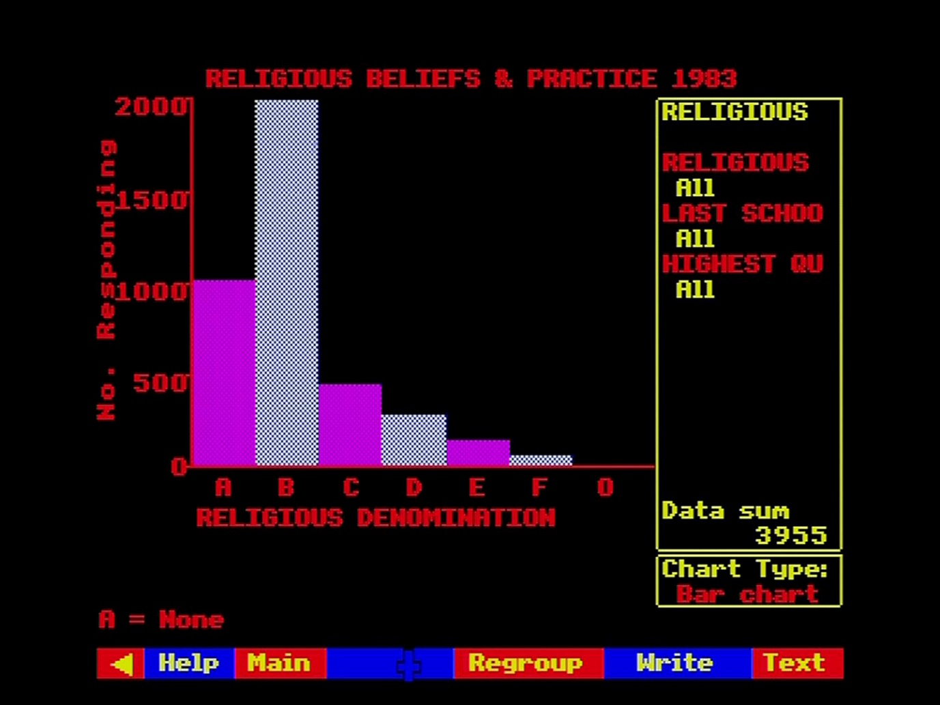

Figure 45 - Example of a chart screen

Every chart consists of several main components, in distinct areas of the screen. The message area at the top of the screen and the menu bar at the bottom are familiar features, common to many Domesday displays. Just below the message area, the title of the data set currently on display is shown. Below this, to the left, is the chart area itself, bounded by horizontal and vertical axes. The vertical axis (or y-axis) is labelled upwards with the name of the dependent variable of this data set, together with a scaling factor showing how the original data values have been modified to make a simple chart. Also along the vertical axis is a series of scale points. The horizontal or x-axis is also labelled with the name of the current primary classifying variable and a series of letters corresponding to the categories of that classifying variable. Further down is a message beginning "A=... " which shows the name of the first of the categories. The others can also be displayed, as we shall show. On the right-hand side of the screen are two boxed areas, the upper of which is the variable key area showing the status of all the variables in the data set, the lower being the chart key area showing which type of chart is currently in operation. Sometimes the variable key area contains the message "More". This means that there are more than six classifying variables for this data set. The first six are shown on the screen and you can call up the rest by placing the screen pointer over the "More" label and pressing [ACTION].

#### Types of chart available

Our example above shows a **single bar-chart** in which the dependent variable is plotted for each category of the primary classifying variable as a vertical bar with a height corresponding to the value of the dependent variable, measured against a scale along the vertical axis (or y-axis). This is a simple form of the statistical diagram known as a "histogram".

Another type of chart available is the **pie-chart** in which the several values of the dependent variable are shown as sectors of a circle, with the whole set of sectors adding up to the whole circle and each individual sector's size proportional to its share of the whole:

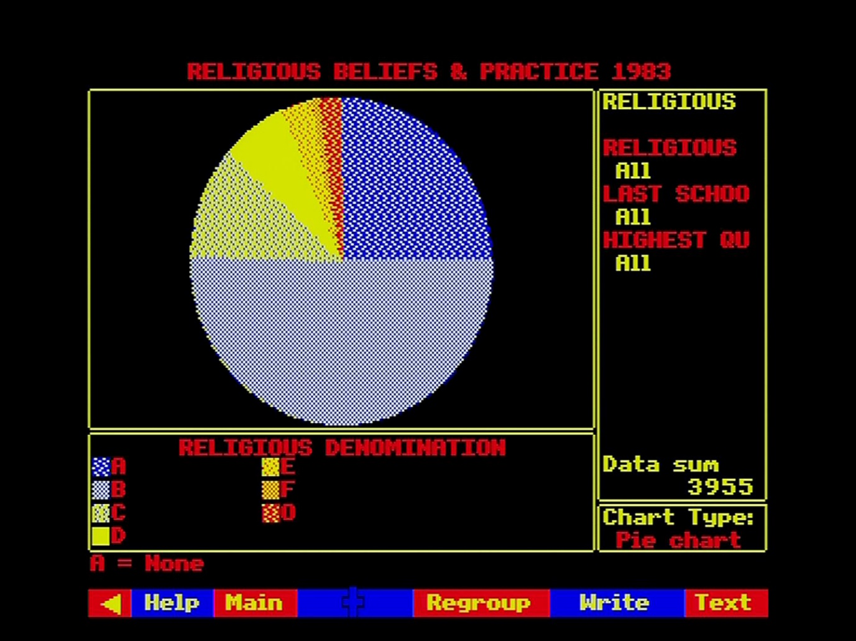

Figure 46 - Pie-chart

This is equivalent to the single bar-chart except that whereas the former highlights the comparative value of each classification of the dependent variable, the pie-chart focuses on its proportional share of the whole.

When the data set contains an independent variable, which represents an element of time, then the **single line-graph** is appropriate. This is different from bar-charts in that, as well as displaying the values of the dependent variable at the actual points of classification by the primary classifying variable, the line graph interpolates (i.e. calculates for itself) all the values in between.

On a line-graph the value of the dependent variable is plotted at a series of positions representing points in time and, by connecting these points by straight lines, at all the intermediate points. Clearly this only makes sense along a time variable, since it is meaningless to interpolate intermediate values between the categories of other types of independent variable, e.g. between "Yorkshire" and "Lancashire".

All the above types of chart show the dependent variable plotted against a single classifying variable.

There are three further types of chart which allow a second classifying variable to be introduced:

The **back-to-back bar-chart** is like the single bar-chart, except that instead of a single bar corresponding to each category of the primary classifying variable, a series of mini-bar-charts is plotted showing the values of the dependent variable for all the categories of a second classifying variable within each category of the primary classifying variable:

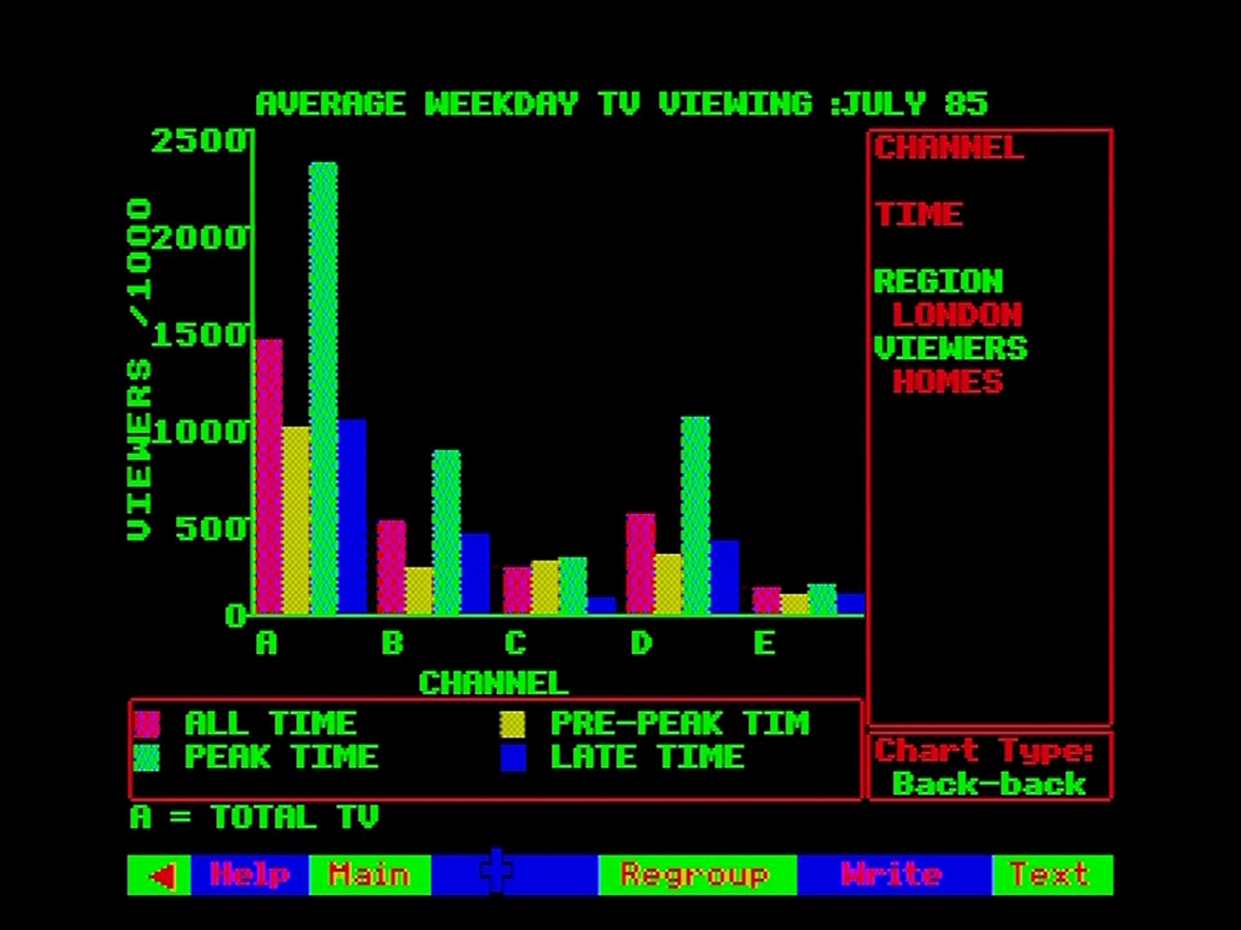

Figure 47 - Back-to-back bar-chart

You should be aware that the maximum number of bars capable of being plotted on any bar-chart is 24. Thus, when specifying a back-to-back bar-chart, the product of the numbers of categories in the primary and secondary classifying variables should not be greater than 24. You can vary the number of categories in operation for any classifying variable by the **Regroup** function explained later.

An alternative to the back-to-back bar-chart is the **looping bar-chart** in which the mini-bar-charts showing the values of the dependent variable for all categories of the secondary classifying variable within each category of the primary classifying variable are shown full-size in the chart area of the screen, but automatically displayed one after the other with each chart shown for a few seconds and then replaced by the next.

Finally, the **multiple line-graph** allows time-series data to be displayed by a second classifying variable. In this case a series of lines is drawn with the different lines corresponding to the categories of the secondary classifying variable:

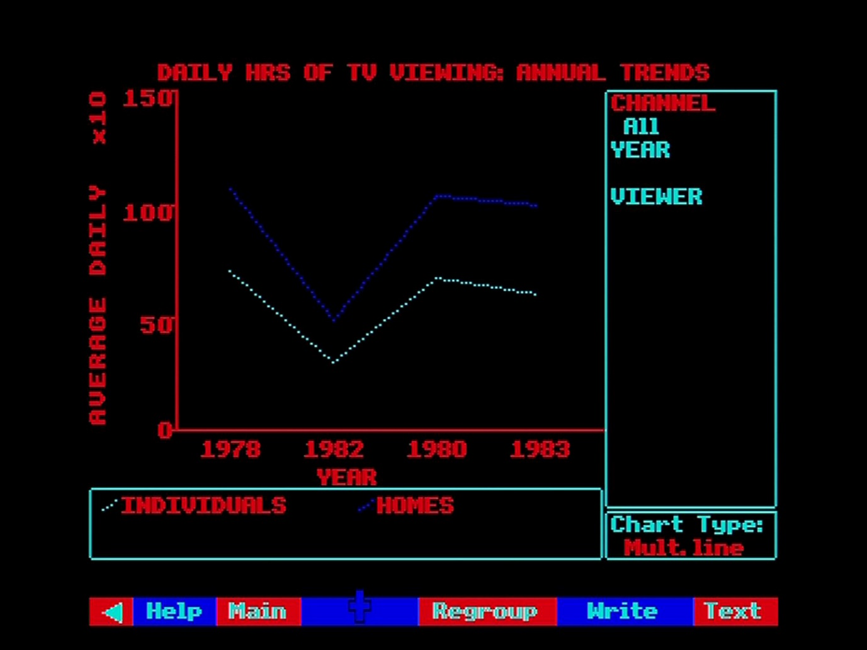

Figure 48 - Multiple line-graph

The maximum number of lines displayable is four so the maximum number of operating categories of the secondary classifying variable is also four.

#### Entering the charting procedure

As soon as you ask to see an item which is a tabular data set then the system will immediately invoke the charting procedure and show you an initial display of your data according to some pre-set "starter " parameters specified by the data compilers. This includes the type of chart to be displayed in the first instance, although you can change this, as you will see later.

With the initial chart on the screen you are now free to begin modifying and manipulating the display to get out of it what you particularly want to see.

#### Examining data values

The first thing you may want to do with a chart is to check what actual numbers underlie the diagram you are seeing. The actual values of the dependent variable can be displayed at any time from any chart, although the exact mechanism varies slightly from one chart­ type to another.

On a **bar-chart** of any kind, you place the pointer within any bar which is of interest and press [ACTION]. Immediately the exact height of the nominated bar will appear in the message area. The vertical position of the pointer does not matter, provided it is within the area bounded by the two axes. It is the horizontal position which identifies the bar to be examined.

On a **line-graph** of any type, the pointer can be placed anywhere at all in the chart area within the axes and pressing [ACTION] will cause the current height of the pointer above the x-axis to be displayed in the message area. Note that the pointer does not have to be on one of the plotted lines. Any position of the mouse will be reported. You should be aware that this method cannot be relied on to report the actual value of any plotted point with absolute accuracy. The system works out which screen-element (or "pixel") the pointer is at and calculates the position of the bottom left-hand corner of the pixel. Depending upon the scale of the y-axis, this could be significantly different from the actual value in the source data set.

Hint: Line Graph to Bar-chart

If you are displaying a line graph and it is important to find out the accurate value of one of the underlying data values, all you do is convert the whole display to a bar-chart and display the accurate data values from the new chart.

On a **pie-chart** the label-area below the x-axis is used to nominate data values to be displayed. You place the pointer within the little square indicating the colouring of the sector you wish to examine, press [ACTION] and the corresponding data value will appear in the message area.

#### Revealing the full forms of abbreviated names

Many of the labels and names on the chart are severely abbreviated and you can see the full form of any of these by simply placing the screen pointer over any abbreviation in the variable key area and pressing [ACTION]. Immediately the full form of the label appears in the message area at the top of the screen. One slight variation on this is the "A= ... " label under the x-axis. This is a cycling label which will take you through all the categories of the primary classifying variable, i.e. tell you what all the letters along the x-axis mean. You place the screen pointer over this label and press [Change]. Immediately the next category label appears in the same place and repeated presses will cycle the labels round.

#### Changing the settings of variables in the reference population

In a sense, the chart area of the screen, displaying the relationship between the dependent and primary classifying variable, contains what it is you want to know. The reference population, determined by the status of all the classifying variables other than the primary classifying variable, shows who it is you want to know about.

Imagine a chart where the dependent variable is "percentage of people unemployed", the primary classifying variable is age-group, and the other classifying variables are job-type, industry-type and year. Suppose our chart currently shows percentage unemployment plotted against age-group and in the reference population the variable "job-type" is set to "manual"; "industry-type" is set to "manufacturing" and "year" is set to" 1979". This means that the information we are asking for is the pattern of unemployment across age groups and now we are displaying that pattern for manual workers in manufacturing industry during 1979. If we want to display a similar pattern for a different group of people, say technical workers in service industries during 1985, then we alter the settings of the variables in the reference population.

The operative area of the screen to accomplish this is the variable key-area on the upper right-hand side. This contains the names of all the classifying variables and beneath each one is the name of the category to which this variable is currently set. There will be one exception to this: one of the category names will be blank. This is the primary classifying variable whose categories are, of course, all shown along the x-axis.

You place the screen pointer in the key-area over the category-name you want to change and press [CHANGE]. The current category will immediately change to the next category in the sequence for this variable and repeated presses will cycle round all the possible categories of this variable. Having altered the setting of one variable, you move on to the next until the entire reference population is as you want it. In this way, and following our previous example, you could set up the new chart showing percentage unemployment by age-group for technical jobs in service industries for 1985 by changing job-type from "manual" to "technical"; industry-type from "manufacturing" to "service" and year from "1979" to "1985".

Please note that a change in the reference population does not immediately affect the chart. You will, however, see that a flag marked "Replot" has appeared over part of the data-set title indicating that the current chart no longer reflects the true status of the data and when you have finished all your changes you will need to replot it using the **Replot** option described below.

#### Choosing a new primary classifying variable for the x-axis

Anyone who has spent time drawing statistical charts will know how tedious it is to complete a complicated plot only to find that you have plotted the dependent variable against the wrong classifying variable. You've plotted agricultural yield by various crops, but you really need it by farm-type. With Domesday, this is no problem. You go back into the key area with the screen pointer and place it over the name of the variable (remember VARIABLE name this time, not category name) and press [CHANGE]. Immediately the category name for the nominated variable will become blank and you will notice that the variable which used to be the primary classifying variable, indicated by a blank category name, now has a category name displayed beneath it like all the other ordinary classifying variables. Again, this has no immediate effect on the bulk of the chart, which needs a **Replot**.

#### Change the type of chart display

Suppose you have a bar-chart and you need to know how much of the total is represented by each bar. The easiest way to find out is to replot this data as a pie-chart. To select an alternative chart-type you move the screen pointer into the chart-key box, over the name of the chart-type currently in effect and press [CHANGE]. The chart-name will immediately change to the next available type of chart for the data in hand and repeated presses will cycle round the full range of available types. Not all chart-types are appropriate to every set of data, but you don't need to worry. The system sorts out what is possible and only offers you viable options. Again, you need to **Replot** before you will see your new chart.

#### Selecting a secondary classifying variable, where required

As described above, certain chart types require both primary and secondary classifying variables. These are the back-to-back and looping bar-charts and the multiple line-graphs. You select a secondary classifying variable exactly like the primary, by placing the pointer over the required variable (not category) name and pressing [CHANGE].

#### Plotting a new chart using Replot

**Replot** is selected from the menu bar to re-draw the chart according to changed specifications. For charts other than bar-charts, and even on bar-charts where you have specified a new chart type or where you have asked for a new primary or secondary classifying variable, this will involve clearing the chart area completely and plotting a whole new chart.

Where you have changed the reference population for a bar-chart, however, there will be no need to clear the chart area completely; it is simply necessary to adjust the height of the bars. In this case the system tries to aid your understanding of the difference between your old and new charts by "animating" the change from one to the other. Each bar will gradually shrink or grow to its new height. In certain cases, this may mean that the new height of a bar cannot be accommodated within the old scale of the y-axis. In this case, rather than abandon the interpretive value of the animation, the oversize bar will simply be plotted with a pointed top, indicating that it exceeds the current height of the y-axis and leaves it to you to re-scale the y-axis if you feel it is necessary.

Replot can result in certain error conditions, flagged by warnings in the message-area:

**Too many groups to plot - please regroup**

This means that you are asking for more than 24 bars on a bar-chart or more than four lines on a multiple line-graph. The only remedy is to reselect variables so that the plot becomes within limits, or invoke **Regroup** to reduce the number of categories of your selected variables.

**Unreliable estimates**

This means that you have been too restrictive in your choice of reference population and there are now too few data values in your chosen subset to make meaningful interpretation safe. The only remedy is to increase the scope of the reference population.

#### Re-scaling the y-axis

When necessary you can request a re-scaling of the y-axis by positioning the screen pointer over the y-axis label and pressing [CHANGE]. The y-axis will automatically readjust to a scaling appropriate to the current maximum height of the displayed bars and the bars themselves will adjust in animation to their new correct heights.

### Further options available from the menu-bar

Upon completion of your initial chart display, the menu bar will contain the following options:

|  |  |  |  |  |  |  |
| --- | --- | --- | --- | --- | --- | --- |
| < | Help | Main | Regroup | Write | Text |  |

It should be noted that **Regroup** will only be offered when the data set in question is additive.

**Text** will give you access to the pages of descriptive information supplied by the experts who compiled this data set for the National Disc, to aid you in interpreting this data. We strongly recommend that you study the text attached to any data set from which you want to draw conclusions, and you should read the further notes on this in the section “Displaying and manipulating data maps”. After selecting **Text**, the menu bar becomes:

|  |  |  |  |  |  |  |
| --- | --- | --- | --- | --- | --- | --- |
| < | Help | Main | Print |  |  |  |

**Print** allows you to print out the page on the screen, but refer to the section “Printing, downloading and copyright” for advice on copyright before printing out text. During printing the menu bar becomes:

|  |  |  |  |  |  |  |
| --- | --- | --- | --- | --- | --- | --- |
| < | Help | Main | Quit |  |  |  |

**Quit** aborts the printing process and returns you to the Text option above.

**Main** from either of the two menus above takes you out of Text and back to the main chart display.

**Write** allows you to download onto a magnetic disc the data underlying the current chart display. Write is described more fully in sections “Controlling the system” and “Appendix III - Formats of downloaded files”.

**Regroup** allows you to re-combine the categories of classifying variables into new groupings and to include or exclude these groupings from the chart. Regroup will only be available for additive data sets, since, as we have observed earlier, no automatic re-combination of non-additive data is possible. This means that Regroup will not be available for any time-series data which, by definition, is non-additive. Regroup is particularly useful for removing data temporarily from the chart, creating new kinds of reference population and reducing the number of categories to within the limits of, say, a back-to-back bar-chart.

When you select **Regroup** the chart area of the screen will be replaced by a series of screens on which the regrouping operations will take place in a logical sequence.

The first screen deals with **selecting a variable to regroup**. It looks like this:

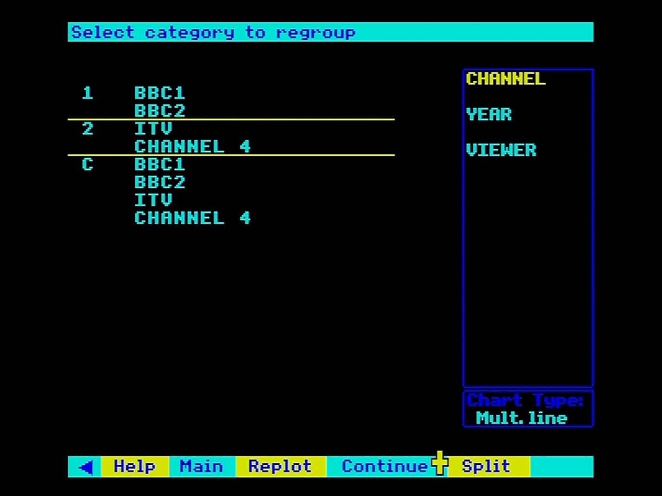

Figure 49 - Variable regrouping

On this screen, you simply place the pointer into the key-area over the name of the variable you want to regroup and press [ACTION]. Immediately the chart area will show current groupings of categories in operation for the nominated variable. For the first time around, the groups displayed will consist' of one separate group for each of the categories of this variable and an extra group, known as the "combined" group which includes all the categories. The values of the dependent variable corresponding to this combined group will be the sum of the data values over all the categories of this variable.

The next screen in the sequence deals with **selecting groups to re-include**. You won't be presented with this screen first time around, and maybe not even thereafter. It only appears when you have chosen to exclude certain groups from the display and this is your opportunity to re-include them. Groups which are currently excluded will be shown in blue and you can choose to re-include them by placing the pointer over an excluded entry so that its group-number changes to yellow and pressing [ACTION]. The blue entry will convert to cyan and the group is reinstated. You can re-include as many excluded groups as you like from this screen.

At this point the menu-bar will have become:

|  |  |  |  |  |  |  |
| --- | --- | --- | --- | --- | --- | --- |
| < | Help | Main | Replot | Continue |  |  |

**Main** within Regroup will abandon your work and restart the Regroup as if you had just entered it from your original chart display.

**Replot** at this stage will restore your original chart display, but with the changes you have specified so far in Regroup.

**Continue** at this stage will carry on to the next stage of Regroup. ·

The next screen-deals with **selecting categories of the nominated variable to regroup**, i.e. which category you want to move from one group to another. You place the pointer over the name of the category you want to "pick up" and press [ACTION]. You are then asked to **select destination group**. You move the pointer to the group into which you wish to place the nominated category, causing its number to turn yellow, and press [Action]. The list of groups will then be re-displayed showing your nominated category in its new group and the system will cycle back to ask again, **select category to regroup**, ready for you to nominate another category to move. You should be aware that the system will not allow you to reduce a variable to only one category. Each variable must be left with at least two categories. When you have completed all the moves you want, you move on to the next stage by selecting **Continue** from the menu bar. (N.B. **Main** and **Replot** are still available for you to abandon or short-circuit the regrouping).

The prompt now changes to: **select groups to be omitted**. This is asking which groups are to be excluded from the next chart. You place the pointer over any group to be excluded, causing the group number to turn yellow, and press [ACTION]. The group will then convert to blue, indicating that it will not be considered when the next chart is drawn. Note also that the excluded group is no longer included in the "combined" group. Further groups can be excluded in the same way and then **Continue** will take you on to the next stage of Regroup.

The prompt becomes: **enter new group names and abbreviations**. The system does not know how to label your new groups and is asking you to supply the necessary details. The places where input is requested are indicated by blue boxes and a flashing cursor. You position the pointer in each box in turn and key the appropriate labels.

This completes the Regroup operation. Selecting **Continue** one more time will take you back to the top of Regroup to go around again and make further changes. Selecting Main will abandon all you have done this time through Regroup and take you back to the beginning as if you had just come from your original chart display and selecting **Replot** will take you back to your chart and re-plot it with your new specifications.

**Main** takes you back out of the chart-display operation altogether and returns you to the main index-searching routines. In the first instance, you will be re-presented with the "hit-list" of item names which were identified in response to your last query. You can then select a further item form this list or abandon the list altogether by initiating a new search, using **Find** or **Contents**.

## The Domesday gallery

**Gallery** offers you the chance to browse through the visual treasures of the National Disc. It is an imaginary gallery, created electronically and containing representations of all the picture sets and surrogate walks, as well as some of the overview articles. The gallery has been constructed in three-dimensional space so that you can walk round it and get to know it. This in turn is designed to help you form a mental picture of what Domesday includes. Of course, this is contained more systematically in the hierarchical **Contents** system, but abstract verbal descriptions can be much harder to comprehend and to remember than pictures arranged in space. Children may find this the easiest and most exciting way to explore our coverage of Britain in the 1980s. **Gallery** is the best expression of our underlying intention to create an electronic exhibition of life today, rather than a database or illustrated encyclopaedia.

### Arriving at the gallery

Every time you start up the National Disc you will begin in the Domesday Gallery. This is the primary state of the National Disc and you will also return to it whenever you press [ESCAPE] to reset the system.

You can also move to the Gallery from any of the other main National Disc functions simply by selecting **Gallery** from the menu bar.

### Moving around the gallery

This is identical in every way to taking any of the surrogate walks. The technique is fully described in the section “Taking surrogate walks”. The fact that the Domesday Gallery is in logical rather than real space makes no difference. The simplest way to turn and move is shown at the top of the first screen: Turn left - point to the left of the screen and press [CHANGE] Move forward - point to the centre of the screen and press [CHANGE] Turn right - point to the right of the screen and press [CHANGE]

The plan of the Gallery can be selected via Plan or Help/Plan on the menu bar:

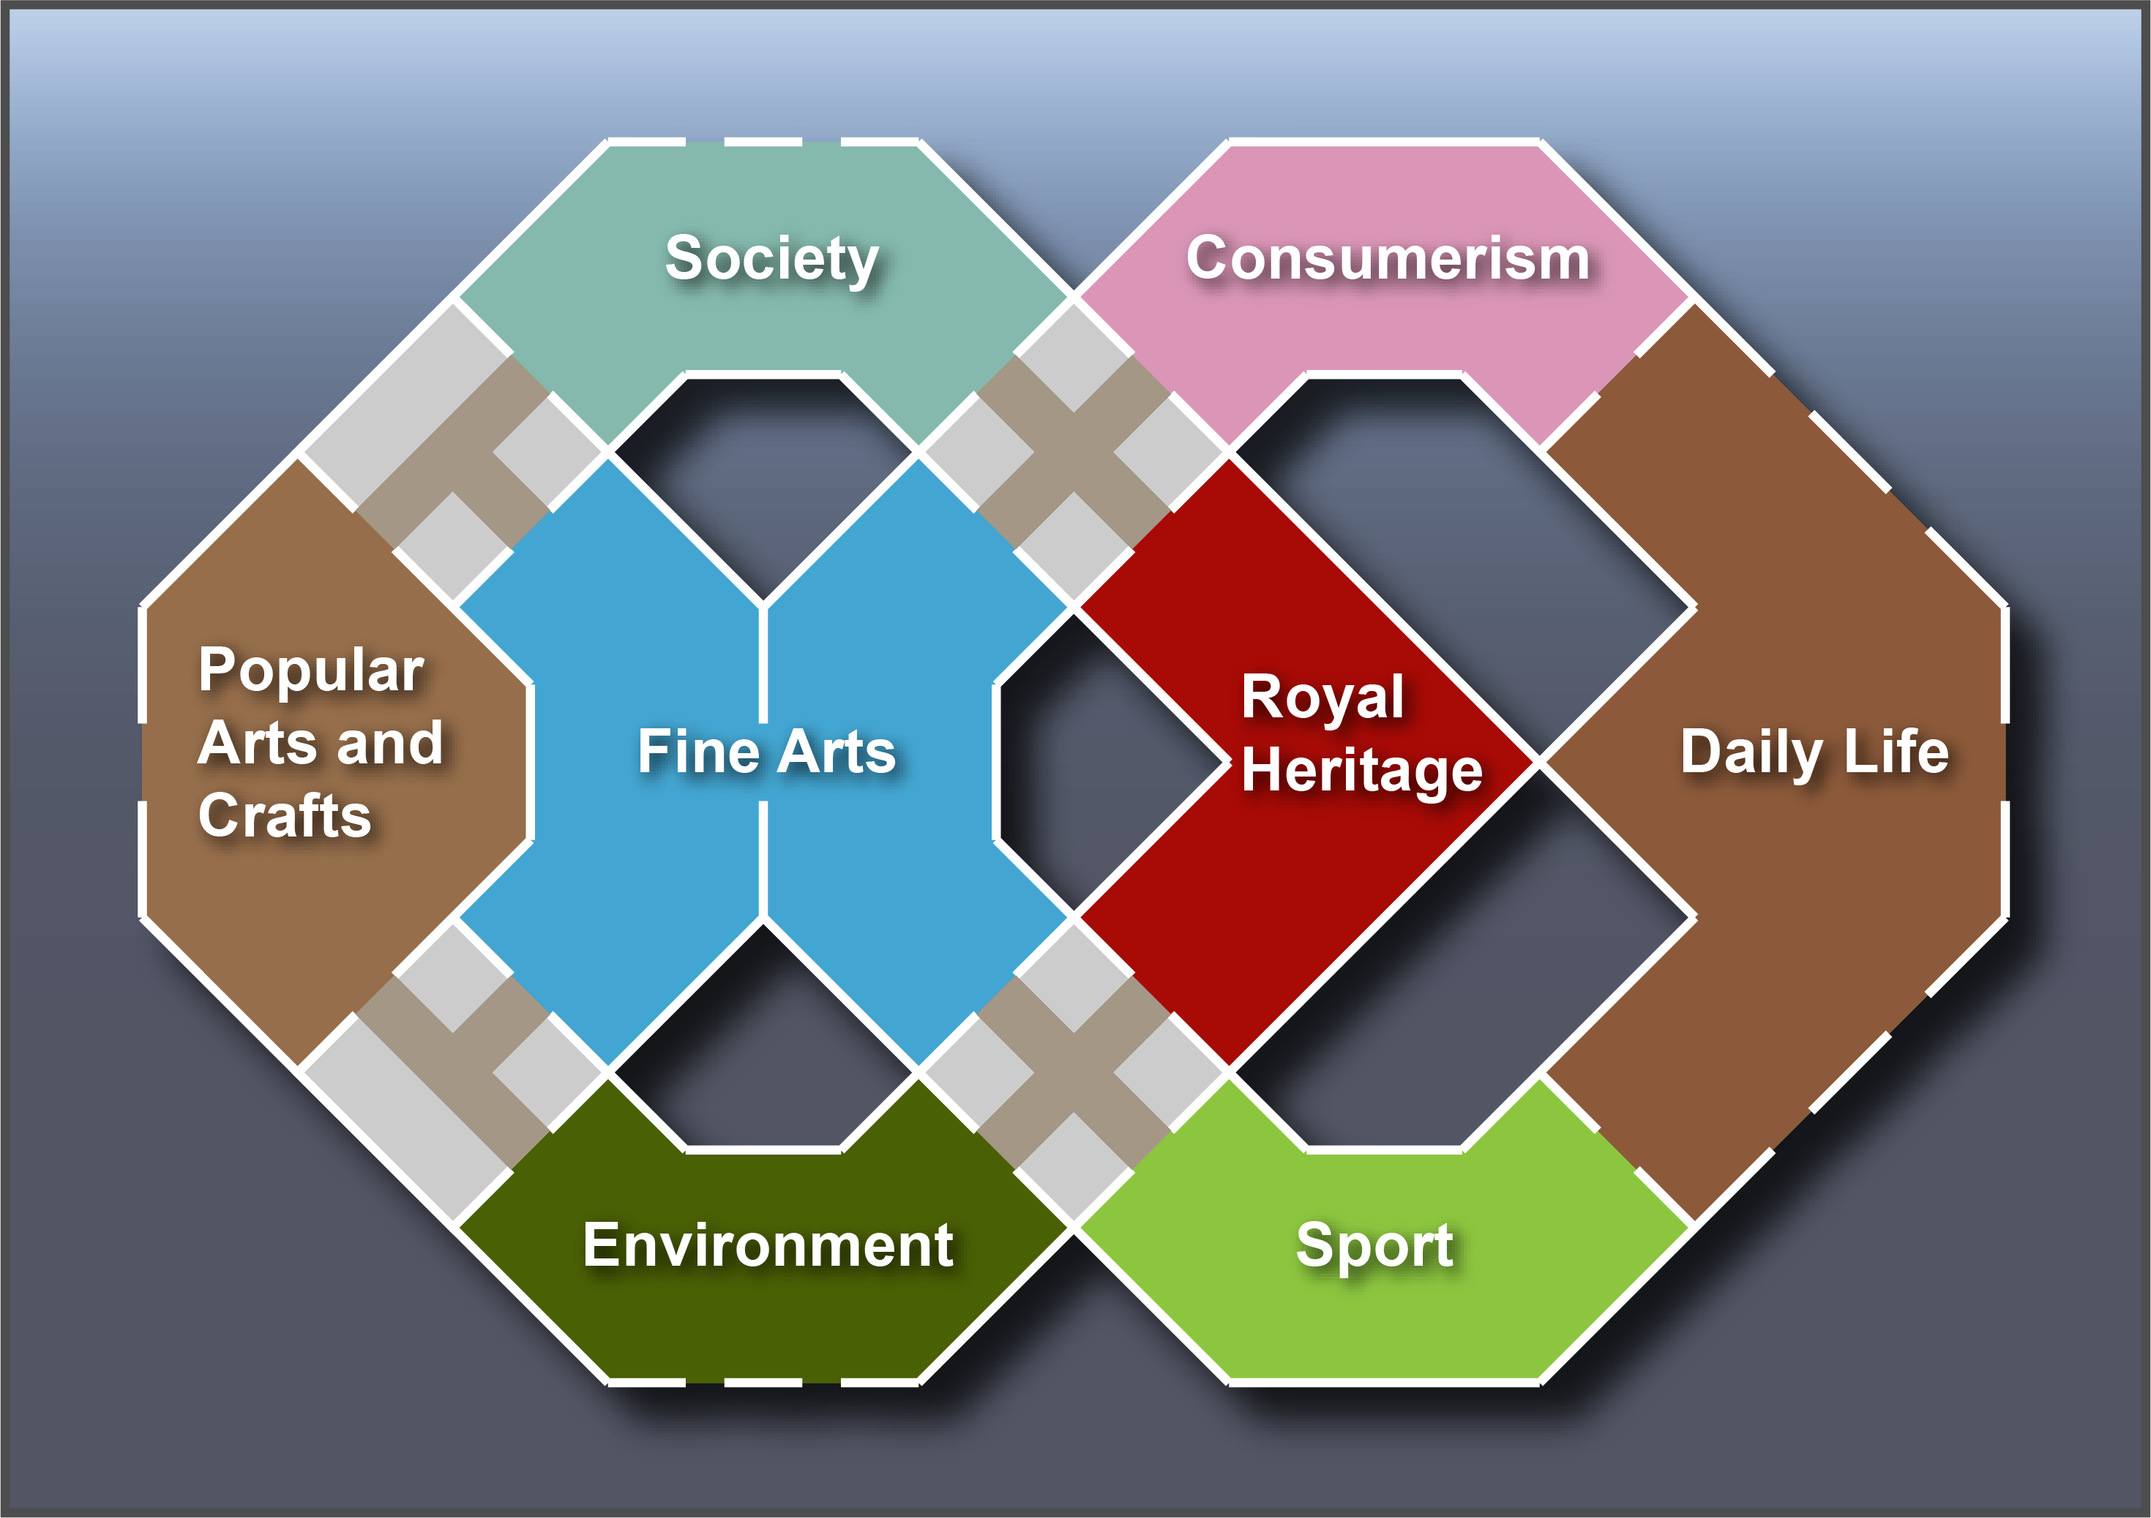

Figure 50 - The Gallery map

The room names are used only for the plan. They do not appear in the rooms themselves, though the style of each room is designed to reflect them. Nor do they relate exactly to the arrangement of the hierarchical Contents system. They have been designed solely to allocate the picture sets by subject matter to rooms of different sizes and styles within the Gallery. The plaques in the rooms are not the names of the rooms but represent text essays in the same subject area that can be examined (see below).

Notice that the rooms are separated from each other by small lobbies with blank walls.

### Examining items in the gallery

The point of the Gallery is not just to enjoy walking round it but to use it as a visual index to items on the National Disc. These are of three kinds:

#### Picture sets

Each of the pictures in the Gallery represents one or more picture sets. For example, the picture of a teapot in the first room represents a set of pictures about British ceramics and pottery. To see this set, point at the lower left corner of picture and press [ACTION].

You are now taken to the title page of the picture set and you can look through it in the usual way (see the section “Looking at picture sets”). Of course, it may not be of interest. The pictures in the Gallery deliberately do not include any text to explain what picture sets they relate to. So, you may be surprised. If you are happily surprised, this is the essence of good browsing. If not, select **Main** and move back to where you were in the Gallery. If instead you select **Gallery** from this menu bar, you will be taken back to the starting position in the Gallery.

In some cases, a picture in the Gallery represents more than one picture set. For example, the picture representing the British Year points on to twelve picture sets, with around 30 pictures in each. In this case what you will see first is a page of text listing these twelve picture sets:

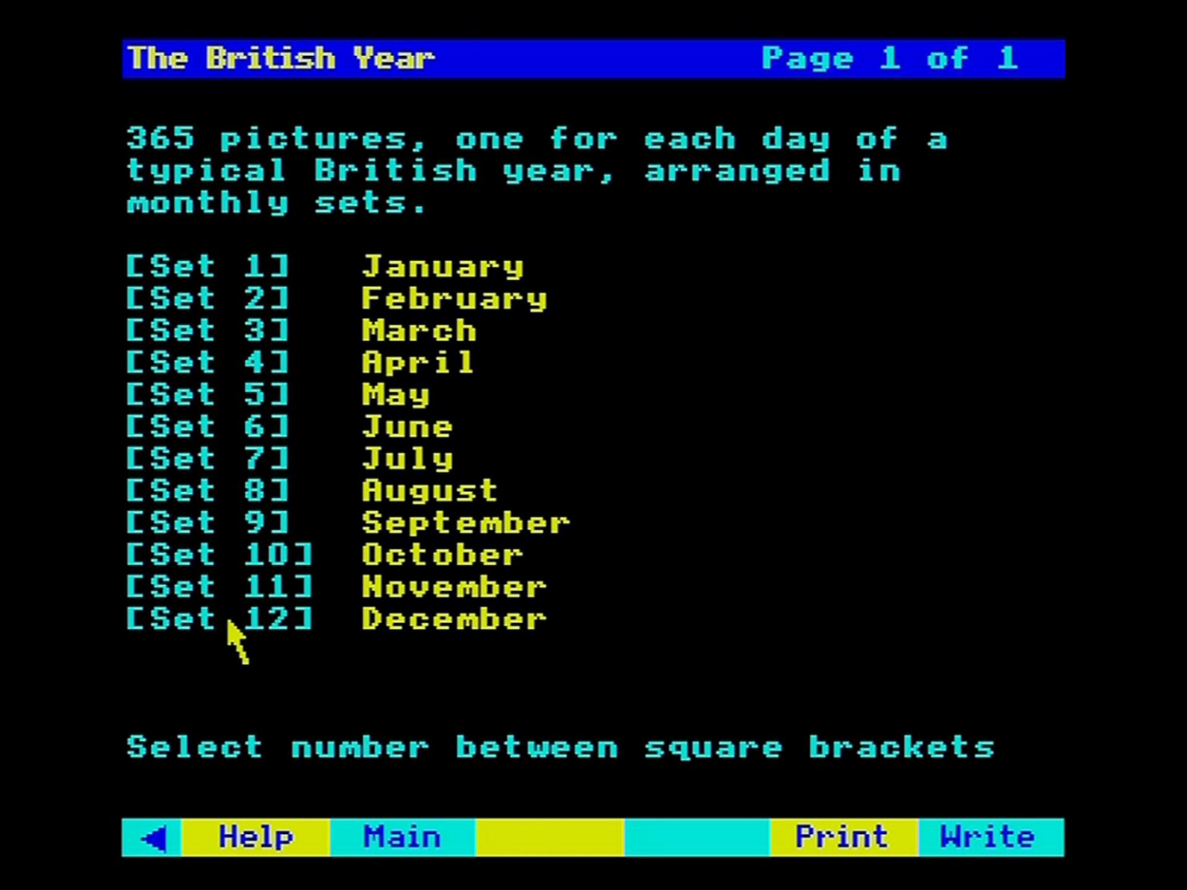

Figure 51 - Picture set index

To choose one of these picture sets, point at the reference within the square brackets and press [ACTION]. Pointing at the name or number on the left of the screen will not activate the move to the picture set. Because this is slightly different from our usual menu-selection grammar, there is a reminder to this effect at the foot of the screen.

#### Overview articles

The plaques on the walls represent the overview articles. For example, examine 'Agriculture' for an essay on agriculture in Britain in the 1980s. Selection is made by pointing at the bottom left corner of the plaque and pressing [ACTION]. You will now arrive at the beginning of the article. You can examine it in the usual way, as described in the section “Reading text”. Return to your place in the Gallery by selecting **Main**.

#### Surrogate walks

It's particularly easy to access the walks represented in the Gallery: just walk through the open doors and begin the walk. There is a door leading to each of the nine walks in the appropriate room of the Gallery.

It is important to realise that these walks are considered by the system to be, as it were, outdoor extensions of the Gallery itself. In other words, the menu bar does not change into the slightly different form used for walks when they are accessed from Find or Contents. For this reason, if you ask for Help Text or demo, you will be given the one appropriate to Gallery, not that for walks.

To return to the Gallery, you can retrace your steps to the beginning of the walk. There facing you will be the door back into the Gallery - a nice interface between the real and the imaginary worlds. Walk straight in. Alternatively, you can press [ESCAPE] to move straight back to the first room of the Gallery. If you want to go back to your last position in the Gallery, set a bookmark there before you walk out of the door.

### Ending your walk around the gallery

When you have finished exploring the Gallery, select **Main** if you have been using the **Move** options, then select any of the main operations like **Find** or **Contents**.

### For example – Exploring pictures about sport in the Gallery and viewing the 1500-metre final from the 1984 Olympics

From the **Gallery** option you arrive in the first room. Select **Move** from the menu bar:

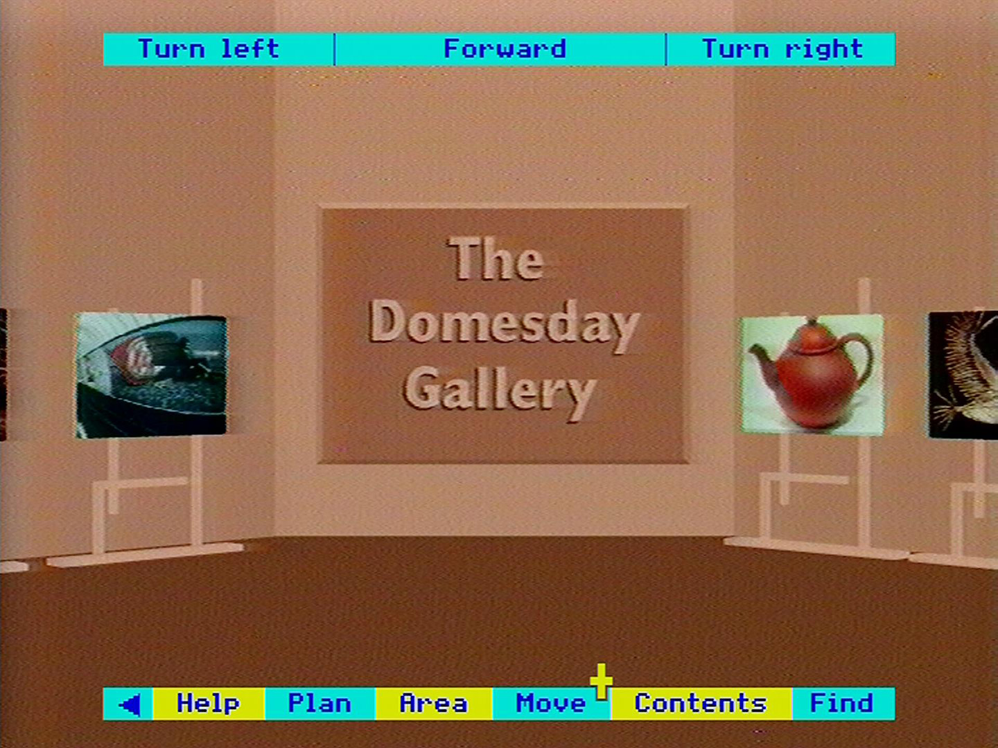

A new menu bar is displayed. Select **Plan** from the menu bar:

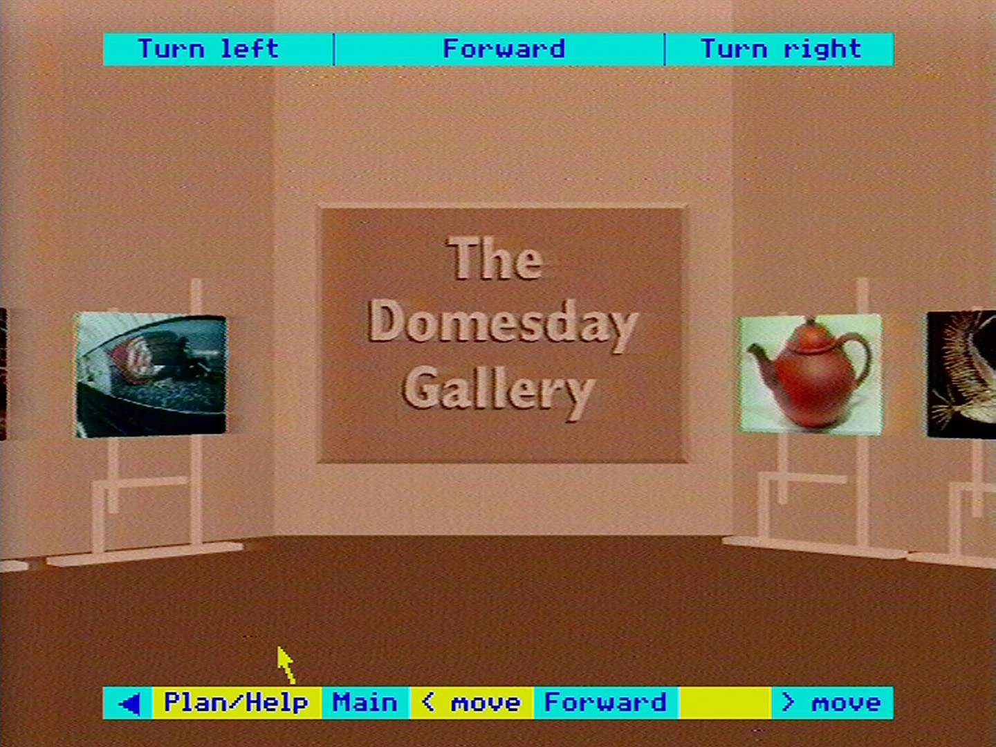

The Gallery plan appears with a blue arrow showing your current position. Note the position of the Sport room. Select **Main** to return to the Gallery:

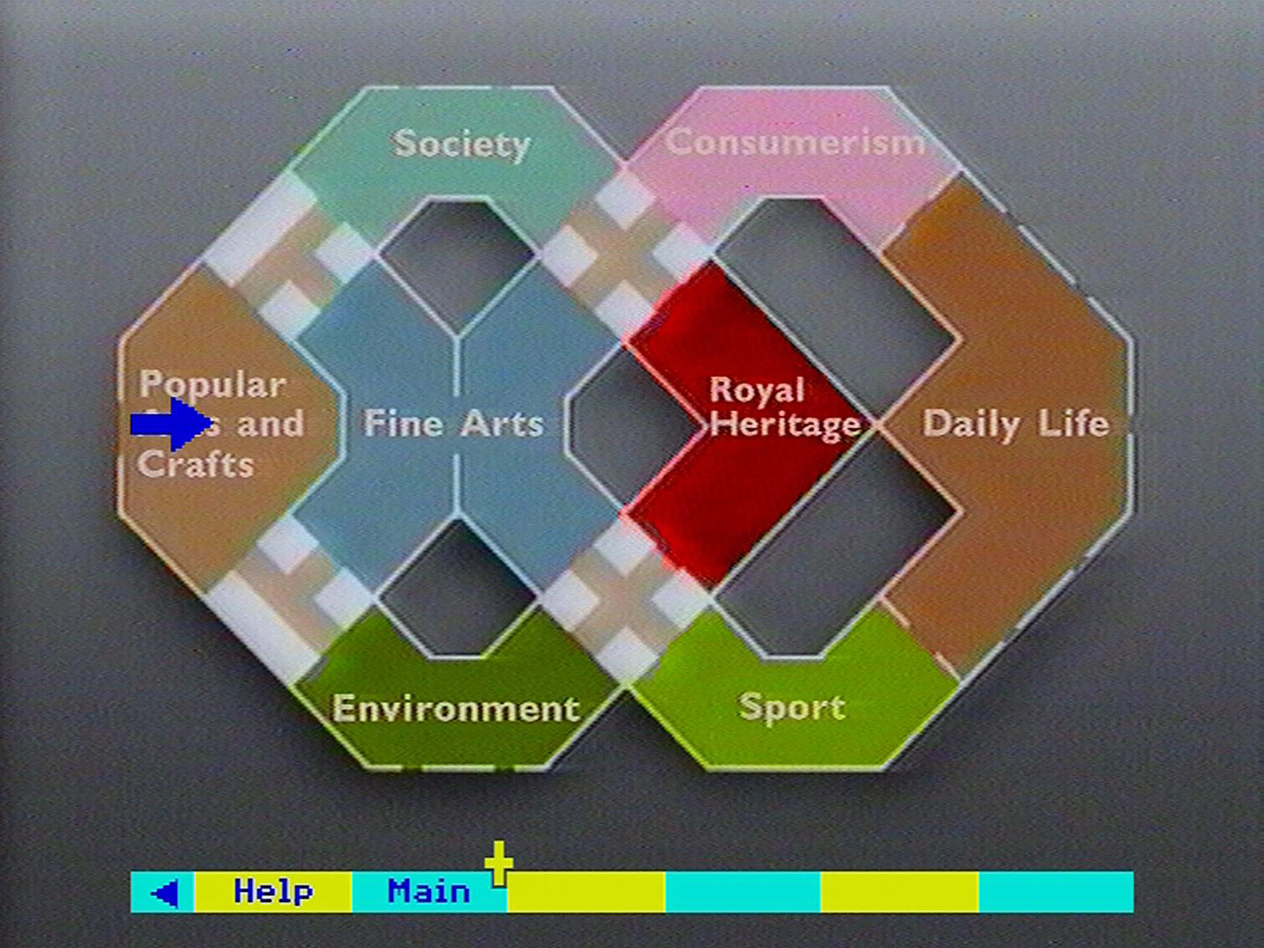

Use the **Move** options on the menu bar (in combination with the mouse if available) to move into the Sport room:

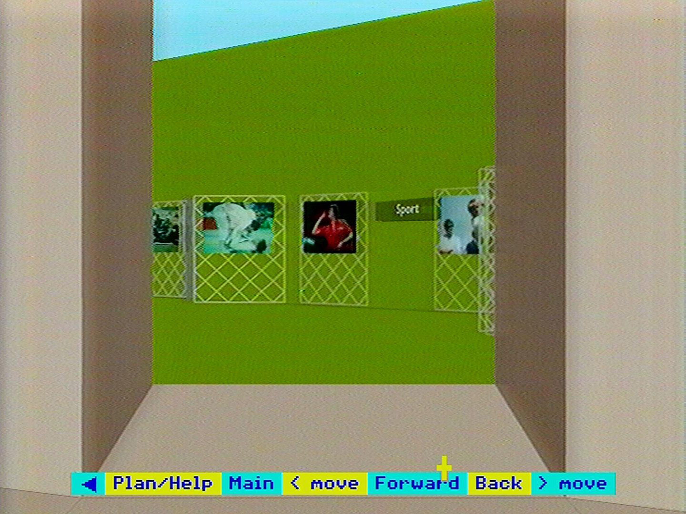

Arrive in front of the picture of Sebastian Coe. Move the screen pointer to the lower left-hand corner of the picture and the press [ACTION]:

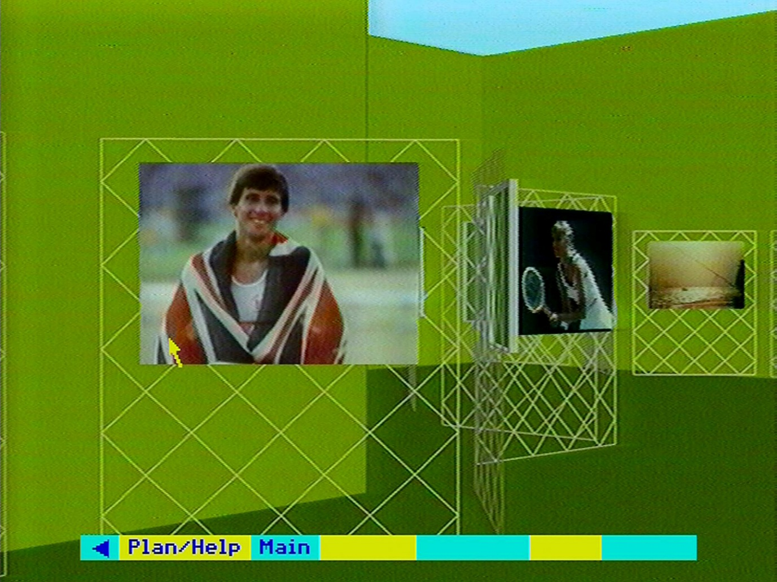

The title slide of the picture set on the Olympics appears. Select **Index** from the menu bar:

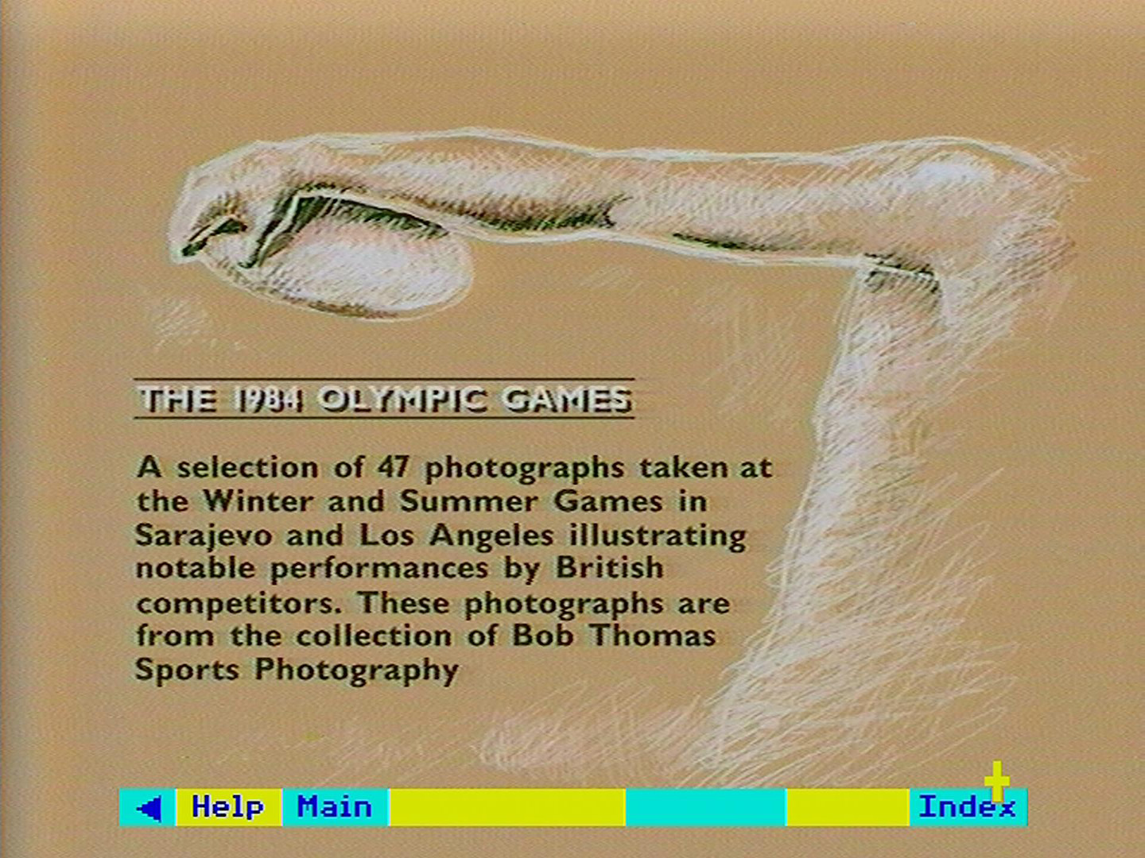

The front index of the picture set is displayed. Choose item 12 for the 1500-metre final:

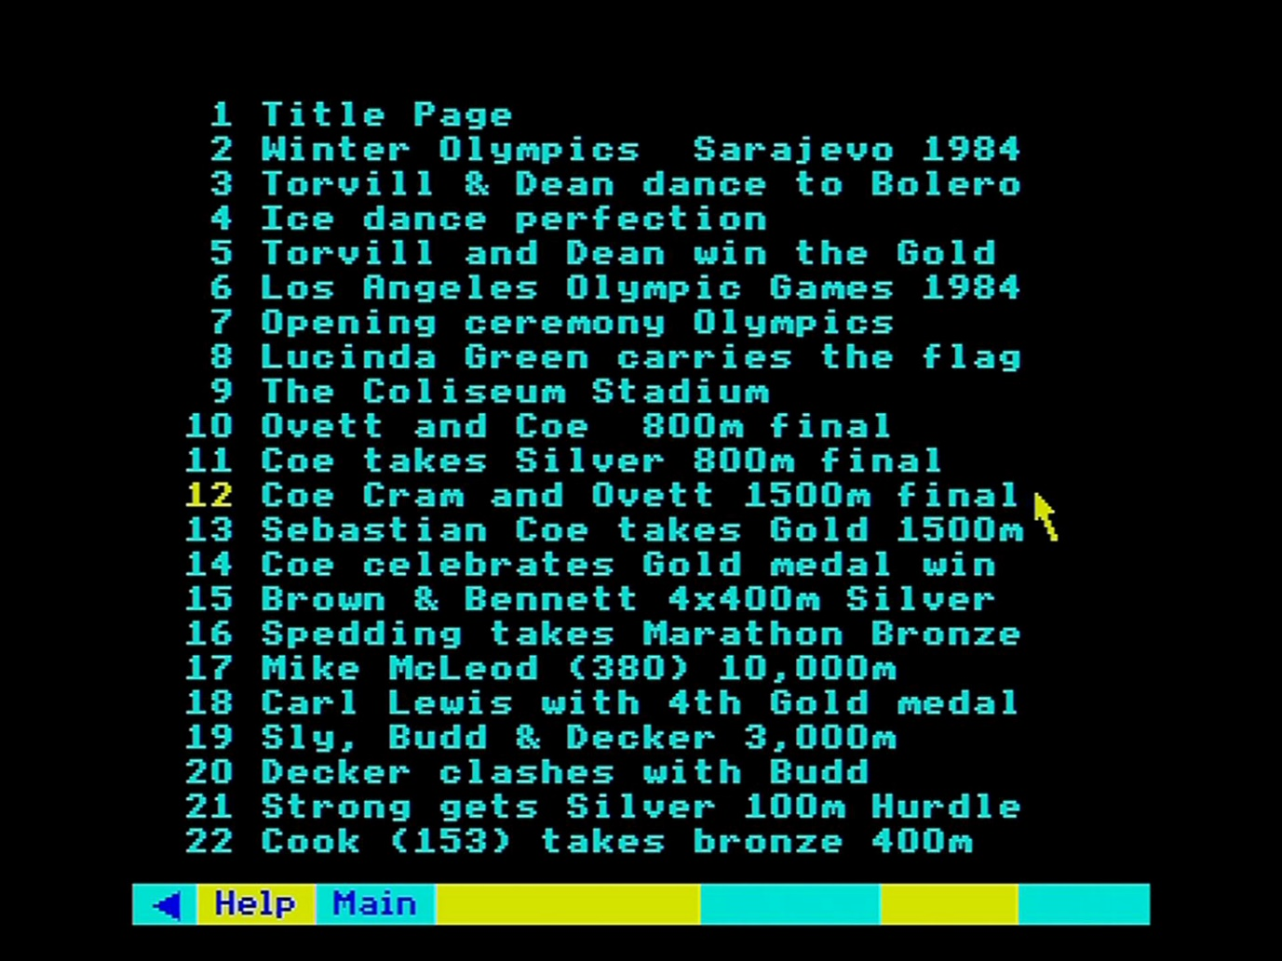

A photograph of the 1500-metre final is displayed:

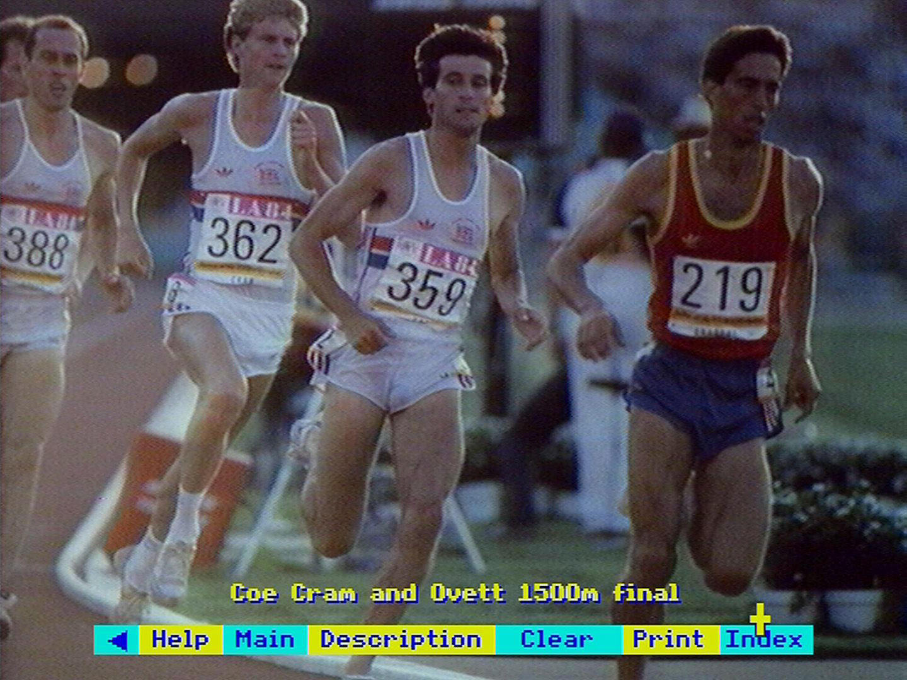

# Postscript on future uses of the system

## Advanced applications of the Domesday discs

**Note**: This section was written in 1986 during the release of the Domesday system. Some of the items mentioned were later released such as the ‘Domesday Display’ software and the ‘Domesday Data Capture’ software. The original section is included here for completeness.

The computer programs described in this book are only a first example of the kind of retrieval and display software that could be developed to make the maximum use of the wealth of statistical, textual and pictorial material contained on the Domesday Discs.

We expect to be adding refinements to the system for future video discs, as well as issuing specialised software on floppy disc. The present suite of programs must work in a universal way - doing everything from walking round a cottage to re-scaling a bar chart. More powerful software could be written by concentrating on small, highly specialised uses of the Domesday material. The pictures and data on the discs can remain the same - they are the raw material that any software will need - but the software itself can become far more sophisticated for specialist applications, particularly as microcomputers become more powerful.

This section is just a glimpse of some of the possibilities for the future: some that most users will be able to undertake on their own, some that will form the basis of future professional suites of software. We anticipate a cottage industry growing up around Domesday as more and more applications are developed for the mass of material which they contain.

The simplest way in which you can customise the discs for your own use is by using the VFS and LVDOS commands. These are fully described in the Acorn VFS and BBC Laservision player manuals. The first step is to search the discs for the pictures you want, using the on-board retrieval software. In each case make a note of the frame number of the picture from **Help**. Now you can move into Basic (or whatever language you prefer) and incorporate references to these frame numbers in your program. For example:

10 *VP 2  
20 *FRAME 5000  
30 G=GET  
40 *FRAME 5030  
etc.

This simple form of 'slide show' can be extended in many directions by using branching commands, animated graphics over video images, music and so on. We may have arranged the pictures on the National Disc into 5 12 sets, but you can re-arrange them into as many new, logical sets as you wish, adding titles and captions for your own use. Access times between pictures will be slightly slower if you jump more than 50 frames between pictures, but this is unlikely to be a problem in practice.

If you prefer the convenience and power of a ready-made authoring language, a package like Microtext (from the National Physical Laboratory) with the appropriate extension commands can produce these kinds of programs very easily. It can also take you into the field of computer-aided learning. You devise a teaching package around material on the video discs, the computer asks the user questions and branches to different parts of the disc according to the user's answers.

You could also consider writing more advanced versions of our other programs. You could, for example, use the walk around Brecon as a visual index to almost every aspect of life today - calling the thematic shots from the different picture sets.

We also plan to release software which will allow you to record a sequence of video-disc moves onto a floppy disc. This can be replayed subsequently and will control the video-disc player just as if someone were operating it. A synchronised commentary can be recorded on an audio cassette. Using the same software, we plan to publish several 'guided tours' around the Domesday Discs by distinguished contributors.

None of these options involve access to the resident software or data on the video disc. This is much trickier to do. In fact, we are aiming to produce such an advanced authoring package, which will allow you to incorporate routines like index-searches and data unpacking in your programs.

The other major extension we are planning will allow you to use your own data with the Domesday display software. This will allow you, for example, to plot area sales figures on any of the background maps and then correlate them with existing data, like the Census variables. Again, a small, multi-dimensional data set of your own (wickets per bowler per season, etc.) could be displayed by the resident Chart routines.

Further in the future, we are aiming, together with our partners in the Esprit programme of the EEC, to add elements of artificial intelligence to the Domesday Discs. Eventually such systems may be able to communicate in natural language (probably many different natural languages) and to respond intelligently to requests for complex information, tailoring the reply to the needs of the user.

We hope this makes clear that the Domesday Discs are far from finished. As a historical record, they are designed to be laid down like wine, gaining value with age. But they are also designed to be a beginning: to demonstrate the enormous potential of interactive optical media for many aspects of our national life. The more they can be developed, extended and re­worked by everyone who uses them, the more value they will gain in this equally important way.

# Appendices

## Appendix I - Disc maps

### Community disc maps

#### South Side

|  |  |
| --- | --- |
| Opening film sequence | 51-1901 |
| Community Photographs | 7250-16100 |
| Level 0 maps | 18790-18796 |
| Level 1 maps | 18797-18802 |
| Level 2 maps | 18803-19243 |
| Level 3 maps | 19286-31096 |
| Level 4 maps | 31166- |
| Level 5 maps | 32739- |
| Community Photographs | 33266-41454 |
| Demonstrations | 44997-end |

#### North Side

|  |  |
| --- | --- |
| Opening film sequence | 51-1901 |
| Community photographs | 11810-16100 |
| Level 0 maps | 18790-18796 |
| Level 1 maps | 18797-18802 |
| Level 2 maps | 18803-19143 |
| Level 3 maps | 19216-30923 |
| Level 4 maps | 31196-31862 |
| Community Photographs | 33196-35214 |
| Demonstrations | 44370-end |

### National disc maps

#### Side A

|  |  |
| --- | --- |
| Opening film sequence | 57-804 |
| Gallery | 803-1122 |
| Gallery Plan | 1123-1124 |
| Picture Test Frame | 1500- |
| Registration Frames | 1501-1503 |
| Background Maps | 24930-25957 |
| Area Selection Frames | 28995-29000 |
| Newspaper Front Page Stories | 29001-29638 |
| Thematic Maps I | 29639-29735 |
| Thematic Maps II | 29875-29909 |
| Thematic Maps Ill | 29925-29959 |
| Picture sets | 42499-49500 |
| Demonstrations | 40905-end |

#### Side B

Chapter 1 - Images of 1980

1980-03-25 Robert Runcie enthroned as Archbishop of Canterbury

1980-04-30 3 Gunmen seize Iranian Embassy in London

1980-05-05 Siege ends when the SAS storm the building and rescue the hostages

1980-05-10 Scottish Cup Final – Rangers v Celtic

1980-06-13 6d piece no longer legal tender

1980-07-05 Wimbledon Men’s Singles Final – Bjorn Borg v John McEnroe

1980-08-04 Queen Elizabeth the Queen Mother celebrates her 80th birthday

1980-09-13 Hercules the bear is recaptured after escaping in the Outer Hebrides

1980-10-08 British Leyland launch the Mini Metro at the 1980 Motor Show

1980-11-10 Michael Foot is elected Labour party leader

1980-12-14 Fans in Liverpool mourn John Lennon

Chapter 2 - Images of 1981

1981-01-05 Peter Sutcliffe – the Yorkshire Ripper – charged with murder after 5 year hunt

1981-01-25 Limehouse Declaration

1981-03-29 Nearly 7000 run first London Marathon

1981-04-04 Bob Champion on Aldaniti wins Grand National

1981-04-10 By election in Fermanagh-South Tyrone

1981-04-10 Riots in Brixton (10-11 April)

1981-05-05 Bobby Sands dies after 66 day hunger strike

1981-06-13 Blank shots fired at Queen

1981-07-06 Aftermath of rioting in Toxteth district of Liverpool

1981-07-21 England win 3rd Test against Australia

1981-07-29 Prince Charles marries Lady Diana Spencer at St Pauls

1981-09-14 South Belfast MP Robert Bradford assassinated

1981-12-20 Penlee lifeboat and 8 lifeboatmen lost while assisting Union Star

Chapter 3 - Images of 1982

1982-04-02 Argentina invades Falkland Islands

1982-04-05 Task Force sails

1982-04-25 Defence Minister John Nott announces recapture of South Georgia

1982-05-01 Task Force attacks Port Stanley Airport

1982-05-02 Submarine HMS Conqueror sinks Argentine cruiser General Belgrano

1982-05-04 MOD spokesman Ian McDonald announces HMS Sheffield hit by Exocet

1982-05-12 QE2 leaves Southampton with more troops for Task Force

1982-05-21 British forces land at Port San Carlos on East Falkland

1982-05-28 Battle of Goose Green

1982-05-28 Pope arrives in Britain for a pastoral visit

1982-06-08 Argentine Airforce attacks ships at Bluff Cove

1982-06-14 British troops bombard positions around Port Stanley

1982-06-15 Surrender signed at 0100 BST

1982-06-22 1 Day old Prince William leaves hospital

1982-07-20 2 IRA bombs explode in London

1982-09-22 TUC Day of Action in support of health service workers

1982-10-11 Henry VIII’s ship Mary Rose raised from the Solent

1982-11-01 S4C starts transmission in Wales

1982-11-02 Channel 4 opens for the rest of the UK

1982-12-06 INLA bomb kills 16 at disco in Ballykelly

Chapter 4 - Images of 1983

1983-01-14 Stephen Waldorf mistakenly shot and injured by police

1983-01-17 Breakfast TV comes to Britain

1983-02-19 Scotland v Wales (Rugby)

1983-06-05 People’s March for jobs reaches London

1983-06-05 Sebastian Coe wins Emsley Carr Mile

1983-06-10 Conservative landslide in General Election

1983-07-12 Hottest July for 300 years

1983-09-25 Biggest prison breakout in British history at Maze Prison in County Antrim

1983-10-02 Neil Kinnock elected Labour Party Leader

1983-10-14 Trade and Industry Minister Cecil Parkinson resigns over affair with secretary

1983-11-14 Cruise missiles arrive at Greenham Common

1983-11-18 Torvill and Dean unveil Bolero in Nottingham

1983-11-20 3 shot dead in County Armagh chapel

1983-12-17 IRA bomb explodes behind Harrods

Chapter 5 - Images of 1984

1984-01-25 Staff at Government Communications HQ no longer allowed union membership

1984-02-22 Relations between coal board and miners union poor over pit closures

1984-03-14 West Belfast MP Gerry Adams shot

1984-04-18 St James Square under siege (Libyan embassy)

1984-04-28 (Libyan) Embassy closed and diplomats expelled

1984-05-28 1500 metres HFC UK Athletics Championships Cwmbran

1984-06-24 AAA meeting Crystal Palace

1984-06-17 Edinburgh games

1984-06-18 Orgreave Coking Plant 6500 pickets confront 3300 police

1984-07-09 York Minister damaged by fire

1984-07-19 Biggest earthquake in UK since 1884 5.5 on Richter Scale

1984-08-12 Banned Noraid director Martin Galvin tries to address republican rally in Belfast

1984-10-12 4 killed 32 injured in Brighton by IRA bomb at Conservative Party Conference hotel

1984-10-23 Michael Buerk reports from Ethiopia

Chapter 6 - Images of 1985

1985-01-10 Sir Clive Sinclair launches the C5

1985-01-30 Television comes to House of Lords

1985-02-11 Civil servant Clive Ponting acquitted of Official Secrets Act charges

1985-02-26 Teachers strike over pay dispute

1985-03-03 Arthur Scargill announces end of miners’ strike

1985-03-05 Miners return to work after exactly a year

1985-04-28 Embassy World Snooker Championship Dennis Taylor v Steve Davis

1985-05-11 Fire at Bradford City FC kills 52

1985-05-29 Liverpool and Juventos fans riot at Heysel Stadium, Brussels

1985-06-08 Irishman Barry McGuigan takes World Featherweight title from Eusebio Pedroza

1985-07-12 RUC stops Loyalist marches through Catholic areas

1985-07-13 Live Aid rock concert televised around the globe in aid of African famine

1985-08-22 55 killed in aircraft fire at Manchester

1985-09-09 1985 sees rioting in Tottenham and Handsworth area of Birmingham

1985-09-15 Europe wins Ryder Cup for first time since 1957

1985-10-06 Nigel Mansell wins Grand Prix of Europe at Brands Hatch

1985-11-15 Margaret Thatcher and Dr Garret Fitzgerald sign Anglo-Irish Accord

Chapter 7 - Images of 1986

1986-01-?? Britain’s only helicopter manufacturer offered rescue by Sikorsky in US and by European consortium

1986-01-09 Heseltine resigns from Cabinet

1986-03-03 24 hour strike by Ulster Unionists over Anglo-Irish agreement

1986-04-14 USAF exercise covers preparations for bombing of Libya by UK-based planes

1986-04-30 Rioting in British gaols follows prison officers’ overtime ban

1986-05-05 Concern grows as radiation from Chernobyl reactor fire reaches Britain

1986-05-10 FA Cup final is Liverpool derby

1986-05-25 UK capitals run for Sport Aid

1986-06-06 Hippy convoy evicted from New Forest

1986-07-23 Prince Andrew marries Sarah Ferguson

1986-07-24 Commonwealth games opens despite boycotts over UK stand against South African sanctions

1986-07-28 Daley Thompson wins Decathlon gold

### Detailed list of National disc picture-sets and frame numbers

|  |  |  |  |
| --- | --- | --- | --- |
| **Key** | **Frame** | **Description** | **No. of Slides** |
| 0 | 2056 | Patrick Lichfield : Photographs | 29 |
| 1 | 2088 | Spotlight on Industry | 216 |
| 2 | 2167 | T.V., Music+ Arts | 29 |
| 3 | 2945 | Combat Sports | 25 |
| 4 | 3066 | Disco, Break Dancing | 17 |
| 5 | 3084 | Contemporary Art (B) | 87 |
| 6 | 2975 | Images of Northern Ireland | 90 |
| 7 | 3183 | British Year: J: Oct. | 31 |
| 8 | 3215 | Angling | 25 |
| 9 | 3250 | Architecture | 20 |
| 10 | 3280 | T.V. Documentaries | 40 |
| 11 | 3330 | Grocery | 600 |
| 12 | 4130 | News Events in Britain 1984 | 37 |
| 13 | 4179 | Roman Catholic Church | 42 |
| 14 | 4222 | Contemporary Art (A) | 97 |
| 15 | 4321 | Chris-Steele Perkins Photo (Brixton, Nottinghill Gate, London) | 55 |
| 16 | 4378 | The Poverty Trap | 32 |
| 17 | 4411 | The Army of the ‘80’s | 65 |
| 18 | 4477 | Gymnasium Sports | 21 |
| 19 | 4507 | Contemporary Music | 46 |
| 20 | 4555 | Forestry | 44 |
| 21 | 4605 | Television/Religion | 18 |
| 22 | 4635 | Cartoons (B) | 60 |
| 23 | 4705 | Who’s Who : The Visual Arts | 73 |
| 24 | 4779 | Pop & Rock Music | 44 |
| 25 | 4825 | Architecture | 23 |
| 26 | 4885 | British Year: 1: September | 30 |
| 27 | 4916 | Who’s Who: Public Servants | 65 |
| 28 | 4982 | Clive Barda: Photograph( Musicians) | 46 |
| 29 | 5029 | T.V. Series & Serials | 74 |
| 30 | 5128 | Rail Transport | 59 |
| 31 | 5188 | Games of Choice | 55 |
| 32 | 5244 | British Films of the 80’s | 82 |
| 33 | 5343 | T.V. Natural History | 27 |
| 34 | 5393 | Car Sports | 23 |
| 35 | 5428 | Who’s Who: Dance | 12 |
| 36 | 5441 | Tate: Exhibition | 19 |
| 37 | 5461 | Science & Technology | 63 |
| 38 | 5560 | Winter Sports | 21 |
| 39 | 5582 | Architecture (Romantic Pragmatism) | 37 |
| 40 | 5622 | Definitive Stamps | 17 |
| 41 | 5642 | Wheel Sports | 20 |
| 42 | 5666 | Comic Cards | 59 |
| 43 | 5726 | T.V. News & C.A. | 21 |
| 44 | 5776 | Environmental Pollution | 42 |
| 45 | 5826 | Magazine Covers | 79 |
| 46 | 5906 | Who’s Who: Stage & Screen | 27 |
| 47 | 5935 | Contemporary Sculpture | 82 |
| 48 | 6020 | Architecture (modernism) | 17 |
| 49 | 6041 | Cartoons (A) | 60 |
| 50 | 6111 | Folk & Country Music | 37 |
| 51 | 6149 | Water Industry | 32 |
| 52 | 6199 | Newspaper Front Pages | 30 |
| 53 | 6230 | British Year: A: January | 31 |
| 54 | 6262 | Architecture (Neo-Classicism) | 17 |
| 55 | 6286 | David Buckland : Photos | 18 |
| 56 | 6308 | British Year: L: December | 31 |
| 57 | 6340 | Hunting & Target Sports | 11 |
| 58 | 6352 | Public & Road Transport | 79 |
| 59 | 6432 | T.V. Drama | 52 |
| 60 | 6531 | Who’s Who: Campaigners | 34 |
| 61 | 6567 | Who’s Who: Science & Engineering | 35 |
| 62 | 6603 | British Year: B: February | 28 |
| 63 | 6632 | Golf | 26 |
| 64 | 6658 | Information – Liverpool – Graphs | 7 |
| 65 | 6668 | Nuclear Power | 18 |
| 66 | 6687 | 20 Years On (Shrubs/trees etc) | 10 |
| 67 | 6687 | Wages etc. graphs | 38 |
| 68 | 6733 | British Telecom + graphs information etc | 23 |
| 69 | 6756 | Cartoons | 12 |
| 70 | 6770 | Fashion (Men) | 3 |
| 71 | 6773 | O.S. Dept. | 38 |
| 72 | 6810 | Association of Illustrators – 10th Annual Unpublished Art | 33 |
| 73 | 6845 | Alternative Medicine | 33 |
| 74 | 6879 | Who’s Who: Music | 98 |
| 75 | 6979 | Cartoon | 40 |
| 76 | 7019 | Marine Life | 53 |
| 77 | 7073 | Tennis | 23 |
| 78 | 7098 | Who’s Who: Medicine | 45 |
| 79 | 7144 | Association of Illustrators – 10th Annual Technical | 24 |
| 80 | 7166 | Coarse Fishing | 3 |
| 81 | 7169 | Ball Games | 25 |
| 82 | 7195 | Houses – Styles, Interiors, Swimming Pools | 30 |
| 83 | 7225 | Pet Paraphernalia | 22 |
| 84 | 7248 | Brewing of Beer | 30 |
| 85 | 7282 | Philatelic Items | 20 |
| 86 | 7304 | Who’s Who: Press + Publishers | 26 |
| 87 | 7331 | Athletics | 33 |
| 88 | 7366 | Village Christmas Cartoons | 37 |
| 89 | 7402 | Who’s Who: Popular Music | 16 |
| 90 | 7419 | Cars of the 1980’s | 52 |
| 91 | 7472 | Textile Design | 43 |
| 92 | 7518 | Motorbikes of the 1980’s | 67 |
| 93 | 7586 | Zoos, Safaris + Wildfowl Parks | 57 |
| 94 | 7644 | British Airports | 47 |
| 95 | 7699 | Marine Fish | 19 |
| 96 | 7727 | Who’s Who: Writers | 73 |
| 97 | 7802 | Association of Illustrators – 10th Annual: Print + Design | 28 |
| 98 | 7831 | The Art of Tea Drinking | 23 |
| 99 | 7856 | Water Sports | 46 |
| 100 | 7903 | Tate: Acquisitions | 65 |
| 101 | 7969 | Island Stamps | 71 |
| 102 | 8041 | Who’s Who: Actors | 60 |
| 103 | 8102 | Association of Illustrators – 10th Annual: Editorial | 41 |
| 104 | 8144 | Sculpture in the Open Air | 22 |
| 105 | 8170 | Insects + Invertebrates | 69 |
| 106 | 8242 | Association of Illustrators – 10th Annual: Book Illustrators |  |
| 107 | 8281 | Pet Rodents + Reptiles | 43 |
| 108 | 8325 | Association of Illustrators – 10th Annual: Advertising | 44 |
| 109 | 8402 | British Political System | 77 |
| 110 | 8483 | Inside BBC T.V. | 50 |
| 111 | 8534 | Interior Design | 65 |
| 112 | 8601 | Water Transport | 47 |
| 113 | 8649 | Who’s Who: Law | 28 |
| 114 | 8679 | News Events in Britain 1985 | 49 |
| 115 | 8729 | Who’s Who: Business + Economy | 94 |
| 116 | 8824 | Who’s Who: Broadcasting | 39 |
| 117 | 8864 | Who’s Who: Sporting Personalities | 91 |
| 118 | 8956 | News Events in Britain 1983 | 37 |
| 119 | 8995 | Opera B | 73 |
| 120 | 9069 | Church of England | 81 |
| 121 | 9151 | Multi-faith Britain | 89 |
| 122 | 9243 | Cricket | 43 |
| 123 | 9286 | Church of Scotland | 34 |
| 124 | 9321 | Opera A | 84 |
| 125 | 9407 | Fashion for Men | 22 |
| 126 | 9430 | Quarry/Reservoir /Scenery /Skies | 12 |
| 127 | 9444 | Weather/Scenery/Environment/Family/O.S. Maps/Geology/Nuclear Power | 112 |
| 128 | 9556 | Canals/Scenery | 20 |
| 129 | 9578 | Who’s Who: Education | 29 |
| 130 | 9608 | Spitting Images | 67 |
| 131 | 9677 | Coins of the Realm | 47 |
| 132 | 9725 | Art Prizes | 18 |
| 133 | 9744 | Folio (Artists) | 33 |
| 134 | 9778 | Towards a Healthier Diet | 18 |
| 135 | 9797 | Equestrian Sports | 27 |
| 136 | 9825 | Marsh Plants | 32 |
| 137 | 9859 | Jane Asher | 25 |
| 138 | 9885 | Stream+ Riverside Plants | 20 |
| 139 | 9906 | London’s Parks | 26 |
| 140 | 9935 | Eamonn McCabe Photographs (Sport) | 36 |
| 141 | 9973 | Adventure Sports | 18 |
| 142 | 9992 | Rugby | 45 |
| 143 | 10038 | Design for Living | 29 |
| 144 | 10070 | Display Design | 43 |
| 145 | 10116 | Still on the Road (Cars + Motorbikes) | 52 |
| 146 | 10169 | New Contemporaries 1986 I.C.A. | 26 |
| 147 | 10195 | The Music Industry + Awards | 21 |
| 148 | 10218 | Clothes for Children | 28 |
| 149 | 10247 | Fun+ Games | 57 |
| 150 | 10304 | Grassland Plants | 63 |
| 151 | 10368 | Prince of Wales | 24 |
| 152 | 10393 | Barry Lewis: Inside Sellafield | 15 |
| 153 | 10410 | Broadleaf Trees | 80 |
| 154 | 10495 | British Year: D: April | 30 |
| 155 | 10526 | The Police Force | 74 |
| 156 | 10602 | Prison Life | 70 |
| 157 | 10706 | The Falkland Islands Conflict | 49 |
| 158 | 10756 | Lichens | 40 |
| 159 | 10797 | Upland Plants | 36 |
| 160 | 10834 | Coastal Plants | 32 |
| 161 | 10900 | Mosses | 33 |
| 162 | 10934 | Ferns | 18 |
| 163 | 10953 | Air Defence | 50 |
| 164 | 11005 | Who’s Who: Politics | 57 |
| 165 | 11063 | Widespread Plants | 74 |
| 166 | 11139 | Wasteland Plants | 27 |
| 167 | 11167 | Magazine Fashion Photography | 18 |
| 168 | 11186 | Who’s Who: Trade Unions | 18 |
| 169 | 11205 | Woodland Plants | 38 |
| 170 | 11245 | Jazz + Black Music | 38 |
| 171 | 11285 | Don McCullin “East of Aldgate” | 27 |
| 172 | 11313 | Sea Defence | 43 |
| 173 | 11359 | David Bailey: Valleys Project | 49 |
| 174 | 11411 | Who’s Who: Explorers | 6 |
| 175 | 11418 | Who’s Who: Food + Drink | 14 |
| 176 | 11433 | Paul Hill – Landmarks, Derbyshire | 11 |
| 177 | 11446 | Historic Buildings | 98 |
| 178 | 11545 | Marketa Luskacova Photographs | 25 |
| 179 | 11572 | Marketa Luskacova – North East Seaside | 15 |
| 180 | 11589 | British Year: C: March | 31 |
| 181 | 11621 | Paper Money | 71 |
| 182 | 11737 | Maths | 35 |
| 183 | 11773 | Band Aid + Live Aid | 29 |
| 184 | 11845 | Beetles | 24 |
| 185 | 11871 | Paul D Barkshire – Photographs | 28 |
| 186 | 11901 | Coniferous Trees | 18 |
| 187 | 11920 | Against the Odds | 23 |
| 188 | 11944 | Animal Farming Methods | 86 |
| 189 | 12289 | Prehistoric to Medieval Sites | 96 |
| 190 | 12387 | Post Medieval + Industrial Britain | 95 |
| 191 | 12485 | James Ravilions – Photographs, North Devon | 18 |
| 192 | 12505 | Music in the open air | 41 |
| 193 | 12549 | Ballet + Contemporary Dance | 49 |
| 194 | 12604 | Peace Politics | 38 |
| 195 | 12643 | Landforms | 42 |
| 196 | 12688 | Flexible Money | 52 |
| 197 | 12744 | Fay Godwin – The Saxon Shore Way | 100 |
| 198 | 12772 | Rock Types | 31 |
| 199 | 12804 | Judy Goldhill – Anglo-Jewish Community | 19 |
| 200 | 12825 | Geological Structures | 23 |
| 201 | 12849 | David Hoffman – No alternative | 54 |
| 202 | 12905 | Marketa Luskacova – The Poppy Story | 24 |
| 203 | 12931 | Stylish Sub-Cultures | 22 |
| 204 | 12954 | Paul Reas – Life in South Wales | 26 |
| 205 | 12982 | Habitats – Freshwater | 14 |
| 206 | 12997 | Habitats – Marshes + Mires | 20 |
| 207 | 13018 | Ian MacDonald – Rosecroft School | 28 |
| 208 | 13050 | Ian MacDonald – Iron Works 1983 – Redcar | 22 |
| 209 | 13074 | Habitats – Woodland + Scrub | 28 |
| 210 | 13102 | Habitats – Lowland grass and Heath | 11 |
| 211 | 13115 | Bob Kauders – Travellers | 23 |
| 212 | 13142 | Habitats – Urban Wasteland | 24 |
| 213 | 13167 | Habitats – Upland Moor and Heath | 20 |
| 214 | 13188 | Bob Kauders – Landscapes | 17 |
| 215 | 13207 | Chris Killip: Another Country | 80 |
| 216 | 13289 | Simon MacBridge: Photographs | 18 |
| 217 | 13309 | Paul Reas: I can Help – South Wales | 27 |
| 218 | 13338 | Habitats – Coastal | 34 |
| 219 | 13379 | Basketry | 23 |
| 220 | 13403 | Hospital Care | 47 |
| 221 | 13452 | Ballroom Dancing | 26 |
| 222 | 13479 | Working with Wood | 26 |
| 223 | 13511 | Francois Dolmetsch – Urban Landscapes | 19 |
| 224 | 13531 | Cattle Breeds | 20 |
| 225 | 13553 | Bill Stephenson: Work Places | 19 |
| 226 | 13574 | Top Fashion Designers | 62 |
| 227 | 13638 | Lettering + Bookbinding | 32 |
| 228 | 13673 | Patrick Sutherland RNCB | 18 |
| 229 | 13693 | Sheep Breeds | 42 |
| 230 | 13736 | Prince Andrew | 11 |
| 231 | 13748 | Road Landscaping | 11 |
| 232 | 13759 | Landscaping around major works | 16 |
| 233 | 13776 | Landscape for Leisure | 16 |
| 234 | 13793 | Landscape Restoration A | 10 |
| 235 | 13804 | Landscape Restoration B | 23 |
| 236 | 13828 | The British Art Show | 60 |
| 237 | 13890 | Industry in the Landscape | 8 |
| 238 | 13899 | Horse + Pony Breeds | 19 |
| 239 | 13919 | Housing Design Awards | 66 |
| 240 | 13986 | Landscaping in the City | 17 |
| 241 | 14006 | David Barlow – The Body | 47 |
| 242 | 14055 | Peter Fraser – Photographs Colour | 31 |
| 243 | 14089 | Patrick Sutherland – Photographs | 29 |
| 244 | 14118 | Richard Coole: High Flying | 30 |
| 245 | 14151 | Main Stream Theatre | 68 |
| 246 | 14220 | A Change of Scene in Oxford | 33 |
| 247 | 14254 | Fringe Theatre | 66 |
| 248 | 14322 | Bill Stephenson, Public Images, Sheffield | 22 |
| 249 | 14346 | Soil fertility | 17 |
| 250 | 14366 | Changing face of the Cinema | 53 |
| 251 | 14420 | Soil Erosion | 29 |
| 252 | 14451 | 1984 Olympic Games | 47 |
| 253 | 14499 | Darts | 10 |
| 254 | 14510 | Mail Order Fashion | 78 |
| 255 | 14589 | Fashion for Feet | 28 |
| 256 | 14619 | Fay Godwin – Photographs, Landscapes | 57 |
| 257 | 14676 | Underwear + Lingerie | 16 |
| 258 | 14693 | Soil Properties | 52 |
| 259 | 14747 | Charlie Waite – Landscape in Britain | 87 |
| 260 | 14839 | Fruit, Flowers + Glasshouses | 31 |
| 261 | 14871 | John Davies – Cotton/Textile Industries, NW England | 41 |
| 262 | 14916 | Paul Graham – Beyond Caring | 43 |
| 263 | 14961 | Paul Graham – Troubled Land – N. Ireland | 51 |
| 264 | 15014 | Paul Graham – A1 The Great North Road | 13 |
| 265 | 15029 | Patrick Sutherland – Hard Harvests | 35 |
| 266 | 15066 | Somerset Levels | 87 |
| 267 | 15155 | Patrick Sutherland – Grimethorpe – Mining | 41 |
| 268 | 15188 | Making the City Grow | 16 |
| 269 | 15215 | Martin Parr – Point of Sale | 38 |
| 270 | 15255 | Martin Parr – The Last Resort – Liverpool | 63 |
| 271 | 15320 | Martin Parr – Hebden Bridge ‘75-80 West Yorkshire | 77 |
| 272 | 15399 | Homer Sykes – Young People | 28 |
| 273 | 15429 | John Davies – Rhymney Valley | 23 |
| 274 | 15454 | Martin Parr – Prescott 1984 | 14 |
| 275 | 15470 | Martin Parr – Yates’ Wine Lodges | 18 |
| 276 | 15490 | Sporting Style | 25 |
| 277 | 15516 | John Davies – Great Western Railway | 17 |
| 278 | 15535 | Floral Dreams | 37 |
| 279 | 15573 | The Church of Christ Scientist | 14 |
| 280 | 15589 | John Davies – Urban Renewal | 33 |
| 281 | 15624 | Arable Farming | 69 |
| 282 | 15694 | John Davies – Limestone Quarries | 22 |
| 283 | 15718 | Indoor Gardens | 22 |
| 284 | 15741 | How does your garden grow | 50 |
| 285 | 15792 | Gerry Cottle’s Circus 1985 | 40 |
| 286 | 15833 | Motorcycle Sport | 35 |
| 287 | 15869 | Directions in Fashion Design | 13 |
| 288 | 15945 | Pet Fish | 36 |
| 289 | 15982 | Top Hair Design | 25 |
| 290 | 16008 | John Davies – Energy in the N.E. | 30 |
| 291 | 16039 | Right on Cue | 30 |
| 292 | 16105 | Garden Paraphernalia | 30 |
| 293 | 16137 | Garden Furniture | 14 |
| 294 | 16151 | Martin Parr – Bad Weather | 22 |
| 295 | 16174 | Formal Parks + Gardens | 14 |
| 296 | 16190 | Reptiles + Amphibians | 32 |
| 297 | 16223 | Image + Exploration | 36 |
| 298 | 16260 | Image + Exploration – Portraits | 21 |
| 299 | 16282 | Image + Exploration – Landmarks | 9 |
| 300 | 16292 | Image + Exploration – Still Life | 11 |
| 301 | 16305 | Football Fervour | 96 |
| 302 | 16403 | Country Gardens | 17 |
| 303 | 16421 | A day out in the Park | 23 |
| 304 | 16445 | Oxford Sculpture Project | 11 |
| 305 | 16459 | Queen Elizabeth II | 42 |
| 306 | 16500 | Prince Edward | 18 |
| 307 | 16519 | Badges + Stickers | 73 |
| 308 | 16593 | English Folk Dancing | 35 |
| 309 | 16629 | Photo Competition Winners | 11 |
| 310 | 16641 | Variety of Birds | 22 |
| 311 | 16664 | Jane Bown – Portraits | 36 |
| 312 | 16703 | British Year: K: November | 30 |
| 313 | 16734 | Good Food in Britain | 36 |
| 314 | 16771 | Young Styles | 42 |
| 315 | 16814 | Inviting | 34 |
| 316 | 16849 | Perching Birds C | 34 |
| 317 | 16885 | Perching Birds D | 44 |
| 318 | 16930 | Urban Gardens | 53 |
| 319 | 16984 | Topiary | 16 |
| 320 | 17001 | Clothes for the Working Woman | 43 |
| 321 | 17045 | Souvenirs of Halley’s Comet | 8 |
| 322 | 17054 | Mammals | 46 |
| 323 | 17103 | Perching Birds A | 35 |
| 324 | 17139 | Perching Birds B | 62 |
| 325 | 17202 | Milton Keynes – New City | 23 |
| 326 | 17226 | Man’s Best Friend – Dogs | 84 |
| 327 | 17311 | Royal Wedding Ephemera | 19 |
| 328 | 17333 | Container Gardens | 32 |
| 329 | 17366 | Water Gardens | 27 |
| 330 | 17395 | The British Year: E: May | 31 |
| 331 | 17427 | The British Year: H: August | 31 |
| 332 | 17459 | The Craft of Corn Dolly Making | 33 |
| 333 | 17493 | Birds of Prey | 36 |
| 334 | 17530 | Beneath the Ocean Wave | 14 |
| 335 | 17545 | Couples in Cwmbran, South Wales | 16 |
| 336 | 17562 | Divers, Grebes + Cormorants | 19 |
| 337 | 17732 | Seabirds | 44 |
| 338 | 17782 | Waders + Wildfowl | 65 |
| 339 | 17848 | Butterflies | 44 |
| 340 | 17833 | Image + Exploration | 58 |
| 341 | 17952 | Image + Exploration – Colour Photography | 24 |
| 342 | 17977 | Fashion College of the Year ‘85 | 20 |
| 343 | 17998 | Newport survey of religion | 47 |
| 344 | 18046 | Collectors + Collecting | 27 |
| 345 | 18074 | The British Year: G: July | 31 |
| 346 | 18106 | New Trade Unions of the 1980’ s | 19 |
| 347 | 18126 | Catering for Taste | 27 |
| 348 | 18154 | Gamebirds | 15 |
| 349 | 18170 | R.A. Summer Exhibition 1985 | 36 |
| 350 | 18206 | Swans, Geese + Ducks | 52 |
| 351 | 18259 | Freshwater Fish | 35 |
| 352 | 18294 | British Taste in Foreign Food | 41 |
| 353 | 18337 | Fast Food Ephemera | 14 |
| 354 | 18352 | Country House Gardens | 61 |
| 355 | 18415 | All that glitters | 30 |
| 356 | 18445 | The Liverpool Garden Festival | 14 |
| 357 | 18460 | Diana, Princess of Wales | 72 |
| 358 | 18533 | Textiles by hand | 65 |
| 359 | 18598 | Yorkshire Sculpture Park | 43 |
| 360 | 18642 | Restoration + Repair | 41 |
| 361 | 18684 | Working on the land | 79 |
| 362 | 18763 | A Hive of Industry | 60 |
| 363 | 18822 | Flying High | 87 |
| 364 | 18902 | Fun with cars + motorbikes | 79 |
| 365 | 18987 | The Fishing Industry | 65 |
| 366 | 19053 | Time for Beasts + Birds | 75 |
| 367 | 19129 | Rock + Mountain Climbing | 45 |
| 368 | 19174 | Industrial Decline | 27 |
| 369 | 19203 | Outdoor Sports | 84 |
| 370 | 19287 | In Parks + Gardens | 100 |
| 371 | 19387 | Precious Metals | 25 |
| 372 | 19418 | Traditional Working Skills | 55 |
| 373 | 19473 | Time off by the water | 91 |
| 374 | 19565 | Home + Family Leisure | 55 |
| 375 | 19621 | Faces of Youth | 57 |
| 376 | 19679 | Public Services | 26 |
| 377 | 19706 | Time off on Canals | 34 |
| 378 | 19740 | Messing about with boats | 55 |
| 379 | 19795 | Men at Work | 60 |
| 380 | 19859 | Delivering the Goods | 29 |
| 381 | 19889 | Power and Energy | 30 |
| 382 | 19922 | Fun at Fairs + Carnivals | 94 |
| 383 | 20020 | Working on the water | 44 |
| 384 | 20064 | Aviation | 10 |
| 385 | 20074 | City Transport | 58 |
| 386 | 20132 | Motor Car Maintenance | 8 |
| 387 | 20141 | National Heritage as leisure | 68 |
| 388 | 20210 | Behind the scenes | 12 |
| 389 | 20223 | Schooldays | 41 |
| 390 | 20265 | Yachting and Windsurfing | 49 |
| 391 | 20315 | Photographed two by two | 17 |
| 392 | 20332 | British Forces | 32 |
| 393 | 20364 | Street Festivals | 30 |
| 394 | 20394 | Mad about Trains | 49 |
| 395 | 20447 | The Entertainers | 85 |
| 396 | 20532 | Keeping it clean | 31 |
| 397 | 20561 | Family pictures | 28 |
| 398 | 20590 | Construction + demolition | 40 |
| 399 | 20630 | Heavy Industry | 46 |
| 400 | 20667 | Office Life | 32 |
| 401 | 20700 | Indoor Sports | 11 |
| 402 | 20712 | Hobby, Arts, and Crafts | 30 |
| 403 | 20743 | Leisure Centres + Libraries | 34 |
| 404 | 20778 | Rowing + Canoeing | 24 |
| 405 | 20803 | Out and About | 26 |
| 406 | 20829 | Road + Bridge Construction | 28 |
| 407 | 20857 | Children at Play | 100 |
| 408 | 20956 | Time for Folk Customs | 37 |
| 409 | 20994 | Rest + Play in the Country | 66 |
| 410 | 21061 | Wining + Dining | 40 |
| 411 | 21101 | We do like to be beside the sea | 94 |
| 412 | 21195 | Children’s faces | 32 |
| 413 | 21267 | Away from Working Life | 43 |
| 414 | 21311 | Animate and Inanimate Faces | 25 |
| 415 | 21336 | Water in the Landscape | 46 |
| 416 | 21383 | Swings + Roundabouts | 12 |
| 417 | 21395 | Rural Landscapes | 75 |
| 418 | 21480 | School Children | 21 |
| 419 | 21502 | Flora + Fauna | 28 |
| 420 | 21530 | Babies’ Faces | 25 |
| 421 | 21555 | Women’s Faces | 80 |
| 422 | 21636 | Street Traders | 44 |
| 423 | 21680 | Suburbs + Country Towns | 46 |
| 424 | 21726 | Images of Home Life | 23 |
| 425 | 21749 | Shops + Window Shopping | 60 |
| 426 | 21809 | Living Places | 26 |
| 427 | 21838 | Contemporary City Buildings | 7 |
| 428 | 21845 | Bedrooms | 12 |
| 429 | 21857 | Punk Couples + Groups: Faces | 11 |
| 430 | 21868 | Street People | 92 |
| 431 | 21960 | Punk + Skinhead: Faces: Male | 9 |
| 432 | 21969 | Art and Opinion on the Street | 64 |
| 433 | 22034 | Farm Animals | 81 |
| 434 | 22116 | Food + Drink on the Street | 16 |
| 435 | 22132 | Street Furniture | 40 |
| 436 | 22172 | City Streets | 45 |
| 437 | 22237 | Working in the Street | 22 |
| 438 | 22259 | Homes and Gardens | 18 |
| 439 | 22277 | Female Punk Faces | 15 |
| 440 | 22292 | Country Markets | 12 |
| 441 | 22304 | Street Processions + Parades | 26 |
| 442 | 22330 | Street Markets | 86 |
| 443 | 22416 | Town Housing | 24 |
| 444 | 22440 | Urban Unrest | 7 |
| 445 | 22447 | City Rooftops + Horizons | 14 |
| 446 | 22461 | Shopping Precincts + Arcades | 78 |
| 447 | 22539 | The Railways | 45 |
| 448 | 22584 | Crops for food + fodder | 102 |
| 449 | 22686 | Marching Bands | 42 |
| 450 | 22708 | Car Parks | 12 |
| 451 | 22720 | Rural Highways + Byways | 31 |
| 452 | 22751 | Rural Architecture | 73 |
| 453 | 22824 | Country Pursuits | 49 |
| 454 | 22873 | Street Entertainers | 73 |
| 455 | 22946 | Dancing in the Streets | 11 |
| 456 | 22957 | Kitchen Life | 42 |
| 457 | 22999 | Street Politics + Religion | 14 |
| 458 | 23013 | Police, Fire, Health and Rescue | 47 |
| 459 | 23060 | Living Rooms | 49 |
| 460 | 23109 | Night Streets | 27 |
| 461 | 23136 | The Armed Forces | 21 |
| 462 | 23157 | Homeless People | 13 |
| 463 | 23170 | Parents and Children | 24 |
| 464 | 23194 | Meal Times | 18 |
| 465 | 23212 | Agricultural Shows | 30 |
| 466 | 23242 | Shops, Shopping + Markets | 34 |
| 467 | 23276 | Village Festivals | 57 |
| 468 | 23325 | Village Life | 48 |
| 469 | 23372 | Painted Faces | 29 |
| 470 | 23402 | Furniture design | 69 |
| 471 | 23471 | The British Year: F: June | 31 |
| 472 | 23502 | Aquatic Plants | 21 |
| 473 | 23522 | Fungi | 73 |
| 474 | 23595 | Market Places | 51 |
| 475 | 23646 | British Glass Work of the ‘80’s’ | 33 |
| 476 | 23679 | British Ceramics of the ‘80’s’ | 40 |
| 477 | 23719 | Butterflies | 44 |
| 478 | 23759 | Special issue Stamps 1980-86 | 60 |
| 479 | 23829 | Cats | 69 |
| 480 | 23898 | Transport Advertising | 60 |
| 481 | 23958 | The Queen Mother | 32 |
| 482 | 23991 | Princess Margaret | 19 |
| 483 | 24011 | Prince Philip | 19 |
| 484 | 24031 | Poultry Breeds | 73 |
| 485 | 24104 | Royal Residences | 33 |
| 486 | 24138 | Pigs in Britain Today | 14 |
| 487 | 24152 | British Design+ Art Direction Awards 1985 | 75 |
| 488 | 24227 | Royal Cousins | 54 |
| 489 | 24282 | The Royal Parents | 28 |
| 490 | 24311 | Princess Anne | 45 |
| 491 | 24357 | Fish for Food | 39 |
| 492 | 24397 | Drink and be merry | 200 |
| 493 | 24597 | The Royal Wedding | 46 |
| 494 | 24644 | Cheese in Britain | 41 |
| 495 | 24686 | Commercial aircraft | 48 |
| 496 | 24734 | Design Council Awards 1980/85 | 194 |
| 497 | 24930 | Background Maps | 4067 |
| 498 | 29001 | Newspaper Banners | 637 |
| 499 | 29638 | Col. Maps: Weather/Winds etc./Geology/ Mining | 100 |
| 500 | 29875 | Maps: Coloured |  |
| 501 | 29959 | Physical/Soils/Temperature | 84 |
| 502 | 29961 | Surrogate Walk – 2-Bedroom House | 234 |
| 503 | 30211 | Surrogate Walk – Council High Rise Flat | 519 |
| 504 | 30735 | Surrogate Walk – Stockbroker Belt House | 1033 |
| 505 | 31784 | Surrogate Walk-Terraced House | 442 |
| 506 | 32236 | Surrogate Walk – Stone Cottage | 777 |
| 507 | 33035 | Surrogate Walk – Brecon | 2738 |
| 508 | 35786 | Surrogate Walk – Urban Environment | 2169 |
| 509 | 37860 | Surrogate Walk – A Scottish Wilderness | 893 |
| 510 | 38760 | Surrogate Walk – Farm | 2056 |
| 511 | 40890 | Demos |  |

## Appendix II - Technical description of software

The Domesday Discs are the first application of "Advanced Interactive Videodisc", an extension of interactive videodisc technology developed by the Domesday Project. Advanced Interactive Videodisc is a means of storing digital information on an optical videodisc alongside analogue audio/visual material held in the Laservision standard.

All Laservision video disc players will retrieve the analogue content of AIV discs, but enhanced players are needed to retrieve both the analogue and digital material, as in the Domesday system.

The acceptance of instructions to control the video disc player, and the management of the resulting output, is supervised by a software package built into the Philips AIV player, called LV-DOS. Separate documentation is available with information about this system.

Control of the AIV videodisc player by a microcomputer requires a special physical interface and a further piece of controlling firmware, usually housed in the micro as a plug-in R.OM: The Video disc Filing System ("VFS"). In the case of the Acorn BBC Master Series microcomputer, this is an extension of their ADFS firmware and, again, separate documentation and manuals are available from the manufacturers.

The Domesday retrieval software is an applications package written by Logica Ltd. to the BBC Domesday Project specification. It is written in the BCPL language, operating under the VFS and LV-DOS firmware. This retrieval software resides complete on the video discs themselves as part of their digital content. The system is modular and in the course of practical operation, the controlling software "kernel" will return to the video discs many times for individual process routines. Thus the system moves around a series of finite states according to a predetermined transition or "state" table. In this way the system can follow a user through a very wide variety of complex actions.

The modules making up the retrieval system are:

* Kernel package
* Overlay package Initialisation
* State table initialisation Help
* Data handler Screen handler Video handler Printer handler Floppy handler
* Community Disc map Community Disc photos Community Disc text Community Disc find
* National Disc contents National Disc find National Disc area National Disc gallery
* National Disc mappable data National Disc chart data National Disc essay
* National Disc photo National Disc walk National Disc film

## Appendix III - Formats of downloaded files

### Photo and text

(National and Community)

All downloaded files consist of printable ASCII characters, with carriage return (0D hex) as line separator.

#### Photo

The file contains either the short caption or long caption, depending upon what is being displayed when the **Write** option is actioned. The number of lines in a file may be 1 (short), 4(long) or 8 (long). Short captions are 30-character lines. Long captions have 39-character lines.

#### Text

Each file is a screen page of text, comprising a heading and the body text. The heading contains a line for the page title (if any) and a line for the page number.

The body text is 22 lines of 39 characters, separated by carriage returns. Lines are padded with spaces to fill 39 characters.

Hint:

You can display a downloaded page of text directly via the VIEW word-processor. However, manipulation will be hampered by the extra spaces. Users familiar with the BBC Master Series editing function can use *EDIT and do a Global Replace ([f]) with the command string “<up-arrow><space><dollar><slash><dollar>” which strips out spaces immediately preceding each carriage return.

### Tabular data

The downloaded file contains the following elements:

The title of the tabular data set on display.

"Values represent:" and the current y-axis label.

If there is a scaling factor applied to the data values: "Divided by" or "Multiplied by" and "10 <up-arrow>" plus the appropriate exponent value.

"Plotted against" and the name of the current primary classifying variable, together with all its currently included categories.

If there is a secondary classifying variable: "Secondary variable" and the name of the secondary classifying variable, together with its categories.

The name of classifying variable 1.

The currently selected category of classifying variable 1.

The name of classifying variable 2.

The currently selected category of classifying variable 2.

And so on, for all the classifying variables in this data set.

The values from the chart, e.g. from a bar-chart the heights of the bars, listed sequentially in the order they appear on the chart.

### Mappable data

The downloaded file consists of header and data sections. The header is the same for both grid­ and areal-mappable data, but the data sections will differ. The elements of each section are as follows, with grid references in the form km easting, km northing: Standard header:

The title of the currently displayed dataset.

"Area of interest" and two grid­ references showing the bottom­ left and top-right corners of the screen area.

"Values represent" and if a scaling

factor applies to the data values "10 <up-arrow>" and the normalising factor, plus a description of what the data units are. If the data is of incidence type all the above is replaced by "0=Absent;1=Present".

"-2147483648=Missing data".

Areal-mappable data section:

Name of displayed areal unit 1  
Data value for areal unit 1  
Name of displayed areal unit 2  
Data value for areal unit 2

And so on for all areal units displayed within this area of interest.

Grid-mappable data section:

For each 8 x 8 block of grid-squares which lie wholly or partially within the area of interest:

"Grid=" and the bottom-left grid reference of the 8 x 8 block.

If the block is not wholly contained within the area of interest the number of values to be picked up from each row of the 8 x 8 block. The total number of data values between this point and the next header, divided by the number of values per row, gives the number of rows to be included in the block.

Data value 1 in the block.  
Data value 2.

And so on for all values in the block, and for all blocks covering the area of interest.

The values in each 8 x 8 block are output in the following order:

|  |  |  |  |  |  |  |  |
| --- | --- | --- | --- | --- | --- | --- | --- |
| top-right | | | | | | | |
| 57 | 58 | 59 | 60 | 61 | 62 | 63 | 64 |
| 49 | so | 51 | 52 | 53 | 54 | 55 | 56 |
| 41 | 42 | 43 | 44 | 45 | 46 | 47 | 48 |
| 33 | 34 | 35 | 36 | 37 | 38 | 39 | 40 |
| 25 | 26 | 27 | 28 | 29 | 30 | 31 | 32 |
| 17 | 18 | 19 | 20 | 21 | 22 | 23 | 24 |
| 9 | 10 | 11 | 12 | 13 | 14 | 15 | 16 |
| 1 | 2 | 3 | 4 | 5 | 6 | 7 | 8 |
| bottom-left | | | | | | | |

## Appendix IV – Acorn VFS laser disc command summary

The video mixer built into the laser disc player has five video-mixing modes of operation. The following commands instruct the player to switch between the available modes:

1. *VOCOMPUTER (*VP2) – This mode displays only the image generated by the computer
2. *VODISC (*VP1) – This mode displays only the image generated by the laser disc player
3. *VOSUPERIMPOSE (*VP3) – This mode displays the image generated by the computer on top of that produced by the laser disc player by blanking out the part of the player’s picture which is occupied by the computer’s output (i.e. non-black)
4. *VOTRANSPARENT (*VP4) – This mode simply mixes the computer and laser disc output together
5. *VOHIGHLIGHT (*VP5) – This mode dims down the laser disc player’s output except where the computer’s image is on (i.e. non-black) producing a ‘bright up’ effect.

The following commands allow control over the various playback functions of the laser disc player from the command line of the computer:

* *FRAME <frame number> - Go to frame and still
* *STILL (<frame number>) – Go to frame and still (or pause)
* *SEARCH <frame number> - As *FRAME but returns immediately
* *PLAY (<start>(,<end>)) – Go to start frame and play to end frame (default start is the current position and default end is the end of disc). Note: This command works backwards as well as forwards
* *RESET – Send start unit command to laser disc player
* *AUDIO <channel> - Switch specified sound channel(s) on or off
* *STEP (<mode>) – Stop player and, if mode is not 0, move up to 50 frames. Note: mode=1 is forwards and mode=255 is backwards. Mode is a signed 8-bit integer. Default is mode=0.
* *FCODE <F-code string> - Send the string to the laser disc player
* *SLOW <speed>,<direction> - Move at the given speed in given direction
* *FAST <direction> - Move at 3 times normal play speed in the given direction
* *EJECT – Stop the laser disc player and eject the laser disc tray
* *NOEJECT – Disables the physical eject button on the laser disc player
* *CHAPTER <digits>,<opt char> - Play chapter sequence
* *VP<n> - Send laser disc player video mix command

Note:

<channels> means 0 = Both audio channels off, 1 = Channel 1 on only, 2 = Channel 2 on only and 3 = Both channels on.

<direction> means 0-127 = forwards and 128-255 = backwards

<speed> means 5 is slowest and 253 is fastest (only numbers between 5 and 253 are valid)